50 Ways to Improve Soccer Coaching

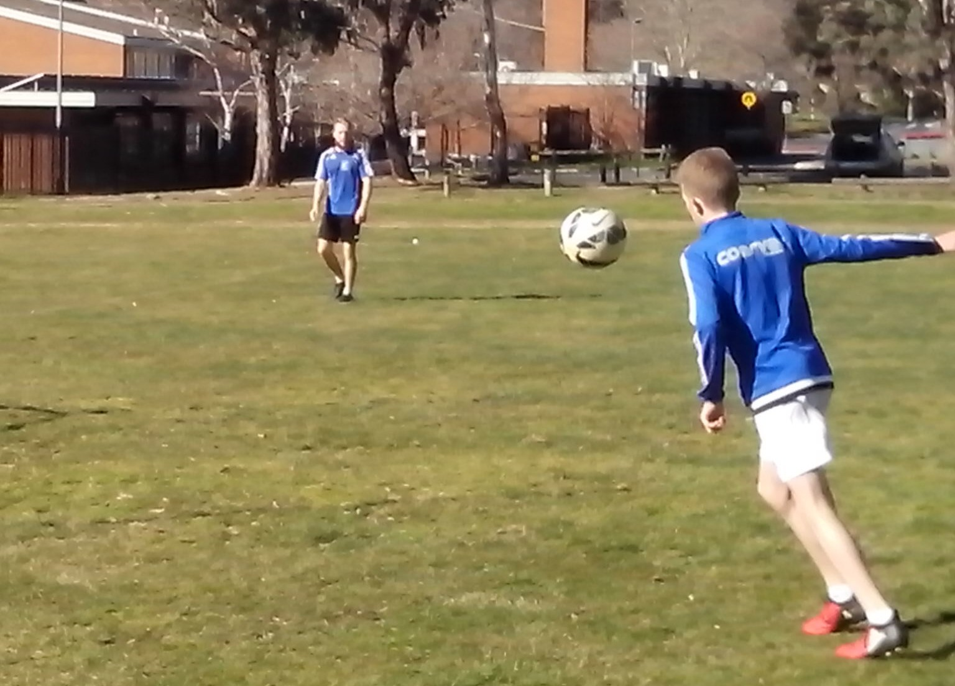

If it’s all the same to you, we need more innovation.

We teach everything we know about the game. The key is to discover everything we don’t know.
50 WAYS TO IMPROVE SOCCER COACHING
Open Learning
Freestyle Soccer
Freestyle Kids
Freestyle Soccer Kids
Fusion
Smooth
Close Repetition Drills
10 Key Elements
10 Key Qualities
Footwork
Vision
Power
Precision
Mobility
Off the Ball
Decision
Belief
Repetition
Challenge
Intuition
Character
Control
Teamwork
Hard Drive
Growth
Natural Skills
Counterbalance
What we Don’t Know
Calling the Shots
Feedback
Game Changer
Wonder
Headstart
Supergrade
Juggling
Game of Cones
Lighten Up
Mistakes
Underlying Cause
Full Circle
Give and Go
Networking
Make Certain
Learning the Four R’s
Mind Reading
Good Sports
Wall Pass
Specialists
Training Themes
Match Warmup
Work Bench
Skills Park
Shooting Gallery
Personal Goals
Safety Net
Track Record
Power of One on One
Quality Control
Home on the Range
Responsibility
Safety
Kids Play
Off Season
Inspiration
Confidence
Total Control
Empower
Making a Difference
Lift Our Game
OPEN LEARNING
Not everybody can teach but everybody can learn.
We all have eyes, ears, mouths and minds. We just need to open them so we can look at players, listen to new ideas, ask questions, think for ourselves and make decisions to suit the needs of talented individuals.
Just by throwing a ball at a kid, you can learn if they are one footed, flat footed, stiff legged, bend their knees, back away from the ball, wait for the ball, move to the ball, stretch for the ball, stab at the ball, strike through the ball, relax, tense up, rush, try too hard to kick the ball too hard or hesitate and kick the ball too soft.
How kids move determines whether their control is smooth or rough. You can identify their balance, timing, rhythm, coordination, agility, flexibility, strength and confidence. The next player will be totally different. All kids are different. Every coach can make a difference.
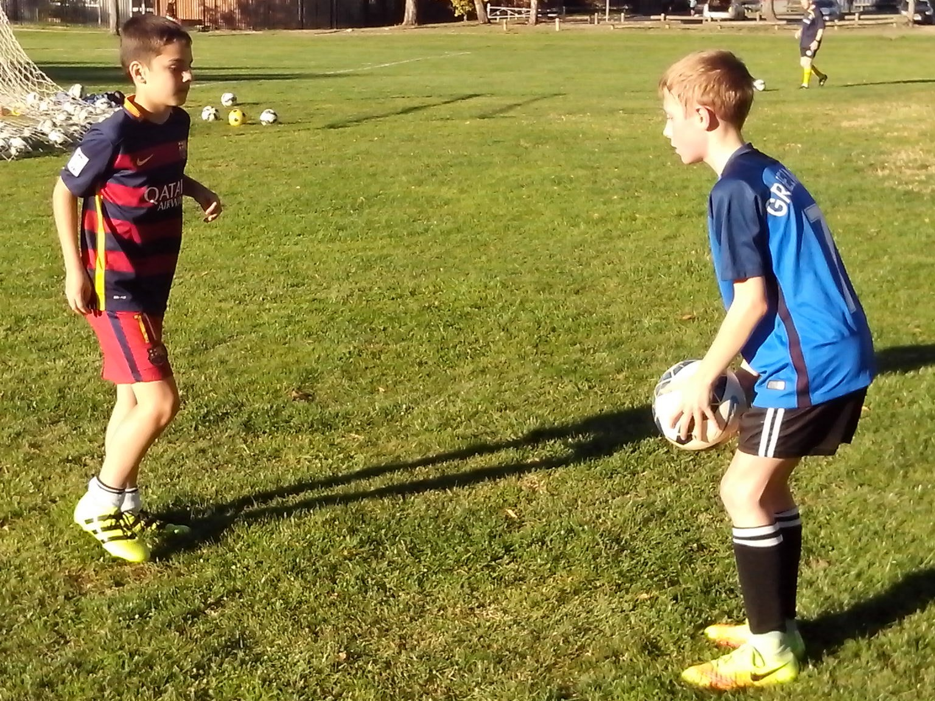
FREESTYLE SOCCER
The greatest challenge in sport is trying to tell a coach that they have the capacity to improve their coaching.
Freestyle Soccer is a search for talent. It’s not a coaching system. It’s a learning program. A coaching system teaches techniques and tactics so that teams can win games. A learning program looks at individual players and identifies their strengths, weaknesses, skills, talents, fears, needs and limits so that every kid can achieve their full potential.
Australia is unique in having vast resources of hidden and untapped Soccer talent. We can’t teach talent with a coaching system and we can’t discover talent without a learning program. Welcome to the world of Freestyle Soccer. It’s a whole new ball game.
We can always look for better ways, smarter ways, faster ways and different ways to improve Soccer kids, basic skills, training drills, match results, shooting practice, coaching and Australian Soccer.
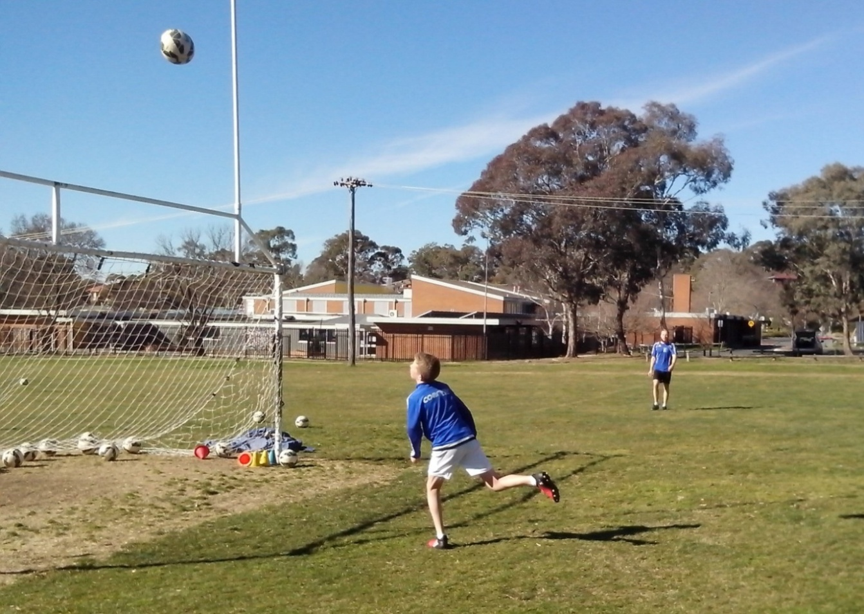
FREESTYLE KIDS
Freestyle kids are the pioneers of the Australian sporting identity. They show the Australian character.
All across Australia there are thousands of kids who train every day on their own or with their mates without any supervision from adults.
These are the Freestyle kids who inhabit the skate parks, BMX tracks, surf beaches, basketball courts and cricket nets. These kids have the freedom to run their own drills and swap tricks without any direction, correction, protection or rejection from well meaning coaches.
Freestyle kids don’t follow an agenda or timetable. They practise what they need to practise and they persevere with a skill until they master it and then move on to the next level. Kids don’t fall apart just because adults aren’t telling them what to do. Freestyle kids develop respect, responsibility, resourcefulness and resilience. Nobody tells kids to go to the skate park. They train because they want to improve.
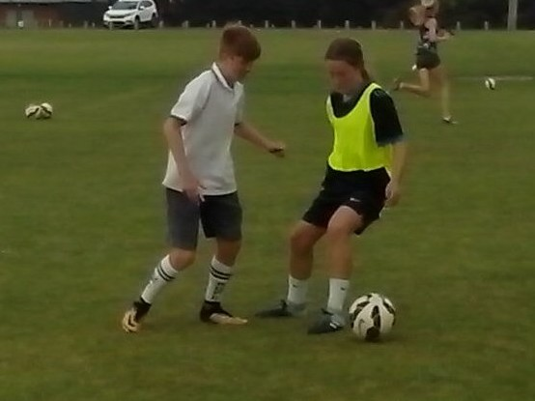
FREESTYLE SOCCER KIDS
If we teach every Australian Soccer kid to be the same, we will miss all the kids who can make a difference.
Freestyle Soccer kids practise every day with a ball and open their minds to new and different ideas. Any coach can identify Freestyle kids in their team by the way they run and call. When we look at the leading football nations of the world, we see elite academies. We don’t see the millions of kids who spend hundreds of hours getting thousands of ball touches by juggling, dribbling and playing games.
Soccer is unique because all the players are different. They all bring something different to the game, whether it’s character, intelligence, mindset, mobility, control, judgement, teamwork, drive, creativity or growth. We can teach the same every day or learn something new every day. We can learn something different from every Soccer kid.
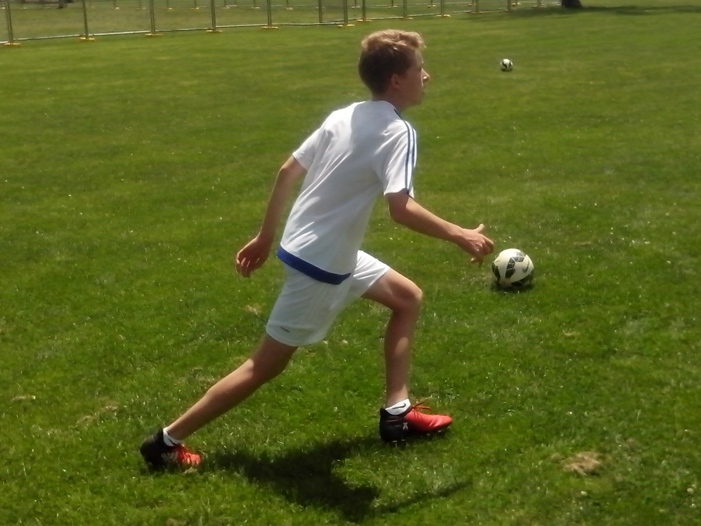
FUSION
Think, move and control. Mind, body and ball.
It’s very simple. We’re teaching Soccer skills without learning about the natural skills that all kids have. We’re teaching perfect striking technique to kids who don’t know how to move their feet or what to look at when they kick a ball. We can improve any kid by looking at human movement, human intelligence, human behaviour and human development. Fusion enables kids to synchronise mind, body and ball.
Any kid can look, listen, think, call, learn, move and kick a ball. The key is to do them simultaneously. We’re teaching all the right stuff. We just need to put it together, get it together and keep it together.
Some kids pass without looking. Some kids move without thinking. Some kids call without moving. Some kids move without calling. Some kids wait for the ball without making a run or a call. Some kids shoot without checking the target. Juggling enables any kid to take 100 steps, make 100 decisions and get 100 ball touches in 5 minutes. Effective control depends on how kids think and how they move.
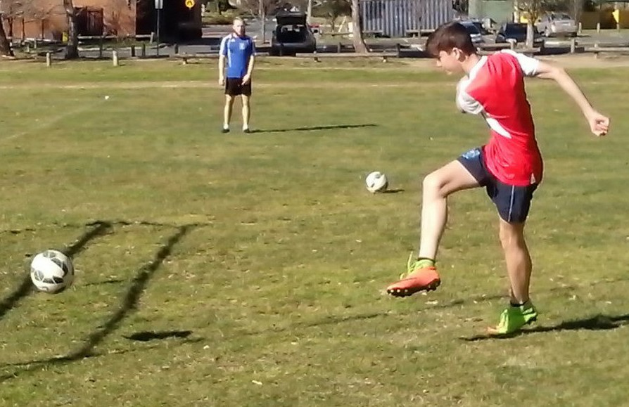
SMOOTH
Slow becomes smooth and smooth becomes fast.
There’s a way that Freestyle Soccer kids achieve their potential. They start with slow, simple, short, steady and smooth moves and gradually build the speed, range, power and intensity until they reach their peak.
Parents, teachers and coaches constantly tell kids to try their hardest so they tense up, rush and make errors. Kids are impulsive by nature and expect too much too soon. They try too hard to kick the ball too hard. Freestyle kids learn to relax when the pressure is greatest. Light becomes smooth and smooth becomes strong. The top players always look relaxed in the box. They control their power and temperament.
Precision becomes smooth and smooth becomes power. Freestyle kids begin power shooting inside the 6 yard box. They develop their accuracy first and then slowly increase their effective range. Kids who practise shooting for 15 minutes a week only have just enough time to rush their shots and blast the ball over the bar from outside the box.
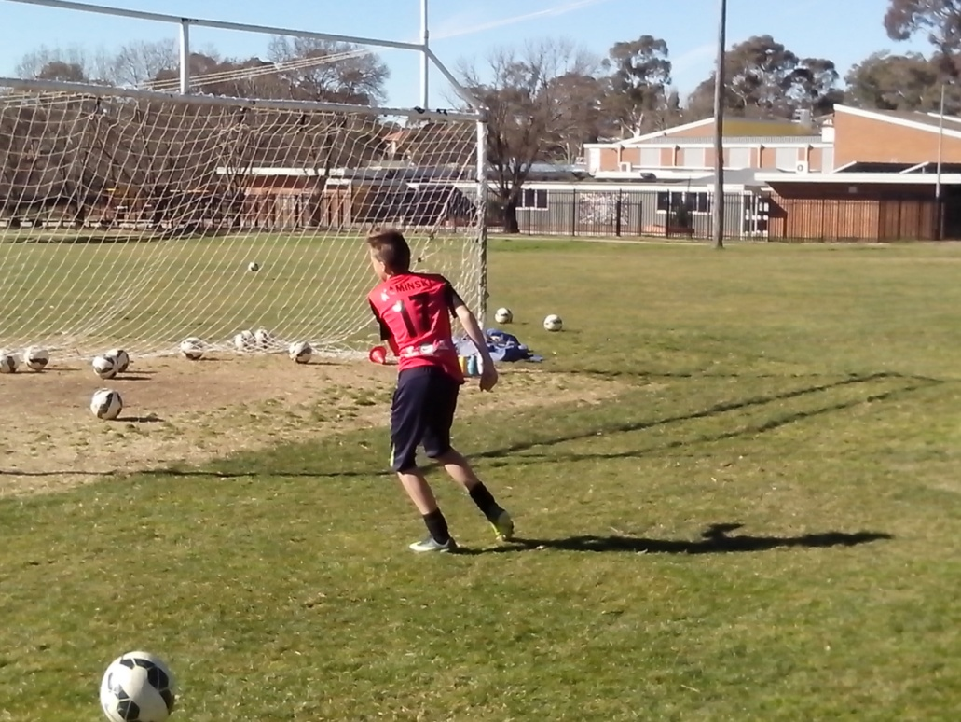
CLOSE REPETITION DRILLS
Freestyle drills make certain that improvement is immediate, clear, measurable and permanent.
Close repetition drills let kids work closely and let coaches get a close look at what kids need to improve. Close Heading in Pairs identifies the kids who try too hard to head the ball too far. Some kids learn to use their head. Freestyle kids move their whole body. We expect kids to head a goalkick in a game but two kids can’t stand two metres apart and head a ball to each other without dropping it. Close Heading in Pairs gives kids confidence to move and use their body.
Juggling in Pairs identifies the kids who pass the ball and then stand still. The Juggling Circle picks out kids who lack the confidence to call or move off the ball and reflects how kids behave in a game.
A lot of kids pass the ball in a game and then stand still and watch. Close juggling in pairs teaches kids to pass and move, give and go, kick and run. They learn the basics of possession: control and support.
Some kids stab at the ball because they stand flat footed. The Game of Cones teaches kids the fusion of mind, body and ball. Think, move and control. Footwork and vision help Soccer kids to find their feet.
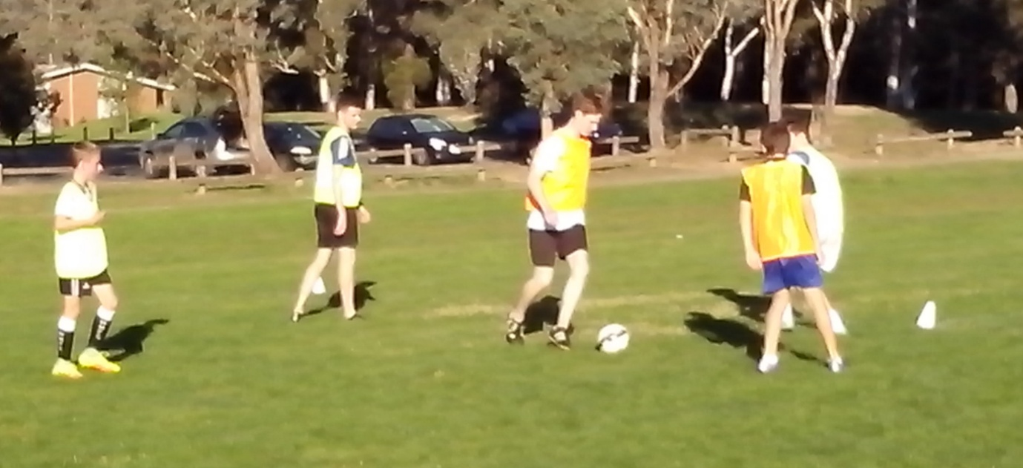
10 KEY ELEMENTS
Freestyle kids keep shooting till they nail it. Once they get it down, they keep it down.
All kids are different. When we teach the same skills to different kids, the results are always different. Soccer skills are simple. Any kid can kick a ball. How kids develop their Soccer ability depends on how well they use their own natural ability.
Any coach can identify skilful kids by using the 10 triggers that activate Soccer skills. Players need footwork and vision, power and precision, movement and decision, belief and repetition, challenge and intuition if they want to improve their Soccer skills and achieve their full potential. We can improve any Soccer kid in 5 minutes just by learning about them and developing their footwork and vision. Freestyle kids need power and precision to score goals, movement and decision to support the ball player, belief and repetition to improve control and challenge and intuition to play their own game.
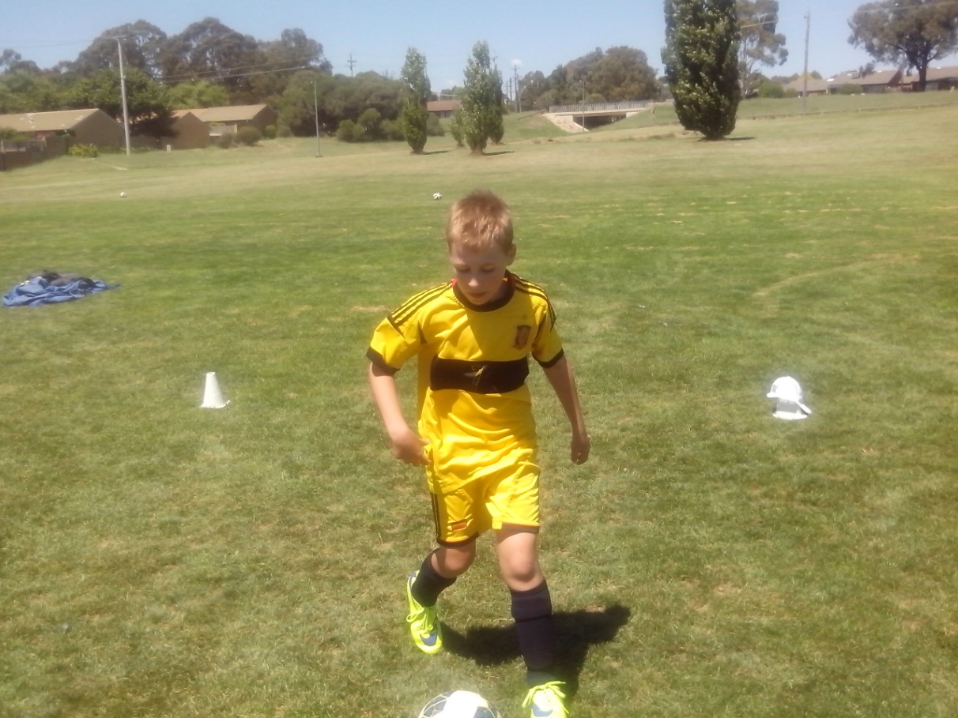
10 KEY QUALITIES
If we think kids lack skill, we’ve got a lot to teach. If we think kids lack talent, we’ve got a lot to learn.
All kids have talent. We can teach skill but we can’t teach talent. Skill comes from the coach. Talent comes from the players. We need a coaching system to develop Soccer skill and we need a learning program to develop talent. Freestyle Soccer is a learning program.
Any coach can identify Soccer talent by learning about individual players and analysing the 10 personal qualities that all kids have. Every Australian Soccer kid has a different combination of character, intelligence, mindset, mobility, control, judgement, teamwork, drive, creativity and growth. Talent depends on how they put them together.
If we believe that kids have talent, we will look for that talent. If we believe kids lack talent, we will teach them all to look, think, stretch, move, kick and play the same way and we will always stay the same.
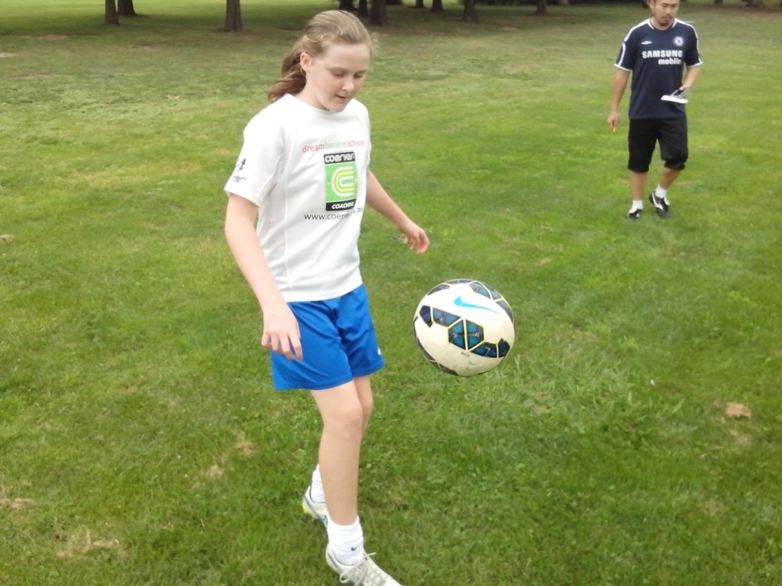
FOOTWORK
We can improve any Soccer kid in 5 minutes just by showing them how to move their feet.
Kids play the way they train. If we teach them to control a ball while they stand still, they’re learning to stand still while they control a ball.
Kids stab at a ball because they stand flat footed and wait for the ball to come to them. Footwork enables players to step into the ball and strike through the ball smoothly. Kids struggle to head a ball because their feet are glued to the ground so they lunge at the ball. Footwork teaches kids to move their whole body when they head the ball.
We spend so much time teaching perfect technique without learning about human movement. We look at the kick and overlook the kid. Soccer is about a kid and a ball. Freestyle Soccer is about a moving kid and a moving ball. Australian Soccer kids don’t become smooth by hopping over a dead ball for 5 minutes or juggling with one foot.
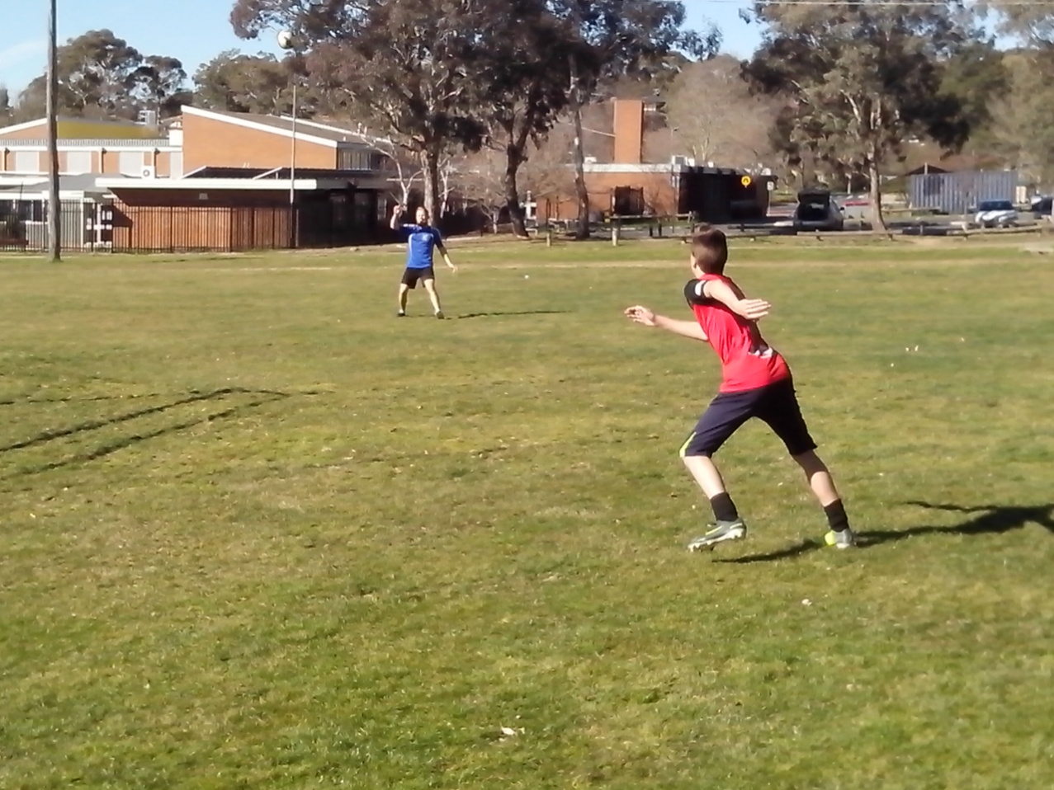
VISION
If coaches can think outside the goal square and stand behind the net, they can see what kids are looking at.
Most kids have no idea what to look at when they strike the ball and no coach has ever told them or thought about it because it’s not written down. Some kids look at the ball when they shoot and some kids look at the target. Some kids look at the target before they shoot and some kids only look at the target after they shoot. Kids who don’t check the target before they strike will always lift their eyes and their head as they kick the ball over the crossbar.
Any coach can discover this for themselves and they can improve any kid in 5 minutes just by teaching them to get ready, take aim and fire. Freestyle kids look up, lock onto target, look down and lock onto ball. Kids spend years kicking a ball over the bar and coaches spend years correcting the technique because we’re locked into one firing system.
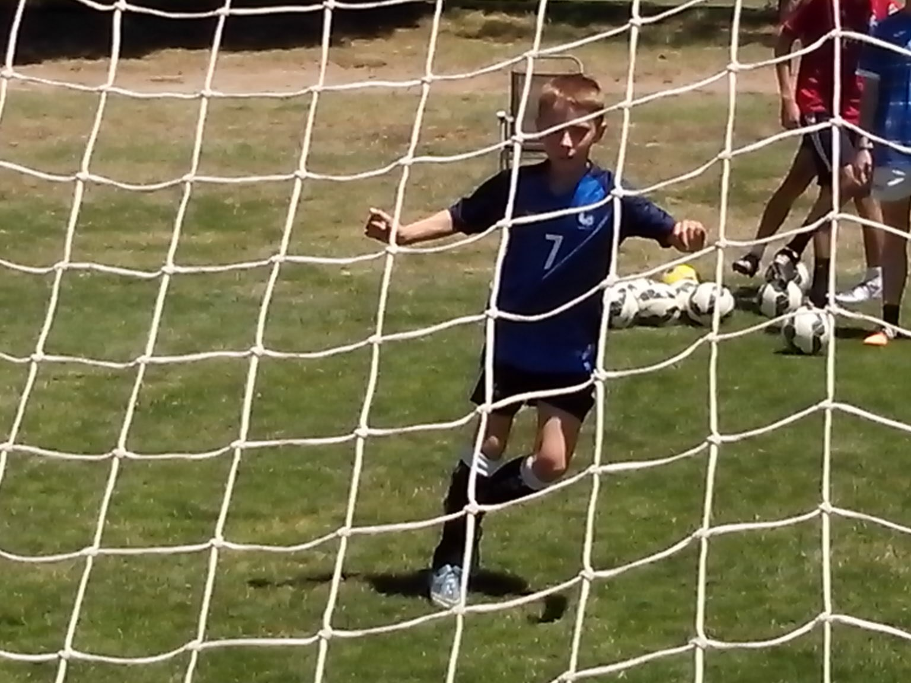
POWER
Most Soccer kids try too hard to kick the ball too hard.
Kids will find power when they stop looking for it. Precision is smooth and smooth is power. If kids can learn to relax and develop their timing first, their power will develop naturally. Nobody in Australia seems to know how to score goals, so that’s our challenge.
Power shooting begins in the 6 yard box. Freestyle kids start with safe, short, simple, steady and smooth control using target cones placed inside each post. They learn to aim small and miss small. They gradually increase their speed, power, range and degree of difficulty until they can keep their shots on target from outside the box. If we can improve any kid in 5 minutes, we can improve Australian Soccer.
Most kids train the way they want to play. They try to learn power shooting by kicking the ball as hard as they can and as often as they can for 15 minutes every week from outside the penalty area. Kids who practise blasting the ball over the crossbar get really good at it.
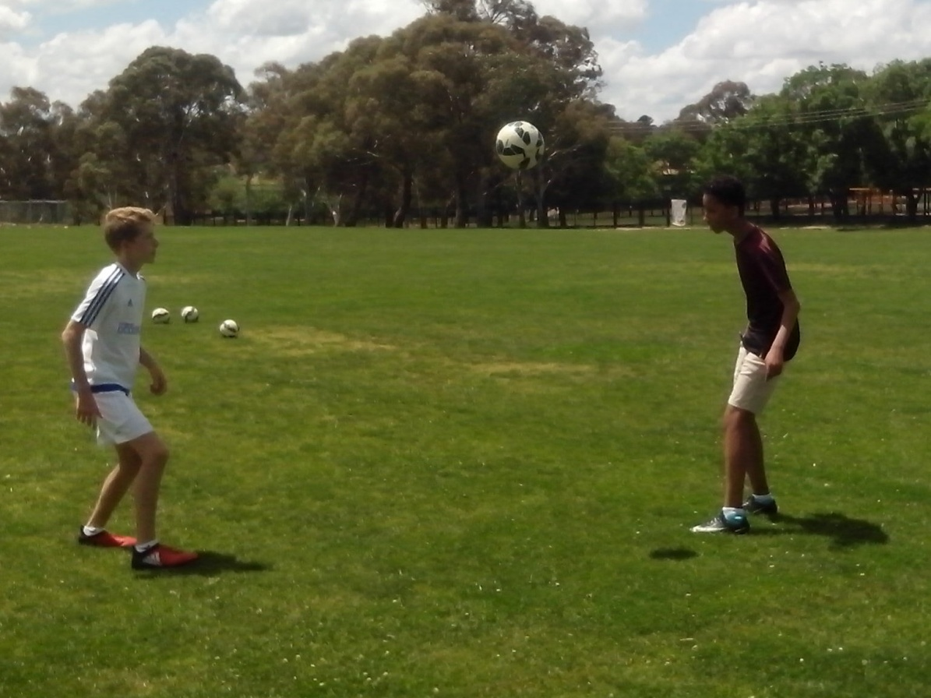
PRECISION
Most Soccer kids miss big because they aim big.
Soccer goals are simply too big. Kids are so strong and the goal is so big that they can’t possibly miss. Oops. In a game determined by goals, kids don’t know how to shoot because coaches don’t know how to score. There are no goal scoring academies to teach them that skill.
The average Soccer goal is 34 balls wide and 10 balls high. Any coach can discover that for themselves. The average Soccer kid aims for 340 targets and puts the ball in the middle where the keeper is. So many shots go through to the keeper. What kids see is what they get.
The average Freestyle Soccer kid aims for one small target on the ground and away from the keeper. Any coach can teach any kid to aim small and miss small. Any coach can discover how to improve any Soccer kid if they have enough time to learn about individuals.
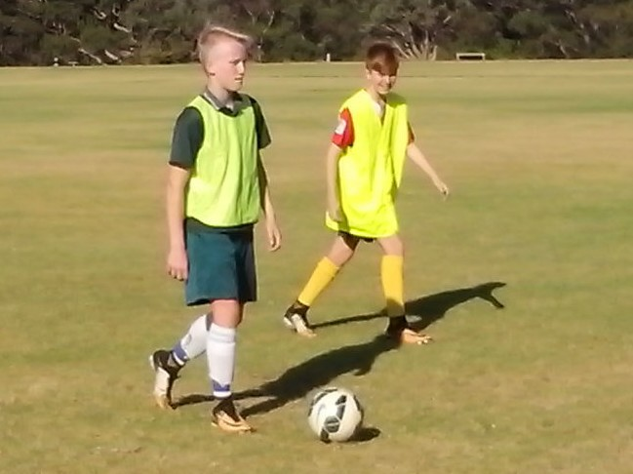
MOBILITY
A lot of kids stand dead still and dead quiet in a game because they’re dead scared of making a wrong move.
Freestyle kids will come off the field with a red face and a wet shirt. That’s what competitive sport is all about. Freestyle kids represent hunger and passion in the game. The more they do in this game, the more they can do in the next game. They use their mobility to disrupt the stability of any defence. Freestyle kids are generators of energy, motivation, intelligence and creativity. The more they think, create and move, the greater their capacity to think, create and move.
All kids have intelligence and talent. It’s what they do with it that counts. Ordinary kids think ‘ball and goal’. They chase the ball until they catch it and then they rush towards goal till they lose it again. Freestyle kids think ‘space and possession’. They look and think 360 degrees and pass the ball around until they can score goals. Any coach can give kids the freedom to use their initiative and play intuitively.
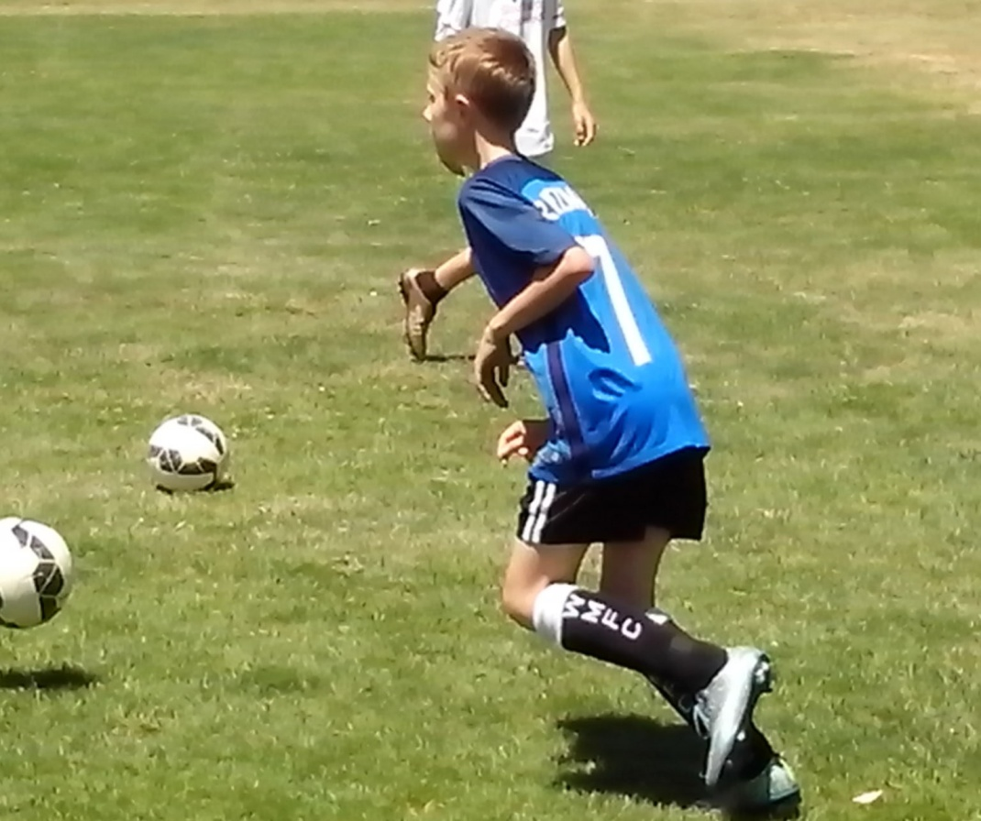
OFF THE BALL
Skilful kids can dominate 5% of the game with a ball. Talented kids dominate the other 95% without a ball.
Tim moves up the field with the ball at his feet. Ahead of him are three forwards who stand with their markers and wait to see where Tim passes the ball so that they know where to run. Sometimes, the forwards will shout ‘Tim’ which only tells him that they want the ball but it doesn’t tell him where they want it.
We spend so much time teaching kids what to do with the ball that we don’t have time to learn what they do without the ball. At training, we focus on technical mistakes. In a game, we follow the bouncing ball. Some kids are scared to run and call in case they do the wrong thing. Any coach can watch kids juggle a ball in a circle and identify those who dictate and dominate and those who hesitate, wait and spectate.
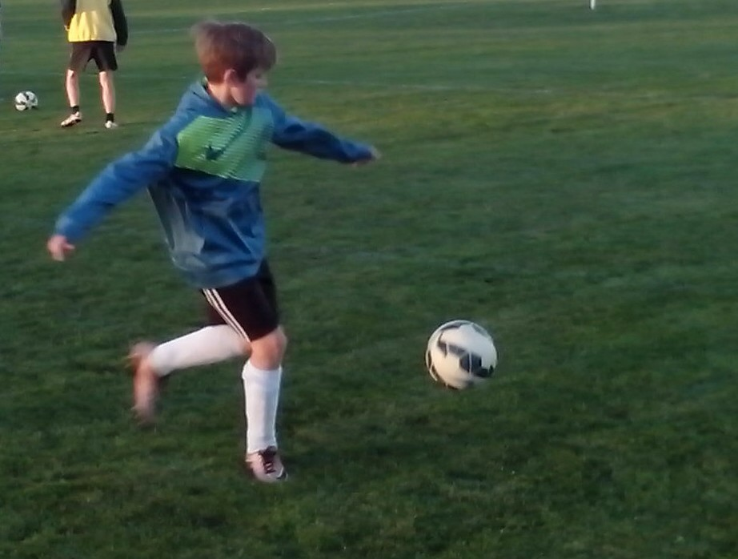
DECISION
The most difficult skill in Soccer is making the right decision.
Any kid can trap, pass, dribble, juggle, head the ball and shoot. The challenge is to choose the right one at the right time. Some kids pass when they should shoot and some kids shoot when they should pass. Judgement can be affected by fatigue, frustration or lack of practice.
Any coach can improve the decision making in their team by giving kids more time on the ball and more repetition drills so that their game becomes more intuitive and the kids become more confident.
Neymar uses 10% of the brain activity of ordinary players. He doesn’t have to stop and think or try to second guess what the coach wants him to do. Calling is an integral part of decision making. Certain kids call where they want the ball. Uncertain kids just call for the ball.
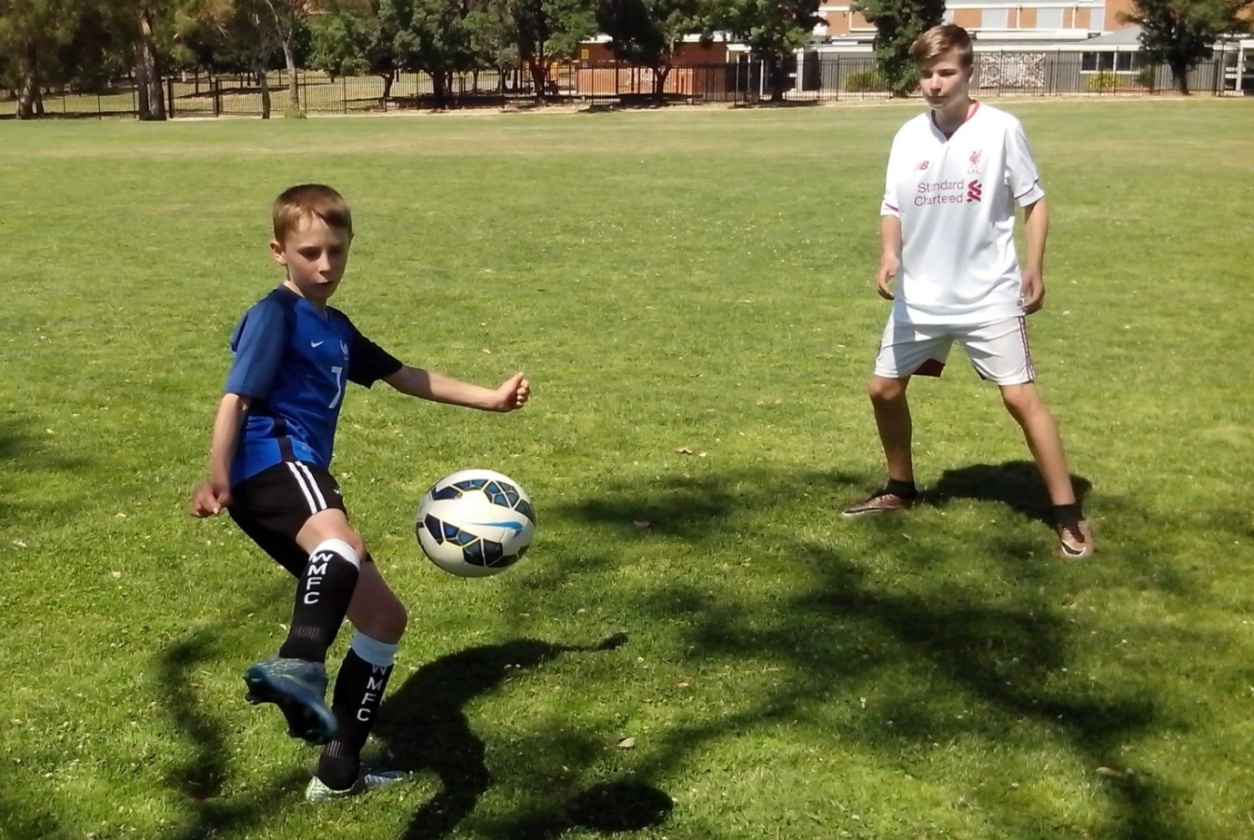

BELIEF
If the kids believe in the coach, and the coach believes in the kids, the kids will believe in themselves.
Belief is the key to the future of Australian Soccer. Our actions are driven by our beliefs.
If we believe that Soccer kids don’t have the talent to reach the top, we will look for mistakes to correct.
If we believe that Soccer kids have the talent to reach the top, we will look for that talent and discover how good Australian Soccer kids really are when they have the freedom to think for themselves.
It’s amazing how talented kids suddenly become when we start to believe in their ability and let them run drills. Kids need to move if they want to improve. They need to believe if they want to achieve.
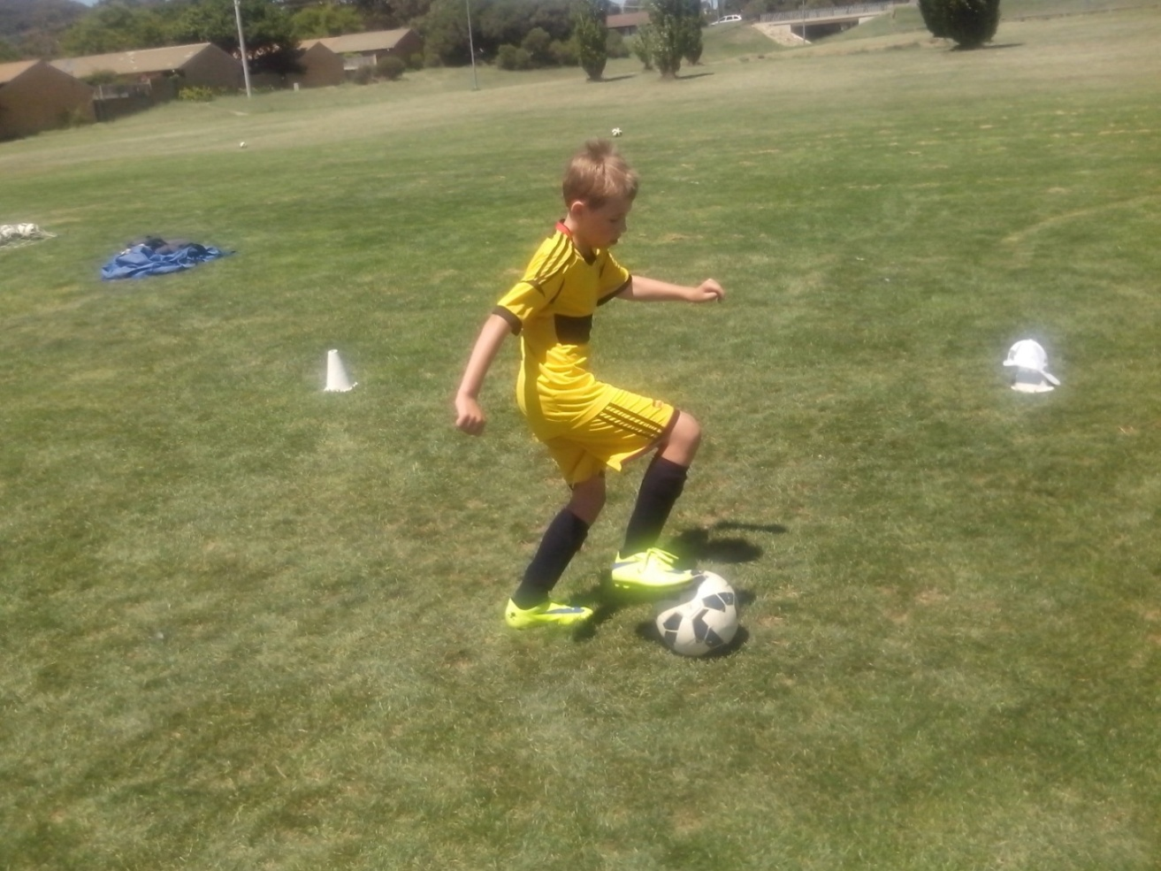
REPETITION
Any coach can discover that it takes 200 kicks to get smooth control and it takes 5 minutes to get 200 kicks.
The average Soccer kid gets 200 ball touches during training sessions. The average Freestyle Soccer kid gets 200 ball touches before training so that they’re ready to train. On match day, Freestyle kids get 200 kicks before kickoff so they’re ready to play when the whistle blows.
Kids who stand in the firing line get one shot on goal every 2 minutes. We’re teaching them to shoot and they’re learning to stand around. Shooting is a basic motor skill, just like running and throwing. At the cognitive level, kids have to stop and think. At the associative level, they get more familiar with the moves. At the intuitive level, kids can control the ball without thinking. The average Australian Soccer kid never gets enough repetitive ball touches to get past the cognitive level. There are simple ways to measure the effects of repetition.
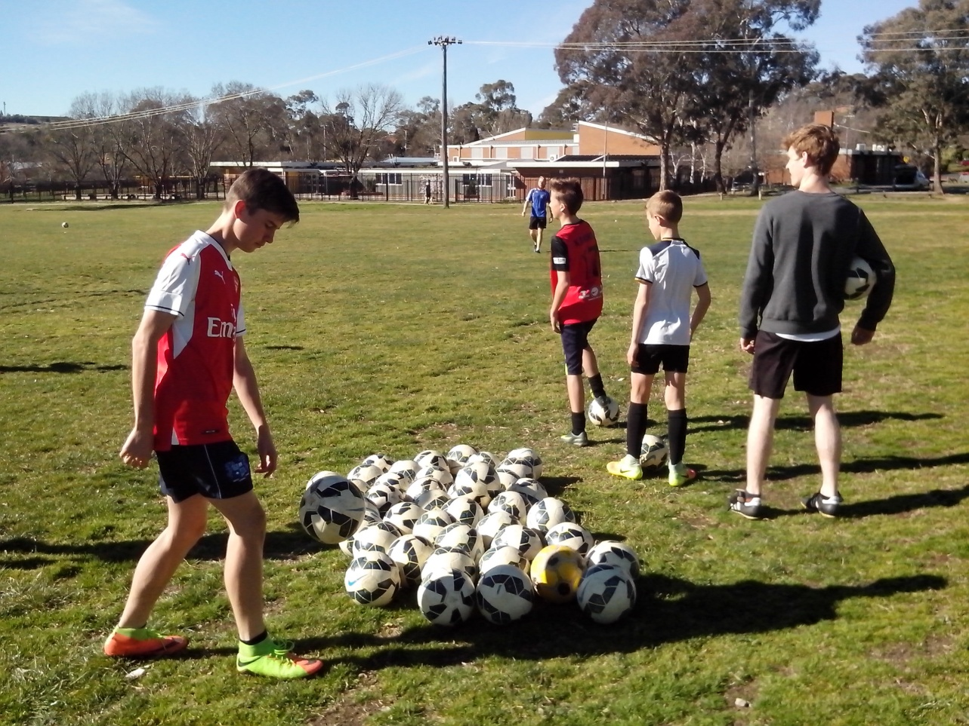
CHALLENGE
The Freestyle challenge is to find one kid who can’t be improved in 5 minutes.
Sport should be a challenge. Let’s face it. Some players stay in their comfort zone and only practise what they can do so they can avoid making mistakes. Freestyle kids practise what they can’t do so they make a lot more mistakes and they learn a lot more from them.
Some kids are conditioned to play it safe and keep the ball on the ground. Freestyle kids love the challenge of volleying, heading and juggling the difficult high ball so they can learn to read the spin and the bounce. Freestyle Soccer needs to be constantly challenged to make it more robust so that it never stays at the same level. Growth depends on a willingness to question old ideas and challenge the new.
The worst we can be in sport is satisfied because then we all become ordinary and avoid innovation. The best we can be is challenged because then we look for different ways to improve. Most Soccer kids aren’t impressed by best practice. They want better practice so they can get thousands of repetitive ball touches and challenge their limits.
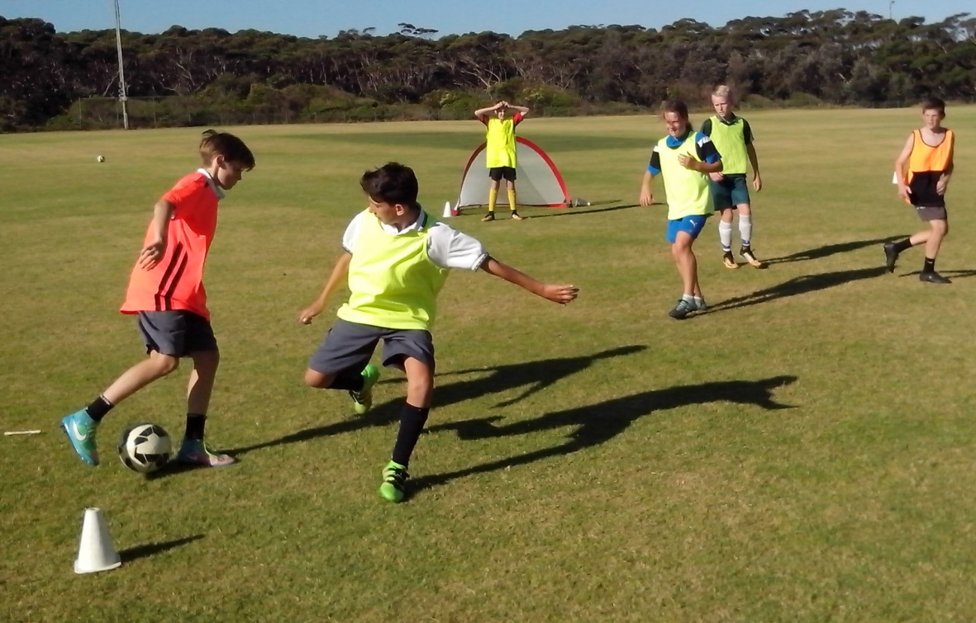
INTUITION
All kids have talent. They just use it differently.
Skill is what we teach kids. Talent is what they do with it. Intelligence is what kids do with their talent. Creativity is what they do with their intelligence. Once we teach them the basics, kids learn to improvise.
All kids look the same when we tell them where to stand and what to do. The instinctive player stands out when the pressure is increased and they need to improvise. When it’s pouring with rain and the field is slippery, one kid will always keep control. Any coach can improve any player in 5 minutes just by learning what makes them stand out.
All kids are different and they all have different talents. Any coach can identify Freestyle Soccer kids by the way they train. These kids constantly look, think, talk, listen and move as they explore options.
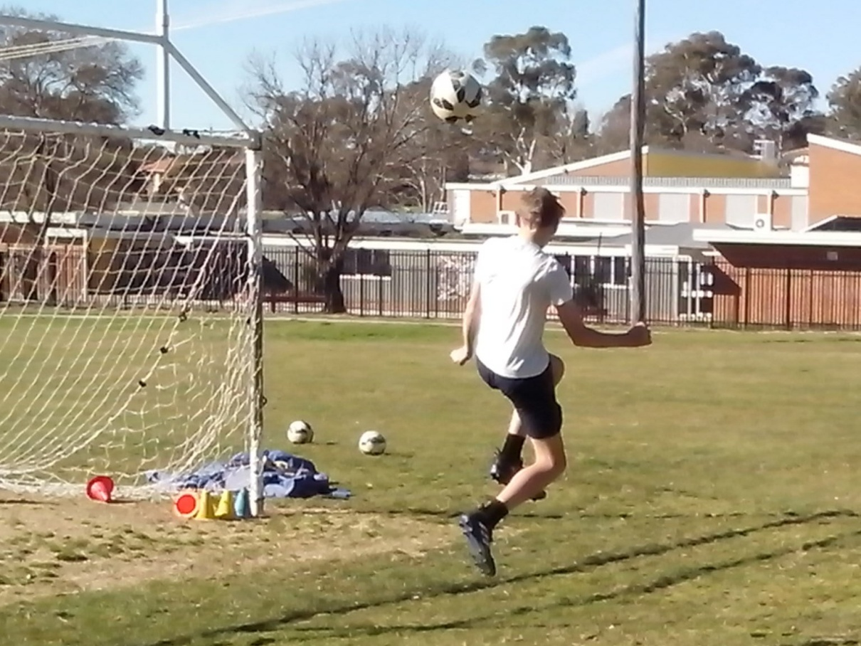
CHARACTER
An observant coach will recognise character both on and off the field.
A one lap race isn’t just about fitness and speed. It provides clues about character and potential. In any race, the coach will identify the three at the front who push themselves and the three at the back who drag their feet. Kids show their personality in everything they do.
If the fastest kid can run a lap of the field in 52 seconds and the slowest kid takes 75 seconds, every kid should be able to achieve a team standard of 60 to 65 seconds. When they repeat the run with a ball at their feet every kid should aim for between 75 and 80 seconds.
When the best ball player can juggle over 100 and the struggling kids can’t make double figures, 20 becomes the standard to reach. Less than 20 can be faked with a bit of luck. It takes a lot of time and effort to beat 20 juggles. It takes character to challenge personal goals.
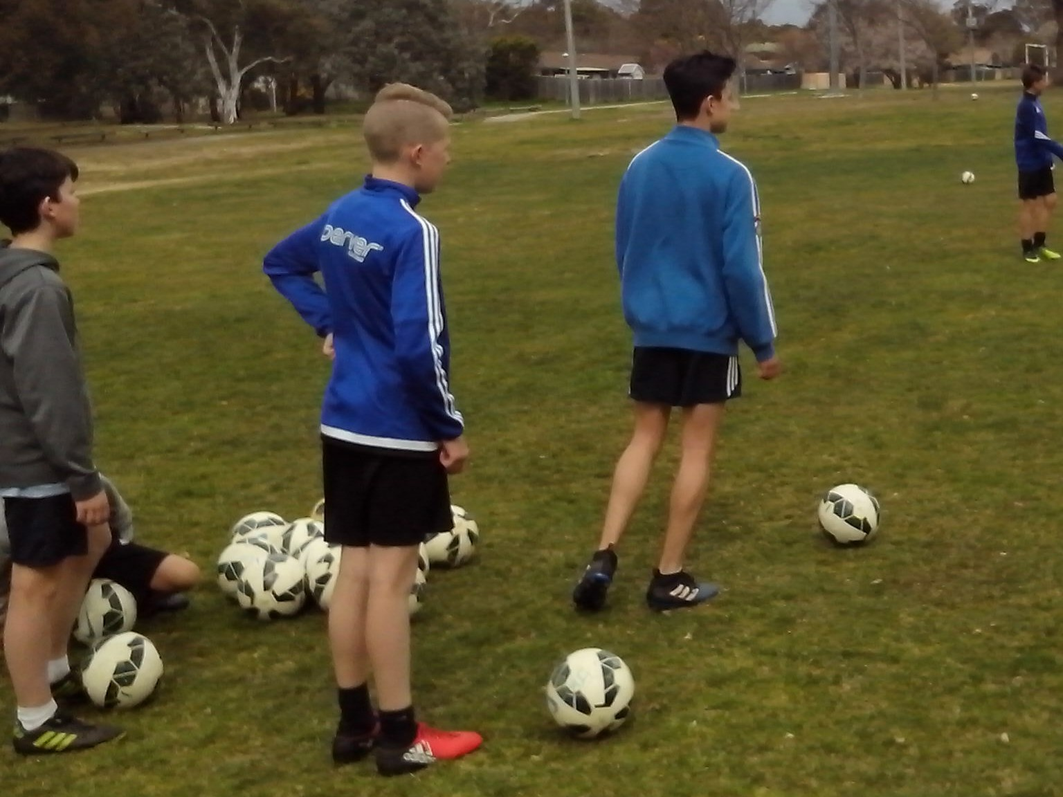
CONTROL
The quality of control in a game is directly related to the quantity of control at training.
Most coaches have no idea how many ball touches kids need to get a feel for the ball. It takes at least 200 ball touches before eye/foot coordination kicks in. Any coach can measure this for themselves. We don’t learn to walk by standing in a line and taking one perfect step every two minutes. We learn to walk by walking. We don’t learn to shoot by taking one shot every two minutes. We just need to shoot.
When kids juggle a ball 30 times, the last ten numbers are a lot higher than the first ten as the mind and body synchronise with the ball. At the start, kids are flat footed and stiff legged. Initial touches are too hard or too soft, too high or too low, too early or too late, too fast or too slow, too left or too right, too loose or too tight. After 200 kicks, control becomes intuitive. It takes 5 minutes to get 200 ball touches.
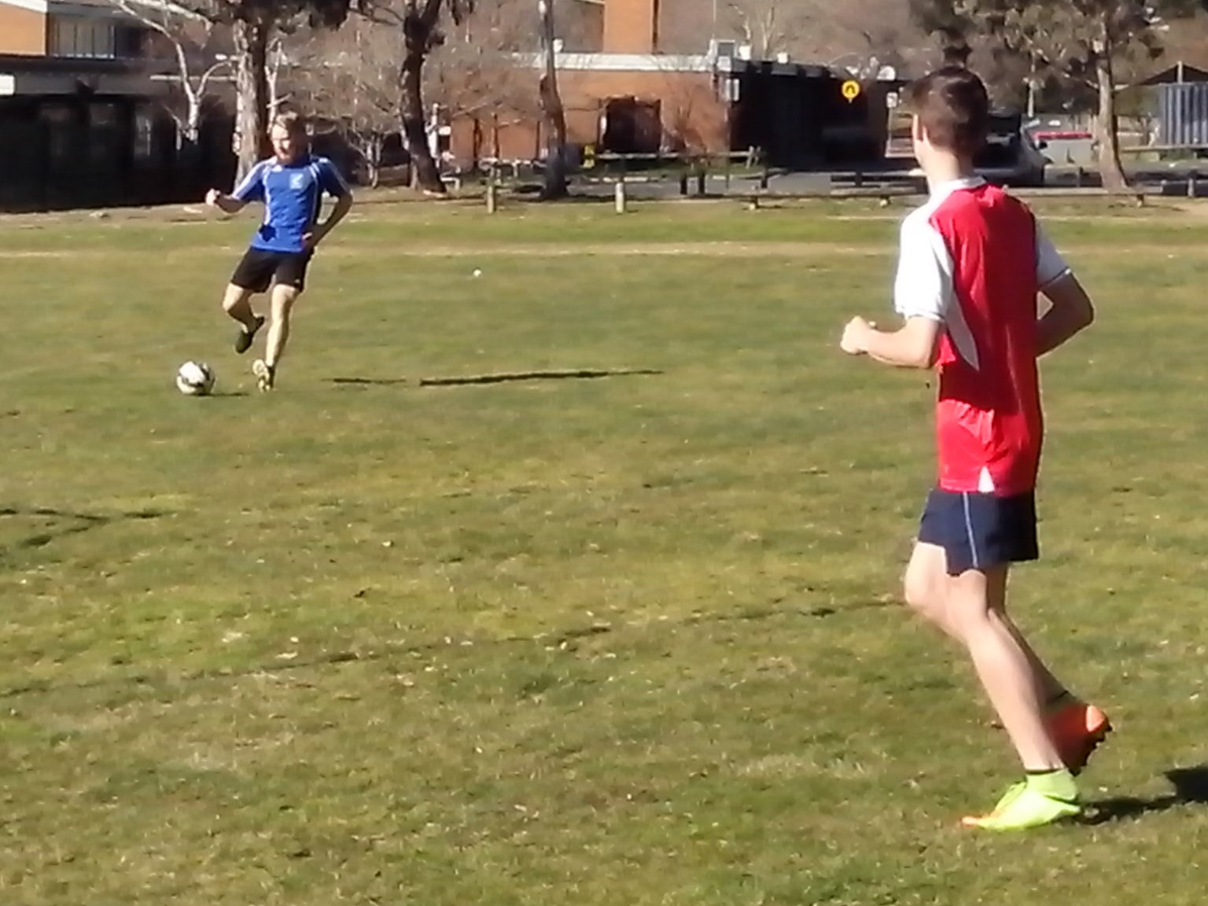
TEAMWORK
Soccer is essentially a team game so Freestyle kids learn to think about the other players.
Teamwork is personality, temperament and behaviour. Some kids are team players and some kids are more suited to individual sport. When the pressure is on in a game, kids need to know that they can depend on their team mates.
Some kids focus on themselves and some kids focus on the team. A coach can teach a team but needs to learn about individuals.
All kids have talent but it’s what they do with it that counts. There are plenty of skilful kids who dribble until they lose the ball and talented strikers who try to impress by blasting the ball over the bar. Freestyle kids keep possession, keep the ball in play and keep their shots low.
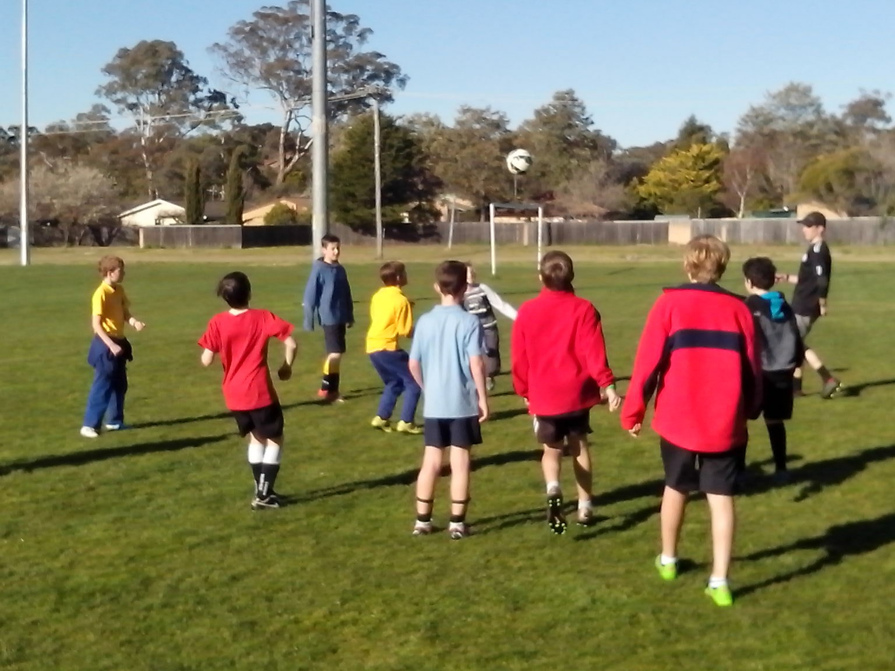
HARD DRIVE
Motivation has to come from the kid. It won’t work if it only comes from their parents or coaches.
The average Soccer kids learn to train when they’re told to train and learn to do what they’re told to do. They don’t need to think for themselves or create their own moves if everything is choreographed. The average Soccer coach looks for the kids who are easy to coach.
There are thousands of Freestyle kids in Australia who train without being told and they’re forced to think for themselves, identify their own mistakes and discover the underlying cause. These kids are never satisfied with being ordinary. There’s something in Freestyle Soccer kids that drives them to do more than they’re told to do. Most coaches have no idea who the Freestyle kids are in their team.
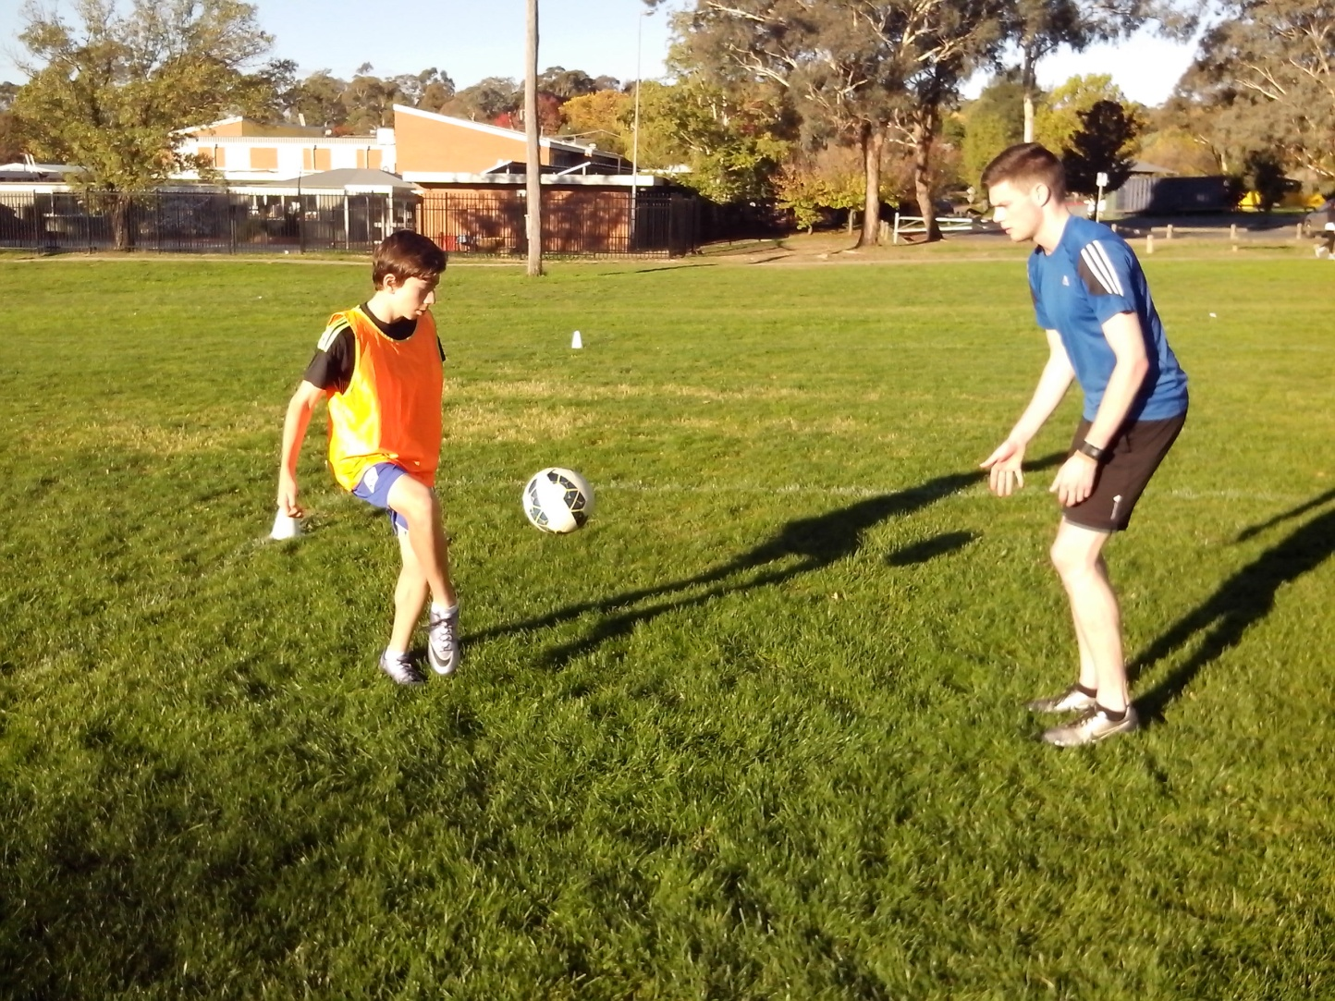
GROWTH
When a coach can measure performance, they can also measure improvement and identify peak skills.
Some kids go through a whole season without knowing how skilful they are or whether they’re actually improving. Freestyle kids keep a record of their fitness and skill levels so they know where they’re up to and what they need to focus on next to challenge their limits. How many Soccer coaches keep a record of player performance?
When kids can actually see their progress, written in black and white, they get the positive reinforcement they need to inspire greater effort. When kids can juggle a ball 20 times, they know they can reach 100.
It’s not enough to grow. Kids need to know that they grow so they can be inspired to try harder and aim further. Any coach can keep a folder of juggling figures so that every kid in the team can see their progress. Kids need to know that they get out of the game what they put into it.
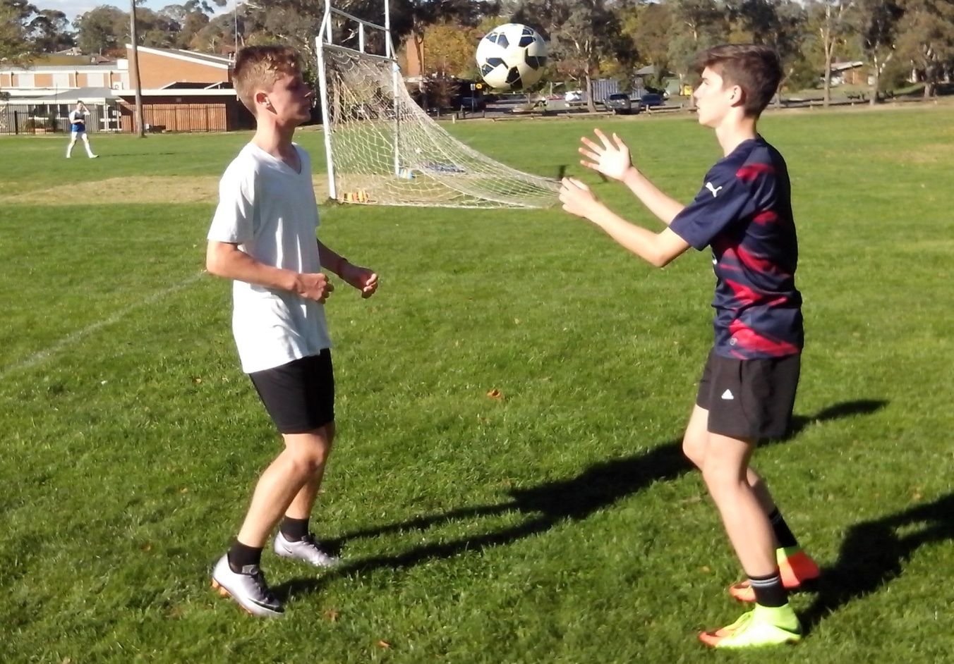
NATURAL SKILLS
When kids kick a ball, we look at the kick and overlook the kid.
We’re teaching Soccer skills to kids who can’t develop their natural skills. We’re teaching perfect control to kids who don’t know what to look at or how to move their feet. If you listen closely to a Soccer game, most sideline comments refer to natural skills not Soccer skills.
‘Look before you pass.’ ‘Give him a call.’ ‘Somebody make a move.’ ‘Think about it.’ ‘Listen next time.’ ‘Watch the blindside.’ ‘Get away from there.’ ‘Concentrate.’ ‘Tell him where you want it.’ ‘Talk to each other.’ There’s nothing wrong with kids or their skills. We just need to let kids look, listen, think, move and call it as they see it.
Growing kids need to develop their natural skills to improve their Soccer skills. Natural skills include looking, listening, understanding, talking, thinking, learning, making decisions and moving. These aren’t Soccer skills. They’re natural skills that nobody is looking at.
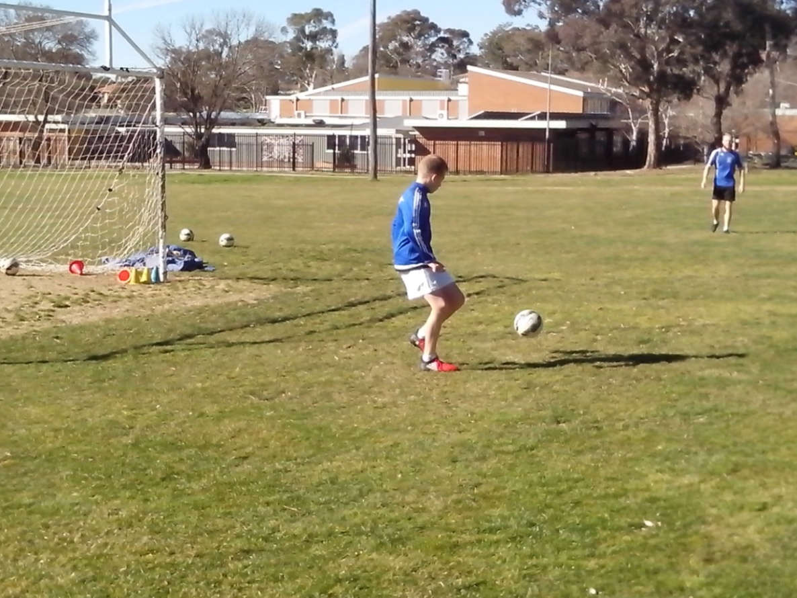
COUNTERBALANCE
There’s nothing wrong with Soccer kids or Soccer skills. Kids simply learn to play the way we train them.
Humans are ergonomically designed to play Soccer. When the left foot moves forward, it enables the right foot to swing through the ball. We run by alternating our feet and we run faster by using our arms.
When we coach little kids to kick a ball, we stop them from moving or using their upper body to counterbalance so that we can emphasise the perfect kicking technique. We focus on the kick and overlook the kid. There’s a reason why Soccer kids stand flat footed in a game and stab awkwardly at the ball instead of striking through it smoothly. There’s a reason why they lead with the kicking foot and not the non-kicking foot. These kids are doing exactly what we coach them to do. How many coaches are ever going to question the way they coach?
We can develop Australian Soccer kids to replace mechanical robots and program them with artificial intelligence or we can give them the freedom to develop their natural talent and make their own decisions.
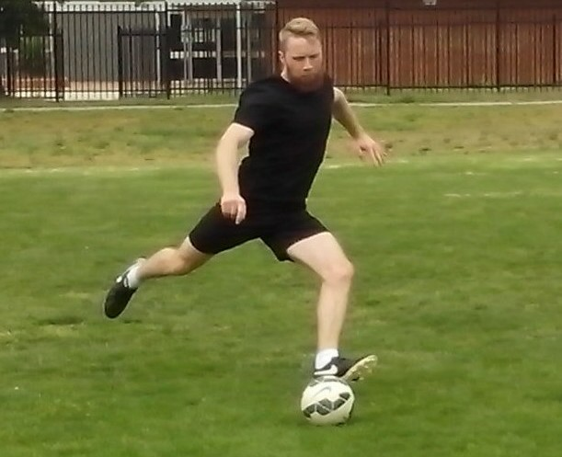
WHAT WE DON’T KNOW
The more we learn about Australian Soccer, the more we discover how little we know.
In a game that depends on goals, we don’t know how to practise shooting so we don’t know how to score goals. We don’t know what to aim for before we shoot or what to look at when we strike the ball. The best we can do is to kick as hard as possible as often as possible.
In a football game of eye/foot coordination, we don’t know anything about footwork or vision. In a competitive ball game, we don’t know how many ball touches kids need before their muscle memory kicks in and their control becomes second nature. In a game of intuition, we don’t know which kids have the power to improvise under pressure.
We don’t know anything about individual coaching, personal trainers, motional intelligence, natural skills or performance measurement. In a game of Soccer skill, we don’t know what each kid needs to improve.
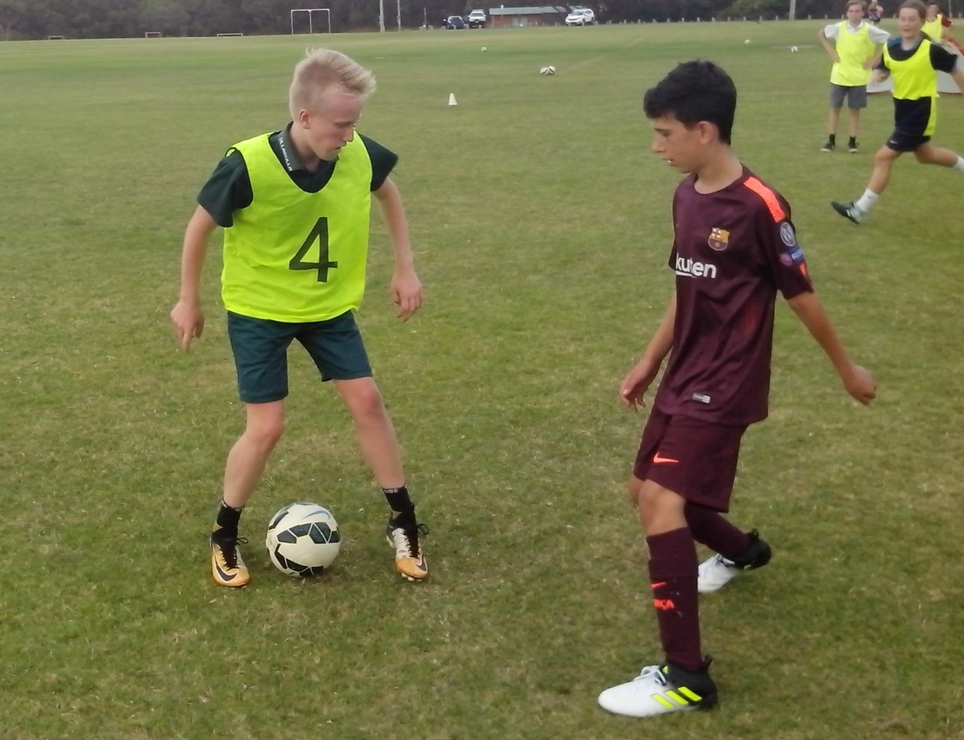
CALLING THE SHOTS
Communication is critical in a team game. Too many talented Soccer kids are missing their calling.
We tell kids what not to call, not what to call. The most common call that any coach can hear on the playing field is ‘mine’ because coaches keep telling kids not to say ‘mine’ so that’s the one word that sticks in their mind. On the sideline, the most common call is ‘Big Kick’.
There are at least 20 passwords that kids can use to keep possession. In the first week, the coach can ask kids to name them. In the second week, the coach can take 5 minutes to test the kids. By the third week, most of the kids will remember most of the calls and start using them.
Most Australian Soccer kids have no idea what to call in a game. Two team mates will clash heads going for the same high ball because neither player calls their name. Players can get caught in possession all the time because nobody tells them ‘Time’ or ‘Man On’. Calling is the simplest and most effective skill in Soccer because it requires no energy and can turn eleven individuals into a cohesive team.
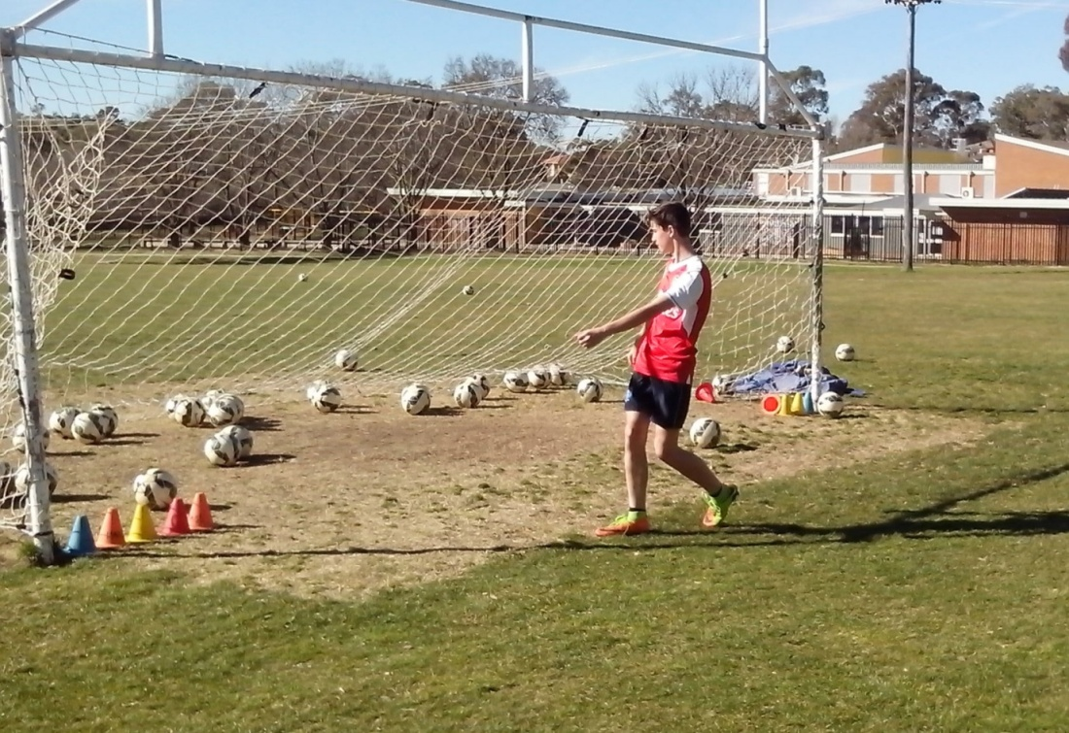
FEEDBACK
The most effective way to stimulate intelligence is to ask questions.
Ask kids why they go to school. All they know is that they go to learn. Most of them learn to do what they’re told. The real reason kids go to school is to learn to think for themselves. Nobody tells them that. It’s the same reason Soccer kids go to training. There are so many skilful kids who only train when they’re told and do what they’re told. We need players who train because they want to train.
If we ask questions, kids will think more about their game instead of waiting to be told what to do and how to do it. If they understand why, they can make their own decisions and achieve a lot more. Ask kids how many kicks they need before kickoff. Ask them how many calls they can use in a game. If you give kids five minutes to write down what they learned this season, you’ll be surprised at what they remember. All kids are different and their answers are all different.
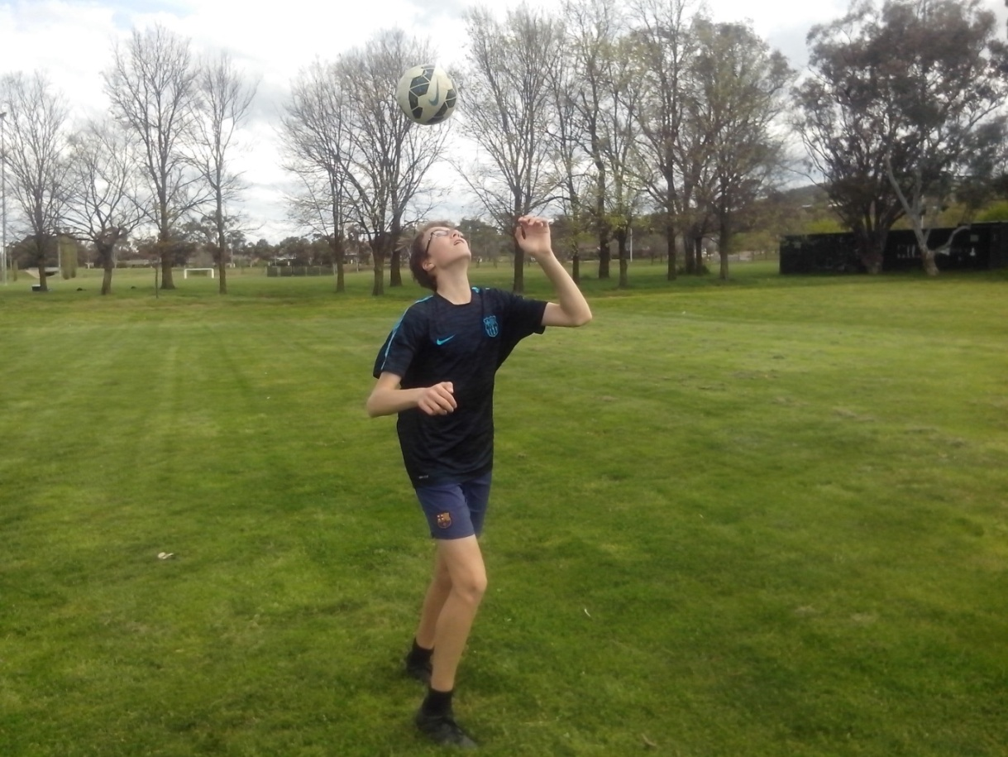
GAME CHANGER
Without doubt, Australia should be a Top 20 Football Nation. With doubt, we can still make the Top 50.
In any endeavour, the only obstacles to achievement are ignorance, laziness, selfishness and fear and these come from within us. Fear is the greatest obstacle in Australian sport. It stops talented kids from heading a ball, creating new moves, juggling solo or shooting at goal. It stops coaches from questioning old ideas or challenging new ideas. Fear of failure stops Australia from being a Top 20 Football Nation. There are only four obstacles that can stifle innovation and change.
Freestyle kids learn to overcome the most common obstacles by increasing their knowledge, workrate, team spirit and confidence. Freestyle kids can’t lose. They either win or they learn. Coaches should never be scared of kids learning something different. It’s more challenging to work with the originals than with the carbon copies.
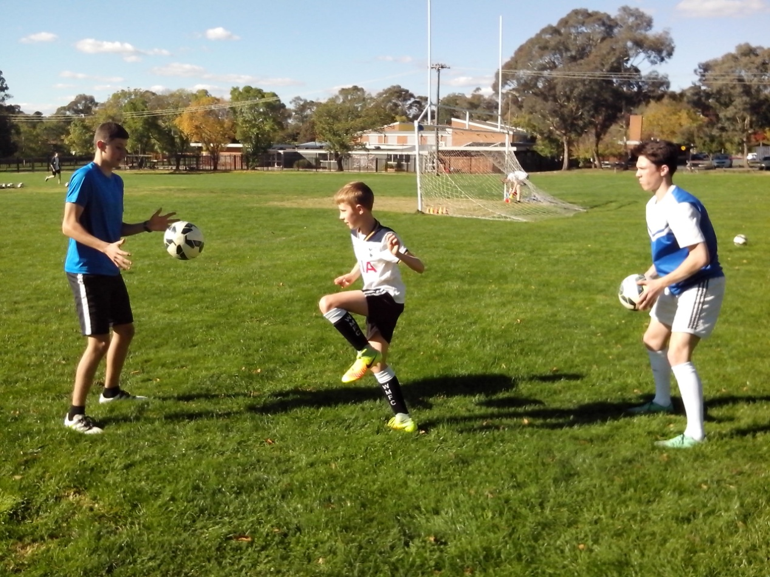
WONDER
We need to look at what we do and wonder why and then look at what we don’t do and wonder why not.
We give the same training drills to every kid regardless of their levels of talent, experience, motivation or their position in the team. If we had a learning program we could discover what each kid needs to improve. We overlook so many talented Soccer kids in Australia.
In a game determined by goals, kids don’t know how to shoot because coaches don’t know how to score. If coaches knew how to score, we would have shooting galleries at every junior club and goal scoring academies in every major Soccer region run by specialist marksmen..
We need to look at what we can’t see and listen to what we can’t hear. We can’t see movement if kids stand dead still and we can’t hear calling if kids are dead quiet. Awareness is the ability to identify what isn’t there so we can discover why. We can’t see talent if kids have to second guess the coach because they’re scared of making mistakes.
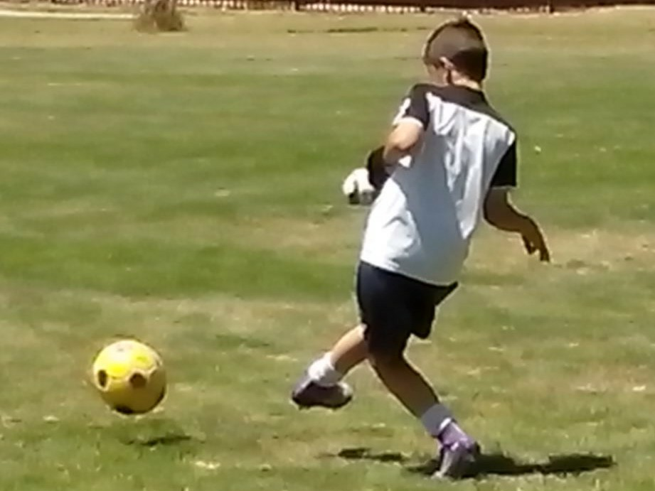
HEADSTART
Some kids stick their neck out to head a ball. Freestyle kids use their whole body.
Heading is the most neglected skill in Soccer because kids are scared of getting hurt. Some kids deliberately arrive late to contest the goal kick in a game. If they can’t avoid the header, these kids brace themselves and close their eyes. The ball always hurts because they let the ball strike them instead of them striking the ball.
Any coach can teach any kid to head a ball in 5 minutes just by using close repetition drills. Heading in pairs gives kids confidence in the air because they start with smooth control and gradually increase the height and range of the ball. A lot of kids use their chest to control the high ball before they volley at goal. The advantage of heading the ball down, instead of chesting it down, is that the head is more directional.
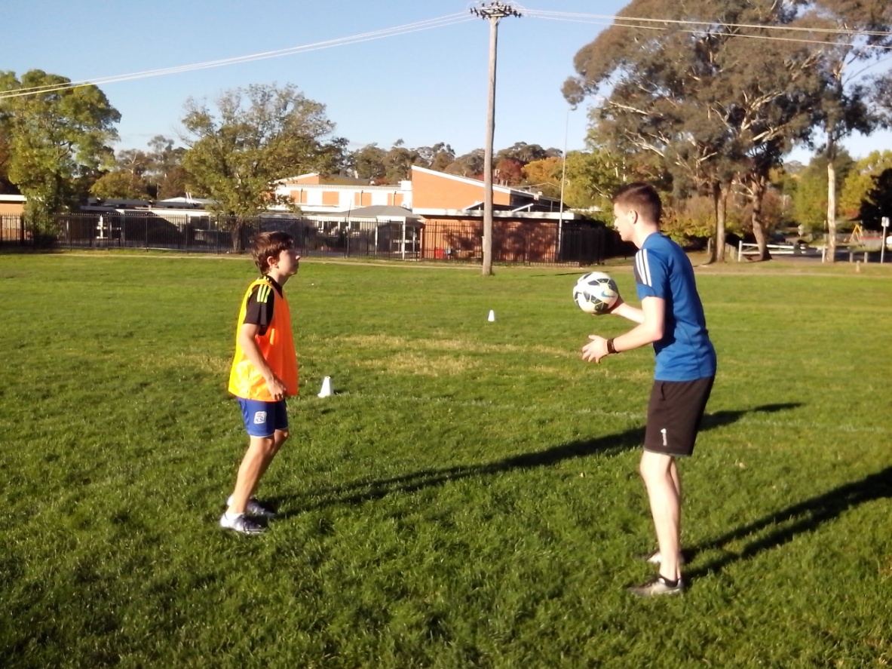
SUPERGRADE
Improving kids is a balance between overlooking them and overcoaching them.
All Soccer kids have external qualities that can be coached (fitness, skill) and internal qualities that can’t be coached (character, intelligence). At grading, we select the fit and skilful kids so that we can teach them fitness and skill. Sometimes we discover too late that the skilful players are too selfish to pass the ball and the fit players are too lazy to run for it.
Grading is a process that separates the kids who can play, and are ready to think for themselves, from the kids who can’t play and need all the help they can get. It’s natural to put the better players with the better coaches. The real challenge is to take the struggling kids and teach them how to reach the top, so we can widen the talent base. We can learn so much more by coaching kids who are difficult to coach.
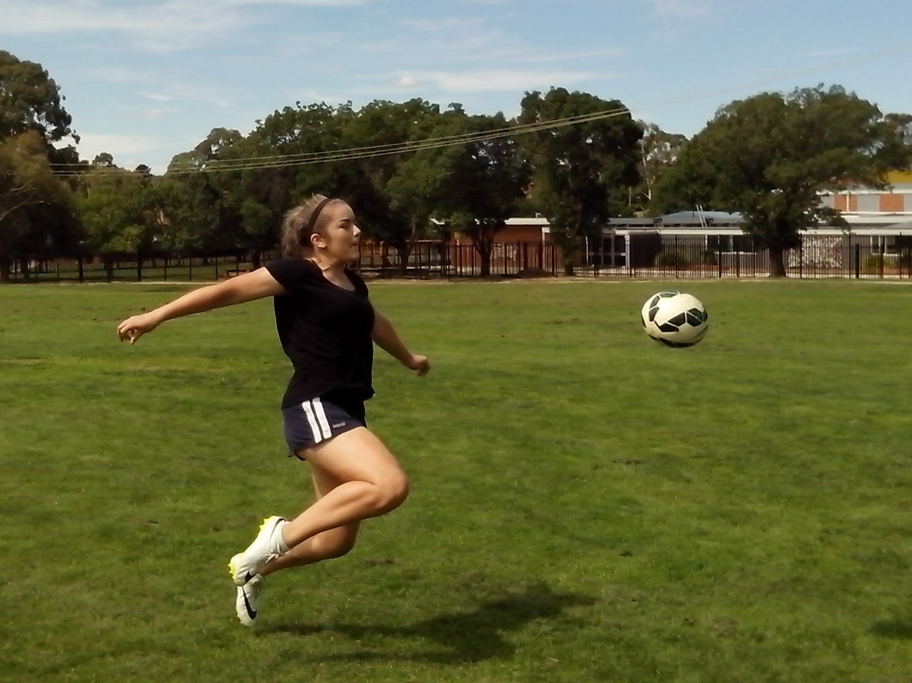
JUGGLING
Juggling is the first step that kids take when they become responsible for their own skills development.
Juggling is a fusion of mind, body and ball. No kid can juggle without footwork , vision, control, balance, timing, rhythm, coordination and confidence. The secret to juggling is as simple as walking and running. Kids just need to alternate their feet with every step so that their control becomes second nature. One footed jugglers are limited by how long they can hop around on one foot. An innovative coach will be able to encourage kids to use both feet without forcing them.
When a coach observes kids juggling a ball, it takes 5 minutes to discover if they’re one footed, stiff legged, flat footed, uncoordinated, try too hard or just lack confidence. It takes 5 minutes to improve juggling skills. Repetitive juggling enables Soccer kids to take 100 steps, make 100 decisions and get 100 ball touches in 5 minutes.
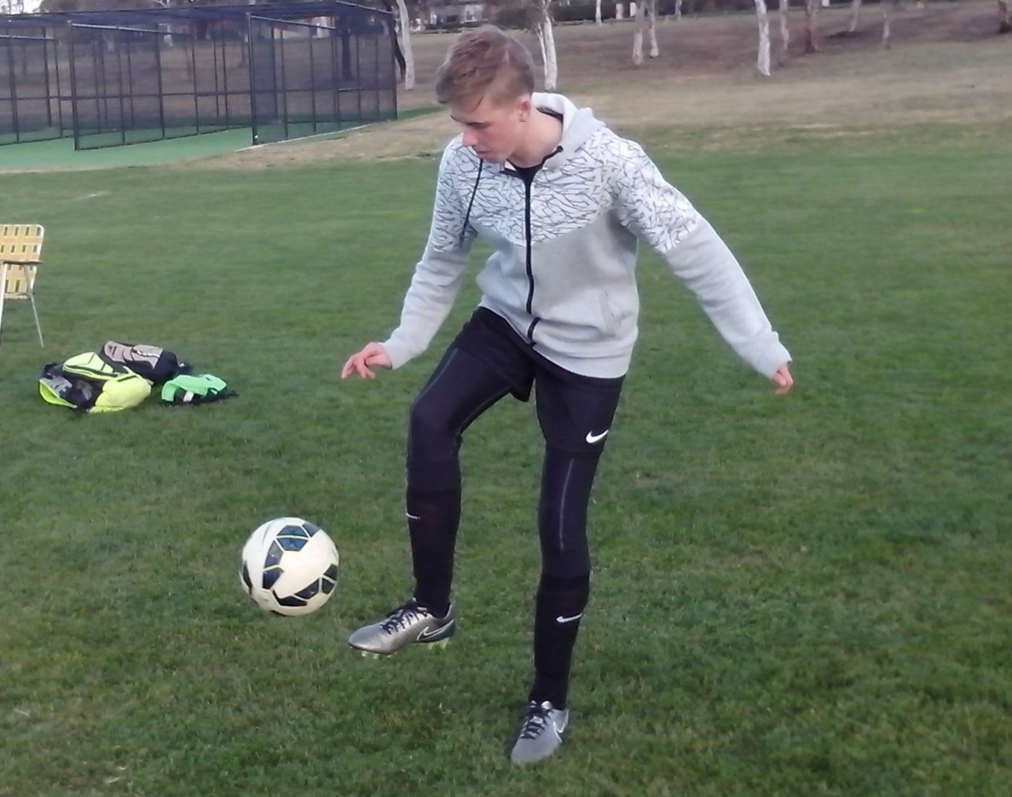
GAME OF CONES
Most strikers don’t know what they’re missing.
Most Australian Soccer kids have no idea how accurate they really are because there are no small targets in Soccer. Most players pass in the general direction of their team mates and strikers aim for the whole goal. When they aim big, they miss big and blast the ball over the bar. When they aim small, they miss small and kick the ball straight to the goalkeeper. There are simple ways to improve shooting accuracy.
The Game of Cones involves free range practice using rubber safety cones as small targets. Freestyle kids learn to aim for the smallest target they can see. They start at a range of 10 metres and establish their precision range first and then gradually extend to 30 metres as they develop their power range. Freestyle strikers get serious about shooting and make certain about scoring.
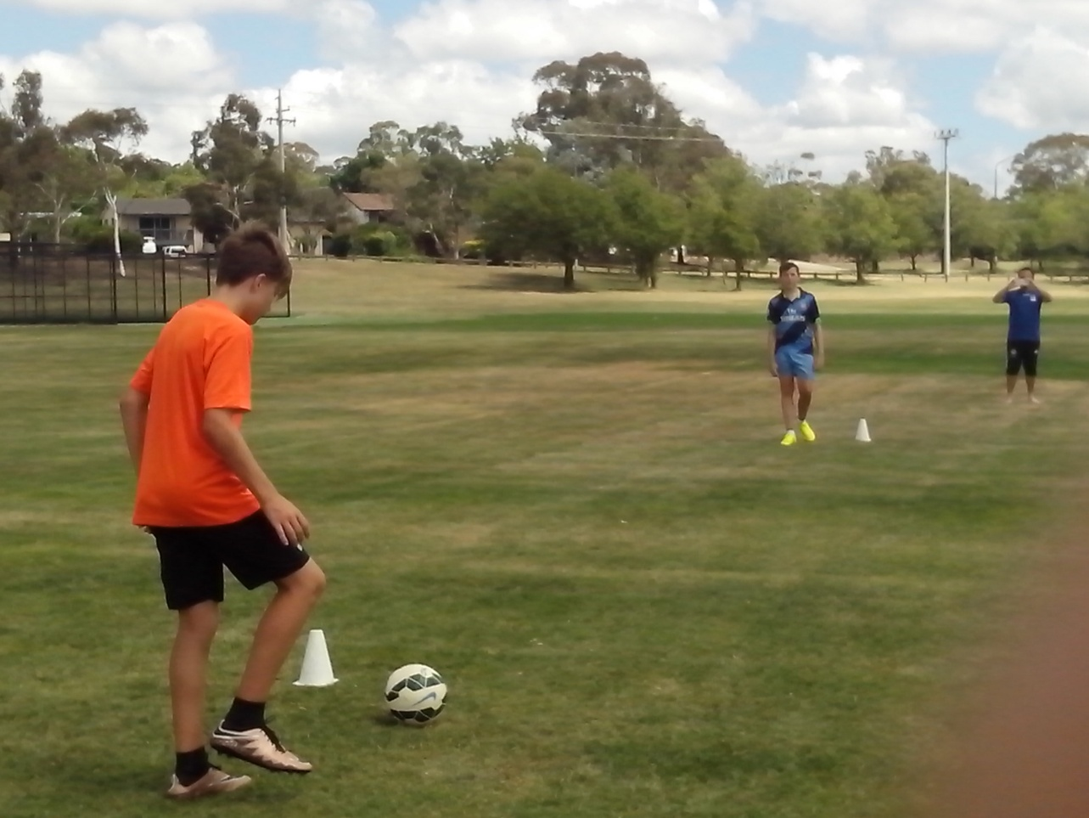
LIGHTEN UP
Well trained kids keep both feet firmly on the ground. Innovative kids stay on their toes and keep moving.
Lighten Up is the most effective close repetition drill that coaches can use. It identifies the natural skills that all kids need to develop their Soccer skills. Lighten Up is an example of individual coaching.
The coach stands two metres in front of each player and throws the ball to them repeatedly so they can head the ball back. They gradually progress to the shoulders, thighs, inside of each foot and the instep.
It becomes immediately obvious that most kids have their feet glued to the ground which makes them lunge at the ball and take a stab at it. Most Soccer kids have never been told anything about footwork. Just by jogging on the spot, kids will improve their ball control as their eye/foot coordination kicks in. Lighten Up develops both feet at the same time and enables kids to get 200 ball touches in 5 minutes. There isn’t one coach who can’t improve any kid with Lighten Up.
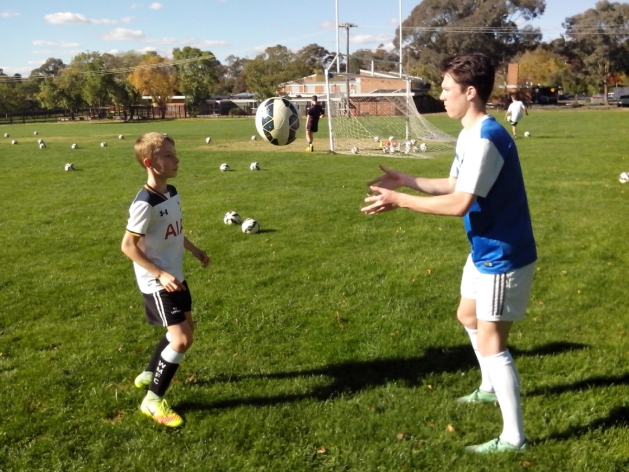
MISTAKES
Do we correct kids because they make mistakes or do they make mistakes because we keep correcting them?
Australian Soccer kids are fast learners. If we correct strikers every time they miss a shot, they soon learn to stop missing because they stop shooting and pass the ball to the next kid. Constant correction doesn’t teach kids to avoid mistakes. It teaches them to avoid constant correction. The main reason that so many talented kids stand dead still and remain dead quiet is because they’re dead scared of being wrong.
Failure isn’t a problem. Fear of failure is. It stops talented kids from playing their own game and stops innovative coaches from believing in kids and giving them responsibility. Some kids lose a game before kickoff because they worry about their opponents or their referee.
Kids make mistakes because they worry about making mistakes in case the coach shouts at them or their mates laugh at them. If we tell kids to make more mistakes, they stop worrying. When they stop worrying, they begin to relax and they stop making mistakes.
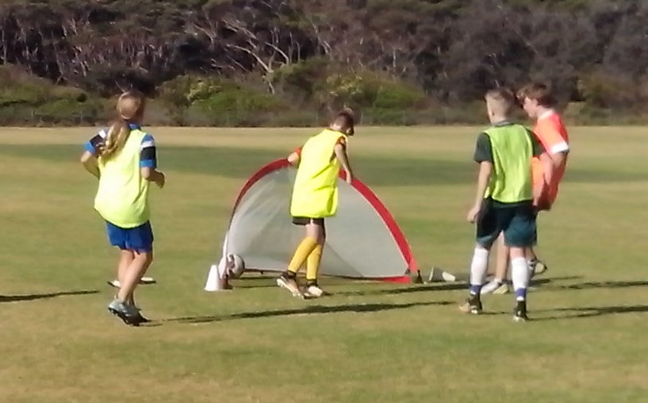
UNDERLYING CAUSE
It’s nearly impossible for adults to watch kids make mistakes without stopping to correct them.
Every time a kid makes a mistake, we honestly believe that we’re helping them by constantly reminding them what’s wrong with them. We can’t help ourselves. Kids are the first to know when they make a mistake. They don’t always need to be told. In a correctional system, kids begin to hesitate and try to second guess what the coach wants.
Kids spend years repeating the same simple mistakes and coaches spend years correcting the same simple techniques. If we let them make mistakes and watch carefully, we can find the underlying cause.
Experts see what they’re trained to see. Soccer coaches are trained to look at technique and look for mistakes. When kids struggle to head a ball, every coach will focus on their head and look at their heading technique. Nobody will notice that their feet are glued to the ground. An innovative coach can improve any kid in 5 minutes by showing them how to get it right without pointing out that they got it wrong.
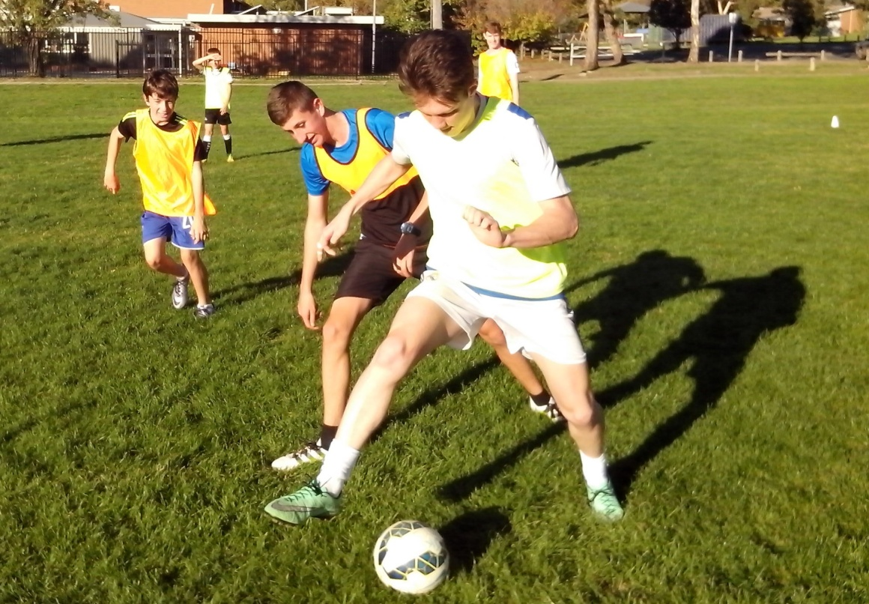
FULL CIRCLE
The first time we take on a new team, do we teach them first or learn about them first?
A juggling circle gives an indication of how kids behave in a game. If we ask a group of 6 to 8 kids to keep a ball up in a circle using one bounce, we soon learn how kids communicate and interact. Beginner groups can’t put 10 passes together without dropping the ball.
Some kids stand flat footed and wait for the pass before they move. Some try to impress with fancy tricks. Some kids don’t say a word. Some kids tense up and rush. Some kick too hard. Two kids go for the same ball without calling their name. One kid will always hang back.
When highly trained and highly skilled kids keep a ball up in a circle, we expect them to get a high number of passes but they can’t. They look great when we tell them what to think, where to stand and what to do but look lost when they have to improvise. We can improve any group in 5 minutes just by showing them how to relax, call and move.
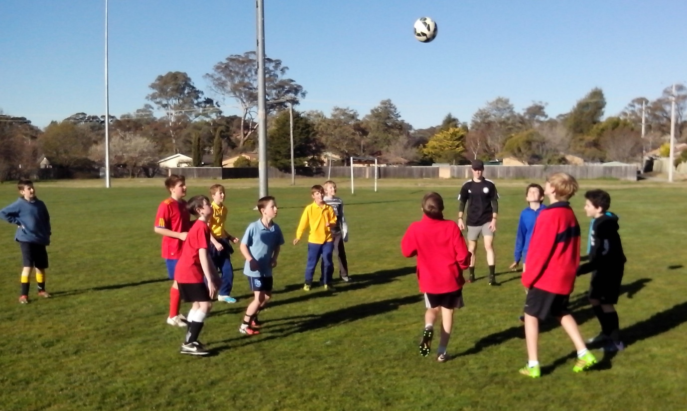
GIVE AND GO
Most Australian Soccer kids pass the ball and then stand still so they can admire the pass.
A skilful kid looks good on the ball. A talented kid looks good off the ball. Close repetition ballwork in pairs teaches kids the fundamentals of possession. They learn to synchronise their control and support.
Juggling in pairs is the quickest and most effective way for coaches to discover how players support the ball player. A lot of kids just focus on the ball and the ball player. That’s why so many forwards get caught offside and so many defenders forget to check the blind side.
Freestyle kids make the best of every minute of every game. They either move up or back, close down tight or create space. When they kick a ball, they learn to pass and move, give and go, hit and run. Freestyle kids don’t wait or hesitate. They dictate and dominate.

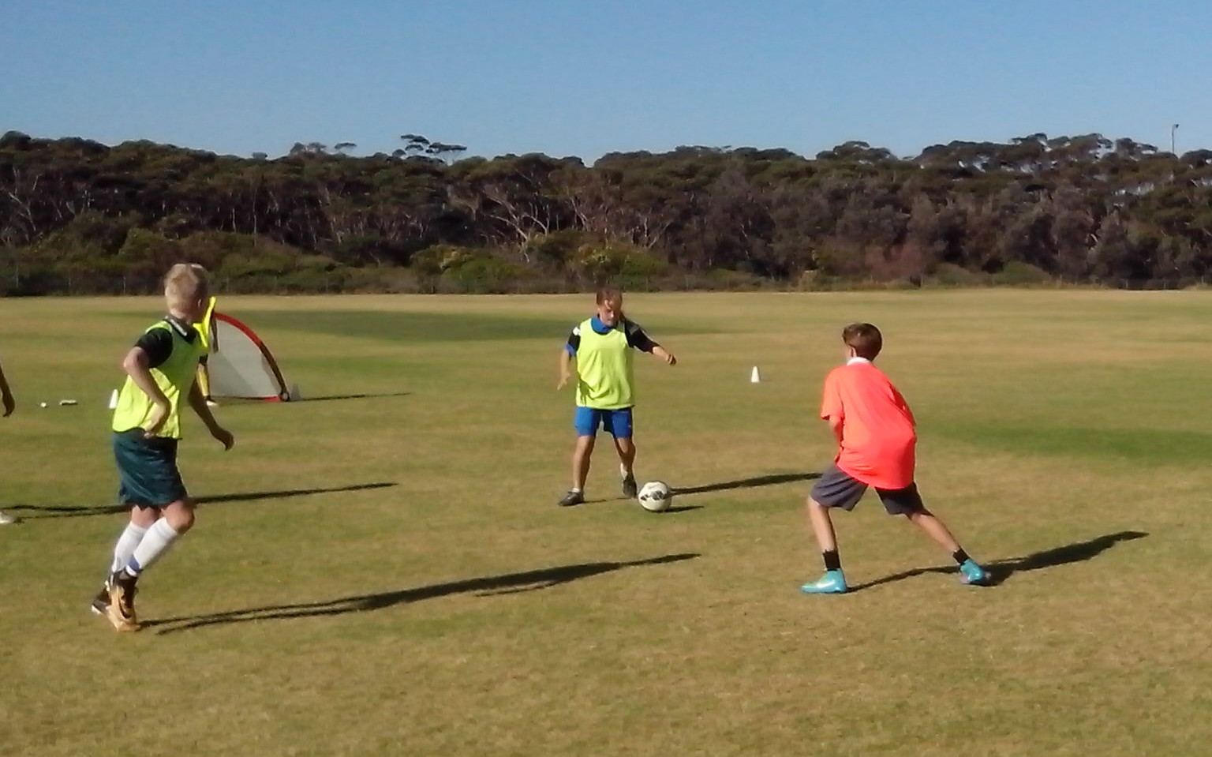
NETWORKING
Practice makes perfect and shooting practice makes shooting perfect.
So many strikers panic in front of goal because they lack practice. The average Soccer kid spends 15 minutes a week at shooting practice which only gives them enough time to blast the ball over the crossbar from outside the penalty box. That’s not a drill. This is a drill. The average Freestyle kid shoots for 2 hours at a time using 100 balls from every range and angle until their marksmanship is second nature.
Most kids don’t know how to shoot because most coaches don’t know how to score. Any coach can discover the secrets of scoring goals by using the 10 Freestyle elements. Any coach can analyse shooting mistakes and discover their underlying cause. Other Football codes have dedicated goal kicking coaches. We need goal kicking coaches who can run shooting galleries at every club and we need specialist marksmen who can run goal scoring academies. Coaches need longer shooting sessions for those kids who like to stay behind at training.
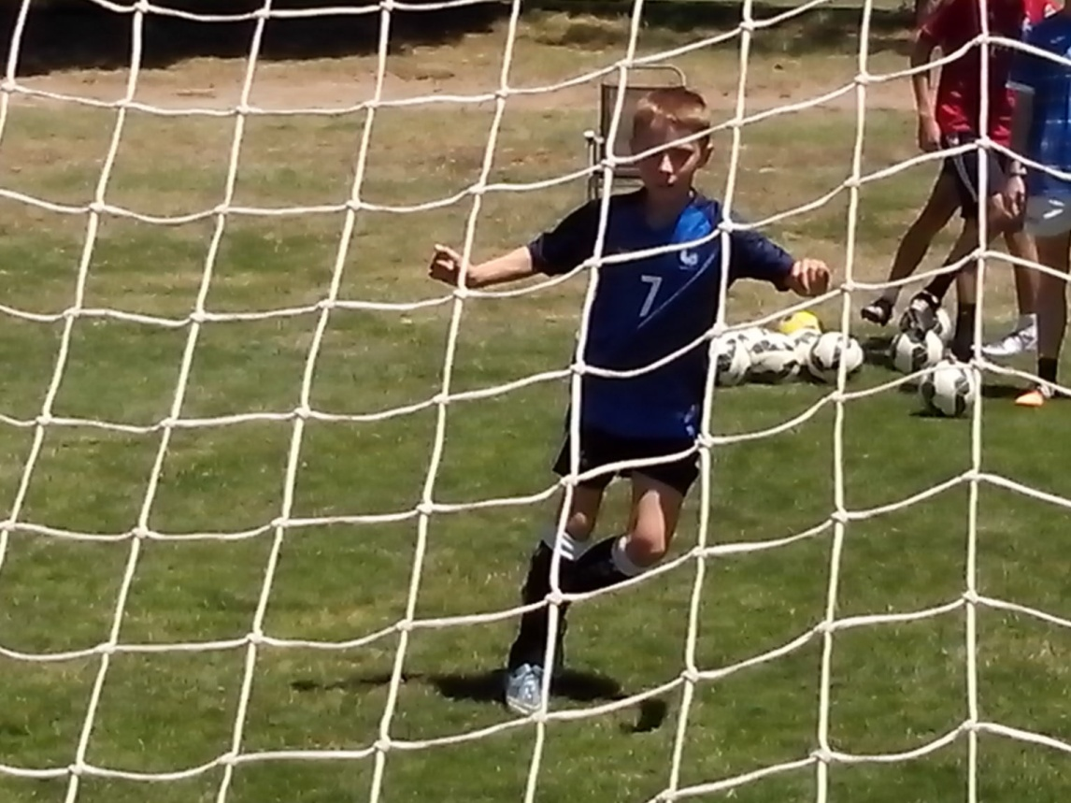
MAKE CERTAIN
Certain coaches develop certain players. Uncertain coaches develop uncertain players.
Freestyle kids are never satisfied with what they achieve. They constantly look for smarter ways to sharpen their techniques. When they shoot, they always look up and lock onto the target and then look down and lock onto the ball. In games, they know their options before they receive the ball. There’s no Time Out for Freestyle kids. They always look, think, move and anticipate 360 degrees. Their key rules are keep possession, keep the ball in play and keep the shots on target.
Skilful kids can dominate the 5% of the game when they have the ball at their feet. Freestyle kids make certain they can dominate the other 95% of the game without the ball. There’s a difference between learning a skill and making certain of a talent. These are kids who practise juggling until they reach 100. They practise precision and power until they can hit a small target 30 metres away and practise shooting for 2 hours with 100 balls until it becomes second nature.
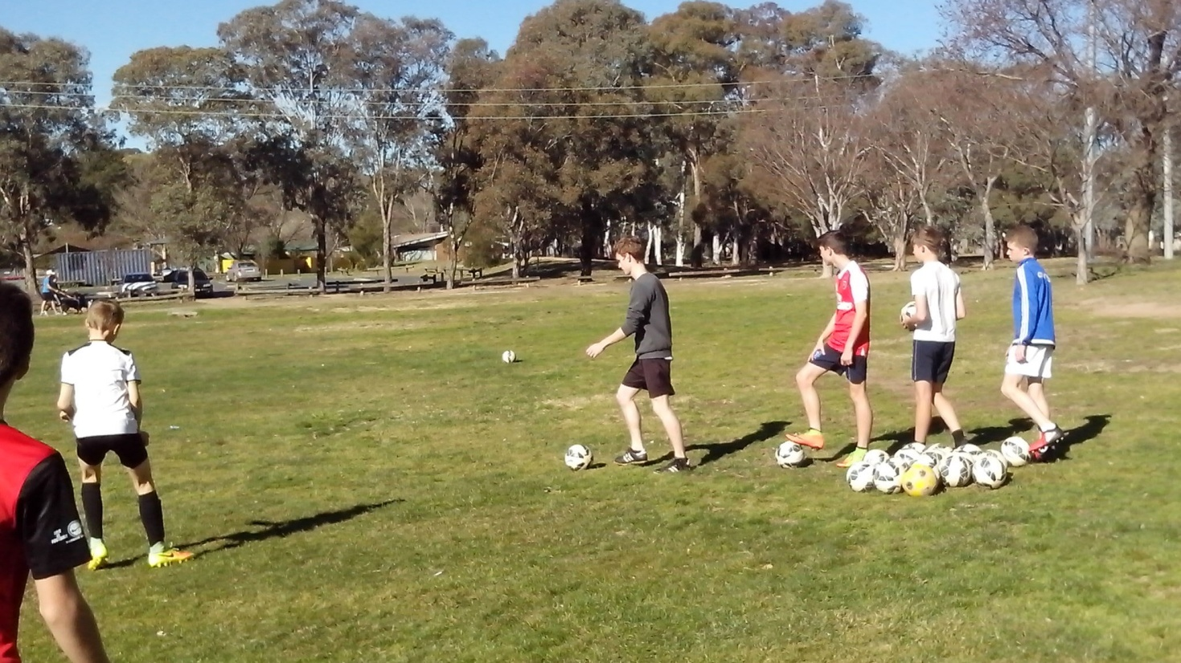
LEARNING THE FOUR R’s
Kids develop what we give them. We need to give them respect, responsibility, resourcefulness and resilience.
The Freestyle kids who practise at the skate parks, surf beaches and BMX tracks learn to work together and face every challenge. The Freestyle kids at the cricket nets and basketball courts learn to run their own drills without supervision from well intentioned adults.
If we do everything for them, kids won’t be able to do anything for themselves. If we give kids a ball, they can develop their own skills. If we give them a net, and 50 balls, they can develop their own drills. Freestyle kids learn to stand on their own two feet.
Freestyle kids develop respect, responsibility, resourcefulness and resilience because they think for themselves and express themselves. They practise what they need to practise not what they’re told to practise. Kids who share a skate park with older kids learn resolve.
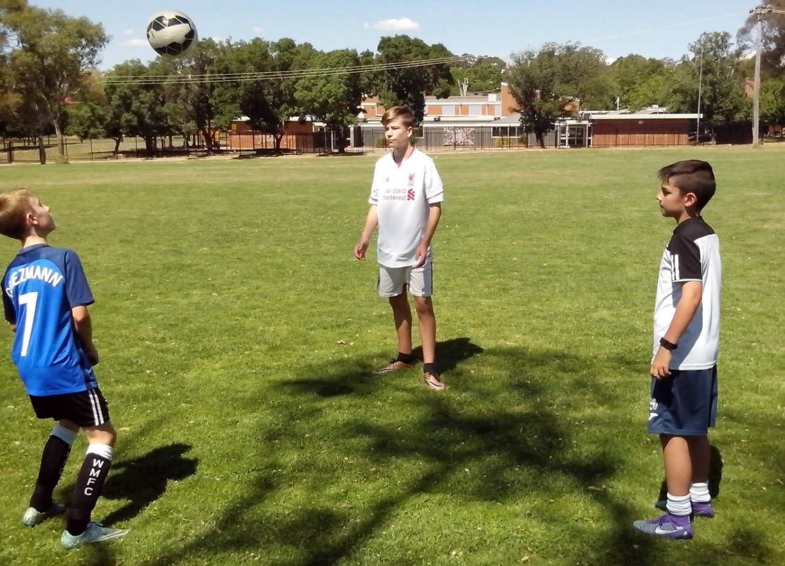
MIND READING
Any coach can read minds if they open theirs.
Ask kids what they aim for when they shoot. They aim for the goal. They aim for the whole goal, the whole target. Specialist marksmen don’t aim for the target. They aim for the bullseye which is the smallest part of the target. Soccer goals are simply too big. Kids miss big because they aim big. Freestyle kids pick a spot and hit the spot.
Freestyle kids know how to score because they discover how to miss. They understand why shots go over the bar or straight to the keeper. Any coach can tell what strikers are thinking by putting small target cones inside each post. Confident kids go for one cone. Other kids will use force as the default setting. They go for the whole goal and blast the ball over the bar. Any coach can read the mind of any striker.
In a game, it’s easy to tell what kids are thinking. Some kids chase the ball till they catch it and then rush towards goal till they lose it again. Other kids pass the ball around till they score. We can tell which kids think ‘ball and goal’ and which kids think ‘space and possession’.
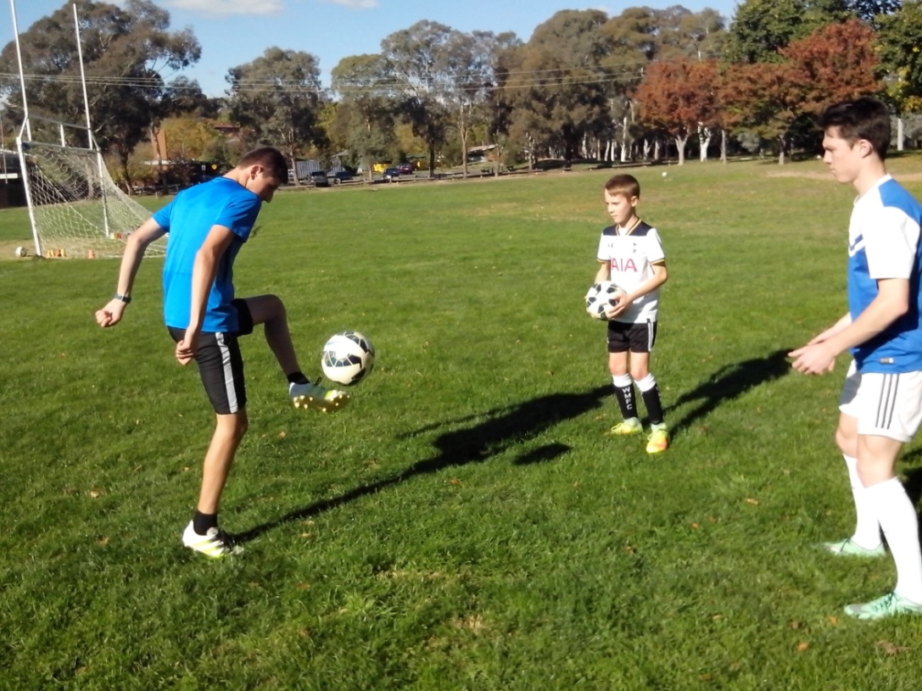
GOOD SPORTS
It’s amazing how quickly untalented kids become talented when we start to believe in their ability.
Some sports have an assistant coach, fitness trainer, defence coach, attack coach, nutritionist or a statistician. Some Football codes have their own goalkicking coaches. Most Soccer teams have a team coach.
There are upper body sports that understand the significance of footwork in the development of total body control. Basketball, tennis, cricket, boxing and fencing all develop footwork drills for their sport.
Golfers, archers and shooters, all learn to aim for the smallest target and control their balance of power and precision. Golfers, tennis players and cricketers hit plenty of practice shots before each game. They practise striking through the ball smoothly not at the ball. AFL kids learn to mark tight, lose their marker and challenge in the air. They have the freedom to look, think and move in any direction. An innovative coach, with an open mind, can learn from every sport.
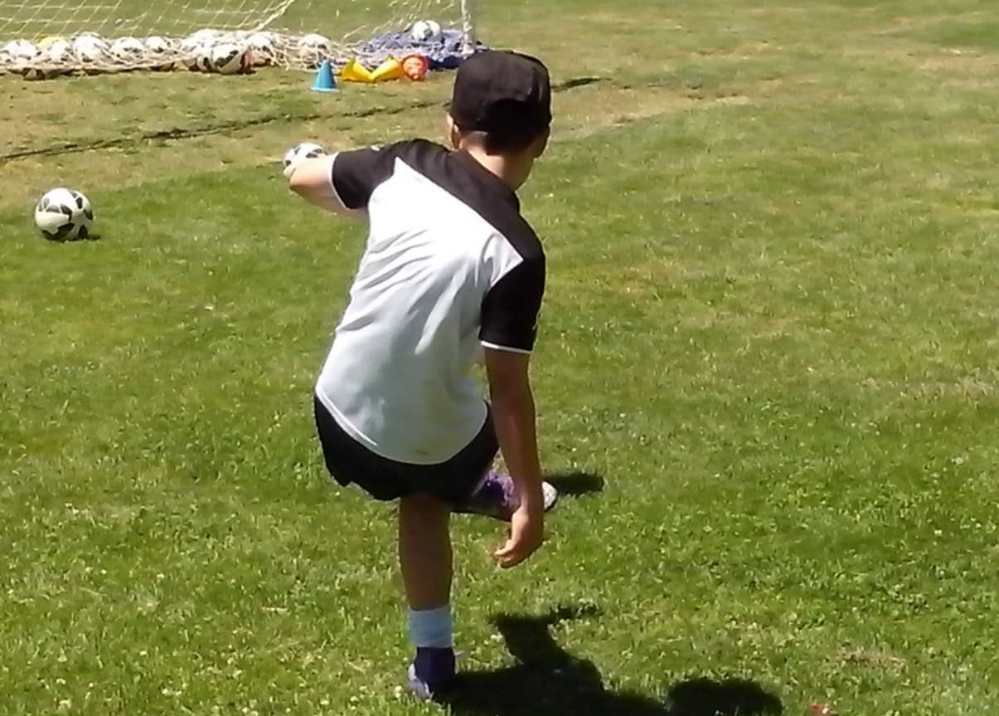
WALL PASS
Kids who get serious about reaching the top make certain they train every day.
Some kids are flat footed which makes their movement stiff and mechanical. Wall practice will get these kids up on their toes.
Some kids are one footed which limits their options in a game. A wall helps players to develop both feet without playing favourites.
Some kids try too hard to kick the ball too hard. A wall can strike the ball harder than a kid and players soon learn to control their power. Close wall practice teaches kids to weight their passes. They can start with light control to become smooth and then smooth becomes strong.
Some kids never get enough ball touches at training sessions to become instinctive and confident. When players stand two metres in front of a wall, they can get 1000 kicks in ten minutes. The close proximity increases their reflexes so that they learn to relax. Every Soccer kid needs to hit the wall if they want to read the speed, spin and bounce of a round ball. When kids get serious, they make certain.
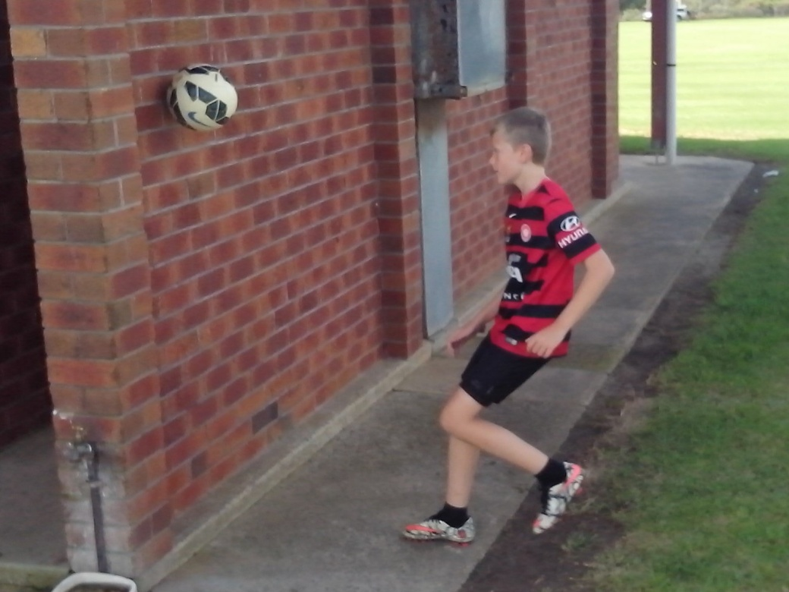
SPECIALISTS
We need specialists in junior Soccer clubs. We already have enough general practitioners.
Every Soccer coach has an area of interest or expertise that they can develop to help other coaches. Every Soccer club is overloaded with hidden and untapped coaching resources. In one session, a senior striker can teach a junior team how to pick the spot, hit the spot and score goals. Other Football codes encourage specialist attack and defence coaches to achieve better results than general practitioners.
There are senior defence experts who can drill fullbacks in the fundamentals of marking. There are senior keepers who can run internal goalkeeping sessions. There are talented ball players who can inspire kids to learn intuitive skills on their own or with their mates.
There are retired and experienced coaches who can assist any team coach by acting as talent scouts in games. They can focus on players for the whole game while the coach has to follow the bouncing ball. Unless we research individual coaching, we will never understand the inspiration that kids get when a senior specialist encourages them.
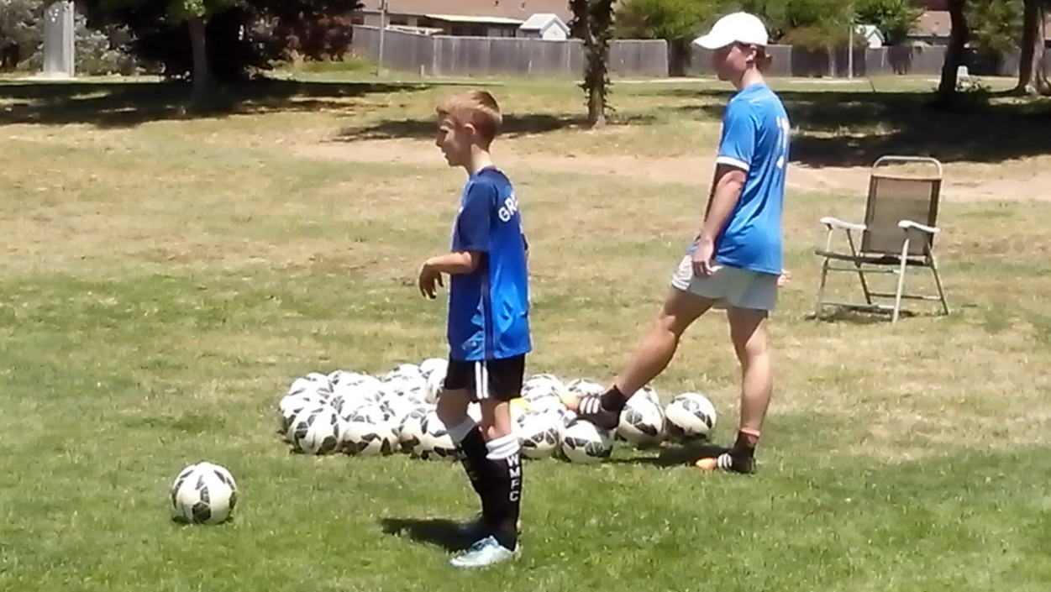
TRAINING THEMES
A coach can develop players to suit training drills or develop training drills to suit the needs of the players.
The average Australian Soccer kid trains for 100 hours a year. The average Freestyle Soccer kid trains for 300 hours a year. The average streetwise Soccer kid in Europe trains for 600 hours a year. There should be a theme for every training session and a reason for every drill. Training should make sense and mean something so that kids understand what to do, how to do it and why. It should be based on last week’s game, this week’s squad and next week’s opponents.
Every game identifies key techniques that need to be improved. Every squad has key roles that they need to coordinate. Every opposition provides a unique challenge that needs to be identified and overcome. Every kid should know what they’re up to and where they’re up to. All kids are different. They have different levels of talent, intelligence and motivation and they play different positions. We can give them all the same training or discover what each player needs to improve.
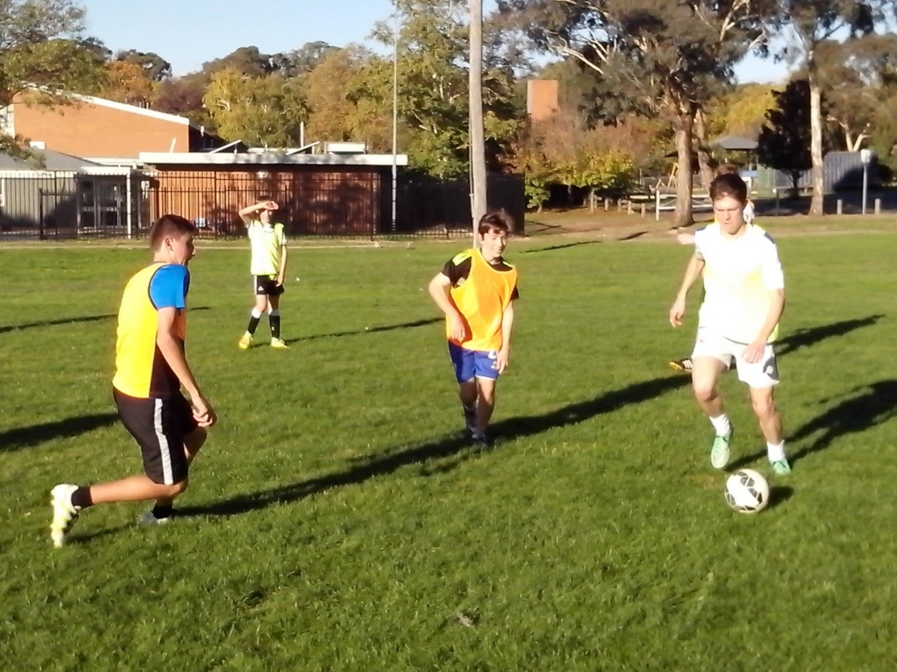
MATCH WARMUP
Some kids don’t know what they’re playing at.
Some Soccer coaches have no idea how to warm up players before a game because they haven’t thought about it. The 30 minutes before each match is the most important time of the week. It determines which players are ready and set to play when the whistle blows.
The mean average Soccer kid gets 20 touches of the ball before kickoff and spends the next 20 minutes making needless errors. If we ask kids and coaches how many ball touches it takes for eye/foot coordination to kick in we discover that nobody has thought about it. Kids need at least 200 kicks before control becomes second nature. The most effective way for players to develop their ball skills is close repetition ballwork in pairs so that they can think, move and control.
Some kids lose a game before kickoff because they worry about the size of their opponents. Freestyle kids think about their own game. Freestyle defenders need at least 100 one touch passes at ranges between 10 and 30 metres so they know how to turn a clearance into pass. Freestyle strikers need plenty of shots to warm up the keeper.
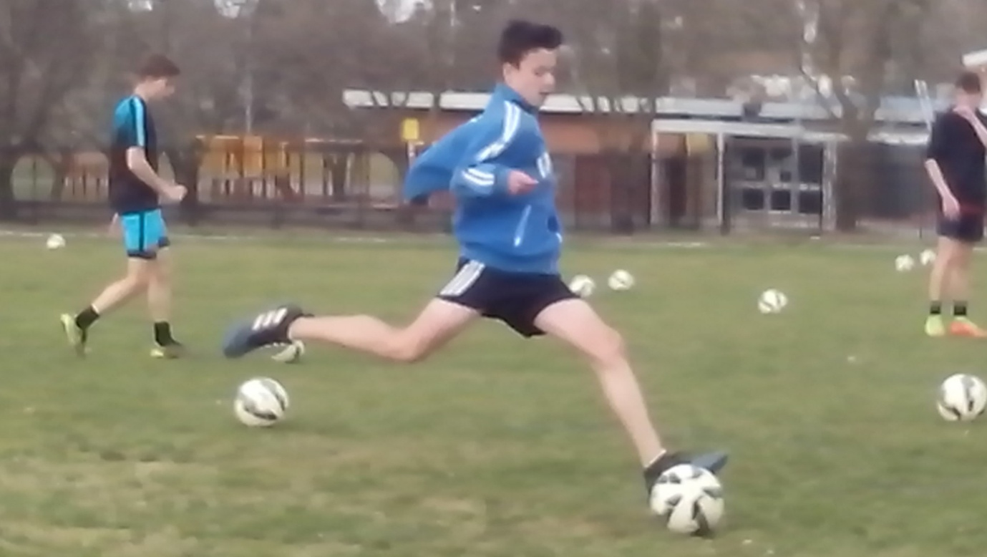
WORK BENCH
Every kid is an integral part of their team both on and off the pitch.
Every Soccer coach is limited by what they can see in a game when they don’t have an assistant. Each player who sits on the bench provides an extra set of eyes once they understand what to look for.
A wise leader may choose to keep the best attackers in reserve while assessing the strengths and weaknesses of the opposition. The starting forwards have instructions to pressure the defence using mobility to test their stability. The key is to draw defenders out of their positions.
Meanwhile, the forward scouts are watching the defence to identify the weaker players. After 15 minutes, the forward scouts are ready to go on as fresh attackers with a clear idea of how to penetrate the goal. Every coach needs to respect every player and believe in their ability to look, listen, think, learn and understand just what the team needs.
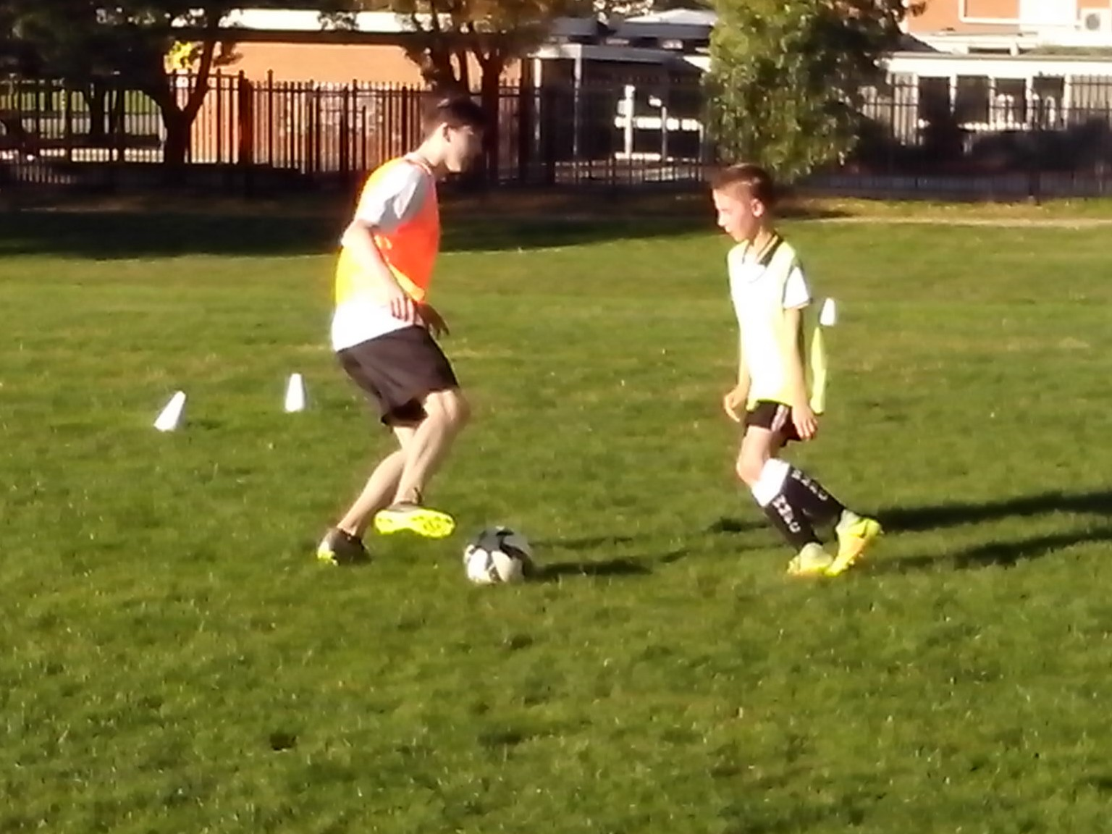
SKILLS PARK
When kids feel stifled, a Skills Park is like a breath of fresh air. It gives them skills, drills, thrills and spills.
A Skills Park, like a Skate Park, is a learning environment where kids have the freedom to think for themselves, invent new drills and swap new skills without direction, correction, protection or rejection from well meaning adults. Nobody tells kids to go and play at the Skate Park. They go because they want to. Something motivates them to practise on their own or with their mates so that they can improve.
Local councils understand the needs of youth. They provide skate parks, BMX tracks, basketball courts and cricket nets so that the motivated kids can train for free. Soccer players need practice nets. Every club needs a Skills Park where teenage mentors can develop responsibility and their leadership skills by helping the younger kids. The Skills Park will ensure that no Soccer kid ever gets left behind.
SHOOTING GALLERY
Every club can establish a Shooting Gallery.
Every training oval has one isolated corner where a single practice net can be set up for kids to use. Some enlightened clubs can even give kids access to portable goals and equipment, so that responsible kids can train whenever they want and they learn to look after the gear.
More kids will turn up when they realise that they can invent drills and swap skills without fear of adult supervision or intervention.
Most Australian Soccer teenagers are already 1 million steps behind the kids from the leading Football nations who get 1000 kicks a day juggling, dribbling and playing on the streets, parks and beaches.
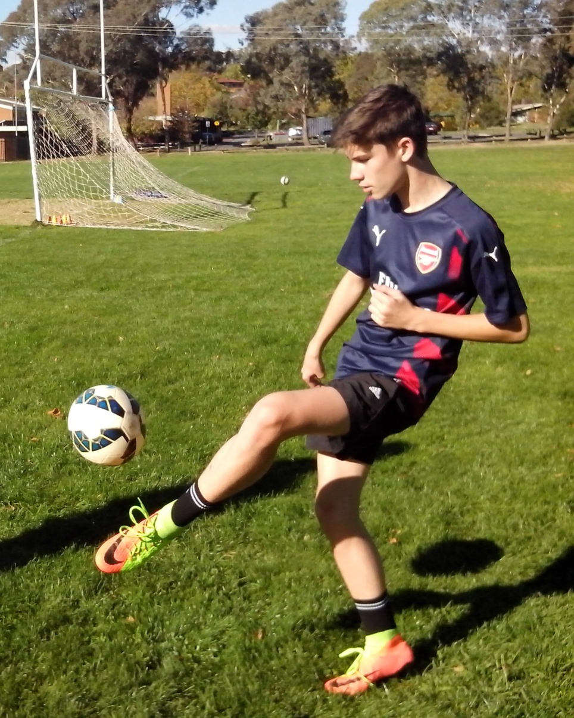
PERSONAL GOALS
Motivation has to come from the kid. It won’t work if it has to come from the parent or the coach.
In a competitive sport, kids need to compete against themselves. Ask kids what they want to achieve. One kid wants to juggle 1000. One kid wants to be a keeper. One kid wants to be the best and fairest.
The first time a kid juggles a ball or runs in a race, they’re setting a personal best target that they can improve on if they work at it. Most kids don’t know how good they really are because coaches can’t tell them. Ordinary kids learn what they’re told to learn. Freestyle kids quickly learn that all kids are different, all kids have talent, all kids make mistakes, all kids can practise, all kids can improve and all kids need is a ball. Freestyle kids don’t need to be told to use initiative.
Motivation has to come from the kid not the parent or the coach. It produces players who train because they want to not because they have to. There’s a lot more to Soccer than winning games. We can teach a kid for one season or we can prepare them for all seasons.
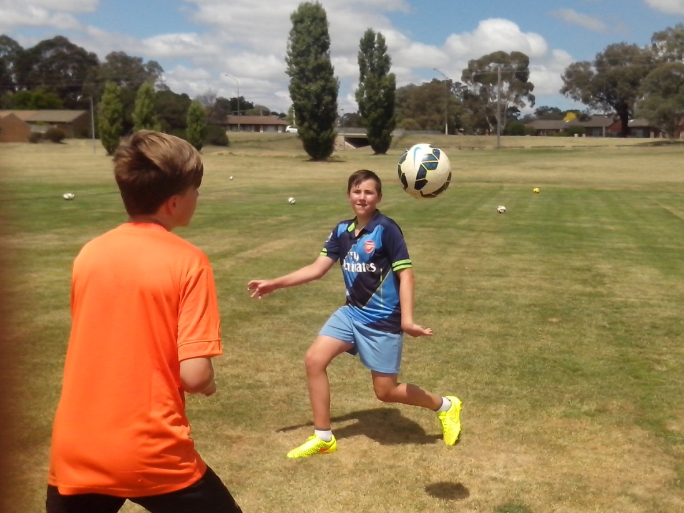
SAFETY NET
In the 10 years it takes to coach the average Soccer kid, not one person will spend 15 minutes with that player to learn anything about them.
The Safety Net is a mandatory assessment for every 10 year old Soccer kid so that coaches can identify generic flaws in a player before they become permanent bad habits.
When 17 year old kids keep blasting the ball over the crossbar, they haven’t just developed that ability. They’ve been doing it since they were 7 and nobody has discovered or addressed the reason why. The aim of Freestyle Soccer is to tackle the issues that we try to avoid.
Any coach can improve any kid in 5 minutes just by observing how they play, learning about them and discovering what each kid needs to improve. No Australian Soccer kid should ever fall through the cracks or get left behind when there are simple solutions to every problem.
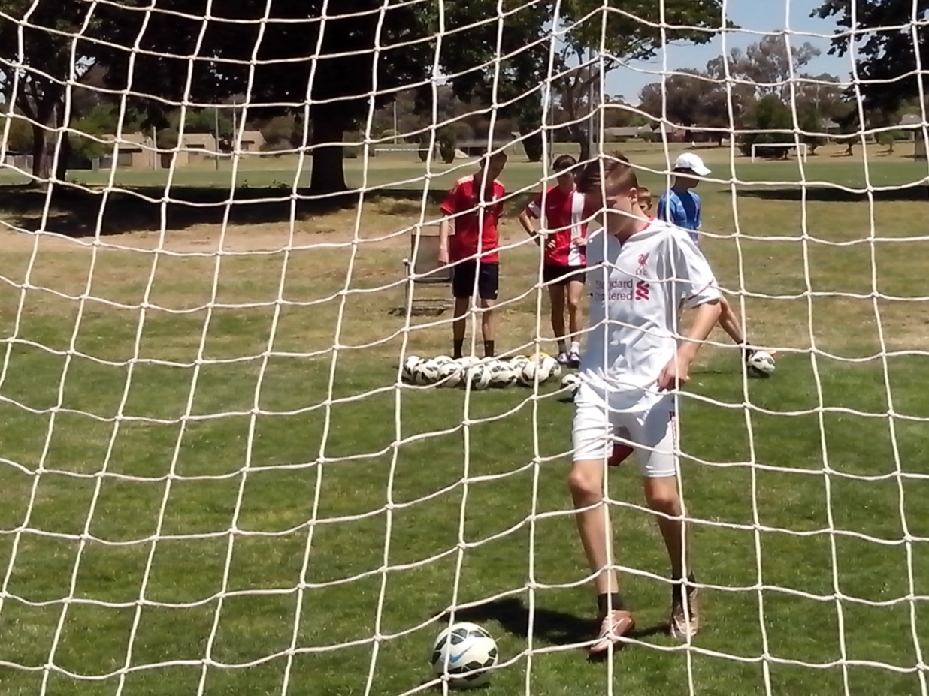
TRACK RECORD
Some kids don’t know their own strength. Freestyle kids do because they keep a written record.
Most Soccer kids have no idea how good they really are until we measure their performance and keep a written record of their improvement and their personal best results. Confidence is based on facts, not sports psychology. We can tell kids that they’re going well but it’s better if they can see clear results written in black and white.
It’s important in competitive sport that kids learn to compete against themselves. Each short term goal motivates them to aim for the next level. Any coach can help kids develop a fitness or skills program.
In the beginning, kids struggle to juggle more than 20 but once they reach that level they make progress at a faster rate. Kids can’t fake juggling. They can only attain a high level through time and effort. Freestyle kids keep a training diary of their fitness and skill levels. Every coach should keep a folder of results so that kids can discover what to work on and what to aim for as soon as they arrive at the oval.
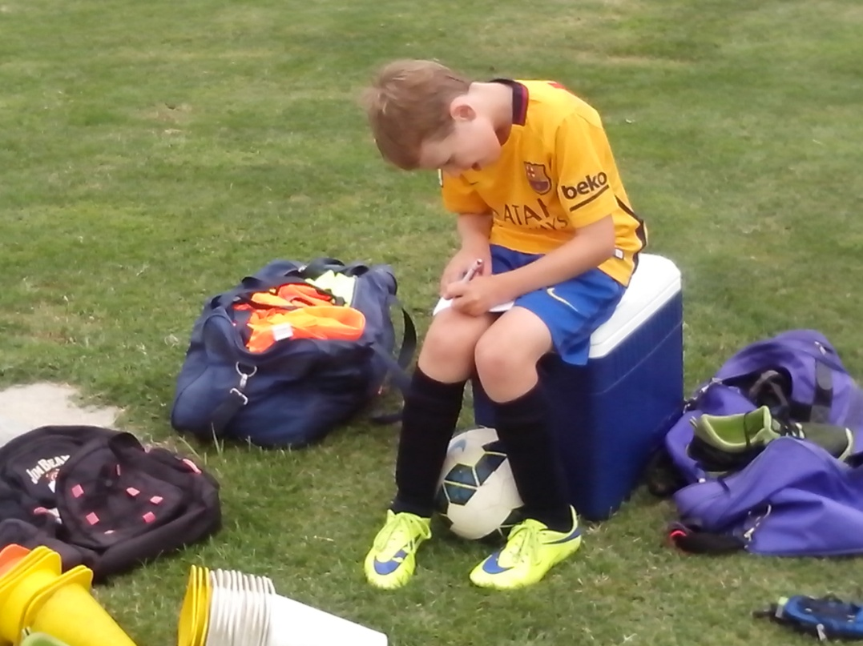
POWER OF ONE ON ONE
If you can show us an untalented kid, we can show you what you’re missing.
We don’t know anything about individual coaching. An individual coach can identify what each individual player needs to improve and pinpoint their unique strengths and weaknesses. A club skills specialist can give each kid a personal training program. A personal trainer can develop a system to suit the needs of every kid and inspire them to challenge their limits. A teenage mentor can encourage a younger kid and demonstrate basic skills to them. Every team coach can use a teenage mentor as an assistant to help them with the team.
A sharpshooter can provide a high calibre shooting session for one striker at a time. A buddy system can ensure that every team player has a training partner to push them at training and encourage them in games. In a team, every coach and kid has the power to lift our game.
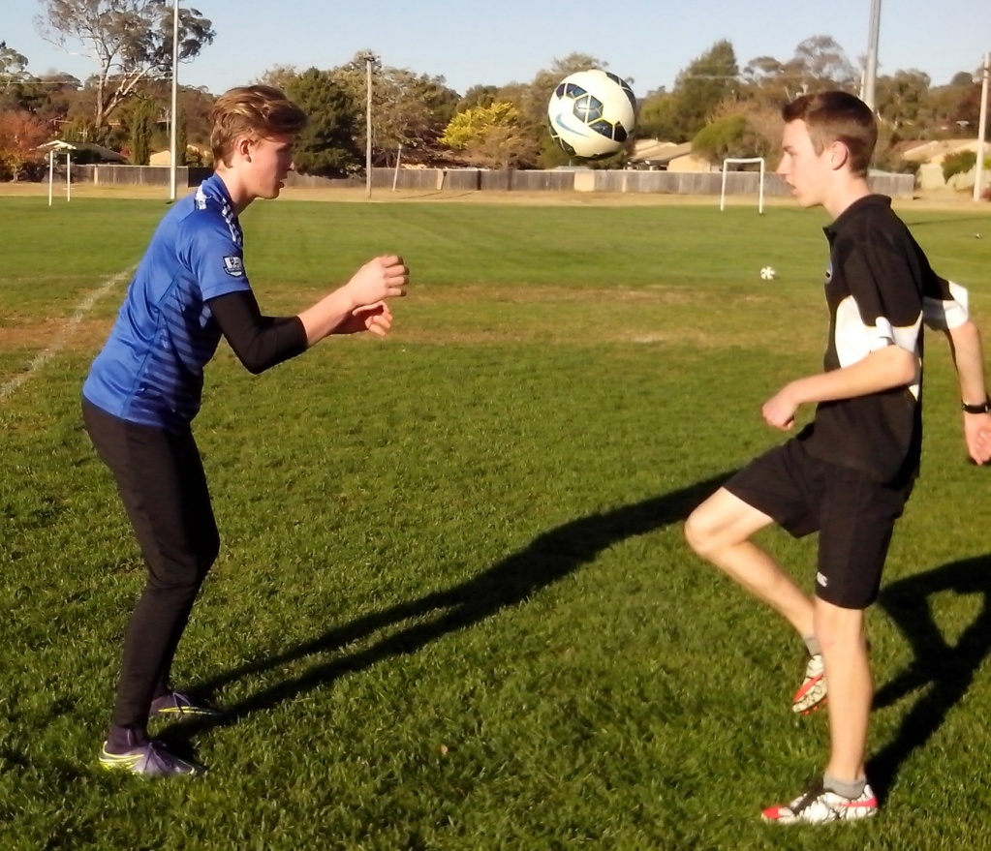
QUALITY CONTROL
There’s a difference between looking for ways to coach the best kids and looking for the best ways to coach kids.
The quality of coaching is not measured by what we teach but by what kids learn. They’re not always the same. When we teach kids to control a ball while standing still, they’re learning to stand still while controlling a ball. A lot of Soccer players stab at the ball in a game because they stand flat footed at training.
When players warm up for a game by standing in a circle and sharing one ball, each kid gets about 10 kicks before kickoff. If they line up to shoot, they stand around and get one shot every two minutes. A lot of kids stand around in a game and wait for the pass before they run.
Kids don’t always learn what we think we’re teaching them. If you ask players to write down, in 5 minutes, what they’ve learned from you this season their list would be a lot different to your list.
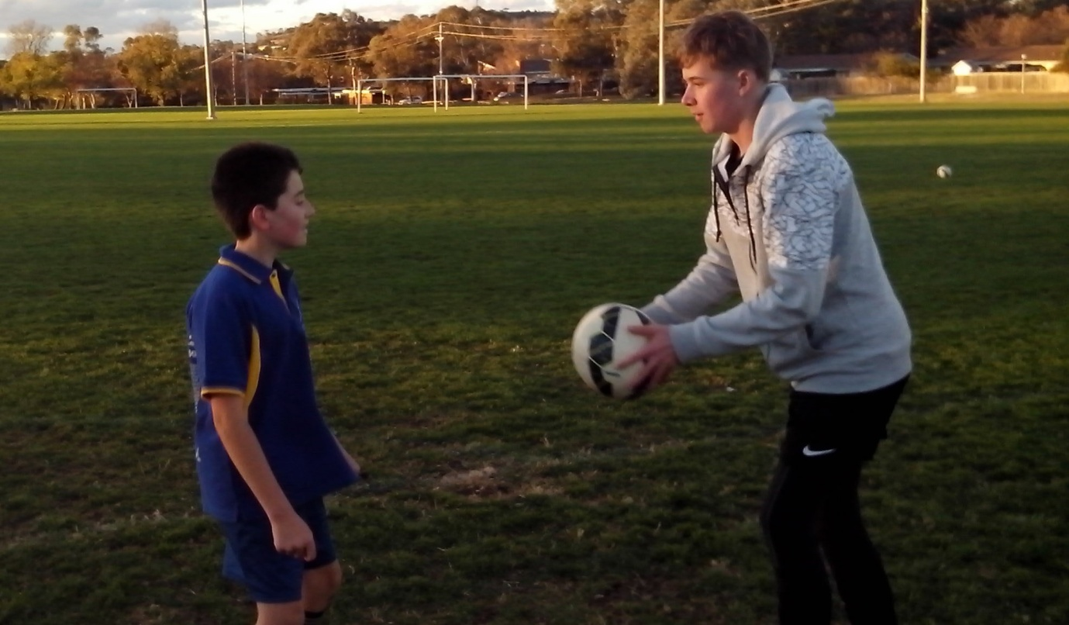
HOME ON THE RANGE
Ordinary training produces ordinary players. Extra training produces extraordinary players.
All kids look the same when we coach them all to be the same. It’s difficult to discover and develop natural talent when we don’t have a learning program to identify character, intelligence or creativity. Most coaches have no idea which kids practise on their own at home.
Freestyle kids train according to their needs, not an agenda or timetable. The kids at the Skate Park will persevere with a specific technique until they can master it and then they will improvise and create their own advanced version.
No kid is ever going to achieve their full potential by training with a team twice a week. When Freestyle Soccer kids reach the age where they can make up their own minds, some of them get serious about reaching the top and they make certain by practising at home. They become surprised at how quickly they produce an outcome when they focus on the input. They will get out of the game what they put into it. Any coach can recognise these kids if they know what to look for.

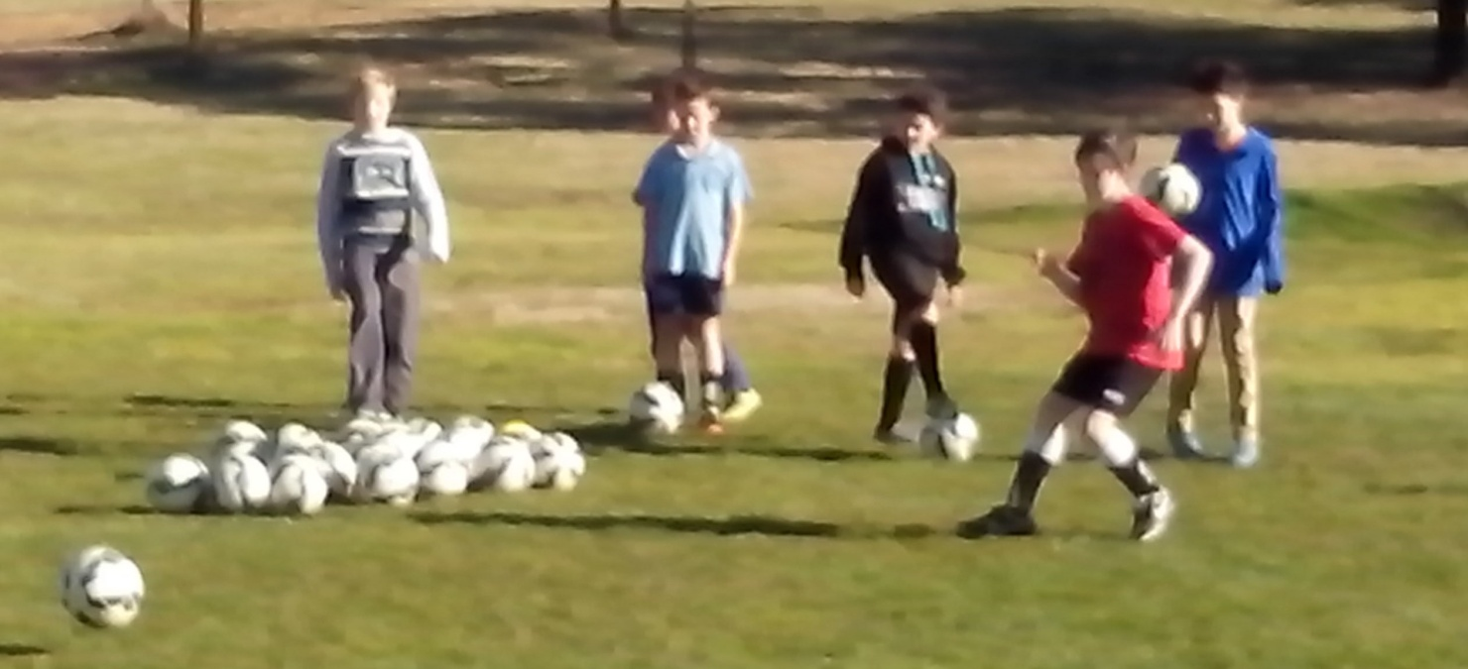
RESPONSIBILITY
Soccer kids will develop at a faster rate if coaches give them responsibility to run their own training drills.
Some coaches train with the team before kickoff. They stand in goal or feed the drills. When the whistle blows, the coaches have had more ball touches than the kids. Coaches don’t play the game so they don’t need to warm up. It’s important to let a team captain prepare the team.
Any kid can kick a ball but they won’t know how to pass, distribute, run a drill or put in a cross if the coach always does it for them. Kids need at least 200 ball touches before games for eye/foot coordination. If we expect kids to play in a game, we need to trust them to run their own training drills so they can learn how to feed and understand why.
Freestyle kids develop self esteem and resilience because they take responsibility for their skills development and never look for excuses when they make mistakes, miss their shots or lose games.
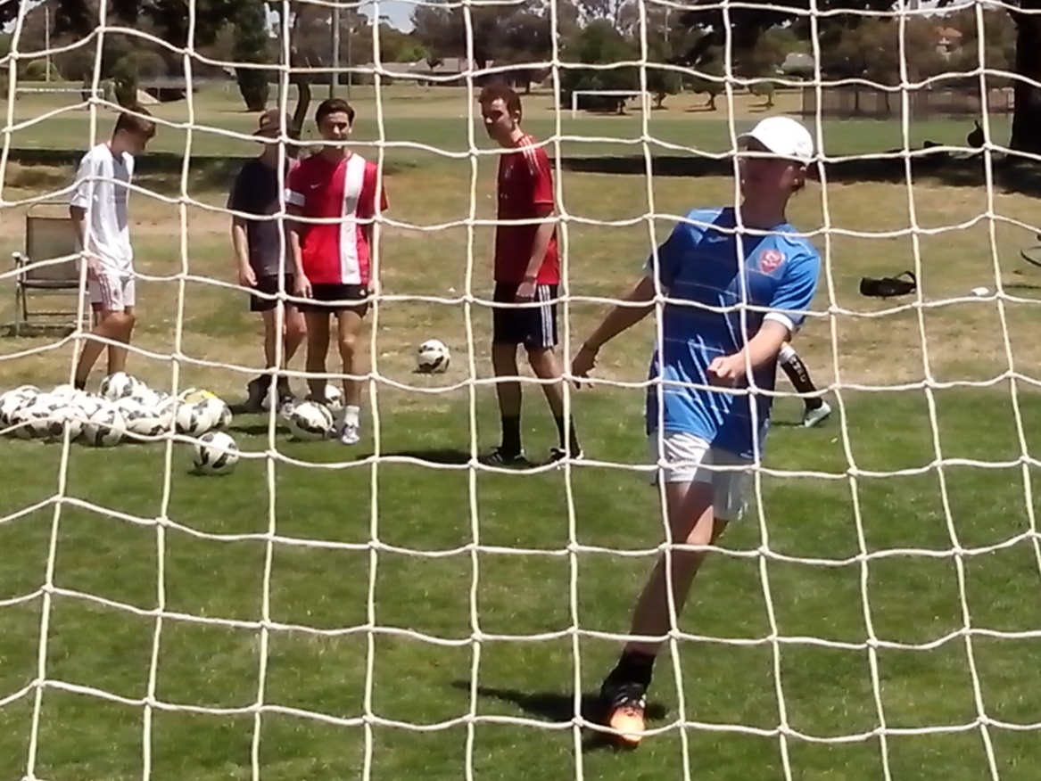
SAFETY
The first priority for any coach is the duty of care.
Safety in Soccer has to be proactive not reactive. There’s no point waiting for a player to get injured before we leap into action. In a game where the wearing of shinpads is a big issue, no goalkeeper should ever be allowed to play in goal without proper keeper gloves.
All across Australian Soccer ovals, we can find colourful pieces of plastic lying around where cones have been broken. Plastic cones crack when kids land on them and can become a safety hazard.
Serious strikers need suitable target cones at training so they can develop precision marksmanship. Rubber or silicon target cones are more durable than plastic, unlikely to crack and they will collapse harmlessly on contact. There’s always room for more innovation.
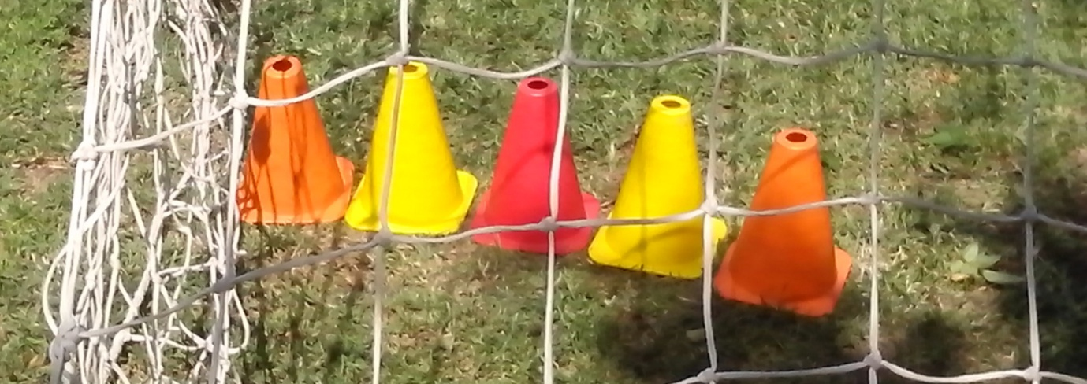
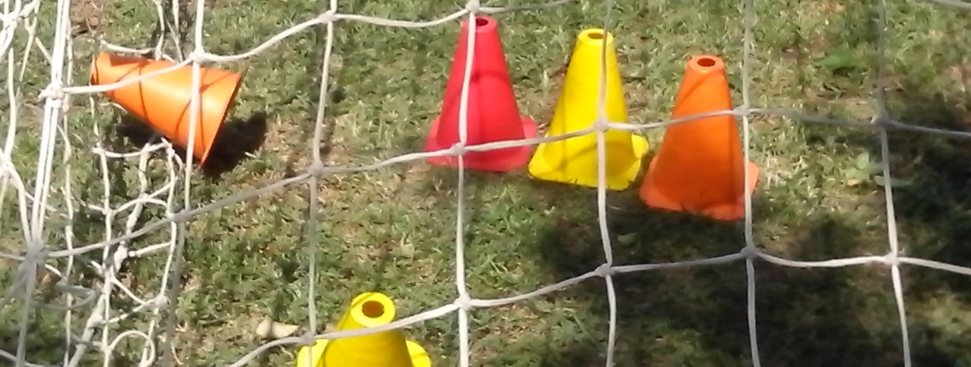
KIDS PLAY
There are skills that haven’t even been invented yet and talented kids who haven’t been discovered yet.
There’s a bunch of kids playing in a small game with jumpers for goals. They run, shout, laugh, rush their tackles, try things, make mistakes and push each other around racing to win the ball. You can feel the energy and hear the noise. They lift the pace and begin to improvise as the game becomes more intense.
Then the coach arrives and, within 5 minutes, these kids are all sitting dead still and staying dead quiet while the coach explains to them the correct way to play. Kids don’t fall apart just because adults leave them on their own. They learn to drive, strive, thrive and come alive.
If we look back 20 years at the way Soccer was coached, we get an insight into what the kids of today are going to think in 20 years time. Did we put the best skills into them or get the best talent out of them?
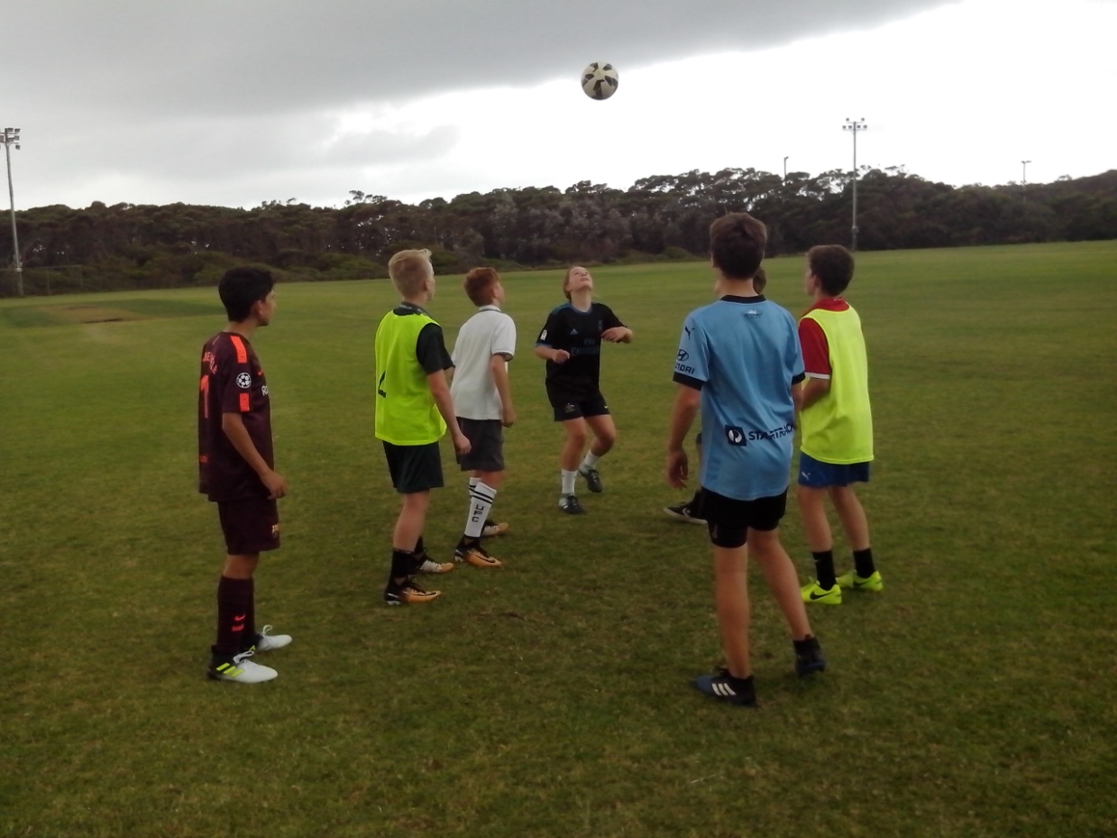
OFF SEASON
There’s a season for ball work and an off season for ball play.
In the off season, winning means nothing. Kids can be themselves and play their own game. They can relax and practise ball skills without feeling pressured by competition. Any coach can run a Skills Park for an hour a week. Every coach has the experience, expertise and ability to be an effective personal skills trainer. Most team coaches have no idea how much they can improve one kid in 5 minutes because they’ve never tried. Off season is a different world of improvisation.
Kids don’t stop growing or developing for six months every year. They can’t maintain peak performance all year but they can keep improving their finer ball skills. The off season is an ideal time for kids to get out on the oval and invent new drills. Close repetition ball drills can make any kid headstrong and footloose. It’s a perfect time for innovative coaches to discover their individual coaching skills.
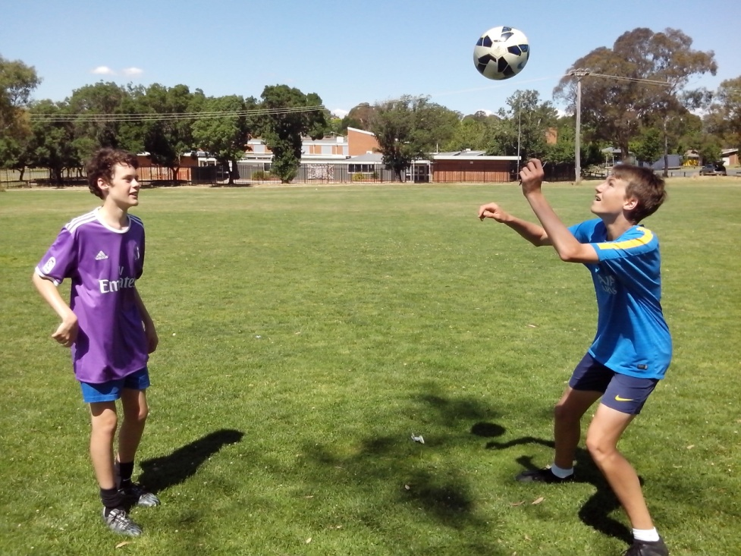
INSPIRATION
If we inspire kids, we can learn what makes them kick.
The greatest inspiration for Australian Soccer kids is not the coach but the name written on the back of their shirts. Soccer is primarily a game of skill. Kids don’t switch to Soccer so that they can play a pyjama version of the game. They expect to learn the skills of Messi, Ronaldo and Neymar. They expect to be coached to the highest level. Sport should be a challenge. Kids should be a challenge.
A good coach will tell kids what to do so that they learn to do what they’re told. A better coach will show kids how to do it so they can practise on their own. The best coach explains why so that kids can think for themselves and decide when and where to do it in a game.
The most effective way to inspire Freestyle kids is to tell them what they can’t do and then watch how they actually do it.
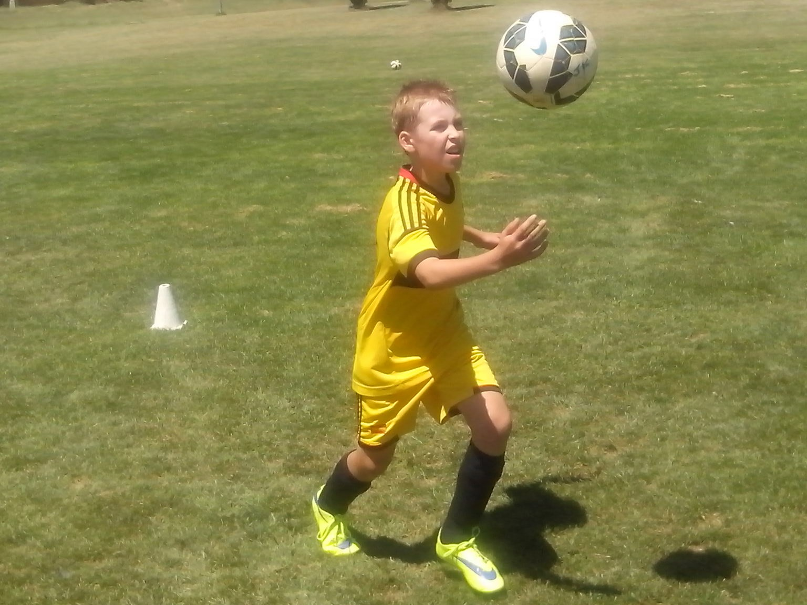
CONFIDENCE
Freestyle Soccer is not about winning. It’s about scoring more goals than the other team.
A team coach develops a kid for one season by building their skill. An individual coach develops a kid for all seasons by building their confidence. The first sign of confidence is when a kid starts to think for themselves and create their own moves. The response of a coach is critical. Confidence is the most important goal for any kid or teenager.
There are so many talented Australian kids who lack confidence and compensate by trying too hard or kicking the ball too high. Force is the default setting when kids believe that they lack the skill to reach the top. Little kids blast the ball over the bar from inside the 6 yard box because they can hear the sideline. call ‘big kick, big kick’. Any Australian Soccer coach can help any kid develop their confidence by focusing on their strengths without highlighting their weaknesses.
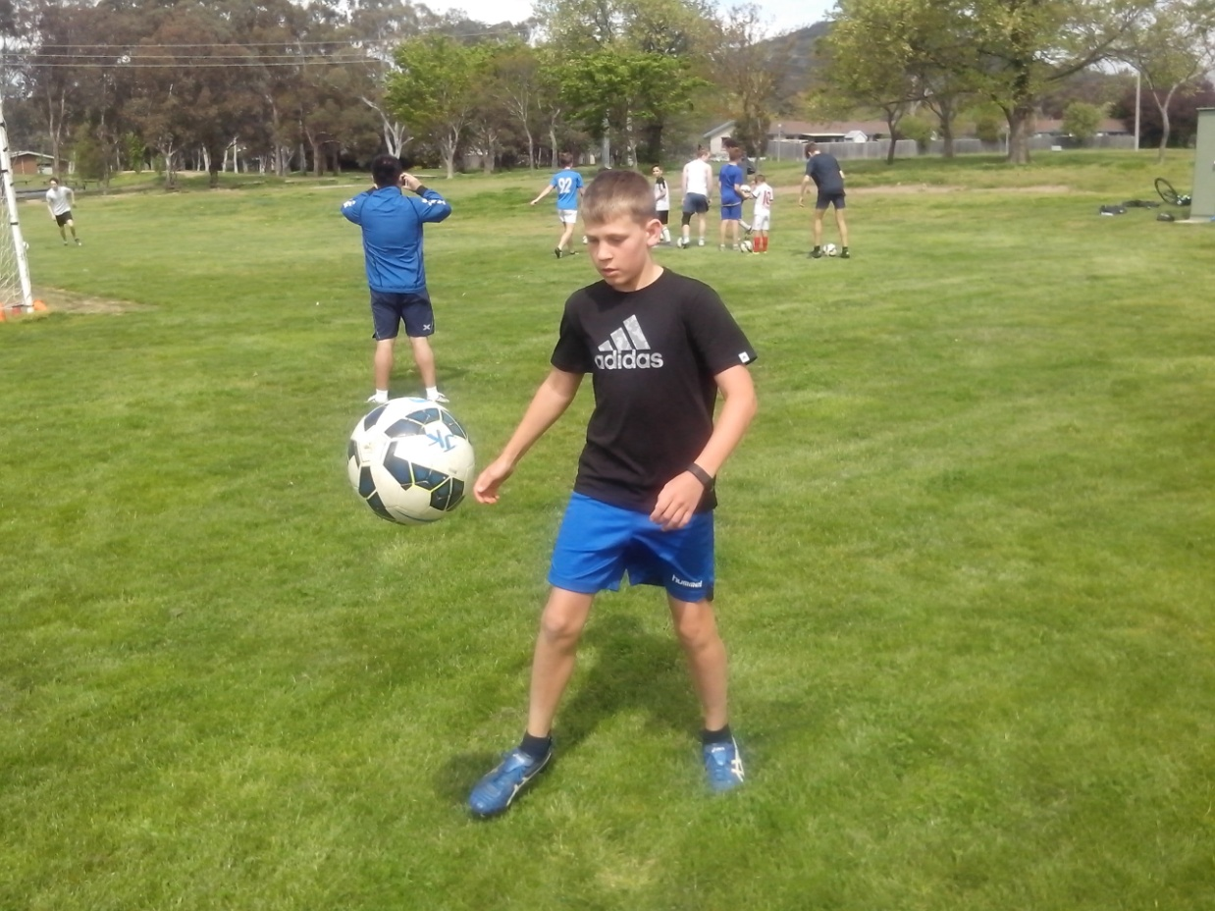
TOTAL CONTROL
Kids need ball control to develop their skill. They need self control to develop their talent.
Sometimes a strength can become a weakness. There are so many dedicated players who try too hard to achieve their full potential. Kids who try too hard, tense up and they rush everything they do. The top players learn to relax and control everything. First, they control their power and their temperament and then they can control the game.
There are plenty of talented players who can’t control their temper or aggression on the field. Some kids are protected from failure and then they struggle to control their disappointment when things go wrong.
So many talented strikers blast the ball over an empty goal because they can’t control their patience or power. There are so many talented Australian Soccer kids who play safe and wait to be told what to do because they’re scared of doing the wrong thing and they can’t control their fear of failure. Freestyle kids push the outer edges.
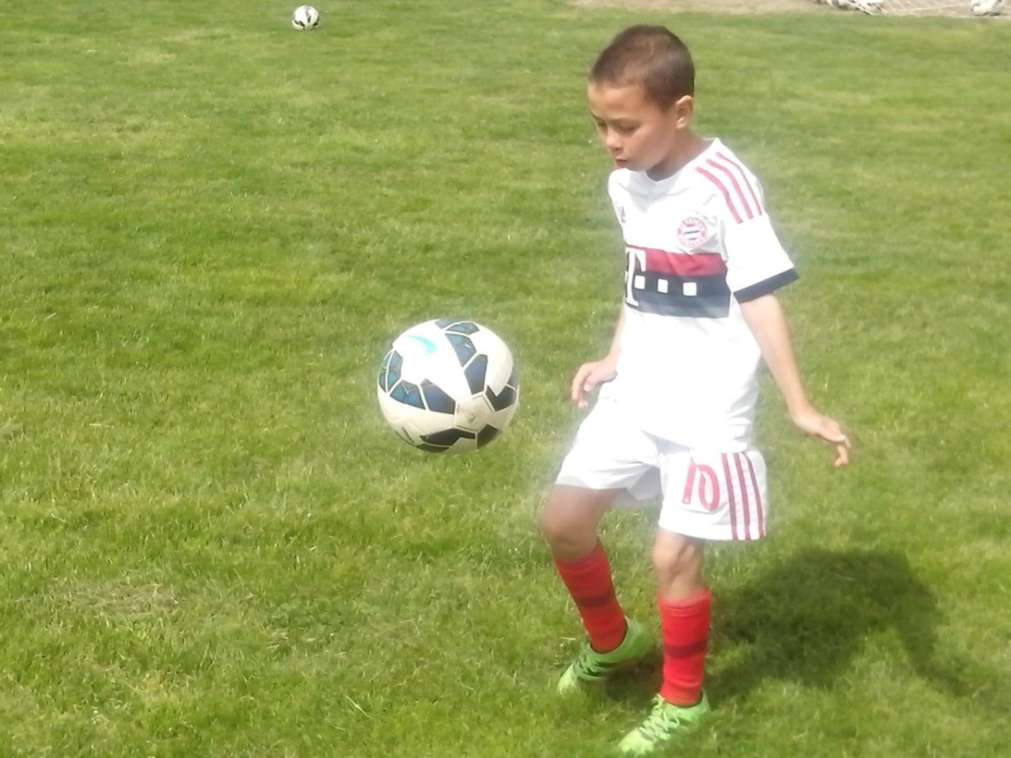
EMPOWER
Any kid can run a training drill. Fear of failure stops coaches from letting them.
All kids are different. Some kids can juggle a ball 1000 times using both feet. Some kids can hit a small target 30 metres away. Some kids can throw a ball into the 6 yard box. Some kids can hit a knuckle ball that changes direction in mid flight. Some kids can turn a desperate clearance into a through ball for their strikers to run onto.
Every team has one kid who can sprint faster than all the other kids. Some kids do extra training on their own or with their mates. Some kids attend high performance training courses. Some kids have their own personal trainer. Most coaches have no idea what their players are capable of. Any coach can identify strengths and weaknesses. A positive coach can develop a team to maximise the power of the kids.
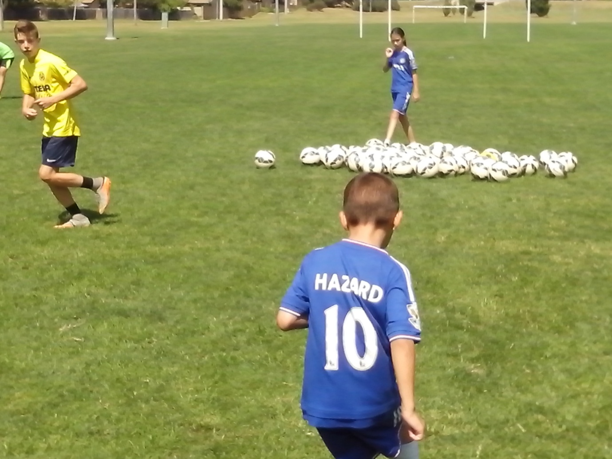
MAKING A DIFFERENCE
If we aim Soccer coaching at the mean average, we can create a lot of mean average kids.
We pick the best kids because they’re different and unpredictable and then we make them all the same. There’s a different key to every kid, a different drill for every skill, a different solution to every problem and a different challenge for every coach. Players aren’t wrong just because they’re different. They’re just different. When kids create a new move, they’re using their initiative and expressing themselves.
We can copy other countries or develop an original system that reflects the national character and sporting values of Australians. We don’t need to visit the Top Football nations to learn about Australian Soccer kids. If we visit the local ovals, the answers are right in front of us. We can teach them all to be the same or we can learn to make a difference. When we learn about our players, we can discover so much natural talent. If there was a 12 year old Messi or Ronaldo in Australia, would we be able to discover or develop them?
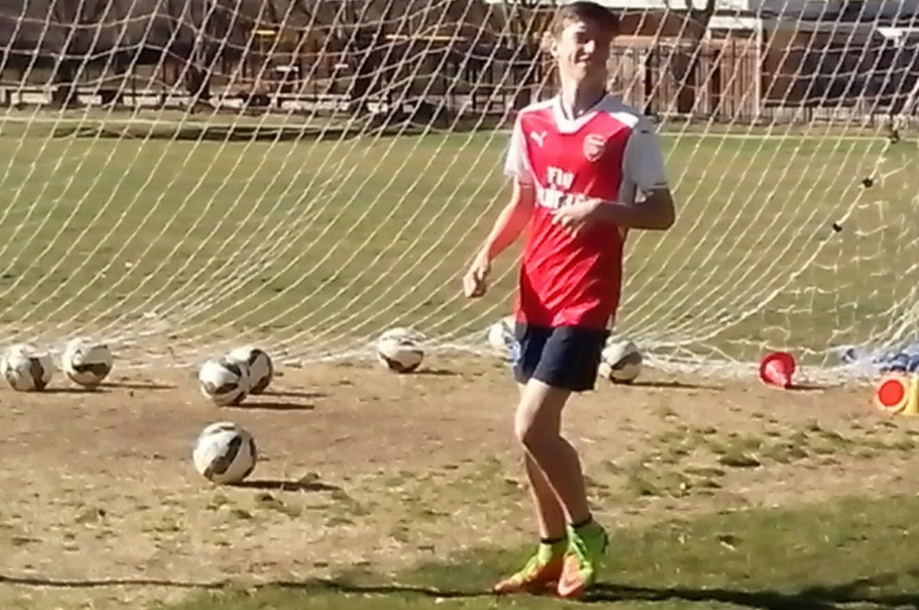
LIFT OUR GAME
Each generation is smarter and more talented than the previous generation. That’s evolution.
We’re looking for the kids who train when they’re told and do what they’re told. They’re not going to lift our game. We’re overlooking the thousands of Freestyle kids who train because they want to train. These are the inspired individuals who always use their initiative.
The next generation of Soccer kids won’t want to stand in line and wait to be told how to think, where to stand or what to do. The next generation of Australian Soccer kids is going to lift our game.
We teach kids to kick and shoot and they want to learn how to pass and score goals. We teach kids where to stand and they want to know where to move. We teach what the tradition generation can do and we can always learn what the innovation generation can do.
