Kapunda Football Club
History of Kapunda Football Club
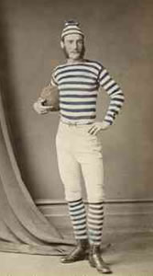 Early Kapunda Football  Player, circa. 1879  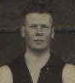  Jack Maguire |  | The History of the Kapunda Football Club.  The Kapunda Football Club does not claim to have a monopoly on all that is good in football but makes no apology for its pride in its past and its confidence in the future.  Another legend was John McGuire, who kicked more than 100 goals in a season on three occasions. In 1939 he kicked the Association record of 135 goals and in the 1935 kicked 30 goals in a match against Nuriootpa, including 14 goals in one quarter.  Never-the-less, the Club may legitimately be proud of many of its past and present achievers such as Jack Dermody who won the Association Best & Fairest Medal in 1930, transferred to Port Adelaide where he captained the Magpies to Premierships in 1936 and 1937 and also captained the State Team in the 1937 Australian Carnival in Perth. Jack was the main instigator of Colts football in the local competition.  Perhaps it is fortunate that the feats and foibles of the characters of our game must mostly go undocumented - for this will allow the tales to grow taller and give much more pleasure (at least to the teller) than would otherwise be permitted.  An original and consistent member of the Barossa and Light Football Association (now the Barossa, Light and Gawler Football Association) the Club's 'A' Grade side has competed in 1,277 official matches, winning 633, losing 628 - with 16 matches drawn. (As at the end of season 2000).  A true pioneer of Australian Rules Football, it seems that the Club played a role in the introduction of goal umpires, goal flags and the push-in-the-back rule.  Whilst for most of the Club's long life, its home has been the beautiful grounds of 'Dutton Park', its early games were played in a paddock near where the Catholic Church now stands and also on the site of the present Rifle Range.  It was this event that leads to the belief that the Kapunda Football Club is possibly the oldest football club in Australia to enjoy an uninterrupted identity.  Thus it was that the institution in which so many men (and women) both young and old, who have experienced so much camaraderie and so many achievements, came into being.  On Wednesday 18th April 1866 a public meeting was held in the North Kapunda Hotel for the purpose of forming a football club. It was unanimously resolved that a club be formed and called 'The Kapunda Football Club'. |  | 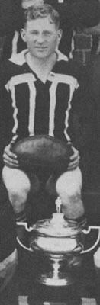  Jack Dermody, 1930

