## Wicked 1v1s for your players

In this year's Champions League with the abundance of skilful players, we've seen some fantastic, match-defining 1v1 situations, and these are best practised by using what I call the "skills corridor".

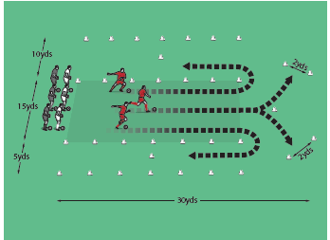

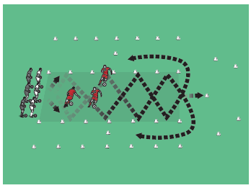

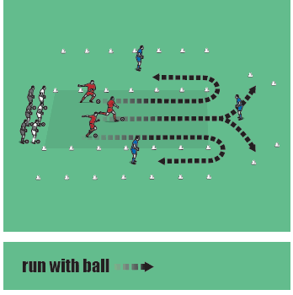

## How to play it

* Set up as shown above by creating three channels, each 15 yards long. One is 10 yards wide (at the top), 30 yards wide (in the middle) and five yards wide (at the bottom).
* At the far end of the middle channel, place a small goal (two yards wide) on each side at an angle. There are also additional cones that act as obstacles.
* Split your players into teams of three.
* The first trio of players move off. The central player must find a way around the central cone to shoot at either goal (see top picture).
* The other two players go around to the left and right. The player going to the left has a wide area to go 1v1 with the cone so he can push the ball past and run on. The player who goes right has a much tighter area to negotiate, so against his cone must use quick feet and a skill that means the ball stays close to him and protected (see top picture).
* The teams get a point each time they get past a defender or run the ball through one of the goals at the far end.
* For the next run-through, tell the players they must touch each side of the channel at least twice in their approach (see middle picture).
* And this time, give the three players a skill you want them to use to beat the "defender": stepover, feint, drag-push, knock the ball past the defender and run around to get it, or something else.

## Developing the session

* Replace the cones with defenders (see bottom picture). Now dribbling players must put the skills and techniques already practised in pressurised 1v1 situations.
* You can also add players along the sides who pass balls across the corridor that the dribblers have to avoid.

## Technique and tactics

* This session is great for match realism and the coaching of dribbling and 1v1 skills. Players can use a number of ways to get past the guarding defenders, so decision making is key to the success of the session.
* You are coaching a number of things in the zone so watch all three players and praise any good attempts to use a skill.
* Defenders must stay on their feet and let the dribbling player do the work.