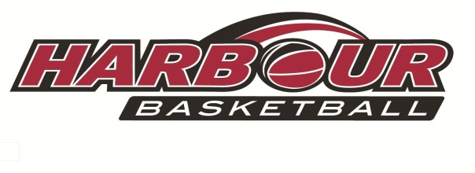

**Harbour DECEMBER**

**Basketball Camp**

**with Coach Kevin Braswell**

Monday 19th December

Tuesday 20th December

Wednesday 21st December

**North Shore Events Centre**



9am-3pm Each Day

PitaPit for lunch (included in cost)

Recommended Ages 7-13

Register now thru the Harbour

Basketball website!

Cost: $150 for three days.