**Dribble past your partner**

This is a great warm-up to get your players confident on the ball so they are ready to play matches.

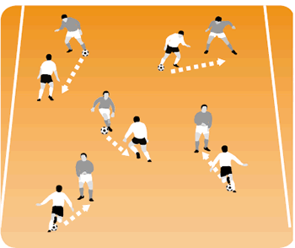

**How to play it**

* Arrange your players into pairs.
* The partner in possession of the ball must dribble with it and try various skills.
* The second player must jockey and continuously change position in relation to the dribbling player to stop him passing.
* On your first whistle, the player in possession turns away from his partner and tries to hold them off.
* On your second whistle, players change roles.