50 Ways to Practise Shooting
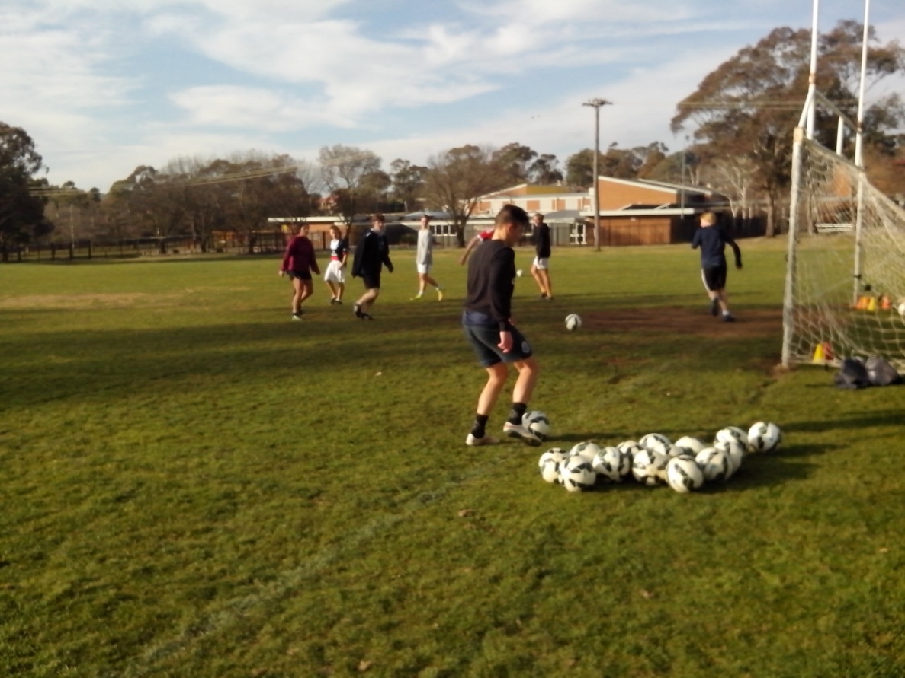
Any kid who can kick a ball can learn how to shoot.

At the end of a shooting session, Freestyle kids don’t want to go home.

SHOOTING PRACTICE
In Freestyle Soccer, marksmanship becomes second nature.
In a game decided by goals, the average Soccer kid spends 15 minutes each week at shooting practice. That’s not a drill. This is a drill. A two hour shooting session for 6 strikers using 100 balls. Kids aren’t impressed with best practice. They want better practice with hundreds of ball touches. A lot of kids play safe and stick with what they can do. Freestyle kids need a challenge and practise what they can’t do.
Most players use their Soccer skills to improve their shooting drills. Freestyle kids use shooting drills to improve their Soccer skills in the goalmouth. They trap and shoot, juggle and shoot, dribble and shoot, head the ball down and shoot, screen the ball then turn and shoot. Everything that Freestyle kids practise has one goal in mind.

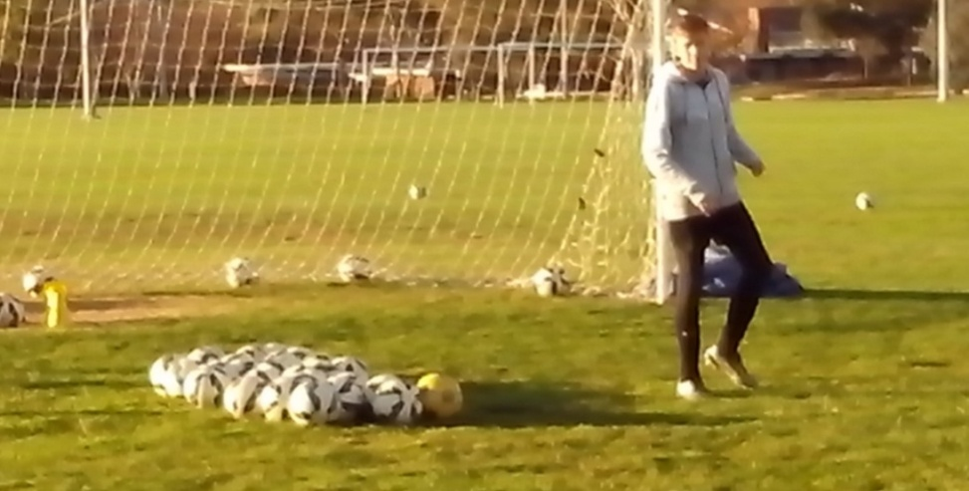
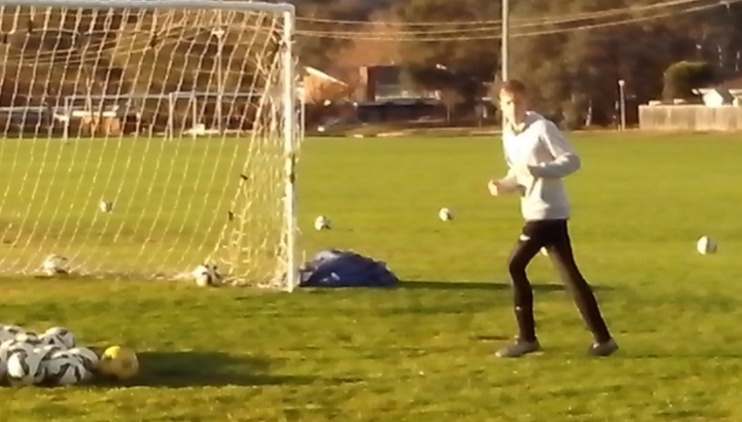
NATURAL ABILITY
Kids need to develop their natural skills if they want to improve their Soccer skills.
The ability to control the ball in a game rapidly increases with the ability to see, hear, think, communicate, anticipate, make decisions and move. Any basic motor skill improves with conscious practice.
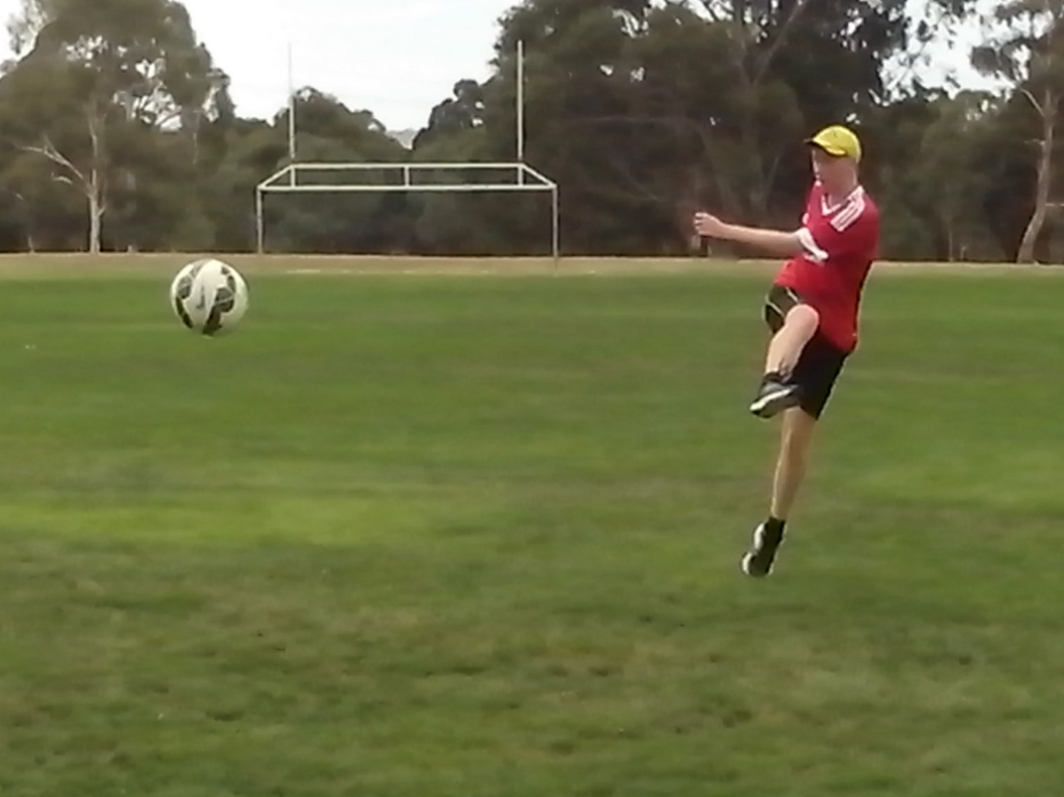
There are ten Freestyle elements that transform skill into talent. Any Soccer kid can develop footwork and vision, power and precision, movement and decision, belief and repetition, challenge and intuition.
We’re trying to teach perfect shooting technique to kids who don’t know how to move their feet or what to look at when they kick a ball. We can improve any Australian Soccer striker in 5 minutes just by learning about their natural skills. Actually, that’s an exaggeration. It takes one minute to discover the kids who stab at the ball and another minute to identify kids who take their eyes off the ball as they shoot.
FOOTWORK
Footwork ensures that any kid can strike the ball naturally.
There are so many talented Soccer strikers who struggle to strike the ball smoothly because they don’t know how to move their feet. When players stand flat footed, and stiff legged, they stretch for the ball and stab at it awkwardly instead of striking through it naturally. When we practise shooting drills, we look at the kick and overlook the kid.
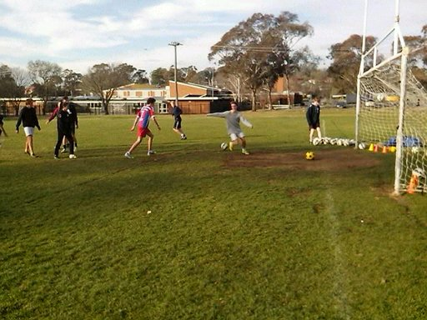
Soccer is all about a kid and a ball. Freestyle Soccer is all about a moving kid and a moving ball. Freestyle strikers move to the ball and kick through it. Kids need to move if they want to improve. They need to believe if they want to achieve.
Kids don’t always learn what we teach them. When we teach kids to kick a ball while standing still, they’re learning to stand still while kicking a ball. Australian Soccer kids spend too much quality time queuing in a line between each shot or standing in a circle sharing one ball before kickoff. Unintentionally, we’re creating a lot of players who stand around and wait for the pass before they make a run for it.
VISION
Vision ensures that any kid can strike the target accurately.
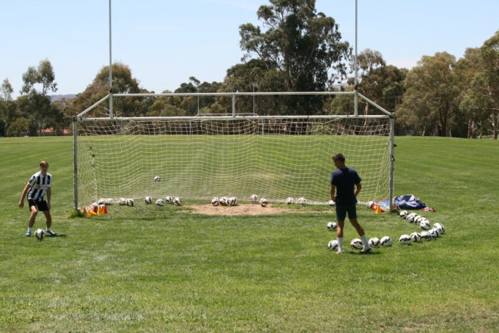
The vast majority of Australian Soccer kids have no idea what to look at when they shoot. No coach has ever told them and no kid has ever thought about it. Some kids look at the ball when they kick and some kids look up at the goal. Some kids check the target before they shoot and some kids only check the target after they shoot.
Experts see what they’re trained to see. When players shoot, coaches look at the kick so they can correct the kicking technique. If they can think outside the goal square, and stand behind the net at shooting practice, coaches would discover how many kids take their eyes off the ball at the precise moment they strike it. Kids are result oriented and look up to see the net bulge. A lot of kids focus on what they can get out of the shot. Freestyle kids concentrate on what they put into it.
The reason so many shots go over the crossbar or straight to the goalkeeper has nothing to do with technique. It’s all about vision. Freestyle Soccer kids learn about vision through close repetition drills. Strikers need super vision in front of goal, not supervision.
POWER
When teams only spend 15 minutes a week at shooting practice, their best chance of success is a long shot.
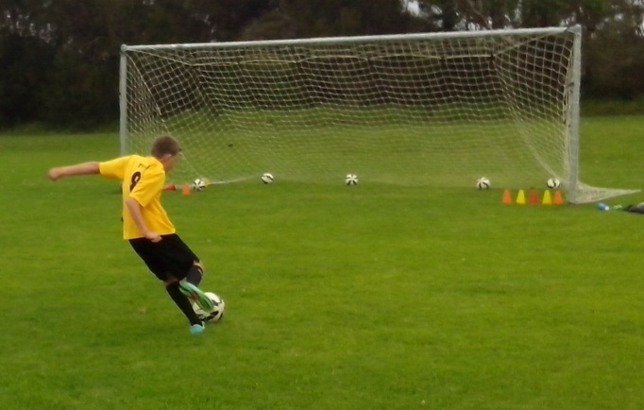
Freestyle strikers regularly spend up to 2 hours at a shooting session. They learn how to finish because they know where to start.
Power shooting begins inside the 6 yard box not outside the 18, so that kids can coordinate mind, body and ball without trying too hard to kick the ball too hard. Slow, short, simple, smooth two touch control on the ground gives kids a basic foundation they can build on. Once their eye/foot coordination kicks in, players gradually increase their range, speed, elevation, velocity and degree of difficulty.
When coaches only practise shooting for 15 minutes each week, their players only have time to blast the ball from outside the penalty box. Freestyle kids are able to develop timing, rhythm, coordination and balance in front of the net and then they can improvise the range and direction of their shots. Power is the product of strength, speed and timing. Force is just the product of frustration and lack of confidence.
PRECISION
Most Soccer kids don’t know what they’re missing. Freestyle kids know because they lock onto clear and specific targets.
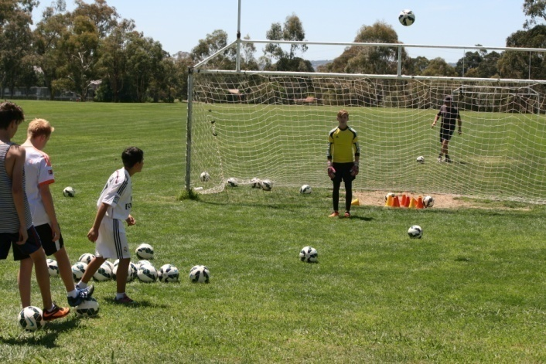
In every team, there’s at least one eagle eye kid who can develop pinpoint accuracy in their distribution and shooting. They miss small because they aim small. What they see is what they get. Most kids aim big and miss big. Boys, especially, shoot with maximum power. Some kids can blast the ball over the bar from inside the 6 yard box.
A crack shot will practise with small target cones. The eagle eye kid can usually knock over most of the cones before other kids get their eye in. Every kid has a peak skill that can benefit their team. Most Freestyle Soccer kids are able to hit a small cone 30 metres away.
If we can identify the eagle eye kids, they can set standards for the other players. By measuring their optimum range of accuracy, kids can understand their limits in a game and not overextend themselves.
Anyone can shoot at a large target. Freestyle marksmen lock onto the smallest target they can see. They get ready, take aim and fire. They look up and lock onto the target, look down and lock onto the ball.
MOVEMENT
We teach kids where to stand and they want to learn where to move.
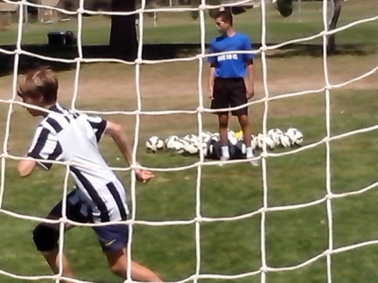
Coaches have the ability to make or break a player without even knowing it. Just because a kid is different or unorthodox in a game, it doesn’t mean that they’re wrong. When the coaching is too good, we risk creating intelligent individuals who only train when they’re told and only copy what they’re told. Kids need to improvise and move.
When a kid makes a run and a call, we can either criticise them for leaving their position and doing the wrong thing or recognise the first sign of personal initiative. Soccer kids only have the ball for 5% of a game. Skilful players can dominate the game with the ball. Talented players can dominate the game without the ball for the other 95%.
At training, kids spend too much quality time standing around and waiting for the ball. In a game, strikers spend too much time following their markers. Any striker who makes any move will take their opponents out of their comfort zone and create something for themselves or their team mates. The striker who does nothing will create nothing. Australia is like any other new kid on the Soccer block. We can either wait to see what happens or make it happen.
DECISION
Any kid can trap, pass, dribble and shoot. The most difficult skill in Soccer is choosing the right one at the right time.
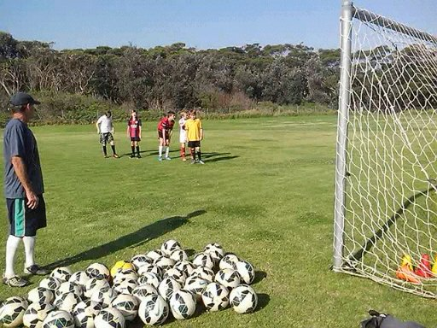
There are three basic stages in the development of motor skills. At the cognitive stage, kids stop and think before making a move. At the associative stage, kids become more familiar with the situations. At the intuitive stage, kids can make the right choice without stopping to think. Most Australian Soccer kids never get enough repetitive touches of the ball to reach the intuitive level. Talented strikers panic in front of an open goal because they have to stop and think too much.
Ordinary kids are waiting and hesitating in a game, trying to second guess what the coach wants them to do in case they get in trouble for being wrong. Freestyle kids have the freedom to think for themselves, make their own decisions, make their own mistakes, learn from them and move on. The key to Freestyle Soccer is to move and improve.
In the pressure of the goalmouth, strikers have less than one second to align mind, body, ball and goal. Freestyle kids know when to take the shot because they’ve done it thousands of times in the shooting gallery and cognitive repetition drills make their decisions intuitive.
BELIEF
If the kids believe in the coach, and the coach believes in the kids, the kids will believe in themselves.
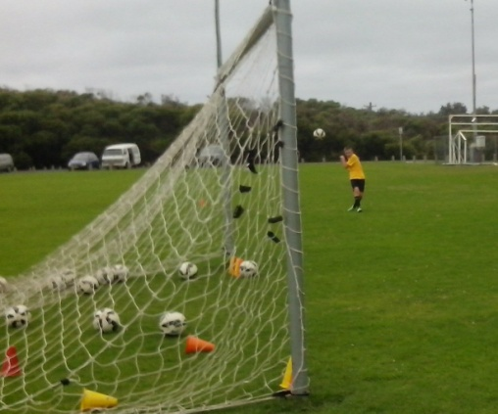
The biggest issue in junior Soccer is not the lack of talent but the lack of belief in that talent. Our beliefs drive our actions. If we believe that kids lack the talent to reach the top, we will teach them to think, look, stretch, move, kick and play the same way and get the same results.
If we believe that kids have the talent to reach the top, we will look for that talent and discover how good young players really are. Fear of failure stops players and coaches from achieving their full potential. Strikers need to believe in themselves when they practise shooting. They can’t make the right decisions if coaches keep correcting every shot. We need to encourage players to take their best shot. Without doubt, any kid can learn how to shoot and discover how to score goals. With doubt, they are just going to hesitate and wait to be told.
REPETITION
Repetition is the key to shooting skill. Familiarity is the key to scoring talent.
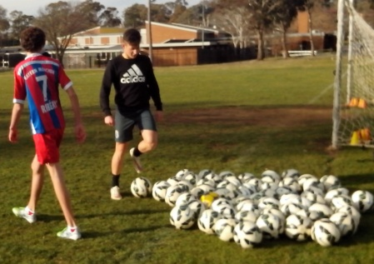
Any kid can hit a large goal. Put a goalkeeper in and the kid suddenly blasts the ball over the crossbar. There are talented strikers who panic in front of goal because they don’t get enough repetition to reach the intuitive level. Most kids have one technique they can use. Freestyle kids have six techniques they can choose from. They practise shooting from every angle, range and height so that nothing can surprise them.
Some kids take one shot at training and then go to the back of the line and talk for two minutes. Freestyle kids can calibrate their shots, learn from their mistakes and immediately adjust their stance and control. Effective marksmanship depends on controlled automatic fire, not intermittent pot shots. Kids who increase the frequency, intensity and duration of their shooting sessions learn to relax in front of the goal. Reputation doesn’t count when the shot is on. Repetition counts.
CHALLENGE
Fear of failure is the biggest challenge in Soccer. Let’s face it.
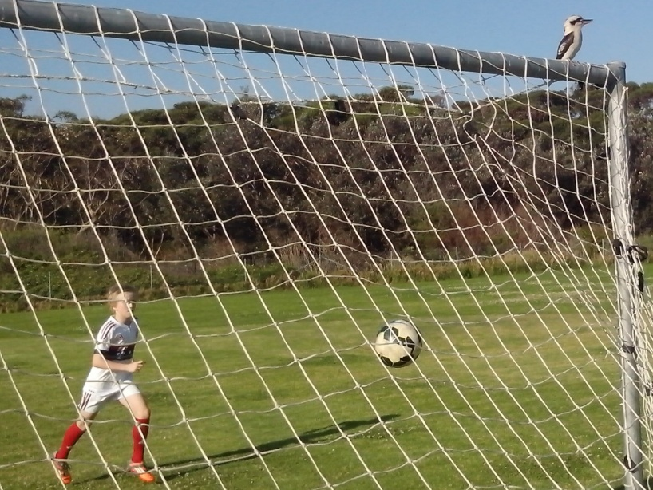
Ordinary Soccer kids stick with what they know. They play safe and practise what they can do. Freestyle kids look for a challenge and they practise what they can’t do. Some coaches try not to lose instead of trying to win. Some kids are scared of a high ball because they only practise with a ball on the ground. We need a system that encourages and challenges the real Australian sporting character and identity.
The mean average Soccer kid starts with non competitive games to protect them from the trauma of failure. Failure isn’t the problem. Fear of failure is the real issue that stops us from trying things. Fear of the unknown stops coaches from looking at new and different ideas.
The mean average Soccer kid looks at a challenge and can only see a problem. The mean average Freestyle kid looks at a problem and can only see a challenge. These are the kids who have the motivation to train without being told to train. Coaches need to discover these kids.
INTUITION
The most effective time to shoot is when the keeper doesn’t expect it.
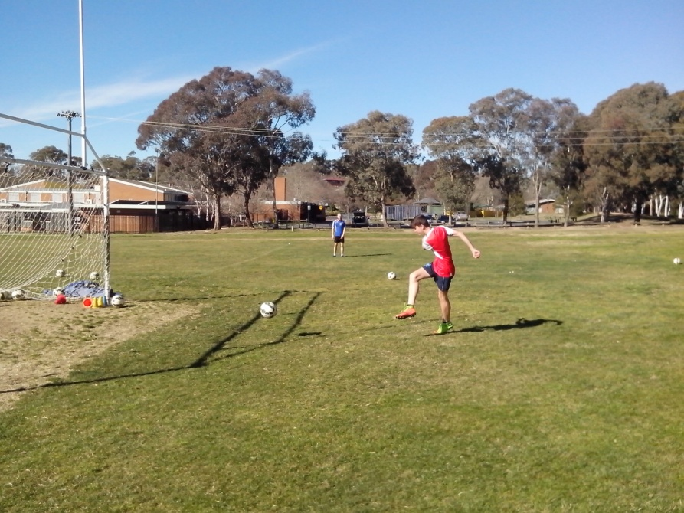
Some strikers inadvertently warn the keeper before they shoot by taking an extra touch or an extra look at the target. Their lack of confidence signals their intention. They try to make the shot easier but it never gets easier. Freestyle kids take one look and one touch. They pick their spot and take their shot. They learn from every shot, hit or miss. Smart players know their options before they receive the ball and often disguise their intention by looking in a different direction. A sharp kid can make a keeper move the wrong way with just a glance.
Freestyle strikers learn from every shot and they store the data in their subconscious ready for later use. Most kids will stop a firm clearance and then try to shoot with the dead ball. Freestyle kids use the energy in the ball and they chip it back over the keeper’s head first time.
Kids in the leading Football nations of the world develop at the intuitive level because they get thousands of ball touches and have the freedom to think, move and control without direction, protection or correction from well meaning adults. At a thousand kicks every day, these kids are already one million steps ahead of Australian kids.
GET OVER IT
The more we learn to miss, the more we learn to score.
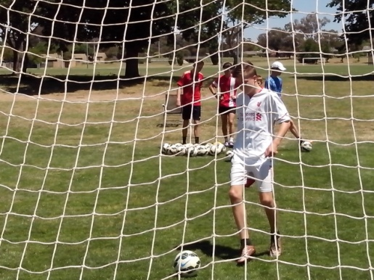
We can improve any striker in 5 minutes just by telling them to make as many mistakes as they like. The key is to learn from the mistakes.
Shooting isn’t a matter of luck. There’s a reason for every hit and every miss. Kids spend years repeating the same simple mistakes and coaches spend years correcting the same simple techniques because they never look for the underlying cause. There are 17 year old kids who have taken their eyes off the ball for every strike in the last 10 years and nobody has ever noticed why their shots go over the bar. If we know what to look for, it takes 5 minutes to improve these kids.
There’s a lot more to shooting than kicking a ball. Shooting ability depends on natural ability. Kids can’t score goals if they don’t know what to look at or how to move their feet. All kids make mistakes but the key is to get over it. We need to stop correcting the kids and start correcting their mistakes before they become permanent bad habits.
SAFETY NET
There are adult strikers who still blast the ball over the bar or kick it at the keeper because nobody helped them when they were kids.
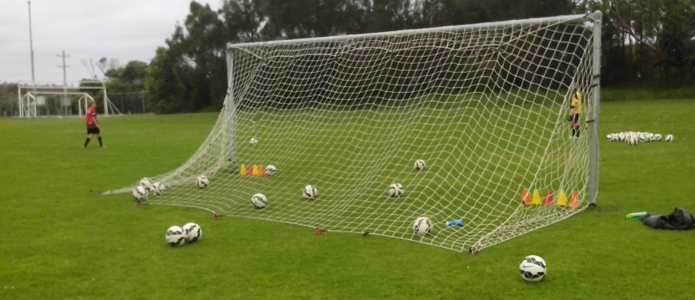
In the 10 years it takes to coach the average Australian Soccer kid, not one person will spare 15 minutes with that player to learn about their strengths, weaknesses, talents, skills, fears, needs, limits or values.
Safety Net is a 15 minute networking drill that uses close repetition ball skills to assess the abilities and qualities of every 10 year old Soccer kid. We can identify what every kid needs to improve just by evaluating their footwork and vision, power and precision, movement and decision, belief and repetition, challenge and intuition.
Some kids stand flat footed and stab at the ball. Some kids are one footed. Some kids try too hard to kick the ball too hard. Some kids don’t know what to look at when they strike the ball. Some kids make mistakes because they worry about making mistakes. We can improve any Australian Soccer kid in a few minutes just by learning about them. No Australian Soccer kid should ever fall through the cracks or get left behind just because team coaches don’t have the time to look at their individual players. Safety Net should be mandatory for every 10 year old Soccer player so that we never give up on any kid.
SMOOTH
Power comes from training. Force comes from straining.
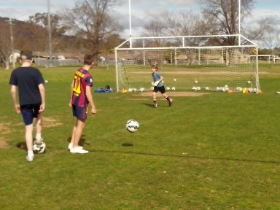
Some kids use the first 20 minutes of a game to warm up. Freestyle kids are ready to strike when the whistle blows. Too many kids arrive at the oval on match day and the first thing they do is try to drive a dead ball over the crossbar from 20 metres out with cold muscles. Most coaches don’t notice because they haven’t been told to notice.
Freestyle Soccer kids will always get 200 touches of the ball before they arrive at training. It takes that many ball touches for eye/foot coordination to kick in and for control to become second nature.
Initial shooting drills should be short, slow, simple, smooth, on the ground and two touch. Freestyle kids gradually increase the range, speed, power, degree of difficulty and elevation as their confidence and ball control improve. The First 5 minutes of anything we do are full of mistakes. That’s human nature and that’s how we learn. Some kids just give up in the First 5. Freestyle kids understand the First 5 and use it to warm up. Slow becomes smooth and smooth becomes fast. Precision becomes smooth and smooth becomes power.
CLOSE UP SHOTS
Close up shots form the basis of footwork and vision, power and precision, movement and decision.
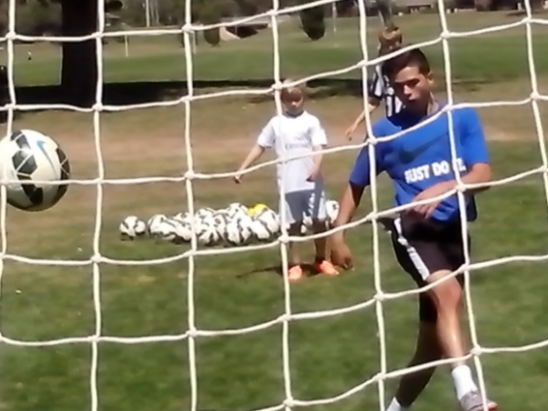
The first two sets of any shooting session are the most important because they set the foundation of balance, coordination, timing and rhythm in the 6 yard box and then strikers can increase their power, range, creativity and intensity. The 6 yard box is the classroom.
Freestyle strikers develop a specific firing sequence so that every shot is certain. Shooting is as simple as repetition. Scoring is as simple as Ready Aim Fire. First, they control the ball. Then they check the target. Finally, they keep their eyes firmly on the ball as they strike.
Freestyle strikers never pass or shoot without checking the target first. They know how to score because they learn how to miss and they can understand why. There’s a reason why shots go wide, over the bar or straight to the keeper. Intelligent players analyse their mistakes and discover the underlying cause so that they learn how to avoid them.
200 TOUCHES
Soccer kids need 200 kicks before kickoff.
There’s a myth that players can just pick up a ball and demonstrate perfect control every time. The average Soccer kid gets 10 touches of the ball before each game and then they spend the next 20 minutes making a lot of unforced errors. The average Soccer coach has no idea how many kicks kids need before their control becomes second nature. It’s not written in the book so nobody bothers to think about it.
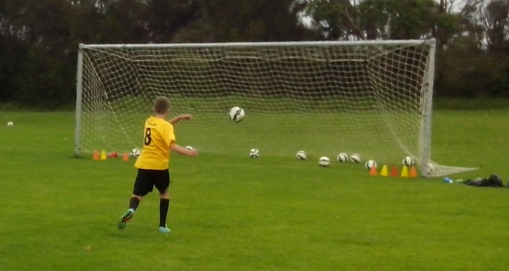
It takes at least 200 ball touches for kids to develop eye/foot coordination and reduce the number of mistakes. Any coach can discover that for themselves just by observation. Initial touches are too hard or too soft, too high or too low, too early or too late, too fast or too slow, too left or too right, too loose or too tight. When a kid juggles the ball 30 times, the last ten figures are a lot higher than the first ten figures. It takes 5 minutes to coordinate mind, body and ball.
A striker needs an intuitive feel for the ball, the angle, the range, the options, the obstacles and the shot. After 200 touches, any striker is ready to keep on target and take the shot. The quality of scoring in a game is directly related to the quantity of shooting at training.
100 BALLS
Take up a ball, make up a drill, shake up the goal, wake up your skill.
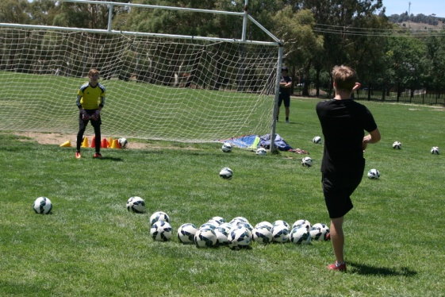
When half a dozen kids can spend 2 hours using a net and 100 balls, coaches will discover how talented and innovative the next Australian generation are. Until then we don’t know anything about Soccer kids because we have no Learning Program to look, listen, ask questions or measure capability. There is so much talent waiting to be discovered.
The average Soccer kid has to retrieve their ball every time they miss their shot at shooting practice. Some kids spend half their time getting their ball back and some kids avoid that by taking the soft shot at the keeper. 100 balls means that kids can get 100 shots at goal before they have to collect them. Kids can open up a whole new world of scoring.
Soccer kids need shooting practice, not standing in line practice or retrieving the ball practice. There isn’t one Australian Soccer kid we can’t improve in 5 minutes just by believing in them. Every kid can discover how to score goals if we give them a shot at it.
GAME OF CONES
There are no small targets in Australian Soccer. Otherwise, we would discover how accurate Australian Soccer kids really are.
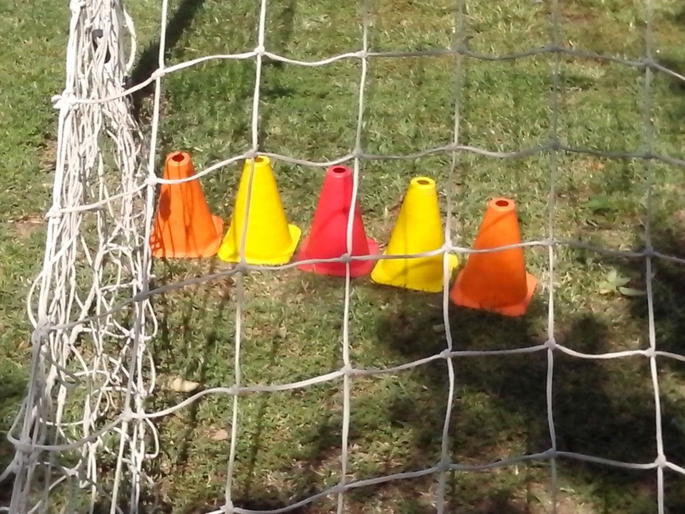
Professional marksmen don’t aim for the target. They aim for the bullseye which is the smallest part of the target. Ordinary Soccer kids aim for the whole goal when they shoot. Some look up and kick the ball over the crossbar. Some kids try too hard and blast the ball wide. Most kids miss big because they aim big. Freestyle kids miss small because they aim small. They use target cones for shooting practice.
Target cones enable kids to develop precision marksmanship. Once they find their range of accuracy, they can gradually develop their range of power. There are 10 year old Freestyle Soccer kids who can consistently strike a small cone 30 metres away because that’s what they practise while other kids concentrate on crossbar challenge.
The game of cones give kids the firm foundation for the confidence they can build on. What they see is what they get.
FREE RANGE PRACTICE
Most kids don’t know their own strength. Freestyle Soccer kids know because they can measure it.
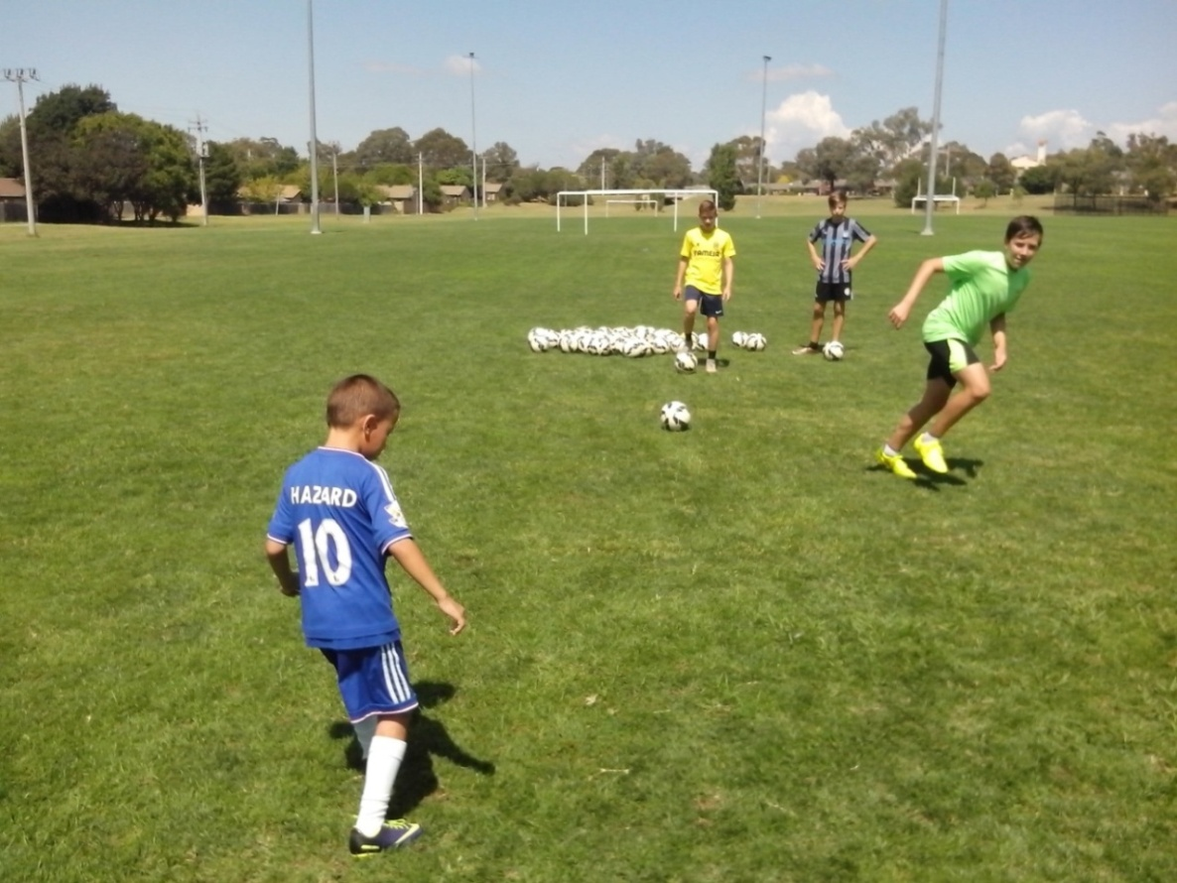
Players can’t score because Soccer goals are simply too big. The first discovery kids make, when they practise with small target cones, is how accurate they really are. Kids don’t know this because we spend years teaching them to shoot as hard as possible at the largest target.
Kids are so accurate that their shots go straight to the keeper. Nobody wonders why. It’s got nothing to do with shooting technique. It’s all about vision. They hit the keepers because they look at them. What they see is what they get. That’s how much we know about shooting.
Freestyle kids use Free Range Practice to learn about their own strengths, weaknesses, fears and limits. The most important subject any kid can learn about is themselves. Kids who check the target first, will always keep their eyes on the ball when they shoot. Freestyle kids pick their spot and hit their spot. They don’t pick the goalkeeper.
HEADING PRACTICE
Ordinary training produces ordinary players. Extra training produces extraordinary Soccer players.
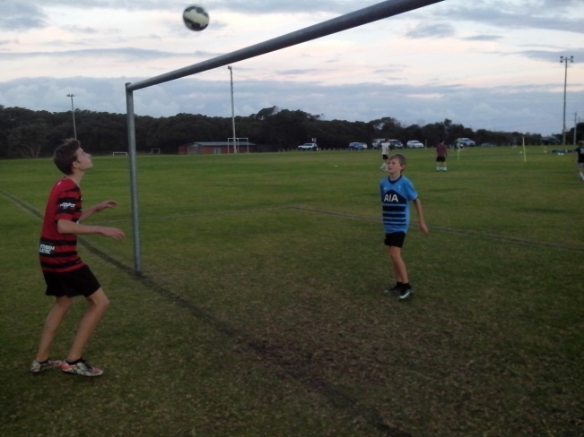
A lot of kids are scared of being hit by a high ball. That’s human nature and easy to overcome. Some kids move out of the flight path of the ball and try to stop the ball with a raised foot. Freestyle kids get their body behind the flight because they always attack the high ball.
Heading is the most neglected skill in Soccer because of the way we coach it. The most common fault is that kids let the ball strike them instead of them striking the ball. Once kids realise that the ball can’t hurt them, they become more confident with heading drills. Heading is a basic motor skill. Freestyle kids use close heading in pairs to get familiar with it. Light becomes smooth and smooth becomes strong.
When a ball is crossed into the box, the first challenge is to redirect the flight which means that kids rotate the body as they strike the ball. The next thing is to head the ball down to make it more difficult for the keeper to reach. As confidence increases, Freestyle kids use their whole body to extend the range, velocity and height of the header.
ONE TWOS
The Wall Pass is the most rewarding shooting drill because it encourages communication, movement and teamwork.
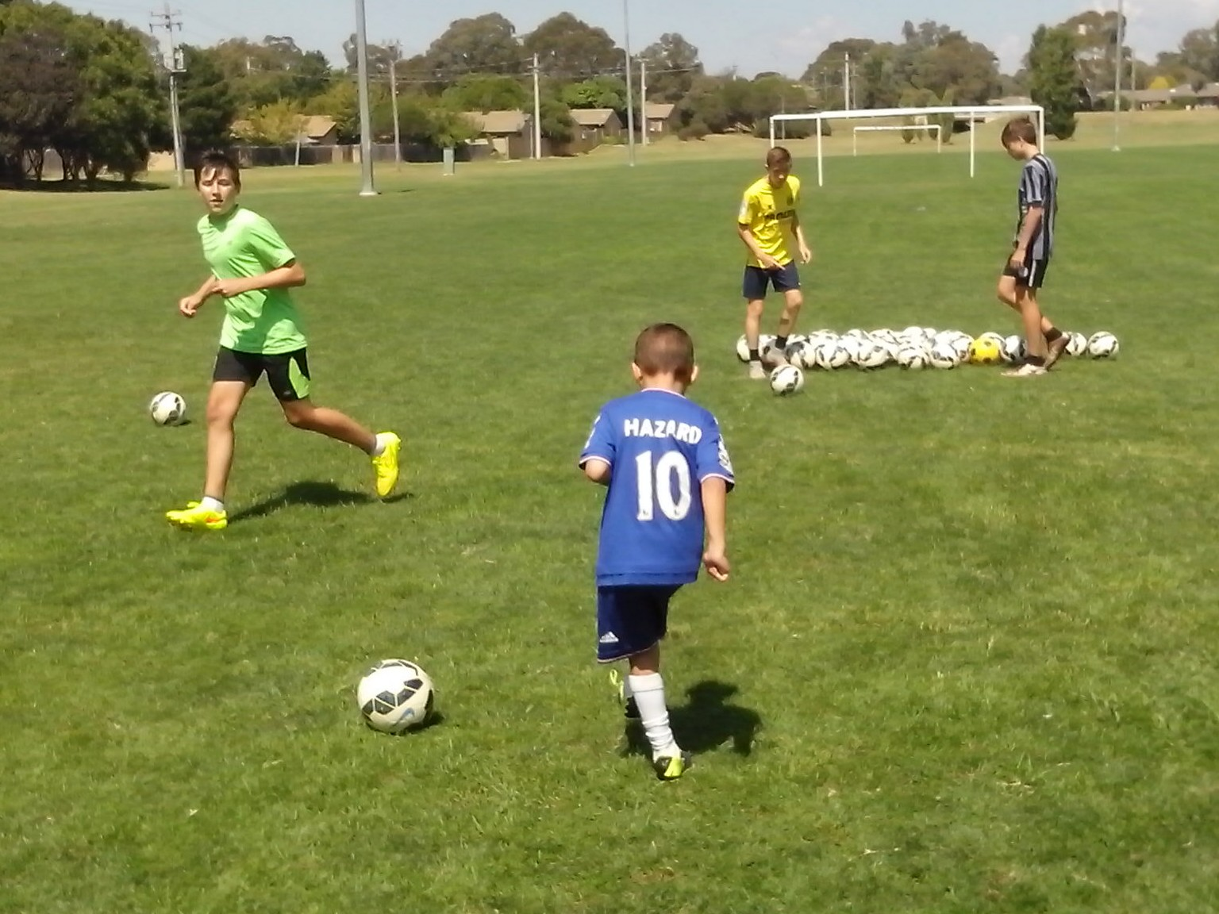
A lot of kids pass the ball and then they stand still and they spectate. The Wall Pass teaches kids to pass and move, give and go, hit and run. It synchronises mind, body and ball and develops intelligence, movement and control so that kids learn to look, think and move.
It’s essential that kids run their own wall passing drills so they can understand how to pass and where to pass. Every kid reaches an age where they stop just passing to the feet and learn to judge the speed, direction and range of a support run. Coaches don’t play in games so they don’t need to run drills before kickoff. It’s nice to have players who do what they’re told and move where they’re told but it’s a lot better to develop players who can think for themselves and initiate their own moves. One Twos teach kids to time the run and the pass.
TRY ANGLES
The mean average shooting session is conducted right in front of the goal. Freestyle kids approach shooting from a different angle.
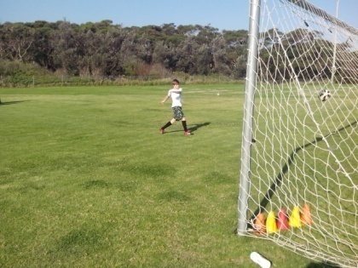
Australian Soccer is very straight forward. Kids run straight forward and kick straight forward. Teams run up and down the field in straight lines. Freestyle strikers learn to attack the goal from any angle and range, facing various directions, so they don’t telegraph the shot. All kids have talent and intelligence and just need to know how to use it.
A 2 hour shooting session with 100 balls enables Freestyle strikers to shoot from any angle using a variety of techniques so that nothing can take them by surprise in the pressure of a game. Too many talented strikers panic in front of an open goal because they only practise shooting for 15 minutes a week. Kids can’t play their own game if they have to stop and second guess what the coach wants them to do.
The key to shooting skill is repetition and the key to scoring talent is intelligence. Once Freestyle kids lock in a firing sequence in their collection of hits, it stays in their memory bank until they need it.
TURNSTYLE
Back to goal shooting drills teach kids to turn and check the target before they shoot.
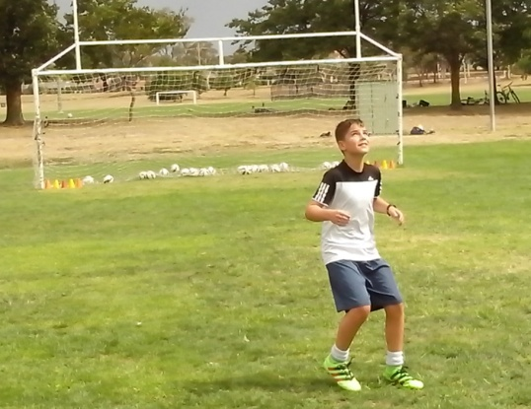
The Safety Net assessment for 10 year olds quickly identifies those kids who look up at the target every time they shoot and indicates whether players aim big and miss big or aim small and miss small. The vast majority of Australian Soccer coaches have no idea what players look at when they shoot because they focus on technique.
Turnstyle drills are the most effective way to teach Soccer kids about vision. When kids stand with their back to goal, they learn to control the ball and turn around and check the target within one second. Then they take a snapshot at goal before the keeper can settle into position.
The average Soccer kid turns around and they look at the whole goal or they see the goalkeeper and kick the ball straight at him. Freestyle kids are conditioned to turn around and lock onto the smallest target. These kids learn to turn and burn. They practise until it’s automatic.
DIFFICULT HIGH BALL
It’s too simple to expect the ball to be played on the ground. In real life, the game is always up in the air.
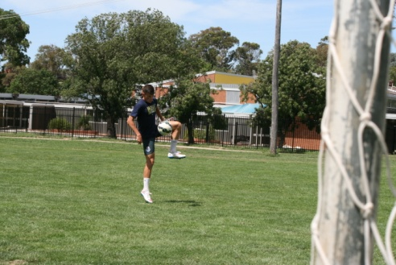
Most kids play safe and simple and look for an easy ball. What makes Freestyle kids stand out is not what we give them but what they keep. They keep the ball rolling, keep possession, keep onside, keep the ball in play, keep the shots on target, keep moving and they keep learning.
The average Australian Soccer kid is trained to keep the ball on the ground so they hesitate when the ball is in the air. Freestyle kids take shooting to a higher level. Once they master the ground ball, they begin to challenge the difficult high ball so that they become familiar and confident with a ball that bounces and spins all over the field.
Freestyle strikers learn to run onto the difficult high cross and judge the intercept. Close repetition drills incorporate chest volley, thigh volley, side volley and head volley. Ordinary kids hold back and wait to see what happens. Freestyle kids move in and make it happen.
LOW HARD BALL
The most important part of the pass is the receiver.
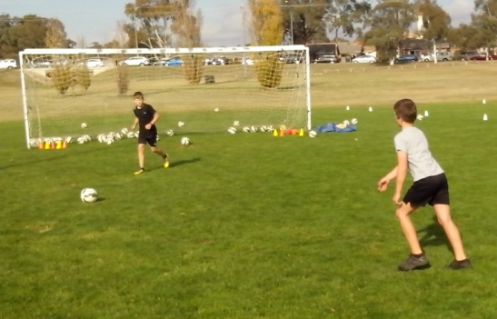
Most kids think that passing is all about accuracy and they hit a pass that’s too hard to control or too soft to reach the support player. A team game teaches kids to think about other people. Once they learn about their team mates, kids know whether to give the ball to the right foot, left foot, the head or into space. Freestyle kids learn to treat their mates the same way they want to be treated. That’s human nature.
Strikers need to read the speed of the feed, so that they know how much momentum to put into their shot. When a low hard cross comes into the goalmouth, a power strike will blast the ball over the bar. Freestyle strikers judge the energy in the pass and can deflect the hard ball into the net with a subtle touch. Kids can only reach this intuitive level of play with hundreds of shots. Ordinary kids never get there.
Soccer kids don’t have the skills to start with the difficult high ball or the low hard ball. They need to build up to this level in simple steps. Repetition is the key to sharp thinking, fast moving and quick reacting under pressure. Goal scorers are specialists just like goal keepers and they need their own academy to develop that same level of expertise.
CHIPPING AWAY AT THE GOAL
Freestyle kids can’t wait to play at a higher level. They can play at a higher level but they just can’t wait for us to get there.
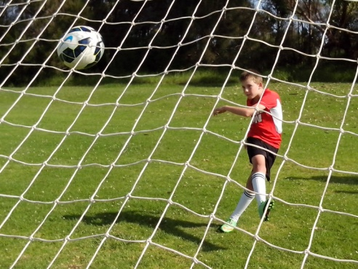
Chipping is a simple way to identify confidence in a Soccer player. Any kid can learn to chip a moving ball but they don’t realise it. If a player is confident, they will kick under the ball and the backspin will float the ball into the air. If a kid lacks confidence, they will get behind the ball and drive it as hard as they can. Force is the default setting when kids don’t have the confidence to use their natural skill. Boys, especially, don’t mind missing their shots as long as they don’t look weak in front of their mates. When the most common sideline call is ‘Big Kick’, boys soon learn what’s expected of them in a game. Freestyle Soccer Makes Certain. When we discover what Soccer kids are uncertain about, there are simple ways to make them more certain.
Chipping is all about confidence and relaxation. Any kid can learn to chip the ball over the keeper and under the crossbar when they stop trying so hard. Freestyle kids learn to improvise basic techniques so they use the microchip in a confined space and they use the rotational chip to disguise their shot. Every goal is just another challenge.
BENDING THE BALL
Most kids learn to follow the basic rules of kicking balls. Freestyle strikers learn how to bend them.
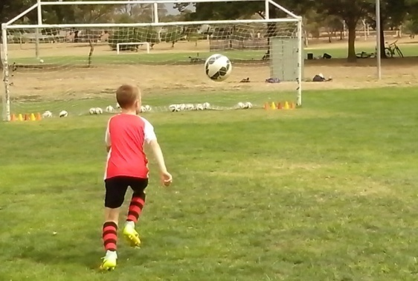
Any kid can learn to be a straight shooter because they spend years kicking through the middle of the ball. Freestyle kids can change the flight plan by cutting or slicing through the side of the ball. Juggling opens up a whole new world of ball control for ball mad Soccer kids. Freestyle kids discover the edge because they spend time improvising.
Uncertain kids will keep the ball on the ground to make it easier to control. Juggling enables Freestyle kids to keep the ball in the air where the control is a lot more challenging. Freestyle kids can develop eye/foot coordination, timing, balance and confidence.
Once kids reach the intuitive level, they begin to understand the aerodynamics of a round ball and can apply topspin, backspin and sidespin to widen their control options. Any player can kick a ball. Freestyle kids develop control. When a kid kicks a dead ball, they apply one basic force. When a moving kid kicks a moving ball, they coordinate various forces. Every ball is just another challenge.
RAPID FIRE DRILLS
Perfect striking technique doesn’t help much when kids stand perfectly still and remain perfectly quiet.
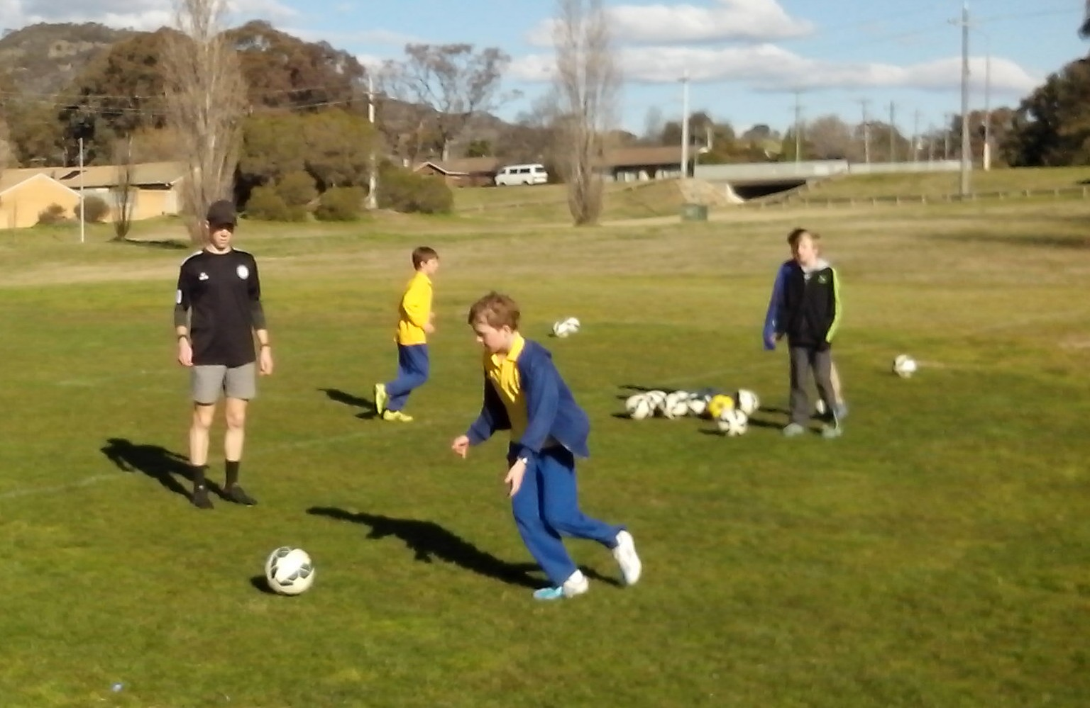
All kids can learn basic skills at the cognitive level, improve control at the associative level and then dominate the game at the autonomous level. Slow becomes smooth. Smooth becomes fast. Some Soccer kids never get enough repetitive ball touches to leave the cognitive level.
The average Australian Soccer kid spends too much time standing in a line with too much time between each kick. Freestyle kids use Rapid Fire Drills to reduce time and space so that they can react much faster at an intuitive level. Under pressure, the left foot can be the right foot.
It’s critical that Soccer kids train the way they play. Once they master conventional techniques, they can increase the speed, range, creativity and degree of difficulty. Freestyle kids always move and improvise because they don’t want to get stuck at the same level for very long.
CROSS TRAINING
A lot of Soccer kids have never practised crossing the ball into the box because a lot of coaches make it easy by doing it for them.
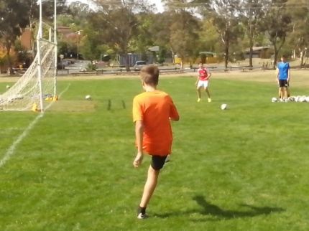
The most common cross in Soccer goes behind the goal line because kids usually play the way they face and don’t know how to rotate on the kick. Freestyle kids learn to master the rotational chip on the run.
The second most common cross in Soccer is floated into the 6 yard box where the goal keeper can easily snatch it out of thin air.
The third most common cross in Soccer is the cross that kids needs to practise. The ball is cut back from the goal line so that the striker can run onto it. The advantage is that the striker is in a position to see the ball and the goal at the same time and also they avoid being offside.
Shooting at goal is a simple skill compared to crossing the ball at speed. The winger has to check the target while sprinting down the wing and then change the direction of the ball before it reaches the line. All kids should practise crossing the ball from left and right.
HORSESHOE
Freestyle kids practise receiving the ball from every angle.
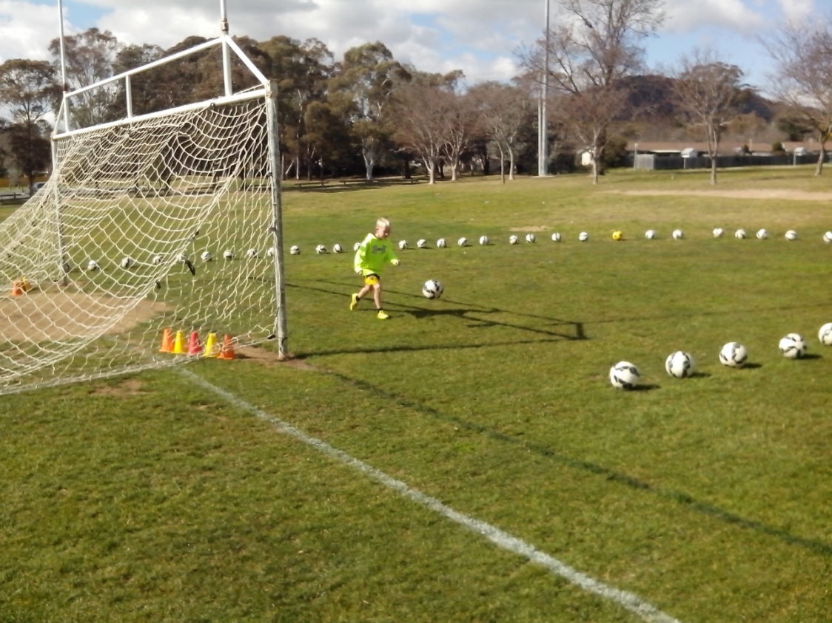
The Horseshoe is a simple drill that enables individual strikers to get 30 shots in 5 minutes so the coach can assess their spatial awareness.
Freestyle kids learn to position themselves in a game so that they can see the ball and the target at the same time. In the Horseshoe, the feeder begins at one end of the semi circle of balls and feeds a difficult high ball one at a time so that the striker has to control the ball first and then aim for the target cones placed inside each post.
The feeder moves along the line of balls so that the distribution angle constantly changes. The feeder might change the ball from a difficult high ball to a low hard ball so that the striker has to keep on their toes and learn to react intuitively. Uncertain players always ballwatch and get themselves stuck in a corner. Freestyle kids look, think and move when they control a ball so they’re always aware of their options both on and off the ball. No pass is ever perfect in Soccer. Certain players will always keep on the move so they can improve their positioning.
RAINBOW
There’s a surefire way to assess strikers and analyse their shots.
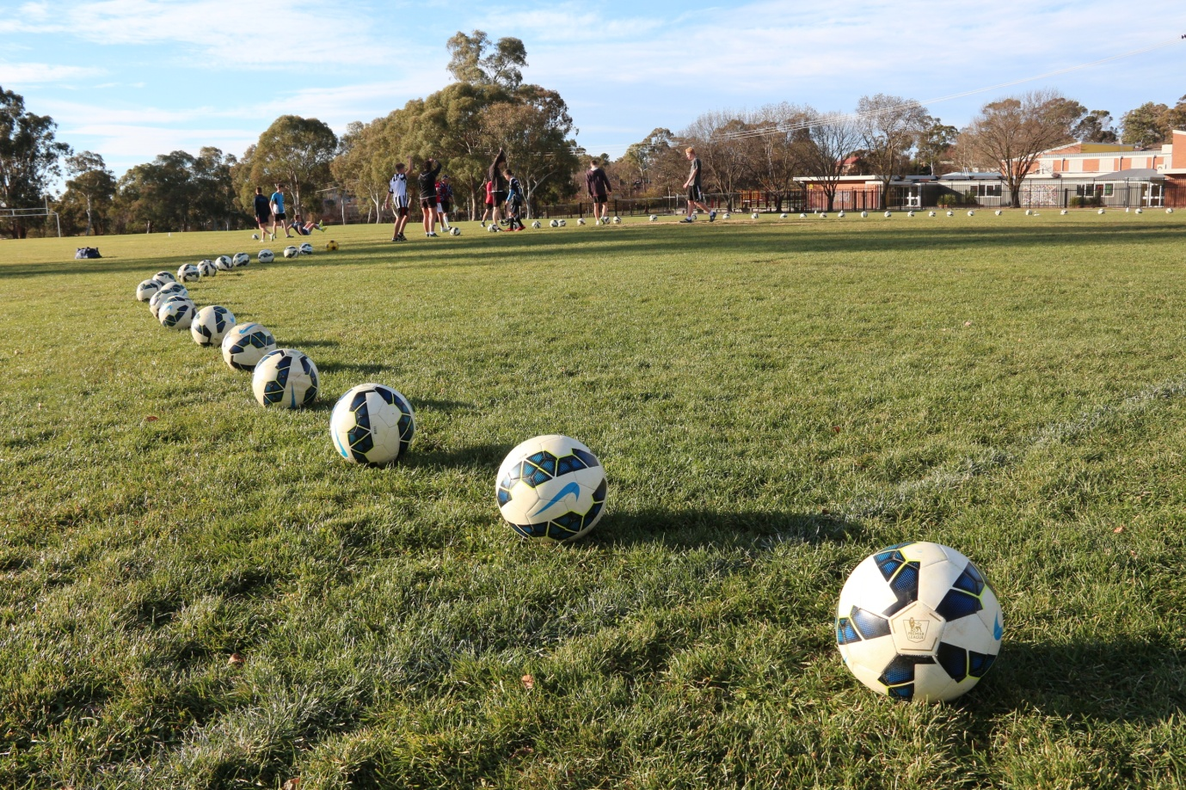
The Rainbow consists of 72 balls around the perimeter of the 18 yard box, about one metre apart. 8 kids line up at one end of the perimeter and take turns to strike each ball at an average of one shot every second. Each kid gets 9 shots at goal and the keeper gets a workout.
The aim of this exercise is to use repetition to develop intuitive skill so that kids learn to lock onto the target and strike the ball without thinking too much about what can go wrong. 72 balls in 72 seconds provide a mass of information for coaches to evaluate and consider.
Video replay identifies what each kid puts into the shot and what they get out of it. It clearly shows which kids take aim before they shoot, which kids take their eyes off the ball when they kick and which kids keep the ball on target. Kids don’t know what they look at when they shoot but video replay can enlighten them and help them to improve.
LEARNING PROGRAM
Coaches are trying to improve Australian Soccer kids without learning what each kid needs to improve. Good luck with that.
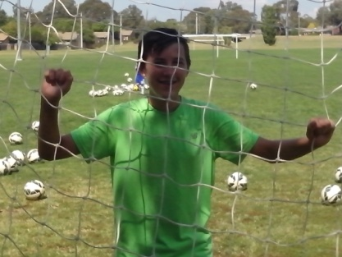
When we teach every kid to be the same, we create a lot of mean average kids. When we learn about kids, we discover that they’re all different and so many have the talent to reach the top if they want to.
Not everyone can coach or teach but everyone can learn. The hidden and untapped resources of Australian Soccer are the talented players and intelligent coaches just waiting to be recognised. If it’s all the same to you then it’s time to look at something different so that we can monopolise the innovation and potential of Australian Soccer.
We can teach every Australian Soccer kid to look, think, stretch, move, kick and play the same way and keep producing the same results or we can learn what makes every kid different and compete with the rest of the Football World. Sport should be a challenge.
LEARNING THE FOUR R’s
Kids develop what we give them. We need to give them respect, responsibility, resourcefulness and resilience.
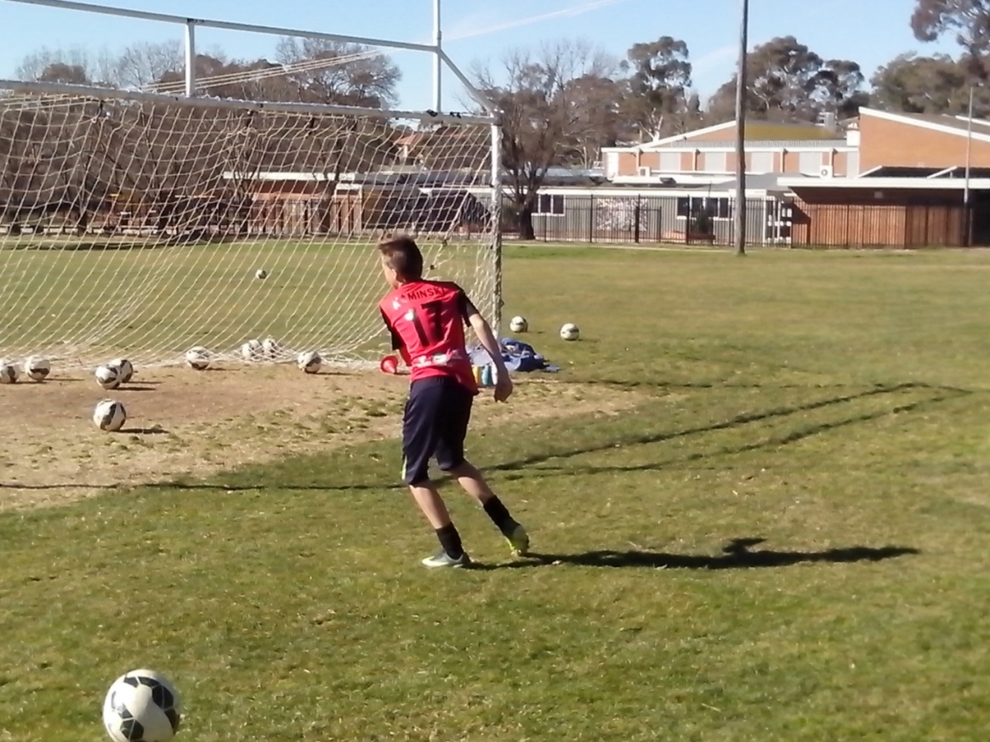
All kids reach the stage where they’re ready to think for themselves and take responsibility for their own decisions. Strikers can’t create their own moves if coaches keep calling the shots from the sideline. Players can’t back their own judgement if they have to continually try to second guess what the coach wants them to do. Kids are very smart and can quickly tell if adults don’t trust them to play their own game.
The last thing strikers want to hear from the sideline is ‘Big Kick, Big Kick’. When the kids can believe in the coach, and the coach can believe in the kids, the kids will begin to believe in themselves.
Freestyle Soccer is not a Coaching System. It’s a Learning Program. We can either teach everything that the old generation can do or we can discover and develop everything that the new generation can do.
JOY OF DISCOVERY
We’re not helping kids by helping them. We need to give kids the confidence to help themselves and freedom to express themselves.
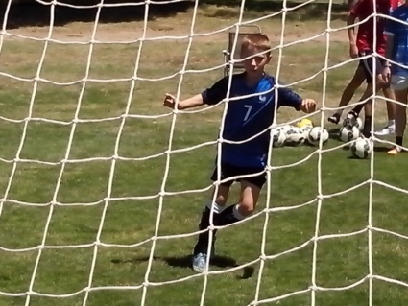
No kid can resist kicking a large ball at a large target. That’s the job description of being a kid. It’s their job to discover how far they can go. Kids achieve because they don’t know what they can’t do. Adults give up too easily because they know what they can’t do. Kids learn more easily than adults because they’re willing to look at new ideas.
If we give kids a ball and a net, they will develop their own skills. If we give them 50 balls and a net, they will develop their own drills. No Australian coach knows this because they’re reluctant to try it. The most important gift we can give kids is the joy of discovery. Let them find out for themselves. Let them run their own shooting drills so they can develop respect, responsibility, resourcefulness and resilience.
SHOOTING GALLERY
Every training oval has an isolated corner that can be set up as a shooting gallery.
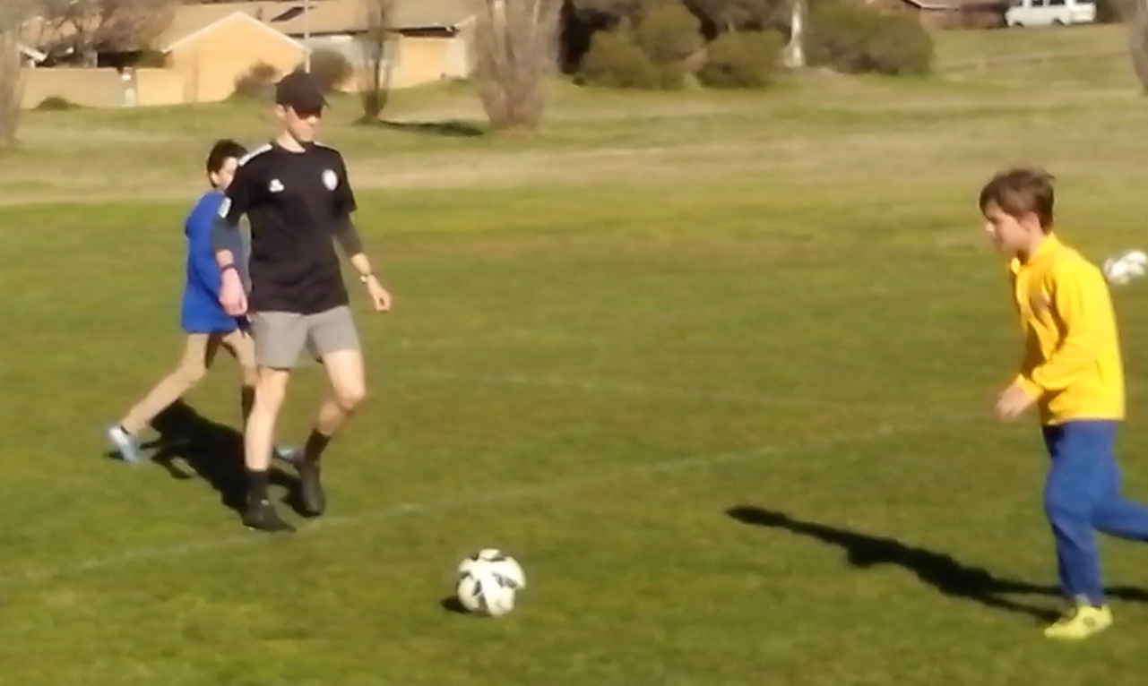
A Shooting Gallery is a single goal set up for the sole purpose of shooting practice. The home team meets up at the Shooting Gallery so they can warm up before each game. On training days, any kid can use the Shooting Gallery for target practice. In a game that depends on the number of goals scored, every club needs a Shooting Gallery.
Too many kids stand around wasting time before a match. Freestyle kids use the Shooting Gallery to get rid of unforced errors. Before kickoff, strikers need to work with the keeper to get a feel for the ball and the pitch. They need to read the surface and the weather. Strikers need to practice corners, crosses and free kicks before kickoff.
At a Shooting Gallery, kids can monitor their shots, identify their mistakes, discover their underlying cause, measure their accuracy, research and develop their own shooting drills, focus on small targets, learn about footwork and vision and increase their power. Freestyle kids use the Shooting Gallery to make goal scoring second nature.
SKILLS PARK
A Skills Park enables Soccer kids to play their own game.
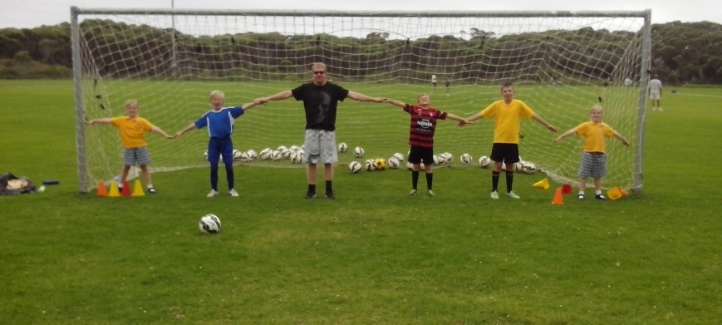
Every innovative Soccer club should have a Skills Park where kids can learn to depend on themselves, think for themselves, believe in themselves, speak up for themselves and express themselves.
Local councils understand the needs of youth. Kids need cricket nets for footwork and vision, basketball courts for power and precision, BMX tracks for movement and decision, skate parks for belief and repetition and surf beaches for challenge and intuition. Soccer kids need their own practice nets for skills, drills, thrills and spills.
A mobile goal is ideal for avoiding damage to the grass. Clubs can give access to equipment so that responsible kids can run their own drills. It’s time for adults to show kids that they can trust them. Kids need to know that we believe in their talent. We need to avoid the constant correction that undermines the self esteem of talented kids.
The Skills Park is an open environment where kids can open their eyes, ears, mouths and minds to new and innovative ideas. Like a Skate Park, the Skills Park enables kids to practise competitive drills without direction, correction, protection or rejection from adults. Any club with a bit of initiative can establish a Skills Park for young kids.
FINISHING SCHOOL
If we knew how to shoot, every major Soccer region in Australia would have its own Goal Scoring Academy.
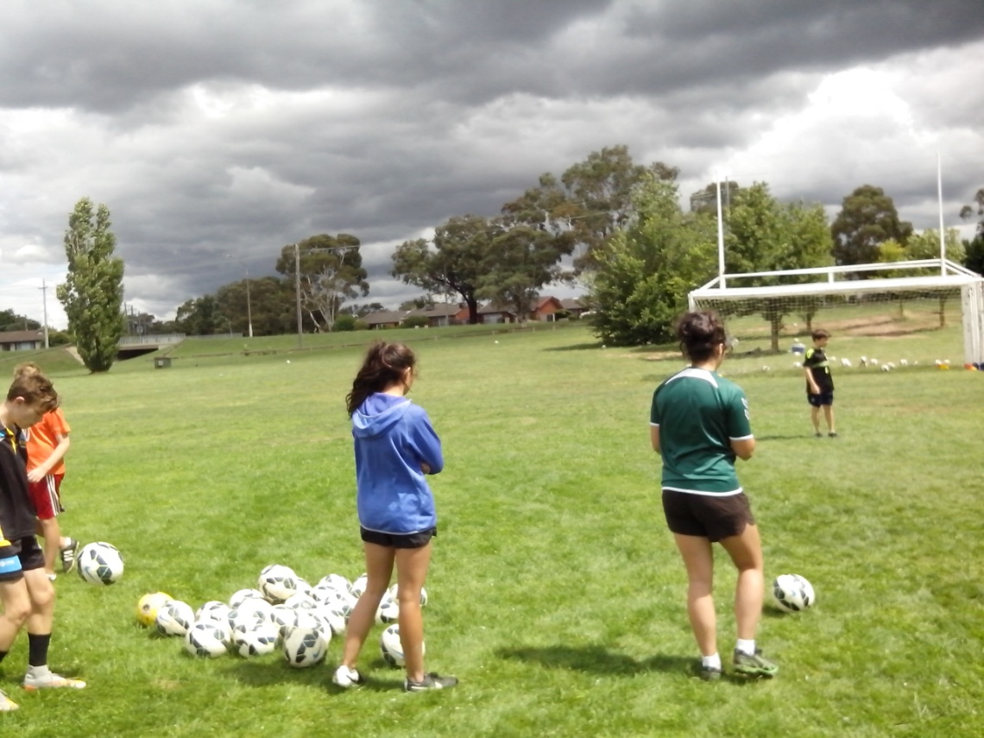
In a game determined by goals, every Football nation should have a Goal Scoring Academy collocated with a Goal Keeping Academy so that talented strikers can train at the highest level and enlightened coaches can identify the hidden and untapped Soccer talent. We just need somebody to step back and look at our game objectively.
In Australian Soccer, we know so little about shooting and even less about scoring goals. We don’t know why so many shots go over the crossbar or straight into the arms of the keeper. We don’t know what kids aim for when they shoot. In addition to teaching establishments, we need research and development establishments where coaches can observe strikers and identify their strengths, weaknesses, skills, talents, fears, needs and limits. There’s a different key to every kid.
SHOOTING PARTY
When Freestyle kids practise shooting, they make fun of it.
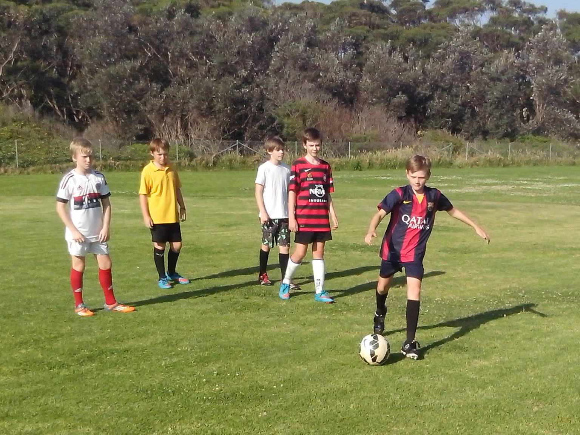
Imagine picking a 3rd division side of 12 year olds and teaching them how to shoot at goal for 2 hours with 100 balls. Suddenly, their whole Soccer World becomes fun, exciting, inspirational and challenging. If we can stop thinking that winning is everything, we can discover that the real potential of the game is the development of kids. If we really want to attract kids to Soccer, a 2 hour Shooting session would do it.
Coaching is a self fulfilling prophecy. Kids become what we expect them to become. If we think that kids are untalented, we will treat them that way and make them untalented. We don’t know how good kids really are because we teach them what we can do and we never have time to discover what they can do. We can improve any Soccer kid in 5 minutes because kids are willing to look, listen, ask questions and learn. Adults may take a bit longer.
.TROUBLESHOOTER
A Troubleshooter helps the kids who have trouble shooting.
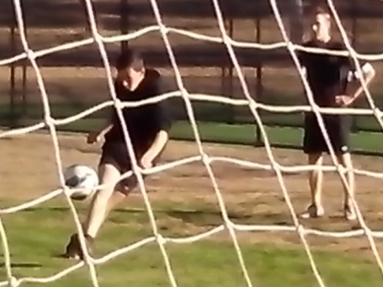
There are never enough Soccer coaches in Australia to identify or develop the vast amount of playing talent. Some codes have an assistant coach, defence coach, midfield coach, attack coach, goal kicking coach, statistician or nutritionist. Australian Soccer is still at the level where one team coach is struggling to do a bit of everything.
Every club should have a Troubleshooter whose sole role is to observe and improve goal scoring ability. The Troubleshooter might just be someone who knows what to look at and what to look for. There are plenty of retired coaches or former strikers who are willing to put something back into the game. The Troubleshooter can focus on the strikers enabling the team coach to concentrate on the tactics.
There is so much untapped coaching talent. The Troubleshooter can look, listen, ask questions and learn. Just by paying attention to individuals, they can inspire confidence, encourage creativity, identify faults, investigate the underlying cause, improvise shooting drills, provide advice, challenge limits and liaise with the team coach.
SHARPSHOOTER
Sharpshooter training shows Soccer kids how much they’re missing.
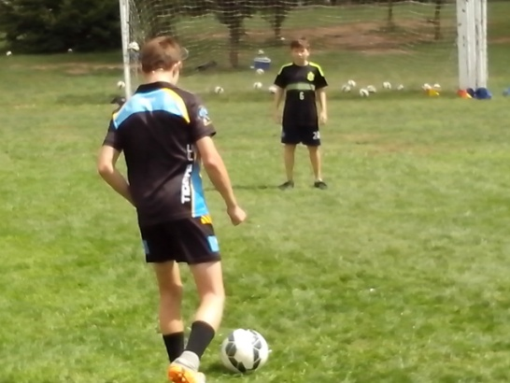
A Sharpshooter is a personal trainer who can run a shooting session for one kid using 32 balls. In one hour, any player can identify their strengths and weaknesses and develop the confidence to score goals.
Shooting skills can easily be improved by integrating mental and physical skills. Sharpshooting teaches kids to think, move and control. Mind, body and ball. A Sharpshooter can assess every kid and evaluate every kick in a few minutes just using close repetition drills.
Shooting ability depends on footwork and vision, power and precision, movement and decision, belief and repetition, challenge and intuition. Scoring talent depends on character, intelligence, mindset, mobility, control, understanding, teamwork, drive, creativity and growth. The Sharpshooter can see what the strikers are missing.
SPECIALIST MARKSMAN
Every Soccer club should have a specialist marksman who is the technical advisor on shooting and goal scoring.
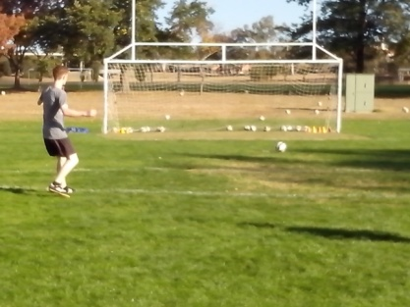
Every Soccer coach has an area of expertise or interest that they can specialise in to help other coaches. In a perfect Soccer world, there’s no need for every Soccer coach to copy every other Soccer coach.
Australian Soccer is overloaded with untapped and hidden coaching resources just waiting to be discovered and activated. In an innovation generation, there are skills and drills that haven’t been invented yet.
If we develop innovative coaches to suit the needs of a system, every coach will stay the same and get the same results. If we develop a system to suit the talents of innovative coaches, every coach will be able to make a difference. Goals are not a matter of luck. There’s a simple reason for every hit and miss. Every Soccer club should have a resident expert who is willing to keep all the players on target.
HIT COLLECTION
The mean average Soccer kid waits till they get right in front of the goal before they shoot.
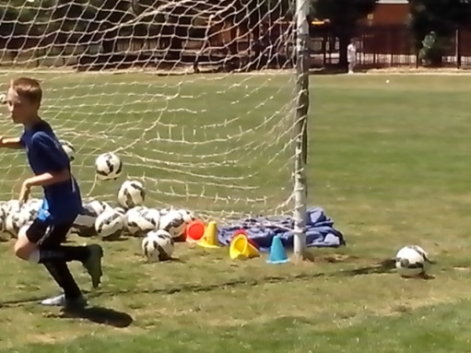
Most Soccer kids have one shot for every situation. Freestyle kids have six shots. They store a collection of hits in the back of their mind for later recall in games. Once players reach an intuitive level of skill through thousands of ball touches, the subconscious mind takes over. Neymar only uses 10% of the brain activity of ordinary players.
Once kids have practised the art of chipping, they can send a firm clearance back over the goalkeeper’s head without having to think about it. Ordinary kids hesitate and question every shot in case they do the wrong thing. Freestyle kids shoot first and ask questions later.
Any ordinary kid who stands in the firing line and waits 2 minutes between each pot shot will forget what their last attempt looked like. Freestyle kids who spend 2 hours shooting with 100 balls learn from every shot and they develop muscle memory and permanent good habits so they can transform their shooting skill into scoring talent.
MIND READING
We can tell kids what to think or we can tell what they’re thinking.
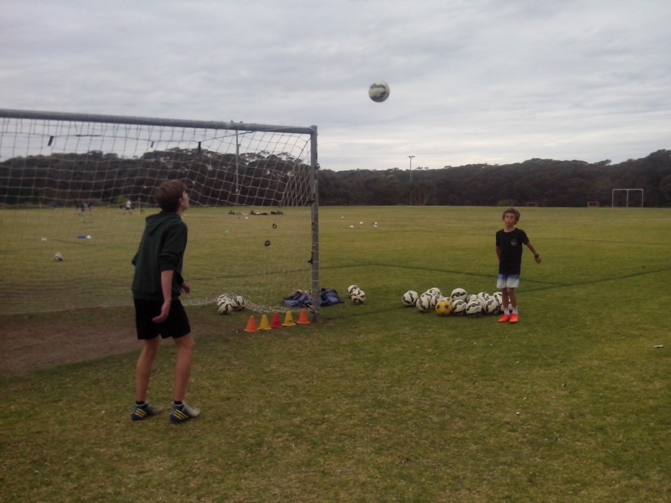
Every coach has the power to mind read their players and they don’t realise it. All kids are different and have different skill sets. The more we learn about players, the more we can understand their strengths, weaknesses, skills, talent, fears, needs, limits and preferences. Then we can develop a better grasp of how to improve every individual player. When any player is different, that makes them unorthodox and unpredictable so that they become more effective against opposition.
When we place target cones inside the posts, at shooting practice, we quickly discover which kids aim small and miss small and which kids aim big and miss big. Kids who pick out a small target will keep the ball on the ground. Kids, who aim for the whole goal, will lift their heads to look up at the net and will blast the ball over the crossbar. Some kids try too hard, some are too casual, some rush, some take too long. By understanding how kids think, we can improve how they act.
BALANCE
The difference between shooting and scoring is the player.
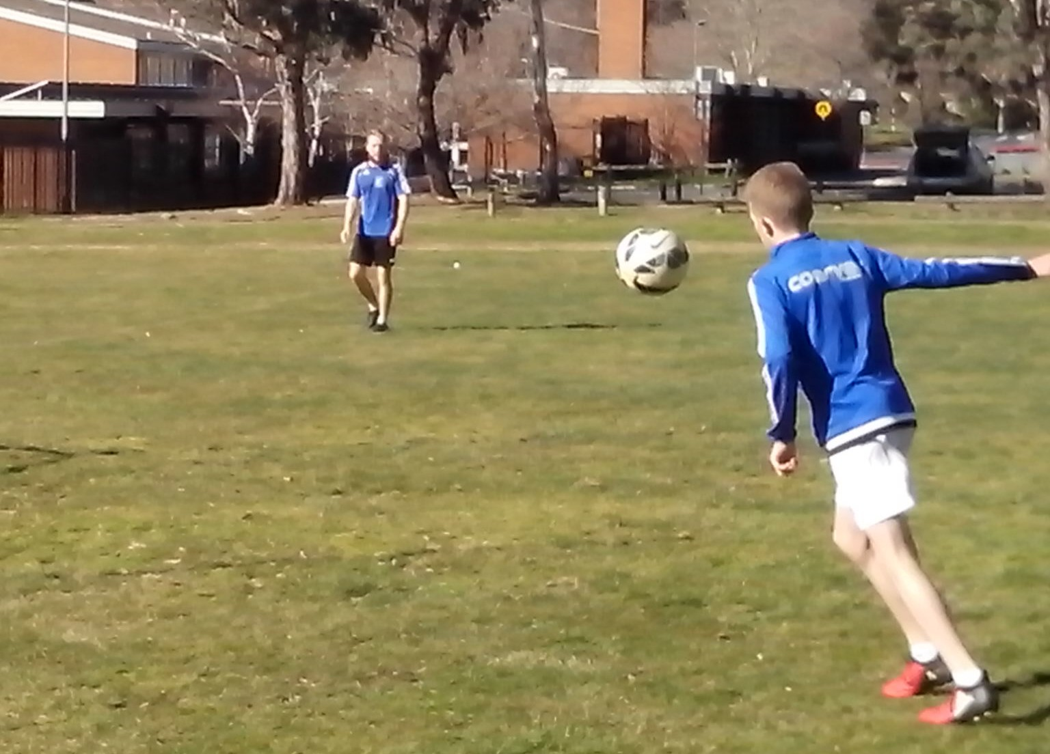
We’re trying to teach perfect striking technique to kids who lack basic motor skills. Any kids who spend too much time sitting in front of a screen begin to lose their natural mobility and eye/foot coordination.
Ordinary Soccer kids struggle to control a ball smoothly without balance, coordination, timing, rhythm and the use of both feet. One footed Soccer players become awkward and clumsy trying to read and control a high ball. They can’t be a complete player with one foot.
When we teach kids to strike the ball, we look at their striking foot and we overlook their standing foot, their arms, upper body and even their eyes. We focus on the kick and ignore the kid. Experts see what they’re trained to see. Coaches look at technique and they look for mistakes to correct. They have no idea what effect it has on the kick when kids stand flat footed or take their eyes off the ball. Kids need to use their whole body to control a ball, not just the contact area.
COUNTERBALANCE
When kids head the ball, watch their feet. When they kick, watch their eyes. When they volley, watch their arms and shoulders.
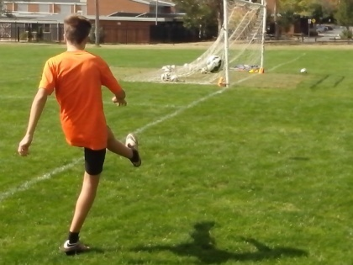
Kids play the way they train. We separate their Soccer skills from their natural skills, and we isolate the contact area, so that kids swing their foot to volley the ball while the rest of their body stays static and stiff. Static skills stifle kids. They stand still, stop the ball, step back, stick a foot out and stab at the ball. Freestyle shooting is a fusion of mind, body and ball. Strikers need to look, think and move their body if they want to maximise their ball control. Everything should flow.
When a top player volleys at goal, they use their upper body to counterbalance the kick and they can vary the trajectory of the ball by leaning forwards or back. A Freestyle kid automatically computes the need to drive a ball low and hard or lob it over an advancing keeper.
Juggling is the most effective and intuitive way for kids to improve their flexibility and agility because the ball is unpredictable and keeps them on their toes. In one minute, a competent juggler can take 100 steps, make 100 decisions and get 100 touches of the ball.
HITS AND MYTHS
If we lower the bar any further, nobody will be able to score goals.
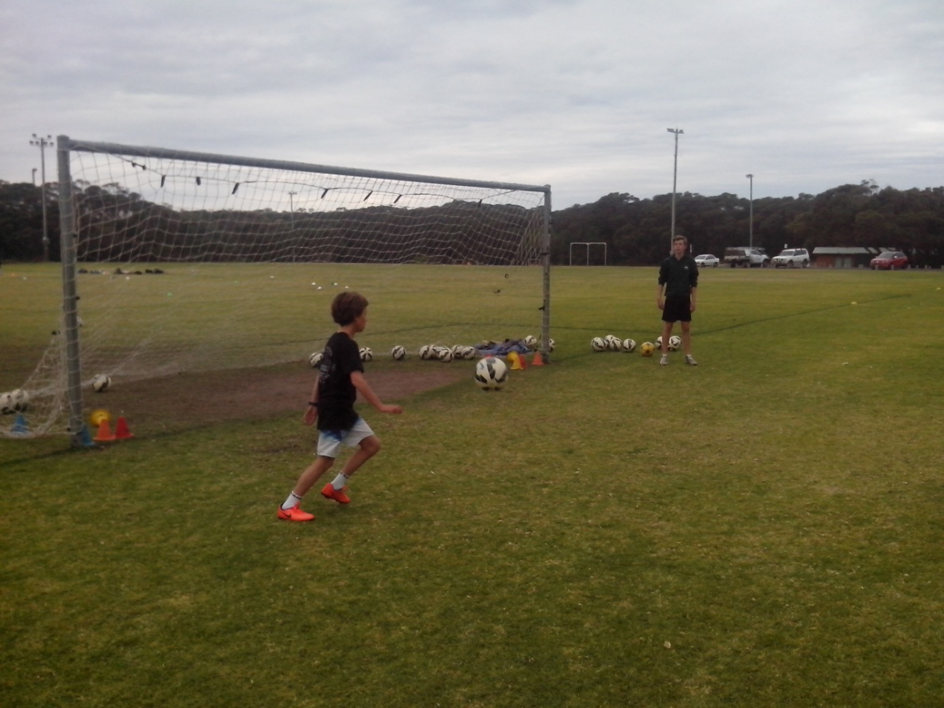
There’s a myth that the vast majority of kids lack the talent to reach the top. Belief in this myth stops us from looking for the natural talent that all kids have. We look for the players who are easiest to coach.
Freestyle Soccer is based on the myth that the vast majority of kids have the talent to reach the top so we look for that talent and, in the process, we discover how good Soccer players really are. Our actions are driven by our beliefs. We can improve any Australian Soccer kid in 5 minutes because we believe that we can and kids believe it too. The Freestyle HQ is the search for Human Qualities that all kids have.
Skilful kids learn what to do. Talented kids discover how to do it and Freestyle kids understand why. There is so much natural Soccer talent in Australia but we don’t have the coaches or beliefs to make the best of it. Most Soccer kids miss why they’re learning. Freestyle kids learn why they’re missing. Kids learn so they can think for themselves.
OPTIMISM
Some kids just stick a foot out. Freestyle kids fire on all cylinders.
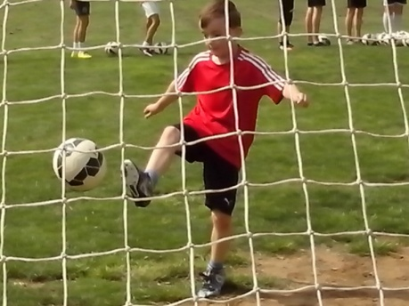
Sport should be a challenge. If a perfect system is too easy to copy, we will become too satisfied and too ordinary. Freestyle kids don’t do ordinary. Freestyle strikers are optimists. They wouldn’t do extra training if they didn’t think they could improve. They look for reasons to try harder and they develop new shooting techniques because they know that Australia has the talent to be a Top 20 Football Nation.
Pessimists don’t miss much because they don’t shoot much. They play safe and pass the ball when there’s too much pressure to shoot. Being non competitive doesn’t teach kids to become competitive. Some coaches and kids see a challenge as a problem and they avoid it. Other coaches and kids see a problem as a challenge and they face it.
Optimists make mistakes all the time because they can challenge their limits and they aren’t scared to miss. Failure isn’t a problem in sport. Fear of failure is the key issue. We can develop Australian characters to suit a coaching system or develop a coaching system to suit the Australian character. We need to boost our national sporting identity.
INNOVATION
If it’s all the same to you, we need to look for something new.

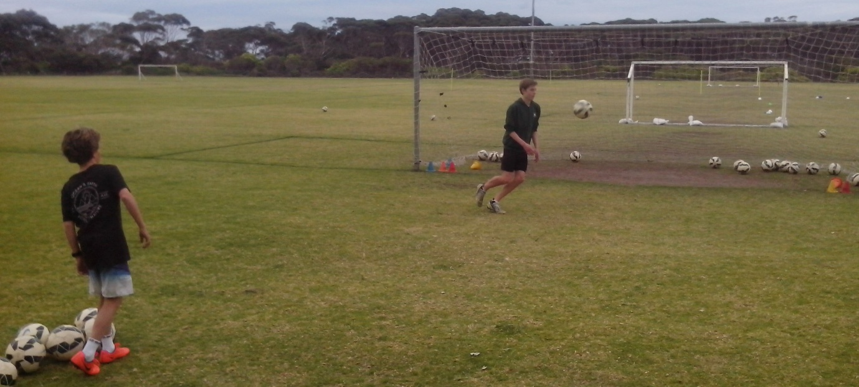
Each generation is smarter and more talented than the previous generation. That’s evolution and that’s how we grow. Innovation is going to come from the next generation. Your kids are going to be more talented than your parents. We can keep teaching what the old generation can do or we can explore what the new generation can do.
Any club can be innovative and establish a shooting gallery for kids, appoint a specialist marksman or organise a shooting program for kids who want to do more. They don’t have to copy what every other club is doing. They don’t need to wait for the next perfect system. They can simply look at their players, learn about them and discover what each kid needs to improve. It’s amazing what kids can achieve when they haven’t been told how untalented they are or what they can’t do.
Any coach can turn the net around and use the area behind the goal where the grass is greener. Any kid can learn to run shooting drills. Anyone can look at what we do and wonder why and then look at what we don’t do and wonder why not. Anyone can improve Australian Soccer if they’re not scared to say what they believe.
THINKING OUTSIDE THE GOAL SQUARE
The first thing we discover about scoring goals is that we’ve got a lot to learn.
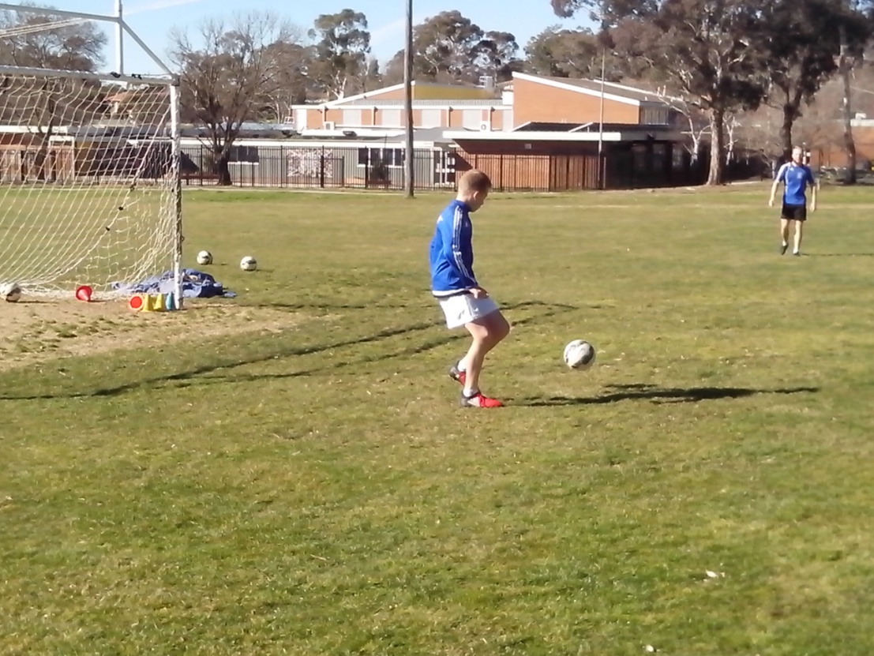
The vast majority of Australian Soccer kids have never discovered the joy of shooting for 2 hours with 100 balls because it’s not in the book.
If we really want to improve Australian Soccer kids, we can easily discover what each kid needs to improve instead of giving them all the same generic, one size fits all training drills.
We know what we’re teaching kids but we don’t know what they’re learning because they’re not always the same thing. We don’t visit the training ovals to monitor the progress of training or to learn what coaches and players are actually doing. We rely on a perfect coaching system to become a Top 50 Football Nation. If we could develop a comprehensive learning program, we could compete with the rest of the world as a Top 20 Football Nation. We just need to believe in an Australian system that reflects the talent of Australian players.
BEHIND THE NET
The more kids do, the more they can learn. Soccer kids need shooting and plenty of it.
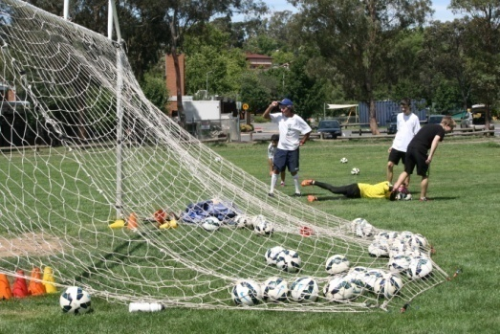
Some clubs discourage shooting practice and chase kids away from the goalmouth to preserve the grass. They need to decide whether it’s more important to grow grass or grow kids. Freestyle kids simply turn the net around where the grass is greener and they use the area behind the goal so they can continue to put the ball into the back of the net.
Innovative clubs understand the needs of kids and provide portable goals that can be wheeled around training fields. Every oval has an isolated corner where a single goal can be set up as a shooting gallery. Clubs just need to open their minds and think outside the goal square.
We can improve any Australian striker just by discovering what they lack. Soccer kids are never going to learn how to score by standing in a firing line and waiting 2 minutes just to have a shot at goal. That’s not shooting practice. That’s just standing in line practice and filling in time practice. Repetition is the single key to competitive shooting.
STRIKE FORCE
Any kid can improve in 5 minutes and any adult can take years to realise it.
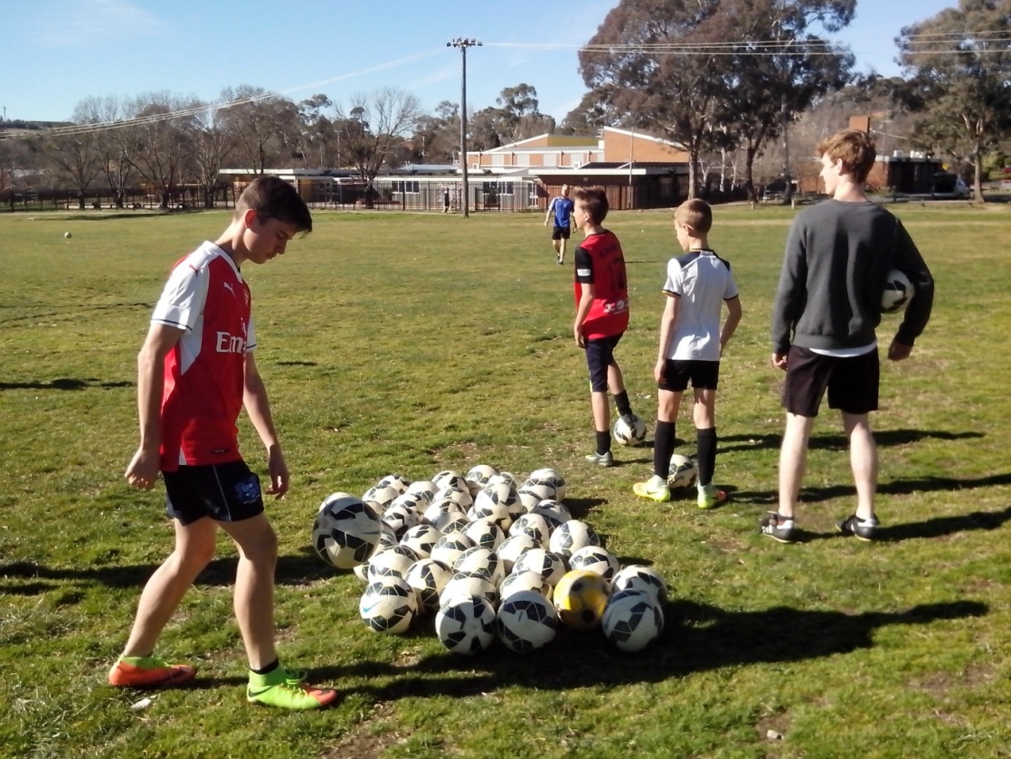
We pick the most talented kids because they stand out as being different and then we train them to copy each other until they all become the same. There’s so much talent that we can’t even see it. A Strike Force is a small team of elite strikers who specialise in power drills and push each other to reach the top. Every kid has the ability and drive to take over and run the drills. Every Soccer kid has a peak skill that defines them and a weak skill that they need to work on.
All kids have talent. It’s impossible for a Soccer player to be untalented because Soccer is a multi talent sport and every kid can develop their own area of expertise. If we can’t see talent in a kid, we need to find better ways to learn about kids. A coaching system is designed to teach skill not talent. Freestyle Soccer looks at footwork, vision, power, precision, movement, decision, belief, repetition, challenge and intuition to discover what makes each kid different.
HARD ROAD
The most important subject in Soccer is the player. If we treat them that way, we will produce better results.
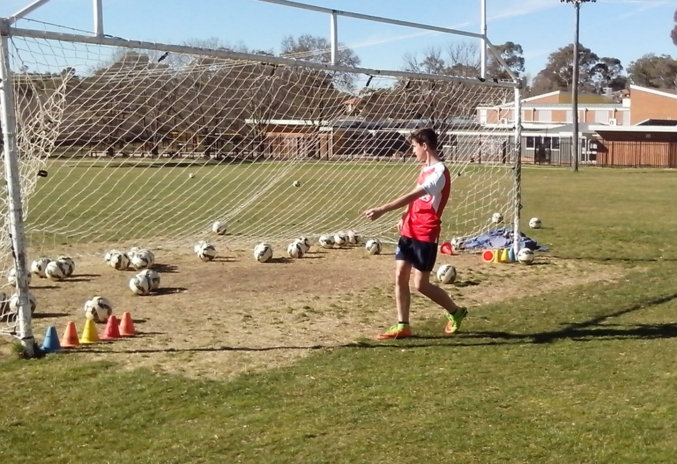
Sport is about making decisions at all levels. We can always take the easy way out or the hard way out. If we always look for the easy road, kids will always stay the same. If we look for the hard road, kids can go as far as they can and from there they can see a lot further.
There are so many talented strikers in Australia but the easy way is to pick the elite kids who don’t need much coaching and give them the elite coaches who can’t teach them much that they don’t already know. The challenge is to pick the struggling strikers who need all the help they can get. Any elite coach should have the power to do that.
Strikers who lack confidence learn to avoid risk by passing the ball so that they don’t have to shoot and miss. Freestyle kids manage the risk by taking the shot and learning from every hit and miss. Ordinary kids practise what they can do. Freestyle kids practise what they can’t do.
EXPERIENCE
Freestyle Soccer is not about winning. It’s about scoring more goals than the other team.
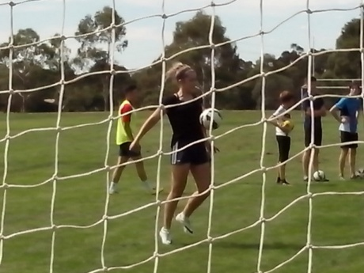
The worst we can be is satisfied. The best we can be is challenged. Australian Soccer kids have no chance of learning how to score goals. 15 minutes each week of blasting the ball over the bar, or straight to the keeper, will never give them the intuitive ability that they need.
Any kid can kick a ball but no Soccer kid can master the speed, angle, direction, range, elevation, spin or bounce of a ball in 15 minutes a week. No player can learn to slice, volley, lob, drive, chip, lift or backheel a ball under pressure unless they get thousands of shots at it.
When kids get serious about playing games, they will learn how to shoot and then discover how to score goals. Freestyle strikers gain goal scoring experience by shooting thousands of times from every range, height and direction. In the leading Football Nations of the world, the Freestyle kids get a thousand ball touches every day. These kids are already one million steps ahead of Australian Soccer kids.
CONFIDENCE
The key to any drill is repetition. The key to any coach is belief. The key to any kid is confidence. Everything else will fall into place.

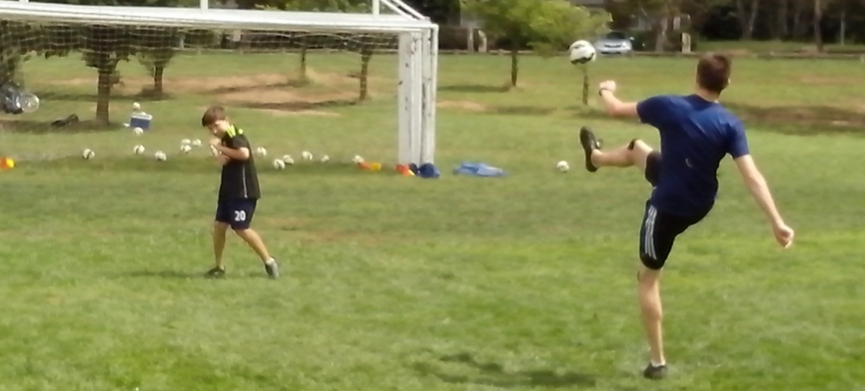
In the world of Freestyle Soccer, any kid can learn how to shoot and discover how to score goals. Kids don’t lack talent. They lack confidence. Confidence is the most important goal for any kid or teenager. Kids can’t build confidence if they don’t get enough shots.
In a coaching system, kids can improve their skills and that helps them to increase their confidence. In a learning program, kids can improve their confidence and that helps them to increase their skills. There’s a different key to every kid and different drill for every skill.
Most Australian Soccer kids can’t shoot because they lack the confidence. Fear of failure is the greatest obstacle in sport. Kids make mistakes because they worry about making mistakes. If we tell strikers to make as many mistakes as they like, they will stop worrying and will start shooting. Failure to score is not the problem. Failure to shoot is what we need to overcome in a correctional system. In Freestyle Soccer, confidence is based on facts not sports psychology. Freestyle kids keep a written record of their results.
RESEARCH AND DEVELOPMENT
The key to shooting is footwork. The key to scoring goals is vision.
Freestyle kids are the real pioneers of Australian sport. Kids are designed to explore and discover. Ordinary kids learn to do what we tell them. Freestyle kids learn to think for themselves and improvise.
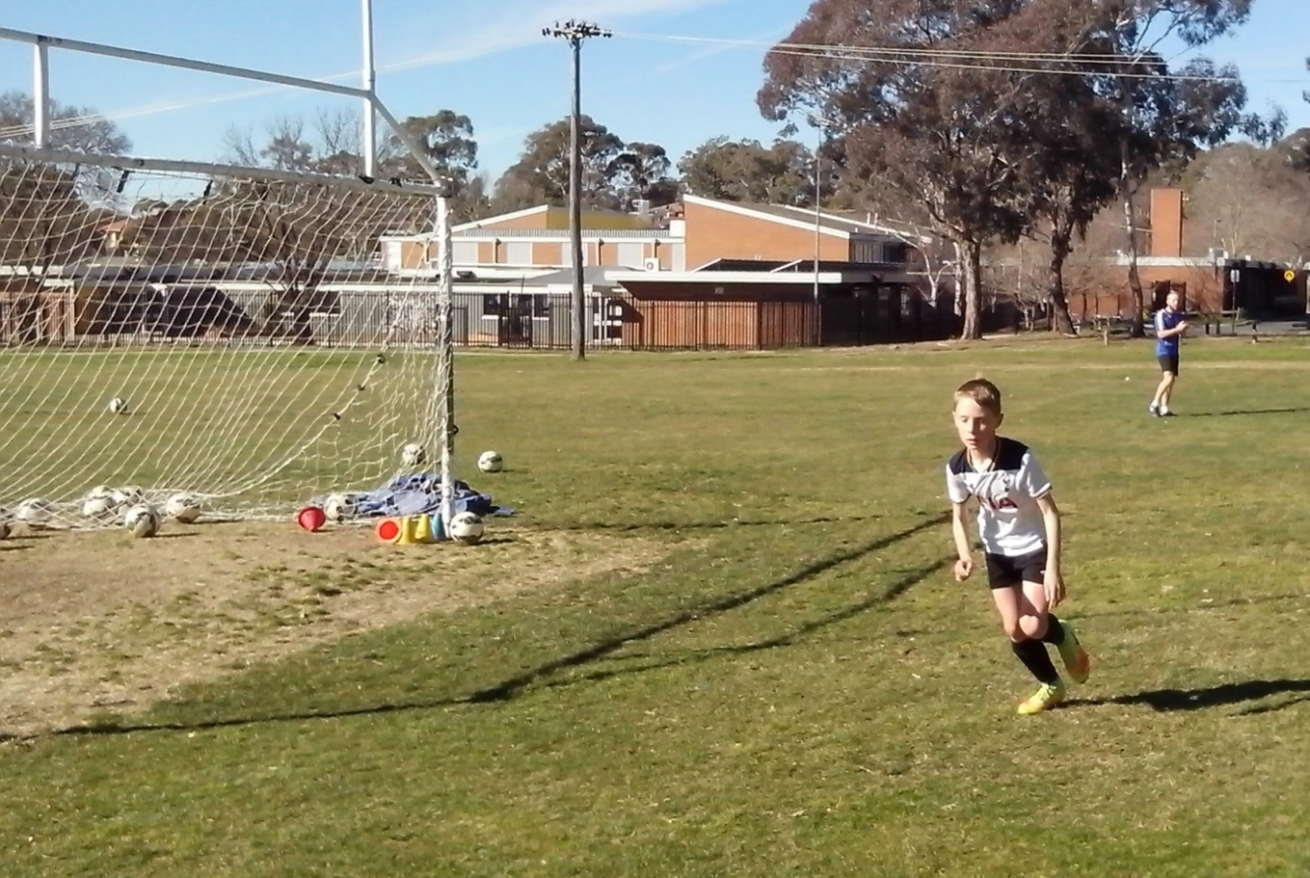
Every Skate Park is a research and development facility for kids where they have the freedom to create new moves and swap old tricks without adults telling them what to do or worrying about them getting hurt. Kids never stay the same. As soon as they know, they can grow.
The only problem with a perfect system is when we believe that it’s perfect and we stop looking for ways to improve. By the time we realise that there’s no more room for innovation, it’s too late to catch up with the rest of the Football world. We can teach the same every day or learn something different every day. In the world of Freestyle Soccer, confident kids will always look for better ways, smarter ways, faster ways, smoother ways and different ways to lift their game.
SERIOUS SHOOTING
1 Net, 2 Hours, 6 Strikers, 10 Target Cones and 100 Balls.
Close up Shots to develop timing, rhythm, balance and coordination.
Two Touch to coordinate footwork and vision. Mind, body and ball.
Wall Passes from both sides of field to develop footwork and vision.
Heading Drills. Direct heading and running onto bouncing ball.
Rapid Fire Drills. Develop sharp movement and quick decisions.
Back to Goal Drills. First touch ball goalside. Turn for vision.
Gravity Drills. Run onto bouncing ball using head chest of thigh.
Chipping Drills. Balance power and precision. Rotational chipping.
Cross Training Drills. Low hard ball and difficult high ball.
Power Drills. Live Shooting from outside the box.
Dead Ball Drills. Free kicks corners throws and penalties.
Give and Go Drills. Running and Calling off the ball.
