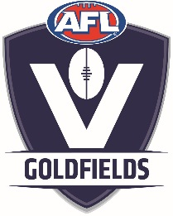

AFL Goldfields Junior Football Academy
- proudly supported by the Western Bulldogs and McDonalds Ballarat
2018 - 2019 PARENT PERMISSION & ACKNOWLEDGEMENT
I ………………………………………………………………………………..… hereby give my permission for my
son / daughter ……………………………………………………………………………….. to attend and participate in the AFL Goldfields Junior Football Academy during the 2018 / 2019 season.
- I acknowledge that my son is covered under the League / Club Insurance Policy with JLT Sport.
- I acknowledge that the payment of $90 is not refundable once my son has participated in at least one session of the Academy.
- I acknowledge that an invitation to attend the AFL Goldfields Academy does not automatically constitute an invitation to attend my Leagues Representative Football Program.
- I will adhere to the AFL Victoria Parental Code of Conduct and encourage my son / daughter to adhere to the AFL Victoria Players Code of Conduct
- I acknowledge that Filming of my son / daughter may take place during the program to assist with developing his / her football skills. Yes No

Contact Details:
Home Phone ………………………………………..
Mobile Phone (Parent) …………………………………..
Mobile Phone (Academy Participant) ……………………………………..
Email Address (Parent) …………………………………………………………………………………………………………..
Email Address (Academy Participant) …………………………………………………………………………………….
Signature of Parent / Legal Guardian ……………………………………………………………………………………..
Signature of Parent / Legal Guardian ……………………………………………………………………………………..
Date: ……. / ……. / ……….

