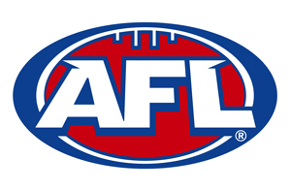

JUNIOR COACH

ROLE DESCRIPTION
Objectives
- To provide the highest standard of coaching and development to
Carindale Cougar players

Responsibilities
- Coach in accordance with the AFL Next Generation Australian
Football Match Policy for the conduct of the game for players
4-11 years of age
JUNIOR COACH
ROLE DESCRIPTION
- Promote the importance of club members adhering to the AFL
Kids First Policy
- Apply the code of conduct for coaching staff and players that
supports the objectives of the Club on and off the field
- Develop and establish an appropriate pre-season training program
- Instruct the players placed under their care generally and to see
that all players carry out sufficient training
- Liaise with other junior grade coaches to establish a consistent
coaching policy throughout the Club
- Provide game day coaching expertise
- For Roy’s, Under 8, Under 9 and Under 10 - ensure every player,
plays in every third of the field (Forward, Middle, Back) in every
match
- For Under 11’s, ensure every player has the opportunity to play in
a variety of field positions across the season
- Attend Club functions as agreed to
- Provide reports to the Coaching Co-ordinator and President as
required
- Register through Sports TG and do mandatory on-line training to
enable accreditation
- Attend in person training sessions as able
- Participate in Cougars Coaching meetings as required

Accountability
- Reports to the Coaching Co-ordinator

