# Pre-season: The lay-off pass

## By Tony Carr

When performed with the right weight and timing, a lay-off pass speeds up attacking play and creates opportunities your team can look to exploit.

## What you are looking for players to do

* Cushion the ball – make it inviting for a team mate to run on to without breaking stride and so he can pass/shoot first time.
* Use good accuracy, timing and weight of pass.
* Use the inside (and outside) of foot.
* Use good communication – verbal, eye contact, hand signals.

You need to use an area 30 yards square.

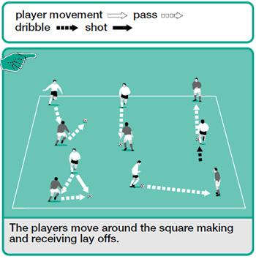

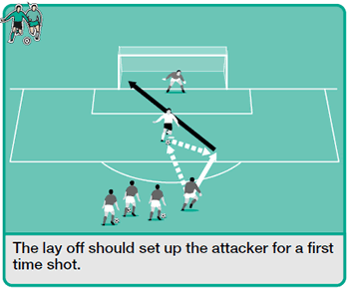

## How to play it

* Split players into two equal groups – those with a ball (group A) and those without (group B).
* A players can pass to any B player, who returns the ball using a lay-off.
* A players must now dribble to a new B player and repeat.
* A and B players switch roles every couple of minutes.

## How to develop it

Players line up centrally and just outside the D of the penalty area, with one player located centrally two yards inside the penalty area.

The first player in the line passes to the "lay-off" player, then shoots first-time at goal. After shooting, he turns and becomes the next player to lay-off the ball before joining the back of the line.

Players laying off the ball must practise passing both to the left and right and using both feet. This will also give shooting practice with both feet.