RED DUST HEELERS IN

ROCKHAMPTON

**April 27- May 1**

 [https://encrypted-tbn2.gstatic.com/images?q=tbn:ANd9GcRAOmgyOrkmrljCUupasSDOAnYJue2mveXFdQmdJD3egL5rseVn1C_yvpXs](http://www.veolia.com/en)

 

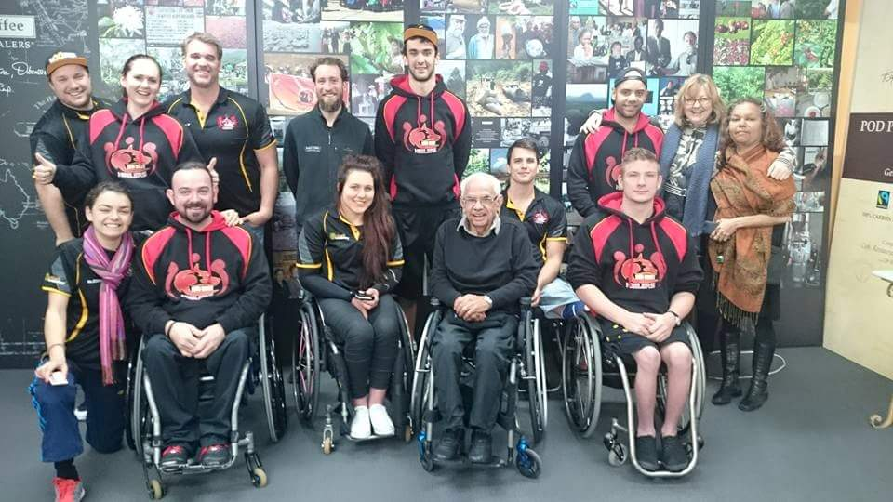

The Heelers with Patron Kevin Coombs OAM in Melbourne 2015 at Jasper Coffee

The Red Dust Heelers (the Heelers) are Aboriginal and other athletes with disability. Some Heelers are also Paralympians including Brad Ness OAM, the Captain of the Australian Men’s Wheelchair Basketball Team, the Rollers

The Heelers Patron is Kevin Coombs OAM Australia’s first Aboriginal Paralympian. Kevin encourages the Heelers to get out into communities to meet with young people, with and without disability. His motto is to ‘have a go at life’ no matter what the disability or individual circumstances. For the Heelers this means increasing participation in disability sports and recreation, education, employment – all aspects of community life.

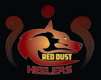

**National Wheelchair Basketball League**

The Heelers also participate in the NWBL. This is Australia’s elite pathway to Paralympic participation in wheelchair basketball. The Heelers actively encourage Aboriginal and other young people with disability to have a go at disability sports. 50% of Aboriginal community members experience disability, 1 in 2, and 1 in 5 in the broader population.

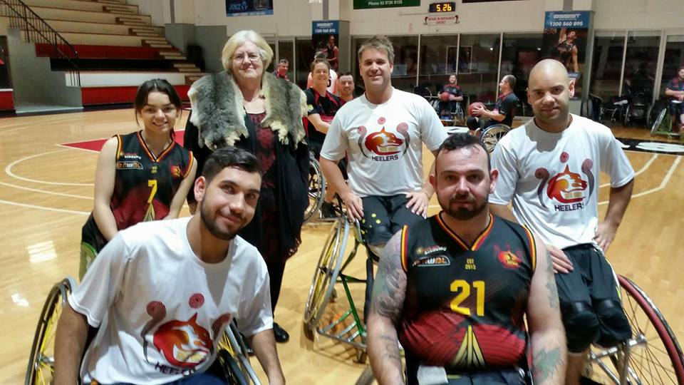

The Heelers with Wurundjeri Elder Aunty Di Kerr at the 2015 NWBL Finals Melbourne

**Wheeling and Healing, Community Engagement**

Prior to NWBL the Heelers arrive early to support community engagement. This includes visits to schools and community groups, running wheelchair basketball clinics and Come and Try – Mini-Paralympic events, including an Ultimate Wheelchair Basketball Challenge that is open to the whole community.

This Year these events will happen under the banner of **Rio Goes to Rockhampton** and other regional centres to celebrate the Rio Paralympics.

**Rockhampton Program Home of the Frenchville Rockwheelers**

**Wednesday April 27**

Training session – Red Dust Heelers with the Rockwheelers at:

Where: Hegvold Stadium

Sir Raymond Huish Drive, WANDAL

Time: 5:30pm-8:30pm

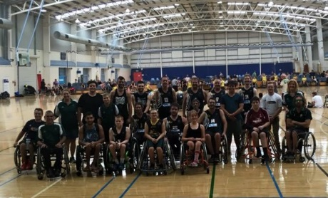

**Thursday April 28**

Book your school or community group in for a visit from the Red Dust Heelers. 2 hours per visit.

Contact:

**Shellie McGregor 0415 418 148**

**RSVP By Friday April 15**

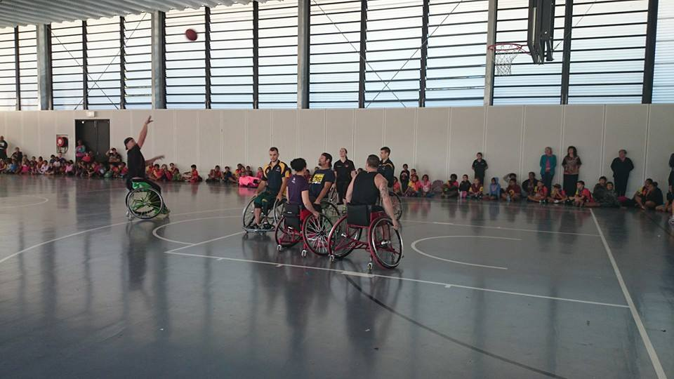

**Friday, April 29 10-11.30**

**Youth Well Being and Leadership Session** **with the Heelers**

Where: Frenchville Sports Club

**RIO GOES TO ROCKHAMPTON**

2pm-4pm

Insert court location

RSVP by April 15 to Shellie McGregor 0415 418 148

This event is open to schools, community groups – the whole community.

All are welcome to join us to:

* Try some Paralympic Sports
* See a demonstration wheelchair basketball game – Rockwheelers versus Red Dust Heelers
* Have a go at wheelchair basketball competitions, shooting, racing
* Join the Ultimate Wheelchair Basketball Challenge game - spectators can also have a go!

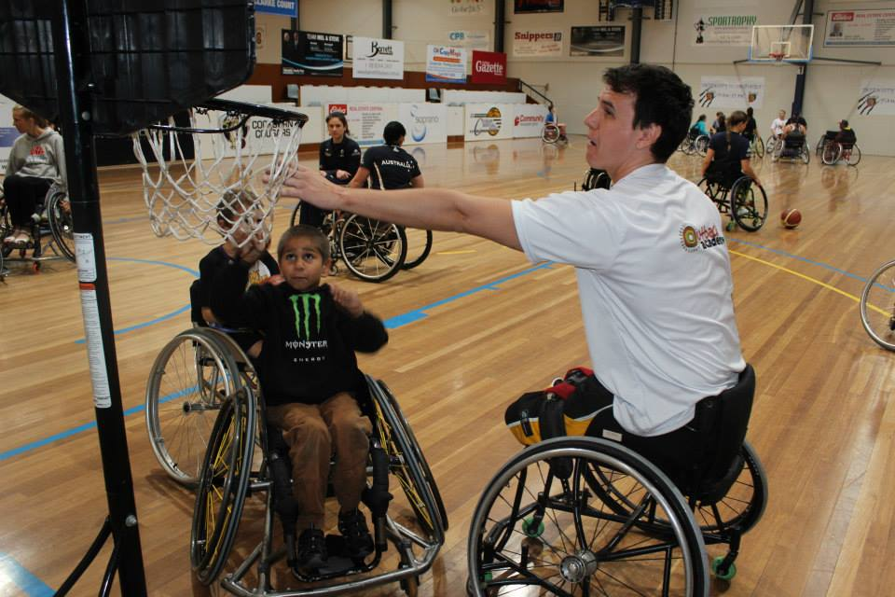

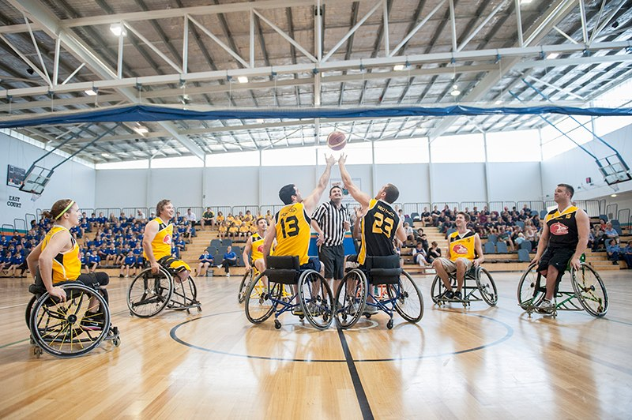

**Come and support!**

**Australia’s Premier Wheelchair Basketball League**

**SATURDAY APRIL 30 - 4 pm**

Red Dust Heelers vs RSL Qld Spinning Bullets

**SUNDAY MAY 1 - 11 am**

Red Dust Heelers vs RSL Qld Spinning Bullets

**Where: HEGVOLD STADIUM**

**Sir Raymond Huish Drive, WANDA, Entry Free**