Speedy 2v1s

By David Clarke
In every match, and in every area of the pitch, overload situations make a telling contribution, particularly if combined with speed and good close control.
Here's a practice that replicates the most common overload - a 2v1. Two attackers need to work a way around the square and pass into each corner without the defender winning the ball. With other teams involved in the practice, attackers are also under time pressure to win.
You might want to start by telling your players to run the game with the ball in hands, like basketball, so they become familiar with the tactical side.
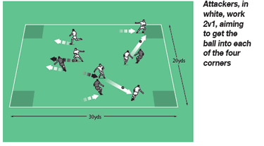
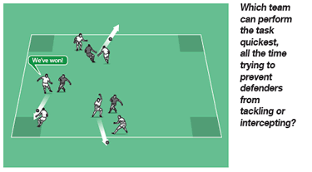
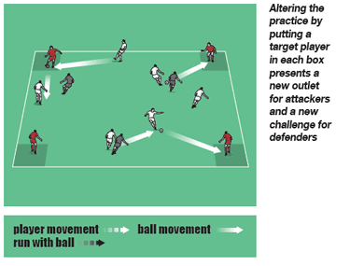

How to play it
- For this practice, you need balls, bibs and cones.
- Set up as shown in the first diagram. You can create numerous 2v1s, but I have used three groups of three here.
- In each trio, there are two attackers and one defender. Attackers have to get the ball into each of the four boxes but can do so in any order. They do this when either of the players receives a pass in the box.
- Defenders must try to win the ball but cannot go into the boxes. If the defender does manage to intercept or tackle, the attacking pair must return to the previous box and try again.
- The first attackers to pass into all four boxes win.
- Run four circuits then change defenders.

Developing the session
- Make the area and/or boxes smaller so the challenge becomes more difficult for attackers.
- Alternatively, designate four target players - one for each box. Now teams score by passing to this player. This gives the defender a choice - does he come forward to tackle or move back to block?
- As another variation, alter the overloads - 3v1 will give attackers more chance of success.

Technique and tactics
- We're looking for good link-up play, an assured first touch, accuracy, weight of pass, and movement.
- The key to this session is the movement and interplay of the two attackers.
- Defenders must react quickly to attacking bursts.
The session is also good for getting players to think how they can save time while ensuring they don't collide with any of the other

