*[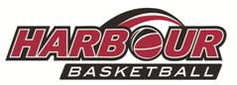](http://www.harbourbasketball.co.nz/)*

**Beginner Referee Course**

**For Secondary School Students**

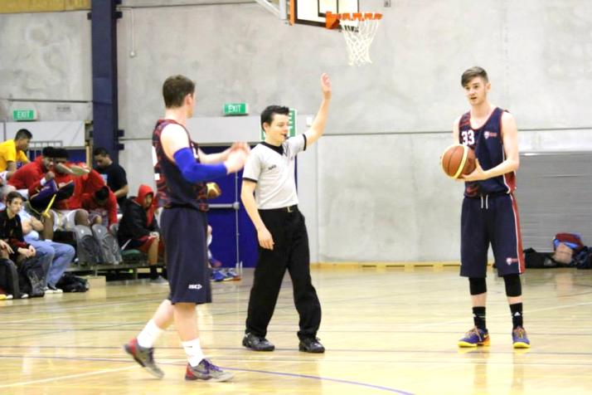

**When:** Monday February 15th

Monday February 22nd

Monday February 29th

Monday March 7th

Monday March 14th

**Time:** 4.30pm - 6.30pm

**Where:** Kings Lounge, North Shore Event Centre

**Age:** Secondary School Students

**Cost:** $10 for all 5 weeks

**Register:** Email – [referees@harbourbasketball.co.nz](mailto:referees@harbourbasketball.co.nz)

Phone - 443 3854 ext 3