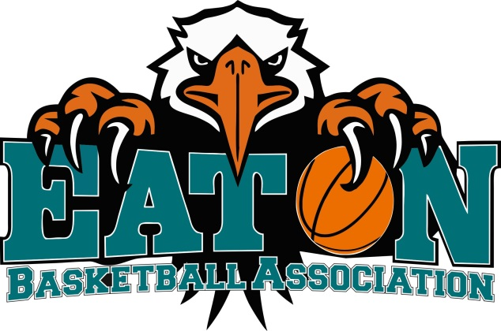

*www.eaton.basketball.net.au*

**Spectators Code of Conduct**

**• Remember that young people participate in sport for their enjoyment and benefit, not yours.**

**• Applaud good performance and efforts from all individuals and teams. Congratulate all participants on their performance regardless of the game’s outcome.**

**• Respect the decisions of officials and teach young people to do the same.**

**• Do not openly show disrespect to an Official of the game, a decision made by an official (right or wrong), or to an Administrator / Committee member.**

**• Never ridicule or scold a young player for making a mistake. Positive comments are motivational**

**• Condemn the use of violence in any form, whether it is by spectators, coaches, officials or players.**

**• Show respect for your team’s opponents. Without them there would be no game.**

**• Encourage players to follow the rules and the officials’ decisions.**

**• Do not use foul language, sledge or harass players, coaches or officials.**

**• Respect the rights, dignity and worth of every young person regardless of their gender, ability, cultural background or religion.**

**• Do not use obscene language, bullying or derogatory remarks towards other members or visitors (parents, spectators) to EBA activities.**

**• This Code of Conduct also extends to any form of Social Networking (twitter, Face book, text message etc.) and any use of these mediums will be treated as being face to face and treated appropriately.**

