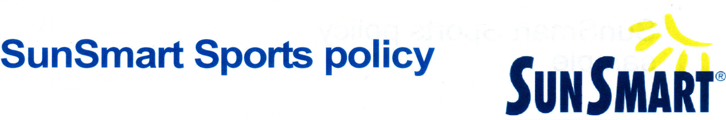
Charlton Football Club's SUNSMART Policy
The following policy is in place to help the Charlton Football Club minimize the risks of overexposure to UV.
Rationale
Too much UV from the sun can cause sunburn, skin damage, eye damage and skin cancer. Australia has one of the highest rates of skin cancer in the world. Two in three Australians will develop some form of skin cancer before they reach the age of 70.
People often experience sunburn and skin damage when playing or watching sport due to extended periods exposed to high levels of UV without appropriate sun protection.
Check the SunSmart UV Alert times to find out when sun protection is required. As a general rule, sun protection is needed from the beginning of September to the end of April in Victoria or whenever UV levels are 3 and above. Particular care should be taken during the middle of the day when UV levels are highest.
From May to August in Victoria, sun protection isn't usually needed unless near highly reflective surfaces such as snow, outside for extended periods or when the UV reaches 3 and above.
Schedules, fixtures and rule
modifications (including a cancellation policy)
- Where possible, training, events and competitions are scheduled to minimize exposure to UV and heat.
- Cancellation of training, events or competition occurs when high risk conditions are forecast.

Where it is not possible to avoid peak UV and heat periods, the following interim steps are taken to minimize the risk of overexposure to UV and heat illness:

- Warm-up activities are limited in duration and intensity.
- The duration of the activity is reduced.
- Activities start earlier in the morning or later in the evening.
- Rest breaks and opportunities to seek shade and rehydrate are increased.
- Officials rotate out of the sun more frequently than usual.
- Player interchange and substitution is used more frequently than usual.
- Activity is held at an alternative venue (e.g. training at a pool).
- Officials, coaches and senior members act as role models by wearing sun-protective clothing and hats, applying sunscreen and seeking shade wherever possible.
Sun protection measures
1. Clothing
- Tops/jerseys are loose fitting and lightweight.
- Where the competition uniform does not provide adequate sun protection, participants are reminded to apply SPF 30+ sunscreen to all exposed skin and wear covering clothing whilst not on the field.

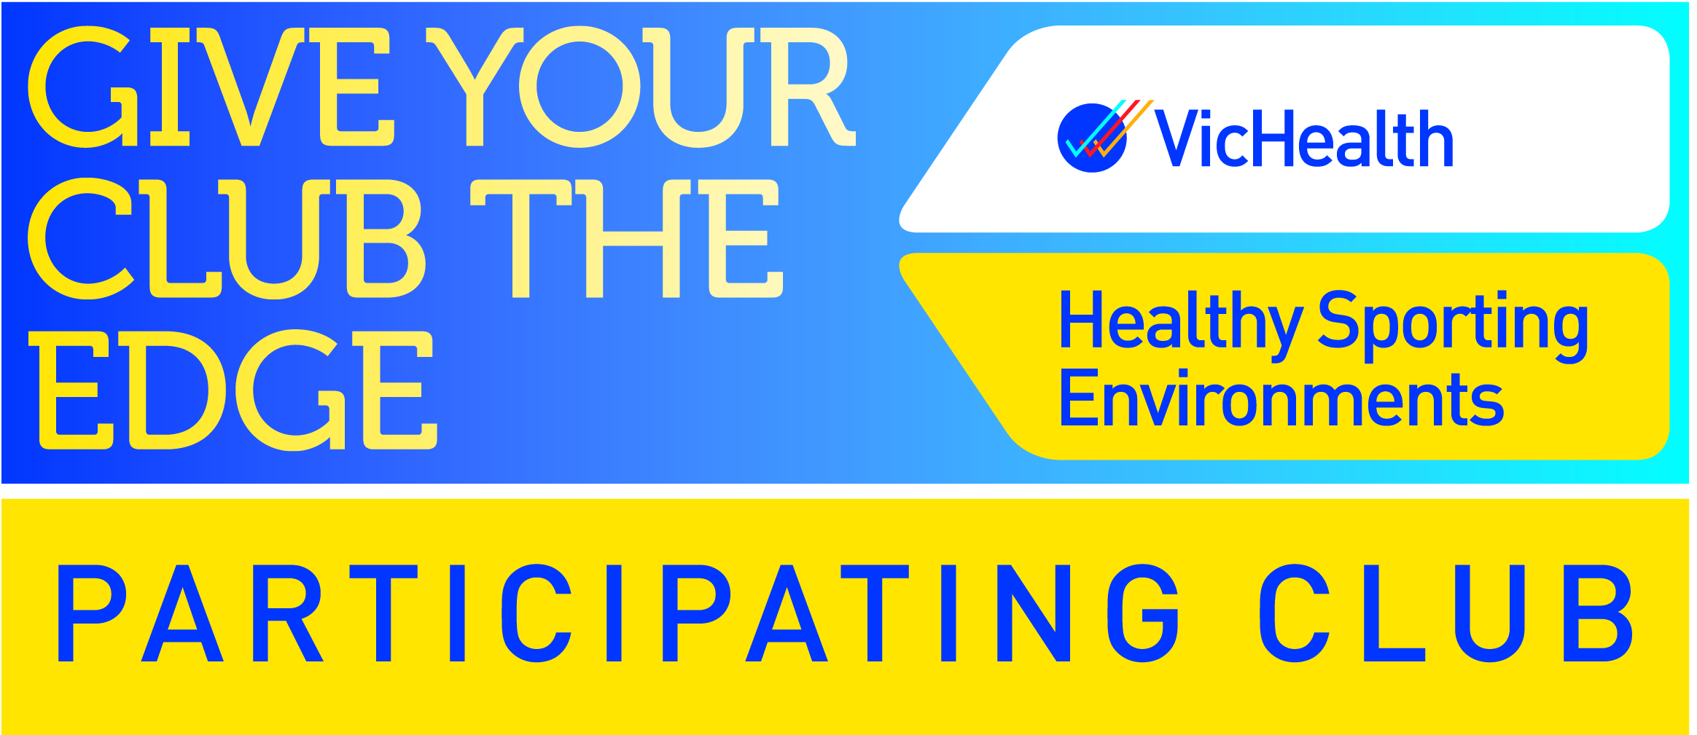
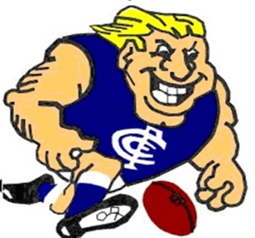
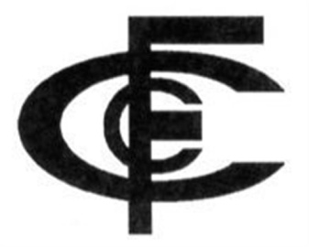

2. Sunscreen
- SPF 30+ broad spectrum, water resistant sunscreen is provided to participants. People with naturally very dark skin (not a tan or olive skin) may not need to wear sunscreen.
- Participants are encouraged to apply sunscreen 20 minutes before training or playing
and to reapply every two hours or immediately after swimming or toweling dry.
- Sunscreen is stored below 30°c and replaced once it is past the use-by date.
- Participants are encouraged to apply a generous amount of sunscreen (the equivalent of one teaspoon per limb).
- The first aid kit includes a supply of SPF 30+ broad spectrum, water resistant sunscreen.
3. Hats
Caps and visors are for sale however, they do not provide adequate sun protection to the face, ears and neck.
4. Shade
- An assessment of existing shade has been conducted (using the SunSmart shade audit resource) at commonly used outdoor venues.
- When not actively playing or between individual events, participants are able to rest in shaded areas.
- Where there is insufficient natural or built shade, temporary shade structures are provided. Spectators are encouraged to bring their own temporary shade (e.g. tents or umbrellas).
- The use of shade from buildings, trees and other structures is utilized where possible (e.g. for player interchange and spectator areas).
- Interchange and presentation ceremony areas are protected by shade.
5. Sunglasses
Spectators are encouraged to wear sunglasses that meet the Australian standard
(ASNZS 1067:2003).
Education and information
- The times when sun protection is required (as determined by the SunSmart UV Alert) are communicated to participants and spectators
- Participants are notified at the beginning of September that sun protection measures need to be implemented.
- Participants are notified at the start of May that sun protection measures are no longer required unless UV index levels reach 3 and above or when participating in alpine or water sports.

Review
- This SunSmart policy will be reviewed annually at the Charlton Football Club’s AGM to ensure that the document remains current and practical.
- This policy was implemented on October 2015 at the Charlton Football Club AGM.

Disclaimer
The information contained in this guide is general in nature and does not constitute medical advice from your doctor or health professional. While all reasonable attempts have been made to ensure the accuracy of the information contained in this guide, SunSmart and associated parties cannot accept responsibility for loss, injury, claim or damage resulting from the use or application of information within this guide.
This information is based on current available evidence at the time of review. It can be photocopied for distribution. Last update: Feb 2016

