# Run past your opponents

## By David Clarke

Quick-footed attackers look great when they run at defenders and leave them tackling thin air. You can teach your players how to do this and give them the confidence to go on match-winning runs.

Watching a player run at and beat the opposition is great for coaches. I, like you, want to see my players take the initiative and run with the ball.

You will often hear the parents of your players shouting "get rid of it" or "pass the ball" but they soon shut up when they see your players regularly going past opponents and setting up goalscoring chances.

## Watch which foot your opponent uses

Beating players is an art but you can help your team by telling them how to do it. They have to watch which leg the opponent is using and where his balance is to take advantage of the situation.

Tacklers often jump straight in and make it easy to go around them but the clever ones wait and jockey until they can make the tackle.

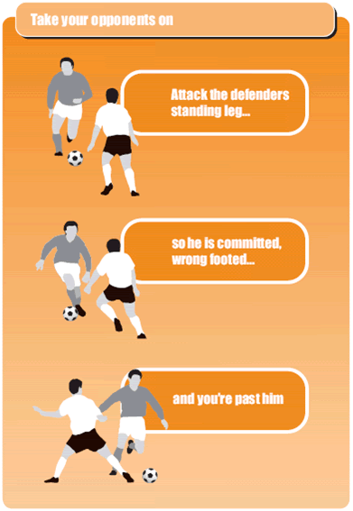

## Use this technique

The defender starts out with balanced footing. But in the second picture, he raises one foot off the ground. If he raises his foot that is further away from the ball, you move out. If he raises his foot that is nearer to the ball, you move in. Get it? You're "attacking" his supporting foot.

**Key coaching tip:** Tell your players to run at their opponent and make him choose one side and your player goes the other.