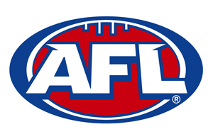
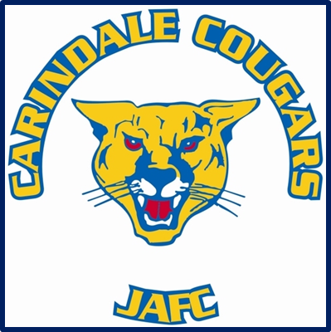

MARKETING

& PUBLICITY OFFICER
ROLE DESCRIPTION
Objectives
- To regularly promote & market the club in a positive light at all times
- To promote the activities of the Club using different mediums
eg. social media, radio, newspaper etc
- To provide support to the Club Committee members to ensure the
efficient operations of the Club
- To maximise communication to Club stakeholders

Responsibilities
MARKETING & PUBLICITY OFFICER
ROLE DESCRIPTION
- Develop / implement a promotional plan for the club
- Assist with promoting the Club in the local and wider community
- Write media release regarding any news items & upcoming events
- Undertake publicity tasks at the request of the President or the
Club Committee
that may reflect on the public well-being of the Club
- Prepare club newsletters and reports
- Assist with attracting and securing sponsorship
- Placing sponsorship in newsletters/ on Facebook
- Main contact person for all media requirements
- Liaises with all media outlets and key stakeholders
- Assist committee with marketing and new business ideas
- Collate weekly “Player of the Week” photos from Team Managers
and post to Facebook
- Collate Photos from season to create Year Book
- Assist other Committee members in their duties as required
- Undertake tasks at the request of the President or Club Committee

Accountability
- Reports to President
- Reports to the Club Committee
- Provide a verbal update at the monthly Committee meeting
- Seek approval prior to committing the Club to any statement to the
local press/social media
- Seek approval from the appropriate Committee member prior to
committing the Club to any action or financial cost

