# Soccer Golf

## By David Clarke

Try this game, which is based on golf, to give your players a fun build-up to their training session or use it as a pre-season warm-up.

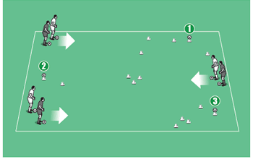

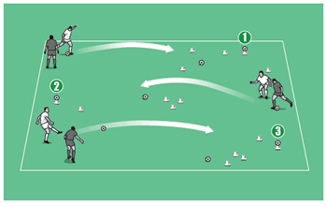

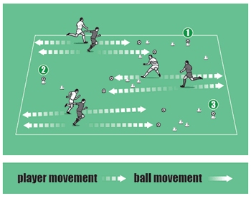

## How to play it

* With the golfing calendar moving into full swing, why not combine football with the fairway?
* Soccer golf can be made as simple or a difficult as you like - arrange a set of three "holes", with distance to the holes and obstacles relevant to the ages and abilities of your players.
* Set it up so pairs of players have to kick the ball towards a target cone (the hole).
* When both players have taken their shot, they must jog to their respective balls. Touching the ball with their foot, they return to the start, then back to the ball, before taking a second shot.
* For every additional shot, the player must approach the ball, touch it, then return to it having run back to the start of the hole.
* At the end of each hole, the winning player is the one to have hit the cone with the fewest number of shots.
* Now move on to the next hole.

## Technique and tactics

* This is a great warm-up that mixes running with technique.
* Players must take care with their passes and shots. Misplaced kicks mean extra running!
* Avoiding any obstacles you choose to lay out means bringing in elements of accuracy.
* Ensure too that there is no walking between shots - players must jog, always on the move.