

**WAGGA WAGGA & DISTRICT AMATEUR FOOTBALL ASSOCIATION Inc**.

**FOOTBALL WAGGA WAGGA**

Policy Number FWW-POL-004

Coach Education Policy

Version 1.0

**Objectives**

To establish a strategic pathway to ensuring all coaches are suitably educated in accordance with FNSW and FFA standards.

FWW’s aim is to have all coaches in the association appropriately qualified by 2018 (4 year plan).

It is recognised that FWW has not taken a strong position in the past on coach education. It is further recognised that it is in the best interests of all players that coaches are suitably qualified to maximise the enjoyment of playing football.

FNSW recognise the following coach pathway

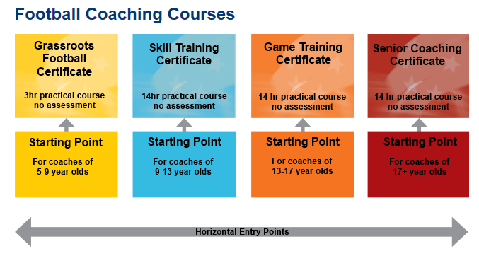

**Constraints to Coach Development**

It is recognised that achieving the aim of having 100% of coaches appropriately qualified will take time due to a number of factors:

1. Resistance from some existing coaches to take up the qualification
2. Time availability
3. Club financial resources

Therefore, this policy has adopted a staggered approach to coach development, with a focus on MiniRoos and Junior Coaches in the first 3 years, with requirements for senior coaching commencing in years 3 and 4. Through this Policy, Football Wagga Wagga will work with FNSW to ensure adequate courses are run to achieve these goals.

It further recognises that in the Over 30/35 competition, coach qualification is not required.

**4-Year Plan**

|  |  |  |  |  |
| --- | --- | --- | --- | --- |
| **Coach Type and minimum qualification** | By the Commencement of Competition Year: | | | |
| 2015 | 2016 | 2017 | 2018 |
| **u6 to u8 team coaches**  **(Grassroots)** | All | All | All | All |
| **u9 to u11 team coaches**  **(Skill Training)** | 50% | All | All | All |
| **U12 to u16 team coaches**  **(Skill Training and Game Training)** | 25% | 50% | All | All |
| **Pascoe/Leonard Cup coaches**  **(Senior)** | - | - | All | All |
| **All Senior Coaches (except over 30/35)** | - | - | - | All |

**Coach Courses**

Based on the 4-year plan, FWW will aim to facilitate the following general schedule of coaching courses:

*2014 (May to December)*

* 1 x Grassroots
* 1 x Skill Training
* 1 x Game Training

*2015*

* 2 x Grassroots (once in March, once during the competition)
* 2 x Skill Training (once in March, once during the competition)
* 1 x Game Training (once in March)
* 1 x Senior Coaching Certificate (during the season)

*2016*

* 2 x Grassroots (once in March, once during the competition)
* 2 x Skill Training (once in March, once during the competition)
* 1 x Game Training (once in March, once during the competition)
* 2 x Senior Coaching Certificate (once during the season, once after the season)

*2017 and each year thereafter*

* 2 x Grassroots (once in March, once during the competition)
* 2 x Skill Training (once in March, once during the competition)
* 1 x Game Training (once in March, once during the competition)
* 1 x Senior Coaching Certificate (once after the season)

**Regulations**

The following regulations will apply to clubs when nominating teams for entry into the competitions:

| **Coach Type and minimum qualification** | **By the Commencement of Competition Year:** | | | |
| --- | --- | --- | --- | --- |
| **2015** | **2016** | **2017** | **2018** |
| **Under 6 team** | All team nominations must be accompanied by a coach with Grassroots Certificate, or be enrolled in a Grassroots Course | All team nominations must be accompanied by a coach with Grassroots Certificate, or be enrolled in a Grassroots Course | All team nominations must be accompanied by a coach with Grassroots Certificate, or be enrolled in a Grassroots Course | All team nominations must be accompanied by a coach with Grassroots Certificate, or be enrolled in a Grassroots Course |
| **Under 7 and Under 8 teams** | All team nominations must be accompanied by a coach with Grassroots Certificate | All team nominations must be accompanied by a coach with Grassroots Certificate | All team nominations must be accompanied by a coach with Grassroots Certificate | All team nominations must be accompanied by a coach with Grassroots Certificate |
| **Under 9 to Under 11 teams** | Half of all team nominations must be accompanied by a coach with Skills Training Certificate | All team nominations must be accompanied by a coach with Skills Training Certificate | All team nominations must be accompanied by a coach with Skills Training Certificate | All team nominations must be accompanied by a coach with Skills Training Certificate |
| **Under 12 to Under 16 teams** | 25% of all team nominations must be accompanied by a coach with Game Training Certificate | Half of all team nominations must be accompanied by a coach with Game Training Certificate | All team nominations must be accompanied by a coach with Game Training Certificate | All team nominations must be accompanied by a coach with Game Training Certificate |
| **Pascoe/Leonard Cup Teams** | - | - | All team nominations must be accompanied by a coach with Senior Coaching Certificate | All team nominations must be accompanied by a coach with Senior Coaching Certificate |
| **All Senior teams (except over 30/35)** | - | - | - | All team nominations must be accompanied by a coach with Senior Coaching Certificate |

Teams nominated without the appropriate coach will not be accepted into the competition, except under exceptional circumstances as determined by FWW. FWW may impose conditions upon team nominations which do not meet the coaching requirements.