

**ADAM CAPORN COACHING SESSION**

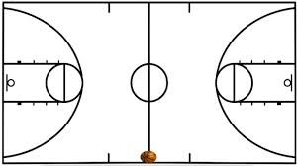

**Join Adam Caporn as he conducts training with the NITP Elite and Emerging boys.**

**When: Monday 22nd September, 2014**

**Where: Parks Community Centre**

**46 Cowan Street**

**Angle Park**

**Adam will be available for a question and answer session after training.**

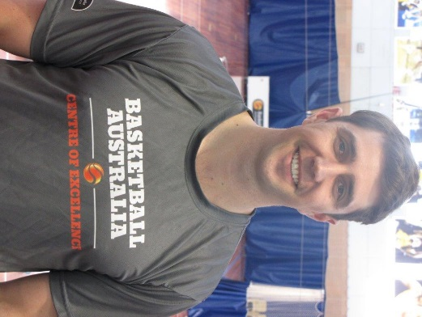

* AIS scholarship holder 2000/01
* Graduate of St Mary’s College, USA
* NBL teams- Wollongong Hawks and Perth Wildcats
* Head Coach of East Perth  2007
* Assistant Coach at St Mary’s 2008-13
* CoE Men’s Head Coach
* Emu’s Head Coach

Please email David Ingham to register

dingham@basketballsa.com.au