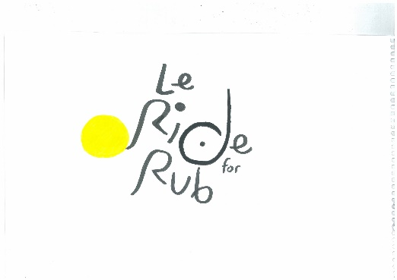

RIDE FOR RUB

*LYCRA FREE ZONE IF POSSIBLE*

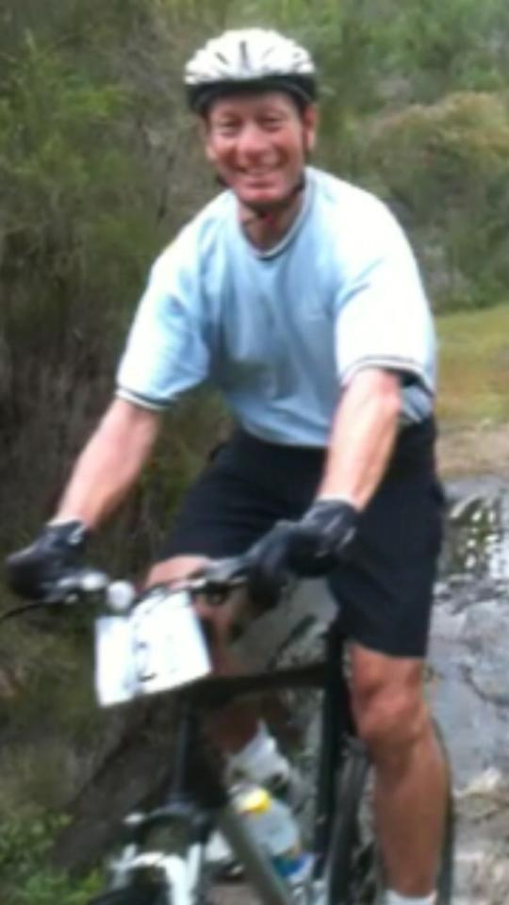DATE: SUNDAY 6th Sept.

TIME: ARRIVE 6:30am – DEPART 7:00am

ADDRESS:

BLACKBURN FOOTBALL CLUB

CENTRAL ROAD BLACKBURN

FUNCTION:

FOOD AND BEVERAGES PROVIDED

COST: $30 p/head with proceeds donated to the Heart Foundation

RSVP by Monday 31st August

RIDE TIME APPROX 2 HOURS – (Riders will be asked to sign a disclaimer)

THOSE NOT WANTING TO RIDE ARE MORE THAN WELCOME TO JOIN

THE POST RIDE FESTIVITIES APPROX 10-10.30am – (Weather permitting)

FOR FURTHER ENQUIRIES PLEASE CALL - Karen O’Halloran on 0418 580 468