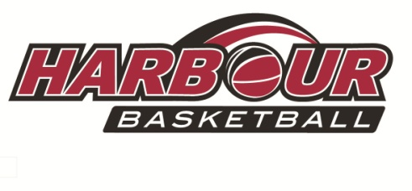

**RODNEY DEVELOPMENT OFFICER**

The North Harbour Basketball Association (“NHBA”) is a leading basketball Regional Sporting Organisation (RSO) that is responsible for the development and provision of basketball programs covering a full range of activities including competitions and tournaments, skill development for coaches and players, development of match officials and representative pathways.

The position of the Rodney Development Officer is a critical role for the successful achievement of NHBA’s strategic goals and objectives that will ensure a stable and sustainable platform for continued growth, the provision of high quality basketball experiences and dominantly position the sport of basketball within the region.

Reporting to the Chief Executive Officer, the Rodney Development Officer is responsible for the development of NHBA’s basketball programme in the Rodney area. The Rodney Development Officer must be a dynamic and inspirational leader with the ability to engage and develop long lasting, constructive relationships with a wide range of stakeholders.

**Key Responsibilities (to include, but not to be restricted to) :**

***Primary School Competition Creation and Facilitation***

* Identify venues for the running of primary school leagues in conjunction with NHBA’s existing primary school leagues. Lock in these venues contractually for a minimum period.
* Maintain and update existing Rodney based schools database regularly, producing quarterly updates for the In-Schools Coaching Coordinator and CEO. This necessitates the identifying of key basketball contacts at each school. All schools to be visited at least twice per calendar year.
* Work with the Competitions Manager as the competition modules are developed.
* Work with the In-Schools Coaching Coordinator to coordinate school visits.
* Work with Women’s Development Officer to implement the Girls Got Game programme.

***Generation of Incremental Funding***

* Work with the CEO to self-fund the Rodney Development Officer position via grant applications , RST funding (Harbour Sport and Aktive), Corporate Sponsorship and user-pays initiatives.

***School Equipment***

* Identify basketball equipment requirements at schools throughout the Rodney geographical catchment area.
* For all other schools look for alternative funding possibilities to obtain equipment.
* Provide each school with basketballs for their sporting equipment inventory.
* Compile a list of schools that want basketball hoops to be installed.

***Creation and Facilitation of Local Basketball Clubs***

* In each of the major towns in Rodney (namely Warkworth, Kumeu, Helensville and Wellsford) identify a key local partner and venues to create basketball clubs for their community.
* Affiliate these clubs once created to Harbour Basketball.

***Other KPIs***

* Work with Coach and Referee Development Officers at Harbour Basketball