



Social **Men’s Basketball**

Entry Form

**Harbour Basketball is now accepting entries for the next Social Men’s**

**Basketball League Starting Wednesday 30th September 2015**

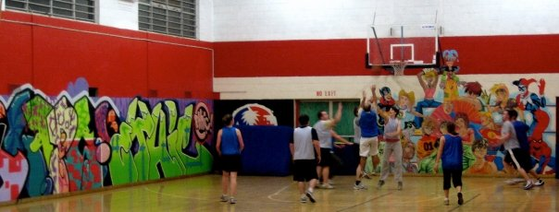**Entries close – Friday 18th September 2015 unless filled prior**

**11 weeks Starts Wednesday 30th September – Games Run for 1hr (4 x 7 Quarters)**

**Cost $860 (Inc GST and Social Membership fee)**

**Must be paid on entry**

**Please pay by direct credit to:**

**ASB, Northcote Branch 12-3053-0401960-00**

**(Please Reference your team name)**

**All Games are played at the North Shore Event Centre**

**Please see rules for all game information**

**Team Name: ...................................................................................**

**Team Contact: ................................................................................ Cell Phone: ................................................**

**Email: ..................................................................................(2nd Email) .......................................................................**

**Team contact (2nd): ............................................................................ Cell Phone: ...............................................**

|  |  |  |
| --- | --- | --- |
| **Player’s Name** | **Date of Birth** | **Email** |
|  |  |  |
|  |  |  |
|  |  |  |
|  |  |  |
|  |  |  |
|  |  |  |
|  |  |  |
|  |  |  |
|  |  |  |
|  |  |  |
|  |  |  |
|  |  |  |

MCj04416310000[1]

**Please contact or visit the** [**Harbour Basketball website**](http://www.sportingpulse.com/assoc_page.cgi?c=1-2857-0-0-0&sID=200779) **for Rules and further information**

**Email:** [**competitions@harbourbasketball.co.nz**](mailto:competitions@harbourbasketball.co.nz) **Phone:** 