# 5v2 three-goal defend

## By ****Michael Beale****

In this game, defenders work hard to pressure their opponent and block shooting opportunities. Having to defend three goals means defenders must make decisions and move quickly to cover space in front of them.

You need to set up an area 30 yards square and use three poles to make the goals. Five attackers face two defenders and a goalkeeper.

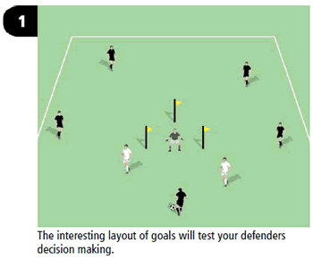

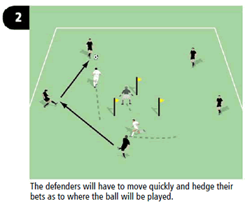

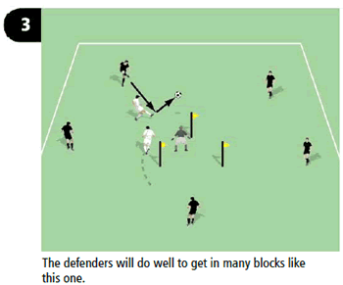

http://www.bettersoccercoaching.com/images/BSC297b.gif

1. The pitch has three goals marked out by a triangle of poles. The defending team (goalkeeper and two defenders) must defend against the five attackers.
2. The attacking team attempts to pass the ball quickly in order to create a goalscoring opportunity.
3. The defending team must work as a unit, pressing the ball and constantly repositioning in order to stop the attackers scoring.

Want more information? Try these links: