Hawks Wednesday Fives - Senior Men

General Information

The competition runs from Wednesday 4th October with the grand final night on Wednesday 6th December (10 games), at Whites Hill College. Games kick off @6.30PM and @7:20PM.

Prize

Winning team will receive $150 voucher to “Grilled”.

Rules of the competition

All players are responsible for reading and understanding the sport specific rules contained herein. All players need to be register at [www.myfootballclub.com.au](http://www.myfootballclub.com.au)

If there are any rules that are not clear please discuss these with the referee prior to the commencement of the game or at half time. Due to the time constraints of this competition the referees will not clarify rules or rulings during the game.

RULE 1: Team Composition & Player Requirements

a) A team may have a maximum squad of seven (7) players.  
b) Five (5) players are allowed on the field at one time, one (1) of which is the goal keeper.  
c) Four (4) players is the minimum number of players that a team can have without a forfeit resulting. Field size 1 quarter of full field (u8/9 size field with u8/9 goals)

RULE 2: Interchange

a) Teams can make as many substitutions as they like in a game.  
b) Substitutions can only take place when the game has stopped and the referee must be notified e.g. (The only time the game stops is when a goal is scored, a foul is committed or the ball goes outside the pitch)

RULE 3: Game Duration

Games consist of 2 by 20 minute halves with the half time break not exceeding three (3) minutes. Teams must change ends at half time. No clock stoppages will be made except under exceptional circumstances at the discretion of the Referee and Sport Convenor. No time outs are allowed.

RULE 4: Game Commencement

a) Teams should arrive 15 minutes prior to the commencement of their match to allow for smooth transition of games.  
b) Any teams that are not ready to commence play with a minimum of 4 appropriate players (Rule 1), ten (10) minutes after the referee has signalled the game can start will incur a 0-3 forfeit loss. NB. The game may go ahead after 10 minutes; however the 0-3 loss will stand regardless of the actual score.  
c) In all circumstances the game must finish at the scheduled time.

RULE 5: Sport Specific Rules

* From a kick off, the ball must be played forward; defending players must be on their own half
* In general play there is NO offside.
* NO throw ins – kick from the line.
* For a goal to be scored, ‘ALL’ of the ball must be over ‘ALL’ of the line.
* ALL free kicks will be direct
* During a free kick the offending team will be allowed to set up a 2 person wall and must be 2(two) metres from the where the kick is being taken. Players in the wall must remain standing at all times.
* NO slide tackling. If a player loses their footing in order to make a tackle, and as a result ends up on the ground, a penalty shall be awarded to the other team.
* During the game, the referee has the option of using 2 disciplinary cards – yellow and red. If a player receives a red card, that player is immediately expelled from the game. No substitute player is allowed to replace a player who is sent off in the game in which a red card is issued.

RULE 6 – Penalties/Sin Bin

* This competition is social. Any rough play, abusive language, backchat or challenge to the referee’s authority etc. will not be tolerated. Team captains must take responsibility for their team and ensure all matches are contested in the spirit of the game.
* Rough play includes any form of aggressive slide tackle, tackling a player from behind, shoulder charging and any other act or omission that, in the referees opinion, places the safety of players at risk. In most instances the following procedure will apply for the above infringements. Note however that the referee is entitled to send off any player at any stage for any reason for any period of time if they feel it necessary to do so for player safety or their ability to effectively control the game.

a) First Offence – Yellow Card

Yellow Card to be given by the Referee. Player may stay on the pitch.

b) Second offence – Red Card

- Automatic Red Card and dismissal from the current game and next game.

- No substitute player is allowed to replace a player who is sent off in the game in which the dismissal occurred.

- If a player receives a red card the week before a finals match this rule still applies, no lenience allowed.  
- If a player receives a red card during a match they are to leave the court immediately and are not allowed to play for the rest of the match, as well as the following scheduled match for their team.  
- The player awarded the red card must give their name to the referee who will record it on the scorecard and pass it onto the Sport Convenor.

RULE 7: Points

Points are awarded in matches as follows:

Win - 3 Points

Draw - 1 Point

Loss - 0 Points

In the event of tied points at the end of round matches, placing’s will be determined by for and against goal count.

Wet weather

If the games will be washed out, both teams will be awarded one (1) point for the game. Please note that the games will not be rescheduled.

RULE 8: Finals

* Competition consist of 7 robin rounds, then the competition will split for final 3 fixtures in Champions league (top 4 teams) and Europa League (bottom 4 teams) and teams will play the last 3 fixtures in their new competitions.
* During Finals matches if f a draw results, five (5) penalties will be taken by both teams.
* If the results are drawn after this then each team will take a single penalty until one team has missed and the other scored. The scoring team will be deemed the winner.
* If extra penalties are needed, a player who did not take one of the initial 5 penalties must take them. No single player can take more than one penalty, unless every team member has taken a penalty already.

Field Map 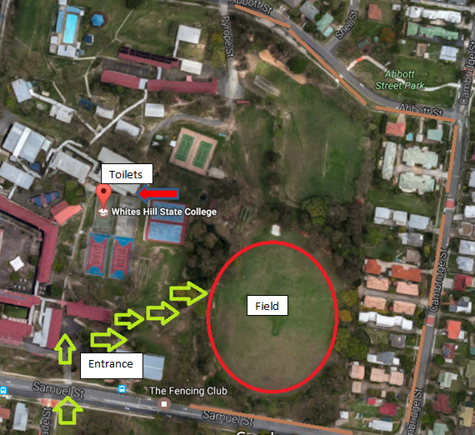

Green arrows are the entry to the College, red circle is the training ground and brown lines highlighting the parking around the school.

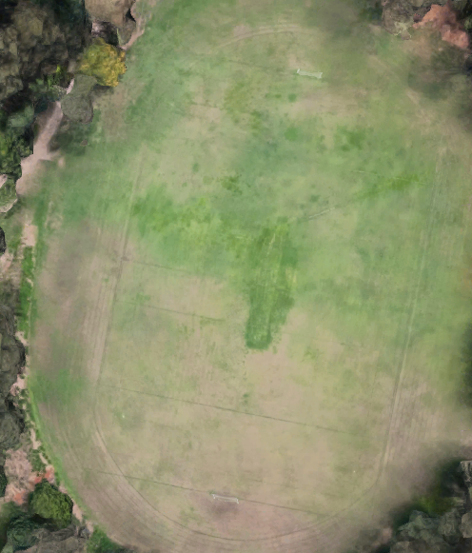

Field 4

Field 2

Field 1

Field 3

Any further enquiries please contact Marek on (07) 3847 3511 or email officehphfc@gmail.com