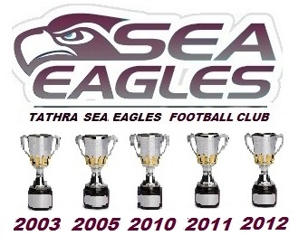

***COACH : BRAD McBAIN TEAM MANAGER : KEV MAY***

***TEAM OF THE DECADE 2003-2013***

***JOHN HARNEY DAVID LITTLE LEIGH MANNING***

***( VICE CAPTAIN )***

***ANTHONY LITTLE***

***LUKE MUNDY***

***( CAPTAIN )***

***JON CREMERIUS***

***ANDREW NAGLE***

***FOLL***

***RU: NATHAN SMITH***

***RR: GRANT VINE***

***R: JASON AINSWORTH***

***INTER***

***ADAM BLACKA***

***TRENT THATCHER***

***MICHAEL LAY***

***STEVEN BLAND***

***TROY O’LOGHLIN***

***PAUL NOACK***

***RYAN O’LOGHLIN***

B:

HB:

C:

HF:

F:

***LUKE TAYLOR BRAD McBAIN MATT MAY***