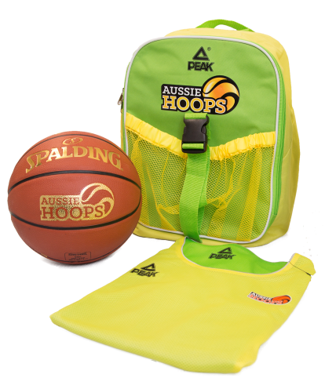

Come and join in at

Coffs Harbour Basketball

**Learn to Play Basketball for all kids 5-12! TERM 3**

**Kicking off again on Sat 29th July at 9am**

**9 week Program - $110 for new participants**

**$90 for returning participants**

**Run by CHBA Development officer Blake Kelly**