

Strategic Plan

2014 – 2018

Authors: Robert Morton and Luke Gordon

Last updated: 24 March 2014

# Presidents Report

***“The big picture”***

A renewed focus for the Eastern Lions Football club will be the future. With the hard work of previous administrators beginning to show off field, our club is now in a position to plan for future years rather than concentrating on one year at a time.

One of the main reasons that Robert Morton and I have come on to lead our club is to introduce a strategic plan, a plan which maps out the direction of the club for the coming five years. The plan will look at all things, from on field and player development to off field issues such as finances, sponsorship and facility development. This will assist the committee develop policies, procedures and other plans to make the club become a more professional, competitive and consistent both on the field and off the field.

Change is what we bring, but we understand that change can take time.

It is fantastic to have a new, positive coach on board who shares the vision of the committee and believes the future should be the club’s focus. Even before season 2014 has commenced, the club has shown great steps towards reaching our long term goal of becoming a 3rd division club.

With the amazing group of under 19 players that have come on board this year and the upgrade to our flood lighting at Fairpark Reserve, we have already achieved a lot of short term goals. With this said we still have a long way to go.

It’s not the 2014 season that I am looking forward to, but more the start of our future planning and the implementation of our strategic plan.

It is important to recognise the contribution made by the committee and players into the development of this plan. Ultimately, the responsibility for the implementation of this plan lies with everyone. It lies with the players, committee and coaches. With this, it was imperative that all stakeholders provided input into the plan and I thank everyone for their efforts.

Good luck to all the players this year, and thank you in advance to all the volunteers that will help us along the way. Your work is invaluable.

Yours Ready,

Luke Gordon

President

# Executive Summary

The Club’s committee, players and members understand the value of strategic planning towards achieving success both on and off the field whilst actively shaping the future of the Club. It is understood that although on field success is the main driver behind football clubs, it is not achieved without first ensuring the success of the club off field.

Ensuring that development opportunities are in place to drive junior integration into senior football, developing a strong connection to the community as well as portraying the club in an image which is to be respected by others and is a source of pride to club players and members are just some of the off field factors that lead to success.

The Eastern Lions Football Club Strategic Plan has been developed by Luke Gordon and Robert Morton in conjunction with the Executive and General Committees, in consultation with club members and key stakeholders. The plan will be reviewed on an ongoing basis to ensure that the objectives set within the plan are achieved and new objectives are set. All members are encouraged to provide input into the plan as it evolves.

The guiding principles behind the strategic plan are:

* To create a proud and successful club culture through:
  + Driving member behaviour;
  + Developing infrastructure; and
  + On field success.
* To develop junior integration between the Eastern Lions Junior Football Club and the Eastern Lions Football Club;
* Create a well governed Club; and
* Maintain the Club’s proud history.

Developing a strategy concerns the entirety of the Club and as such a holistic and transparent approach must be implemented. This strategy is not only the responsibility of Committee members to implement; it is everyone’s responsibility including players and other key stakeholders.

At the Eastern Lions Football Club, together we strive to enrich OUR club for the greater good of tomorrow’s players.

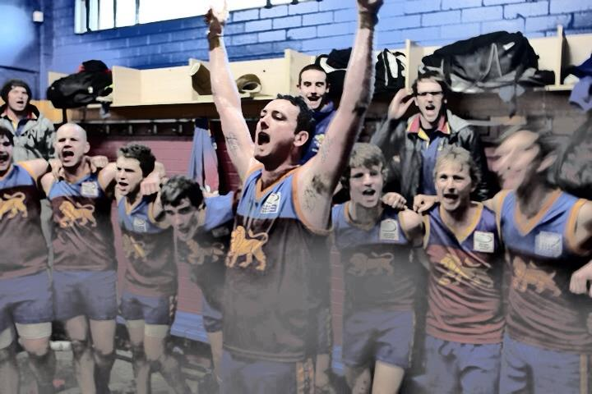

Contents

[Presidents Report 2](#_Toc383190440)

[Executive Summary 3](#_Toc383190441)

[1.0 Club History 5](#_Toc383190442)

[1.1 Additional Club History 7](#_Toc383190443)

[2.0 Club Vision and Purpose 8](#_Toc383190444)

[3.0 Goals 8](#_Toc383190445)

[4.0 SWOT Analysis 9](#_Toc383190446)

[5.0 Club Structure 10](#_Toc383190447)

[6.0 Key Stakeholders 11](#_Toc383190448)

[7.0 Key areas of priority 12](#_Toc383190449)

[8.0 Conclusion 17](#_Toc383190450)

# Club History

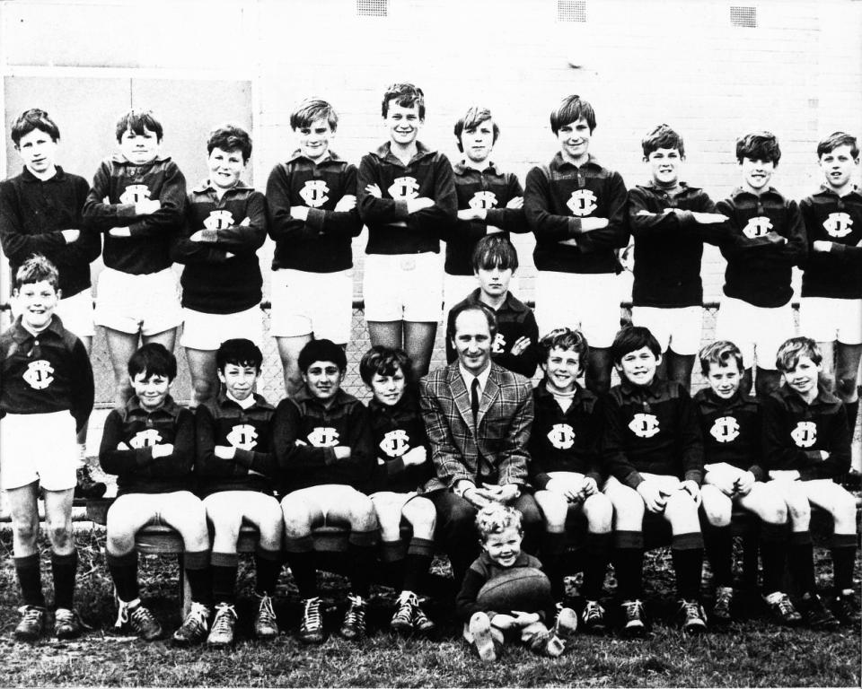The story of the Eastern Lions Football Club begins in 1969, the club’s formation year. Originally known as the Fairpark Football Club, the club ran only junior teams until the first senior team was fielded in 1978 in the Mountain District Football League (MDFC).

The senior’s first game was held at Fairpark Reserve in 1978 against Marysville which saw the home team salute by 5 points. The seniors went on to win a total of 6 games in their inaugural year, which was followed by a very strong season in 1979 where the seniors made the grand final, only to lose to Wandin Football Club by 8 points. After three years in the MDFC, the club entered the Eastern Districts Football League (now known as the Eastern Football League) in 1981.

**Fairpark FC – Junior Team**

Unfortunately the high quality football played in the MDFL did not carry over to the EDFL, with poor seasons in both 1981 (5 wins) and 1982 (4 wins). In 1983 the club returned to finals action with a loss to The Basin in the elimination final. The club played in finals in each year between 1983 - 1992. During the period of time the club experienced elimination final losses (1989 against Warrandyte and 1990 against The Basin) preliminary final losses (1984 against The Basin, 1987 against Ferntree Gully and 1988 against The Basin) and grand final losses (1985 against The Basin, 1986 against Coldstream and 1991 against Lilydale).

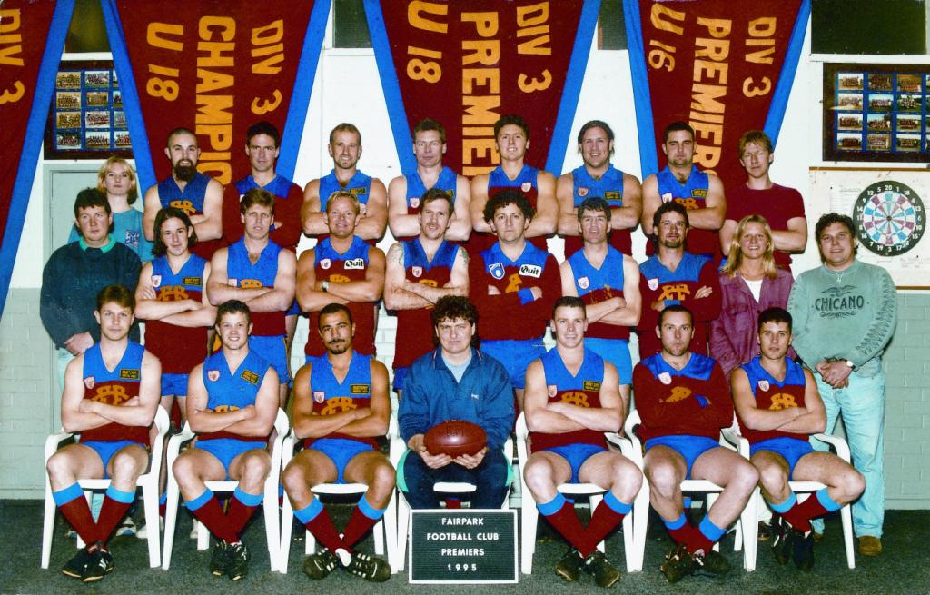

From 1992, the club entered a lean patch which eventuated in being relegated to division 4 (in 1993). The club’s first senior premiership came in 1995 after finishing 2nd on the ladder with an 11-5 win/loss ratio, and saluted against Wantirna South 14.11.95 to 13.13.91.

**Fairpark FC Senior Team – Premiers 1995**

The following year saw the club relegated back to division 4 in what was an unlucky circumstance, with the club only falling into last place on the ladder after the final round. Since this time the club has remained in division 4, featuring in only 3 finals series.

The club’s reserves team has experienced more success than the senior team over the years, winning grand finals in 1985, 1986, 1988, 1989 and 1990. Similarly, the colt’s team experienced grand final success in 1984 and 1985.

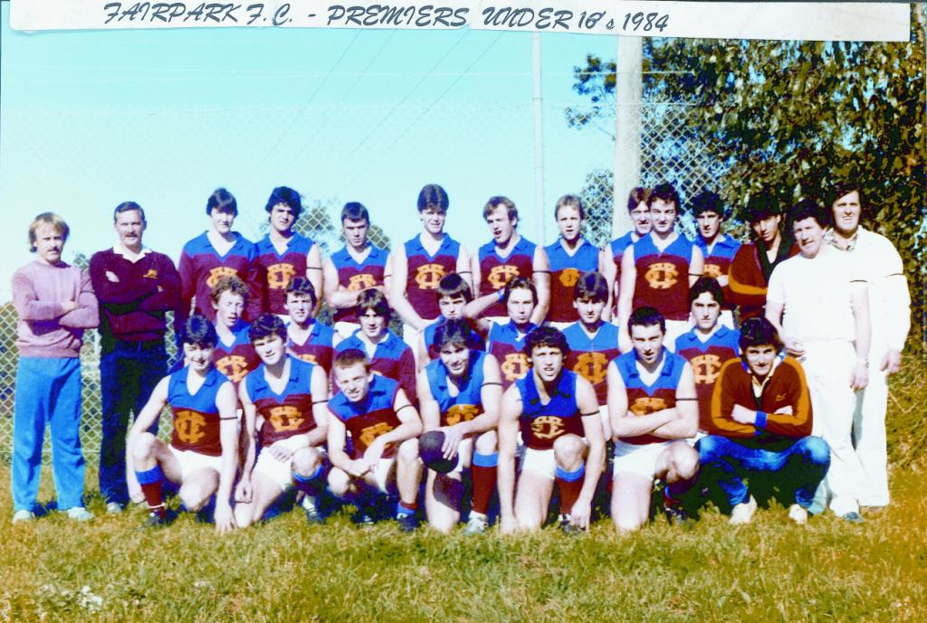

Since the club’s formation in 1969 and the subsequent senior inclusion in 1978, the club has been well represented with many players winning league best and fairest awards, highest competition goal kicking awards as well as being selected for the league team of the year on many occasions.

**Fairpark FC U18’s Premiership Team 1984**

The club continues to strive for success both on and off the field by creating an inclusive and respectful culture. The committee will continue to work with players and members to create a sustainable football club which focuses heavily on pride, commitment and consistency with the aim of entrenching future success into the clubs branding whilst retaining the successful history of the club.

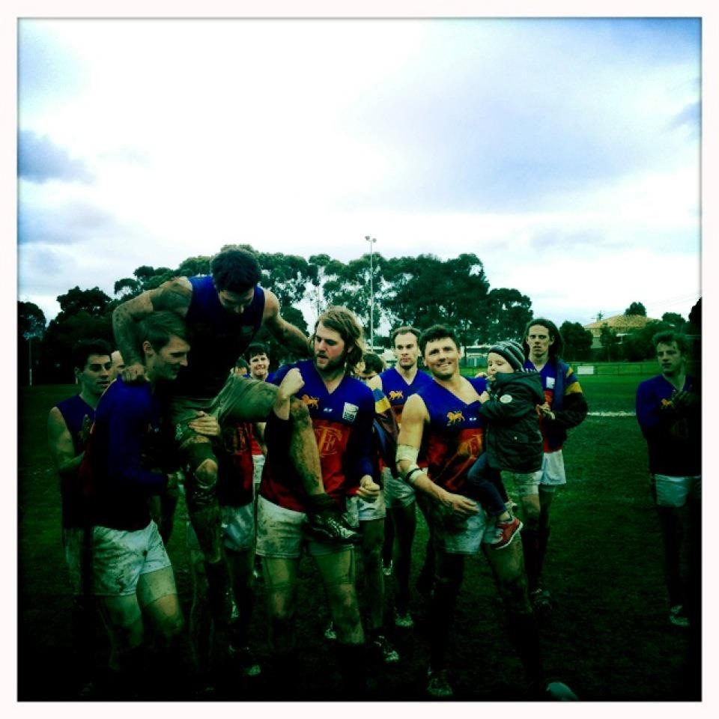

# 1.1 Additional Club History

|  |  |
| --- | --- |
| **Senior Premiership**   * + 1995   **Reserve Premierships**   * + 1985   + 1986   + 1988   + 1989   + 1990   **Most Games**  **(Seniors and Reserves combined)**   1. G.M. Smith 356 2. Andy Hayman 331 3. Danny Russo 297\* 4. Trevor Bell 261 5. Brett Luttrell 243 6. Leigh Rankin 235\* 7. Marcel Vanden Broek 215 8. Reece Taranto 210\* 9. Adam Hull 190 10. Graham Gardiner 187   \*still Playing  **Greatest Winning Margin – 207 points**   * Round 2, 1984 – Fairpark FC 43.17.275 v Mt Evelyn 9.14.68 * Round 17, 1989 – Fairpark FC 34.20.234 v Mt Evelyn FC 4.3.27   **Greatest Losing Margin – 189 points**   * Round 19, 1981   Fairpark FC 5.3.33 v Norwood FC 33.24.222  **Highest Score**   * Round 2, 1984   43.17.275 v Mt Evelyn FC  **Lowest Score**   * Round 18, 2004   1.6.12 v The Basin FC  **Best start to the season**   * 7 wins in both 1989 and 2008 | **League Best and Fairest Winners (Seniors)**   * George Steiner   1988 Division 4  1989 Division 3   * Dylan Strydom   1995 – Division 4  **League Best and Fairest Winners (Reserves)**   * C:\Robert\Footy\den.jpgMark Church   1984 Division 3   * Craig Wilkinson   1988 – Division 3   * David Bourke   2002 Division 4   * Wolfgang Van Damme   2004 Division 4  **League Best and Fairest Winners (Colts)**   * Craig Bakes   1983 Division 3   * Martin Eckholdt   1999 – Division 3 & 4 combined  **Senior League Leading Goal Kickers**   * Colin Morris 77 goals   Division 3 1991   * Martin Eckholdt 58 goals   Division 4 1995  **Most Wins in a Season**   * 16 wins in 1991   **Least Wins in a Season**   * 1 win in 1993   **Longest Winning Streak**   * 10 games in 1985   (rounds 2-11).  **Longest Losing Streak**   * 14 games in 1993/94   (Round 6, 1993 – Round 2, 1994) |

# 2.0 Club Vision and Purpose

The Eastern Lions Football Club (ELFC) strives to provide first class sporting, social and leisure opportunities for its members, whilst ensuring opportunities are also provided to develop personally and to make positive contributions to the community.

# 3.0 Goals

* 1. Short Term Goals
* To develop junior participation with a main focus on fielding an under 17s team in season 2015;
* To field an under 19s Team in season 2014;
* To investigate further facility developments;
* To increase the clubs volunteer base; and
* To create a welcoming environment for families and women.
  1. Long Term Goals
* To be promoted to division 3;
* To work in conjunction with Fairpark Reserve tenants, Knox City Council and both State and Federal Governments towards large scale reserve developments;
* To be financially sustainable; and
* To increase participation within the ELJFC and create a transition program from junior to senior football.

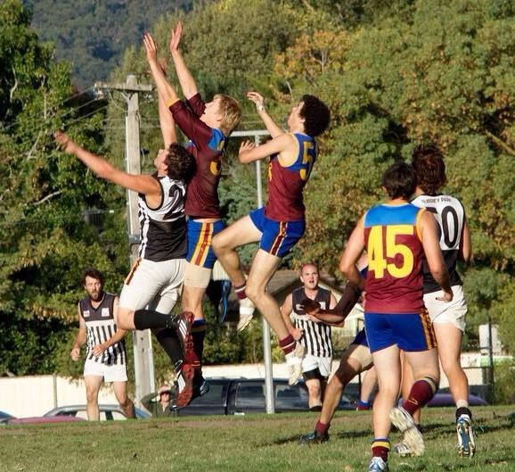

# 4.0 SWOT Analysis

It is imperative to undertake a SWOT analysis to examine the Club’s strategic position, from both the internal and external environments. By conducting the SWOT analysis below, it has assisted in identifying the major factors that are likely to play a role in affecting the Club’s direction and the success of this strategy document.

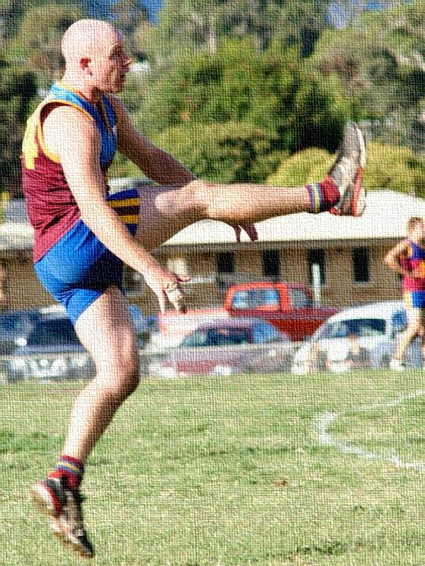

# Club Structure

The Club has adopted a ‘simple club structure’ which possesses a low degree of departmentalisation and formalisation, wide spans of control and has decision making centred with only a few people. This structure allows for quick decision making which is imperative in an ever changing football environment. Although decision making lies with the Executive Committee, all members are actively encouraged to contribute to any topic or issue that may be discussed at both member or committee levels.

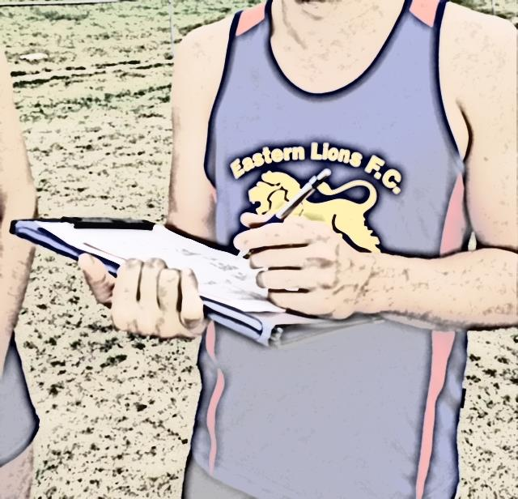

**Executive Committee**

**Treasurer**

Jenny Cutts

**Secretary**

Simon Bott

**President**

Luke Gordon

**Vice President**

Robert Morton

**General Committee**

**Merchandise**

Liam O’Brien

**Sponsorship**

Nick Cowan

**Bar and Canteen**

Rod Morrison

**Asst Treasurer**

David Bentley

**Miscellaneous**

Jason Wellard

**Social**

Brad Banks

**Asst Social**

Jim Hall

**Comm.**

Nick Cowan

**Miscellaneous**

Fil Strati

**Coaching Panel**

**Reserves Asst**

Phil Sankey

**Reserves Coach**

Russel Warbuton

**Senior Asst**

**Senior Coach**

Leigh Murphy

**Fitness Coach**

Russel Warbuton

**Club Members**

**Social Members**

**Playing Members**

# 6.0 Key Stakeholders

The Club acknowledges the support provided by football partners, community sport partners and commercial partners. It is recognised that all three categories of partners play a pivotal role in developing the Club and the sport as a whole. The Club thanks all the partners below.

**Football Partners**

|  |  |  |  |
| --- | --- | --- | --- |
| EFL | AFL Victoria | AFL | Good Sports |

**Community Sport Partners**

|  |  |  |  |  |
| --- | --- | --- | --- | --- |
| Fairpark Netball Club | Johnson Park CC | KCC | Nick Wakeling MP | Alan Tudge MP |

**Commercial Partners**

|  |  |  |  |
| --- | --- | --- | --- |
|  | GWS Mazda Logo.jpg | BGC.jpg | Bristol.jpg |
| back%20in%20motion.jpg | Knox Club.jpg | barryPlant_logo.png | http://i42.photobucket.com/albums/e322/lazyarse_1099/TomlinsonGlass.jpg |

DULUX GRANDVIEW KITCHENS PLASTA MASTA CAMLEX ELECTICAL

A AND M REMOVAL CONTE SERVICES PRO-CRANE

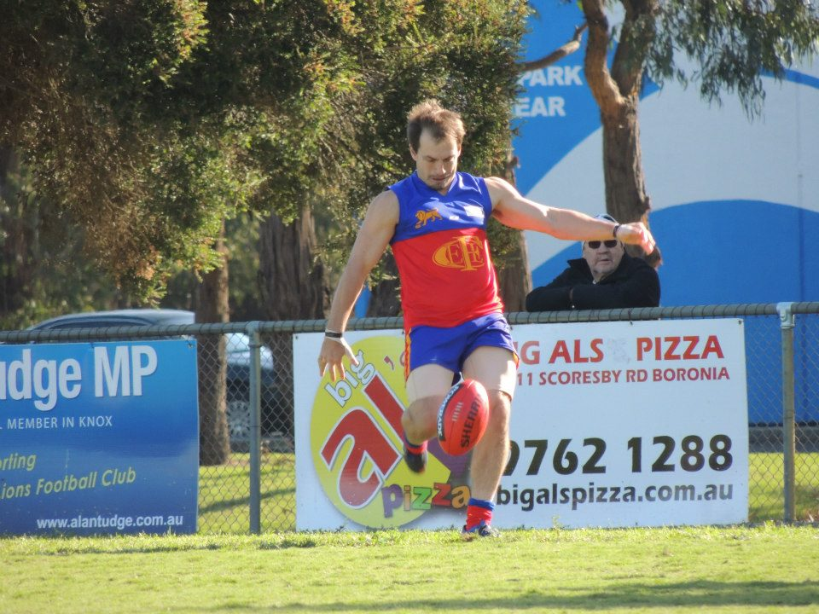

# Key areas of priority

**7.1 On field**

|  |  |  |  |  |  |
| --- | --- | --- | --- | --- | --- |
| What? | How | Review Date | Who? | KPI | Results |
| Achieve a high level of success | * Teamwork * Game plans * Consistency * Fielding competitive teams * Meet individual player KPI’s * Player retention | Ongoing | - Coach  - Captain  - Players | - Finals  - Premierships  - Competitive in 3rd division  - Number of existing players retained |  |
| Display Respect | * Respect Team mates; * Respect opposition; * Respect officials * Respect club | Ongoing | - Captain  - Coach  - Players | - Umpire reports  - Retention of opponents for after match functions  - Positive feedback from EFL community |  |
| Increase junior participation | * Develop a junior integration program * Retain existing players * Recruit new players | Ongoing | - Coach  - Players  - Junior club | - Number of junior participants  - Number of teams fielded  - Number of junior players transition to senior players |  |
| Ensure club is presented well | * Wear dedicated club uniform * Act in an appropriate manner * Promote the club | Ongoing | - Captain  - Coach  - Players | - Feedback from opponents  - Number of disciplinary incidents |  |
| Ensure player safety and injury prevention | * Participate in appropriate training activities including warm ups and cool downs * Follow directions from club trainers * Create player profiles | Ongoing | - Captain  - Coach  - Players  - Trainers | - Low number of injuries  - Up-to-date player profile booklet |  |
| What? | How | Review Date | Who? | KPI | Results |
| Create a ‘Fortress’ at Fairpark Reserve | * High number of merchandise sales * Game day attendances | * Ongoing | - Committee  - Players  - Coach | - Merchandise Sales  - Atmosphere at games  - Number of spectators |  |
| Field Under 19s Team | * Player recruitment * Player retention | - Annually | - Committee  - Players  - Coach | - Number of players  - Number of teams |  |
| Field Seniors and Reserves Teams | * Player recruitment * Player retention | - Annually | - Committee  - Players  - Coach | - Number of players  - Number of teams |  |

**7.2 Facilities**

|  |  |  |  |  |  |
| --- | --- | --- | --- | --- | --- |
| What? | How | Review Date | Who? | KPI | Results |
| Develop high quality football facilities | * Conduct a needs analysis as to what is required (lights etc.) | - Annually | - Committee | - Facility Developments |  |

**7.3 Finances**

|  |  |  |  |  |  |
| --- | --- | --- | --- | --- | --- |
| What? | How | Review Date | Who? | KPI | Results |
| Generate in excess of $35,000 in sponsorship | - Seek potential sponsors  - Develop attractive sponsorship packages  - Player sponsors | - Annually | - Sponsorship Coordinator | - Revenue earned through sponsorship |  |
| Generate in excess of $15,000 through bar | - Social functions  - Game day | - Ongoing | - Bar Manager | - Revenue through bar |  |
| Generate in excess of $15,000 through canteen | - Thursday night meals  - Game day | - Ongoing | - Canteen Manager | - Revenue through canteen |  |
| What? | How | Review Date | Who? | KPI | Results |
| Be successful in applying for grants | - Identify available grants  - Develop applications | - Ongoing | - Committee | - Number of successful grant applications |  |
| Reduce fixed costs | - Reduce equipment, utilities and miscellaneous fees | - Ongoing | - Treasurer  - Assistant Treasurer  - President | - Expenditure of equipment, utilities and miscellaneous items |  |
| Collect 100% of subs prior to round 1 | - Enforce playing restrictions  - Follow up discussions  - Display monies owing on notice board | - Prior to round 1 - Annually | - Assistant - Treasurer | - Revenue obtained through subs |  |
| Create a none player Membership base of 100+ | - New attractive membership packages.  - Retain supports.  - Support data base | - Annually | - Committee | - Data base of over 100 non playing members |  |

**7.4 Player Development**

|  |  |  |  |  |  |
| --- | --- | --- | --- | --- | --- |
| What? | How | Review Date | Who? | KPI | Results |
| Develop leadership qualities in all players | - Leadership roles within the club  - Training | - Ongoing | - Coach  - Players | - Game day directions  - Helps around the club |  |
| Junior Integration | - Develop junior integration program  - Create recruiting booklet  - Field 4 teams in the junior club in 2014 | - Annually | - President  - Junior club  - Players | - Implementation of program  - Number of teams fielded |  |
| Increase work ethic of players | - Players run drills  - Develop leadership | - Ongoing | - Coach  - Players | - Player attitudes  - On field and off field performances |  |
| What? | How | Review Date | Who? | KPI | Results |
| Increase player motivation | - Training structure  - Rewards | - Ongoing | - Coach  - Players | - Training attendance  - Player attitudes |  |
| Increase skill level of players | - Player review  - One on one coaching | - Ongoing | - Coach  - Players | - On field and off field performances |  |
| Educate players on respecting officials and opposition players | - Leadership qualities  - Training courses  - Leadership group meetings with misbehaving players | - Ongoing | - Coach  - Players  - Committee | - Number of red and yellow cards  - Number of complaints from umpires and opposition |  |
| Increase Money pool available to spend on players | * Bringing more revenue into the club | - Annually | - President  - Treasurer | * Yearly increase in money available |  |

**7.5 Club Administration**

|  |  |  |  |  |  |
| --- | --- | --- | --- | --- | --- |
| What? | How | Review Date | Who? | KPI | Results |
| Ensure good organisational governance | * Transparency * Accountability * Democracy * Equity | * Ongoing | * President * Vice President | * Feedback from Club members * Retention of committee members * Efficiency of decision making |  |
| Respect Club history | * Update honour boards * Past player days | * Annually | * Social Committee * President * Vice President | * Up-to-date honour boards * Number of past player events run * Past player feedback |  |
| Ensure social media pages and website are up to date | * Recruit Communications coordinator | - Ongoing | - Coms. Coordinator | - Number of followers on Twitter and Facebook  - Content on pages  - Number of website hits |  |
| What? | How | Review Date | Who? | KPI | Results |
| Recruit and Retain volunteers | * Develop volunteer recruitment and retention plan | - Annually | - President | - Implementation of plan  - Number of volunteers |  |
| Ensure all required tenancy papers are submitted to Council on time | * Return all required paper work to Council | - Annually | - Secretary | - Submitted forms  - No breach of tenancy issued |  |
| Run monthly committee meetings | - Ensure timely notification to committee members is given  - Ensure minutes of meetings are required | - Monthly | - Committee  - Secretary | - Number of meetings held |  |
| Successfully conduct the clubs AGM | - Ensure timely notification to club members is given | - Annually | - Executive Committee | * Was the AGM was held |  |
| Ensure the team line up is registered on EFL website prior to games | * Register team line up on EFL website each Thursday post selection | - Weekly | - Secretary | - Team line up on EFL website weekly |  |
| Have articles on the club in local paper | - Liaise with Knox Leader  - Send match reports and other stories to Knox Leader | - Weekly | - Executive Committee  - Coms. Coordinator | - Number of articles in local paper |  |

# Conclusion

The Executive Committee, in conjunction with the General Committee, players and other key stakeholders have developed this document to guide the club’s future planning. This document will be continually updated to reflect the changing dynamics of the football environment.