NPL Pathway Program
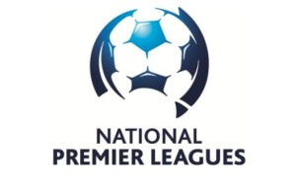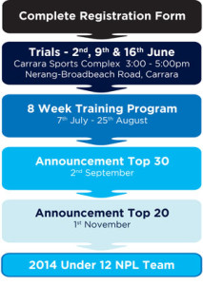
The NPL Pathway program is a training program designed to work with players and coaches from community clubs and give them an introduction to the FFA National Curriculum and also the ‘elite pathway program’ for Australia. The program is fully endorsed by Football Federation Australia, Football Queensland & Football Gold Coast.
Trials
3:00 – 5:00pm.
2nd, 9th & 16th June 2013 at Carrara Sports Complex, Nerang-Broadbeach Road.
Team Selection
Trials will start in June and run for 3 weeks at no cost. A total of 60 players will be selected to make four equally strong zones by a selection committee who will hold a minimum of a FFA/AFC ‘C Licence’.
Selection Committee
Name | Qualification
Gary French | AFC/FFA ‘B Licence’
Mark Wakeling | AFC/FFA ‘A Licence’ Part A
Grae Piddick | AFC/FFA ‘B Licence’
Nathan Kelly | AFC/FFA ‘B Licence’
Jared Adamson | AFC/FFA ‘C Licence’
Shannan McLuckie | AFC/FFA ‘C Licence’
Training Program
7th July – 25th August 2013
The selected players will train Sunday afternoons at Palm Beach Soccer Club, which should not affect local clubs games and training. The training sessions will go for a maximum of 2 hours, which will include a mixture of skill acquisition training, game training and a round-robin.
Zones
Southern Zone | North East Zone
Murwillumbah | Runaway Bay
Kingscliff | Musgrave
Tweed Valley Kings | Southport
Tweed Heads | Magic TFA
Banora Point | Surfers Paradise
Border United | Ormeau
Tugun
Palm Beach
Tallebudgera

North West Zone | Central Zone
Coomera | Mudgeeraba
Pacific Pines | Robina
Nerang | Burleigh Heads
Gold Coast Knights | Broadbeach
Mt Tamborine | Merrimac
Canungra
Beechmont
Selected Player Cost
Players who are selected for the training program will receive a full Nike playing kit.
$130.00 per player.

