# Set it back

## By Tony Carr

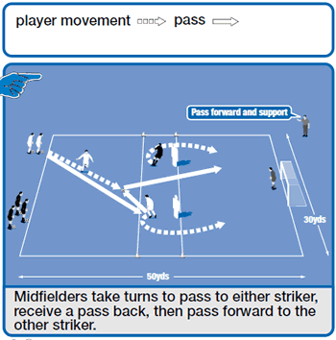

**Session - 15 minutes**

Mark out a pitch with a goal at one end and a 10-yard channel in the centre, as in the picture above. Use two strikers and split the rest of your players into two lines of midfielders. A midfielder makes a diagonal pass to one of the strikers, in the centre channel, who controls the ball and then sets the ball back to the midfielder.

Now the midfielder plays a through pass to the second striker, who runs around the flag/mannequin to shoot at goal. The midfielder now becomes a striker for the next ball from the opposite line of midfielders.

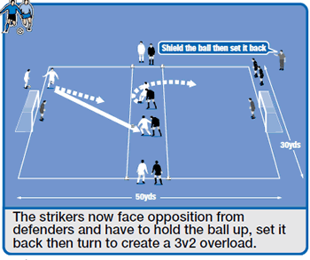

## Development - 15 minutes

Now use two teams and add another goal at the opposite end of the area (see picture above). Each team has two midfielders next to their goal. Their role is to pass a ball forward and run to receive a set-back pass and help create a 3v2 overload.

The team also has four players that work in pairs and rotate being either forwards or defenders.

To start, the white midfielder passes to one of the strikers inside the centre channel (the striker receives inside this area because it forces physical contact) and runs to receive a set-back pass.

Now the game continues in a 3v2 situation, in which all players are free to use the entire pitch to either score a goal or stop one being scored.

Offside rules apply. For the next attack, two new defenders and strikers enter the pitch and the black team attacks.

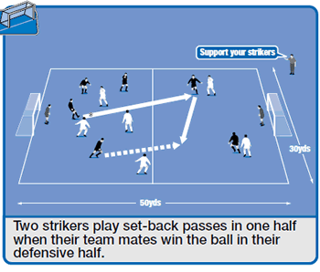

## Game situation - 15 minutes

Use two teams and the same size area but remove the 10-yard centre channel (see picture above). The pitch is split in half. Inside the white team's defensive half are two defenders and two strikers from the black team.

The rest of the outfield players are in the other half. Start the practice with the white team attacking inside the black team's defensive half of the pitch When the black team wins possession, it passes forward to its strikers.

Now up to three black players can support the forward pass and receive a set back pass from the strikers to score a goal. No white defenders can run back and defend the counter attack. Halfway through the game, swap restrictions on each team. The team that scores most goals wins.