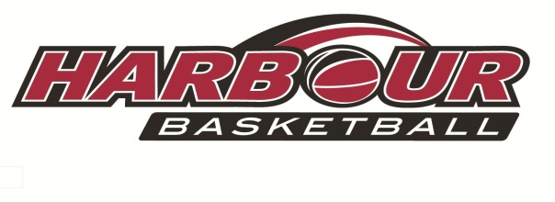

**HARBOUR BASKETBALL REPRESENTATIVE TRIALS**

This is your opportunity to become part of the most successful basketball association

in New Zealand. These trials are held in 2016 for the 2017 rep season.

**Please read your trial times and venues very carefully for each age group**



**U15 Boys**

Trial 1 Saturday 26 November @ NSEC 11.00am-12.45pm

Trial 2 Sunday 27 November @ NSEC 11.00am-12.45pm

Trial 3 Saturday 10 December @ NSEC 11.00am-12.30pm

**U15 Girls**

Trial 1 Saturday 26 November @ NSEC 1.00pm-2.30pm

Trial 2 Sunday 27 November @ NSEC 1.00pm-2.30pm

Trial 3 Saturday 10 December @ NSEC 12.45pm-2.00pm

**U17 Boys**

Trial 1 Saturday 26 November @ NSEC 2.45pm-4.15pm

Trial 2 Sunday 27 November @ NSEC 2.45pm-4.15pm

Trial 3 Saturday 3 December @ AUT 12.00pm-1.30pm

**U17 Girls**

Trial 1 Saturday 26 November @ NSEC 1.00pm-2.30pm

Trial 2 Sunday 27 November @ NSEC 1.00pm-2.30pm

Trial 3 Saturday 3 December @ AUT 11.00am-12.00pm

**U19 Girls**

Trial 1 Saturday 26 November @ NSEC 4.30pm-6.00pm

Trial 2 Sunday 27 November @ NSEC 4.30pm-6.00pm

**U15-Born 2004**

**2003**

**U17-Born 2002**

**2001**

**U19-Born 2000**

**1999**

Trial 3 Saturday 3 December @ AUT 11.00am-12.00pm

**U19 Boys**

Trial 1 Saturday 26 November @ NSEC 4.30pm-6.00pm

Trial 2 Sunday 27 November @ NSEC 4.30pm-6.00pm

Trial 3 Saturday 3 December @ AUT 1.30pm-3.00pm

 Players ARE recommended to participate in all three sessions.

 All participants need to bring the following: **water bottle, reversible singlet**

**(or two t-shirts/dark and light )**

 Trial Fees are set at $32 for all three sessions.

You must register and pay via our online registrations on our website

Registrations taken on the day will be charged $35.00.