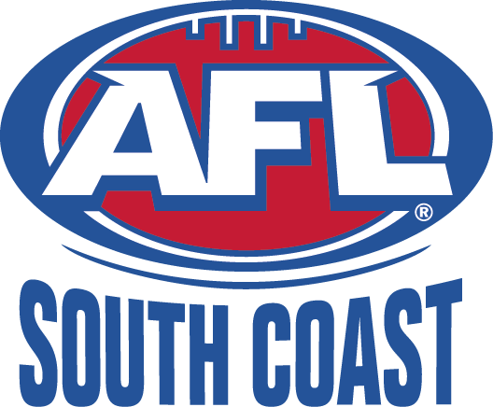
ILLAWARRA JUNIORS

AFL South Coast Incorporated
ABN: 83 986 595 815
Minutes of the Illawarra Juniors Administration Committee Delegates Meeting
held at the Dapto Leagues Club on Thursday 19 June 2014 at 7pm

MINUTES

- Present Committee: Mike Christie, Bill Reid, Peter Gamble, Dave Johnson, Jessie Mulholland
Present Delegates:, Geoff Pryke (Tigers), Glen Bachelor (Swans), Tony Baerwinkel (Dapto/Port), Wayne Barrett (Lions), Steve Thorne (Roos).,
Guests: Michael Dobie
Apologies: Crows, Power, Hawks
Absent: Hawks

- Last meetings minutes: accepted by Geoff Pryke, seconded by Glen Bachelor

- Correspondence: none tabled

- Chairman’s Report:
- No report.

- Competition Manager Report:
- No report

- Youth Girls Manager:
- 23 girls aged 13-16 (including 5 from Illawarra) to compete as South Coast United at girls carnival on 28/6. Team has been drawn from Illawarra to Eden and Cowra.

- Representative Manager Report:
- U14’s playing 8/7 in “alternate” GSJ carnival
- U/16 squad has come together. Peter mentioned efforts of Luke Vanzin, Jacob Hennessy and Zac Forst for driving recruitment of the squad.
- U/12’s, 14’s and 16’s play 27/28/29 June at South Coast Carnival.

- Umpires Coordinators Report:
- Bill reported that U/9’s, U/10’s and U/12’s are generating the most code of conduct issues ie adults approaching umpires etc. Bill clarified that only ground manager can approach umpires. Clubs should reiterate to there volunteers/parents that U/9’s and 10’s are non-competition and should not be generating these reports.
- If umpires are to be cited for misconduct clubs should call or email Bill Reid asap to discuss. Clubs can still lodge a report.

- Football Operations Manager:
  - No reports came out of the weekend of 14/15 June.
  - Water runners are to have the correct vests on and should be listed on team sheets
  - Some players have been missing from team sheet. Team managers are to ensure team sheets are correctly updated.

- AFL Development Manager Report:
- Not much school activity in term 2.
- DJ’s team are doing after school centres in numerous regions.
- Currently working in St Josephs High School
- Paul Kelly Cup has been on.
- NEAFL game 6/7
  - Gold coin entry
  - Posters distributed to clubs
  - ½ time events in every game
- Holiday program flyers given to delegates.

- Lions Liaison Report: No Report

- Club Issues

  - 2015 U/18’s comp.
    - Michael Dobie attended as representative of AFLSC. It was explained junior club delegates would like to make an submission for the U/18’s (or highest junior age group) to be run by the juniors, teams to be part of junior clubs and games played on Sundays as part of the junior program.
    - Wayne and Glen reiterated this position and explained that junior clubs were not given the opportunity to make their case at the extraordinary meeting held in Nowra as it was not made clear that this meeting would result in a final decision on the U/18’s comp for next season.
    - Discussion revolved around:
      - It is easier to retain kids if they can continue to play for their junior club.
      - How can junior committee engage senior clubs to be involved with junior development
      - Benefit of playing Sunday’s is that families with younger siblings stay together.
      - Juniors to provide retention/recruitment strategy
      - Junior club can enter U/18’s side if aligned with senior club (for fixturing).
    - Michael Dobie asked junior committee/delegates to provide a proposal to AFLSC for running U/18’s as a junior agr group on Sundays.
    - Michael was asked if seniors have been asked to demonstrate what they are doing re U/18 recruitment.
    - Question raised – can seniors and juniors meet to discuss 2015 U/18’s comp? Michael advised he will be facilitating a senior/junior meeting on 23/7 and discussion re U/18’s can be incorporated into this.
    - Point was made that junior clubs can form combined U/18’s teams.
  - Wet weather rounds
  - Extension of break between games. It was confirmed clubs can request a 10 minute extension to the break between games if one or more of their players have been umpiring the game beforehand.
  - AFL sponsorship of Bonaira ground lighting. In repoonse to question from Lions DJ confirmed AFLNSW did not pay $25k toward ground lights.
  - Around the table:
    - Glen B asked if opposition clubs are notified of tribunal decisions. Bill confirmed clubs can enquire with Jesse/Gin re penalties imposed. Clubs can advise their parents/players that a player has been dealt with and a penalty imposed.
    - Geoff P asked if team numbers are limited. Mike advised this was discussed at a previous meeting and it was decided that team numbers can be greater than stated in the by laws. Mike to confirm wording of decision.

- Committee Discussion/Decisions
  - Wet weather cancellations. Dates for playing games lost to wet weather rounds were put aside at the start of the season. Mike to check dates.
  - Ground bookings for finals. Figtree to be used for SF. NDP for GF. PF venue by application. All clubs can bid to host any round of finals. Jessie to send notice to clubs asking for applications to host finals.
  - Trophies. Pete Gamble graciously agreed to order trophies for association presentation night (again).
  - Preso night – Jessie to book Dapto Leagues auditorium for Mon before GF.

- Next Meeting: 17 July at 7pm – delegates invited from 7pm to 8.30pm.

- Meeting Closed: 9.45pm

