**SOCCER MOTOR SKILLS**

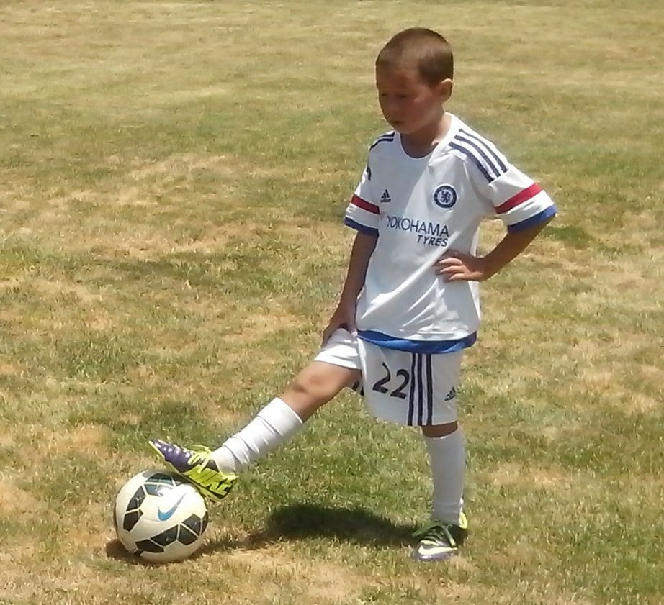

***All kids are different and every Soccer kid can bring innovative ideas and intuitive moves to the game.***

**INTRODUCTION**

***Some kids develop their natural motor skills and some kids are all thumbs.***

In Australia, there are so many talented Soccer kids who never reach their true potential because they don’t fully develop the natural motor skills and mind skills that all kids have.

In games, some kids stand dead still, some kids stay dead quiet and some kids are dead scared of making the wrong move.

We can improve any Soccer kid in 5 minutes because kids are willing to look, listen, ask questions and learn. Adults may take a bit longer.

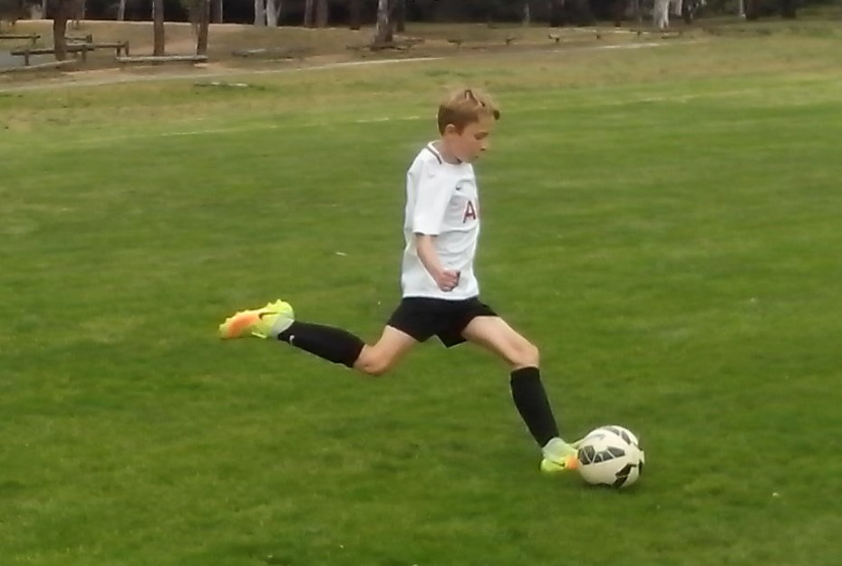

**MOTOR SKILLS**

***Kids learn at the cognitive level***, ***practise at the associative level and play at the intuitive level.***

We all have motor skills and we need to choose and use them or we will lose them. We all have the ability to walk, run, jump, throw, catch, twist and turn. We can develop motor skills at three levels.

At the cognitive level, we stop and think before we move. Movement is slow. At the associative level, we begin to relax. Slow becomes smooth. At the intuitive level, our decisions and moves are second nature. Smooth becomes fast.

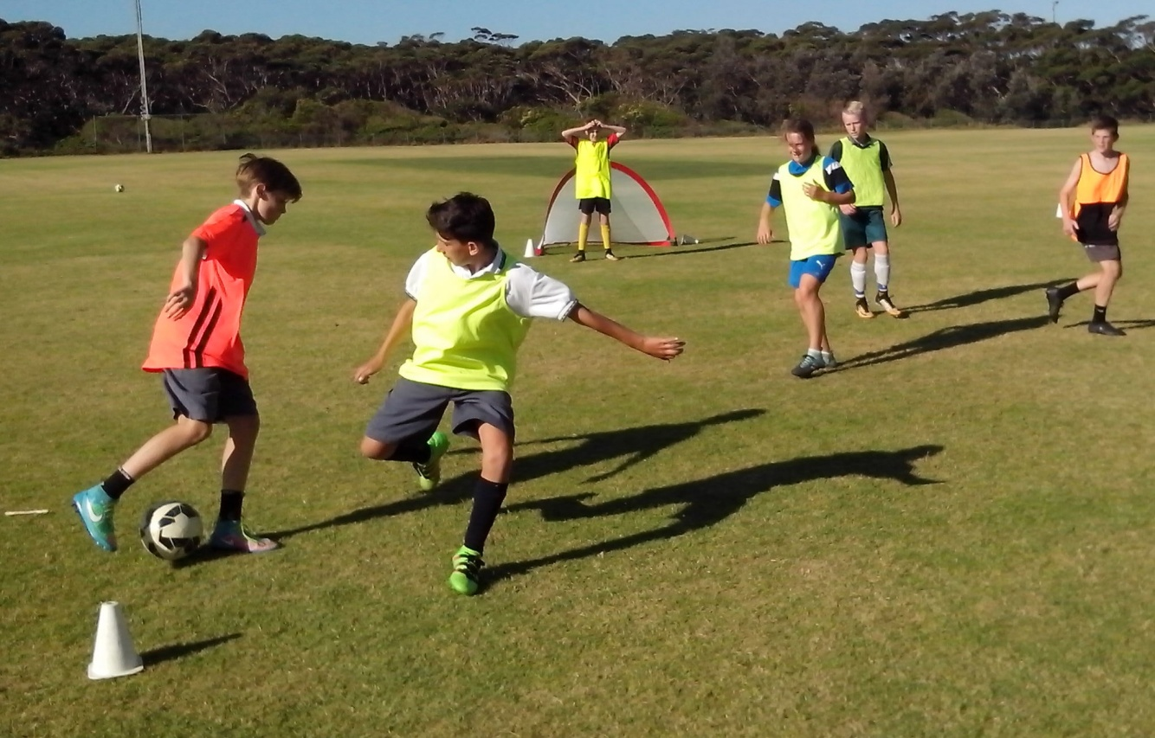

**MIND SKILLS**

***We all have eyes***, ***ears***, ***mouths and minds. We just need to open them.***

We all have intelligence. It’s what we do with it that counts. Mind skills include looking, listening, thinking, learning, understanding, remembering, asking, anticipating and making decisions.

We’re not helping kids by helping them. The more we think for players, the less they can think for themselves. If we give kids more responsibility, we can discover how smart they really are. Soccer innovation will come from the next generation.

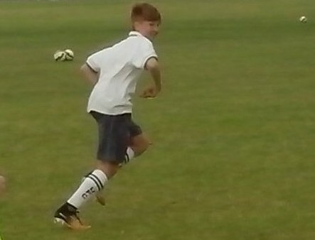

**SOCCER SKILLS**

***Kicking is a basic motor skill just like walking and running.***

Any kid can learn to kick a ball, trap a ball, screen, dribble, head and shoot. At a cognitive level, kids start with short and simple, slow and smooth drills so they can develop correct technique.

At the associative level, kids will move with the ball as they become more confident. At the intuitive level, kids will increase their speed, range, power and the degree of difficulty.

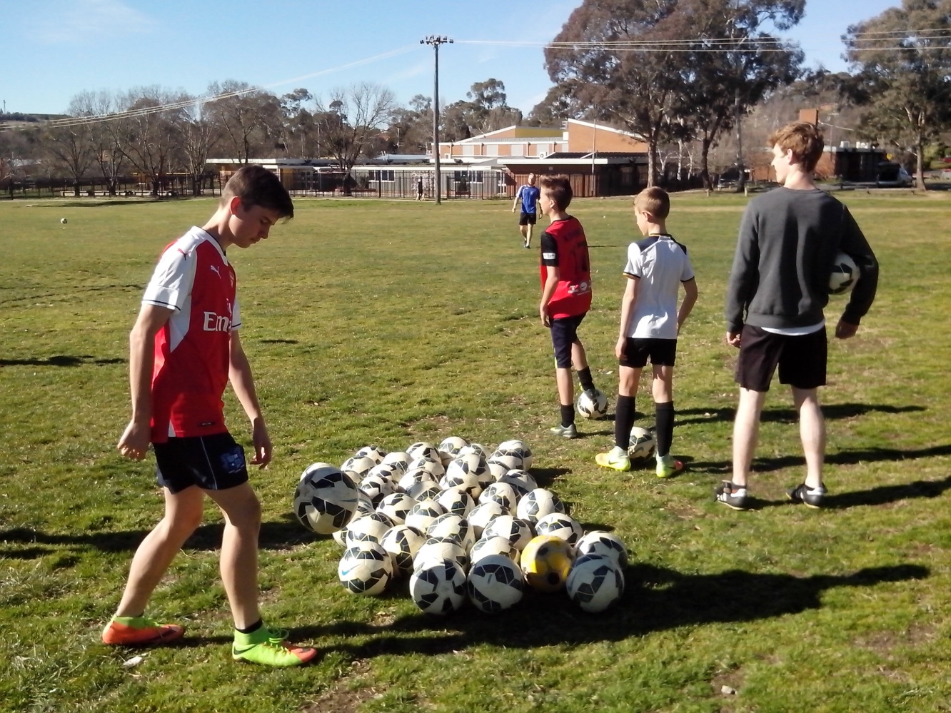

**REPETITION**

***Repetition is the key to skill development.***

It takes 200 ball touches for kids to evolve from the cognitive level to the intuitive level. Initial touches are too hard or too soft, too high or too low, too early or too late, too fast or too slow, too loose or too tight, too left or too right. After 200 ball touches, the unforced errors will disappear.

Most Soccer kids never get enough ball touches to get past the cognitive level. What we teach is not always what kids learn. We make kids stand still so we can teach them to kick and then we can’t understand why they stand still to kick in a game.

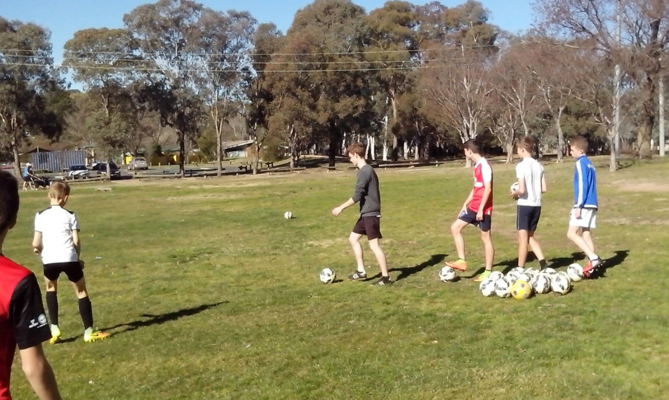

**FUSION**

***Look****,* ***think****,* ***move***, ***control. Mind****,* ***body and ball.***

Fusion is the synchronisation of mind skills, motor skills and Soccer skills. Close repetition drills are designed so that kids learn to look, think and move while they control the ball.

Kids who train on their own learn to keep on their toes and look around while they control the ball. Ballwork in pairs encourages kids to support and communicate with each other. We can teach kids to kick and shoot but they want to discover how to pass and score goals. We can teach them where to stand but smart kids want to learn where to move.

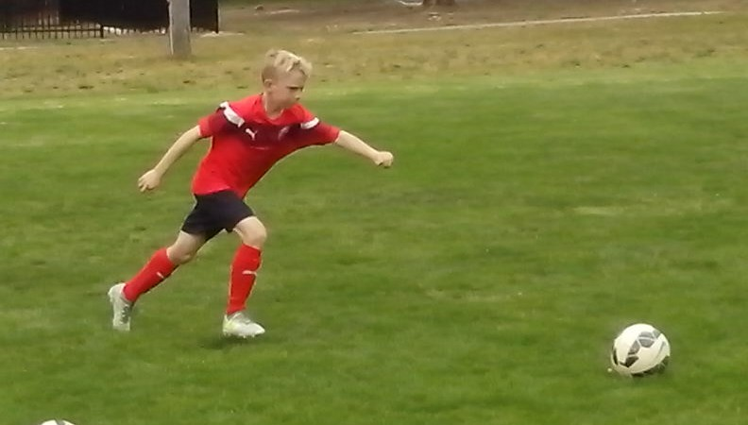

**BALL TOUCHES**

***European kids get 1000 ball touches a day and are one million steps ahead of Australian kids.***

The average Soccer kid gets 200 ball touches in a training session. The average Freestyle kid gets 200 ball touches before training so that they’re ready to train.

Kids who stand in a firing line waiting to shoot at goal get one shot at it every 2 minutes. A Freestyle kid can get 200 ball touches in 2 minutes just by juggling or kicking against a wall. A lot of kids kick a ball and then stand still and admire it. Kids need to pass and move, give and go, hit and run.

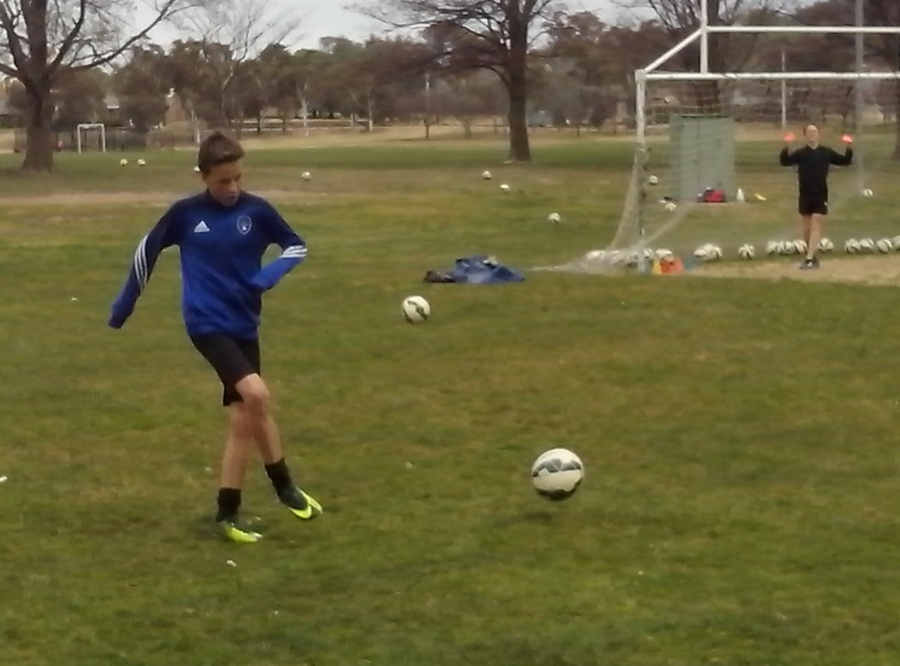

**FREESTYLE KIDS**

***Freestyle kids use skate parks, BMX tracks, surf beaches, basketball courts and cricket nets.***

Freestyle kids train without adult supervision so they’re forced to develop their own motor skills and mind skills. They have to think for themselves*,* create their own moves*,* speak up for themselves*,* express themselves*,* run their own drills*,* make their own decisions*,* make mistakes*,* learn from them and move on. Freestyle kids develop respect responsibility resourcefulness and resilience.

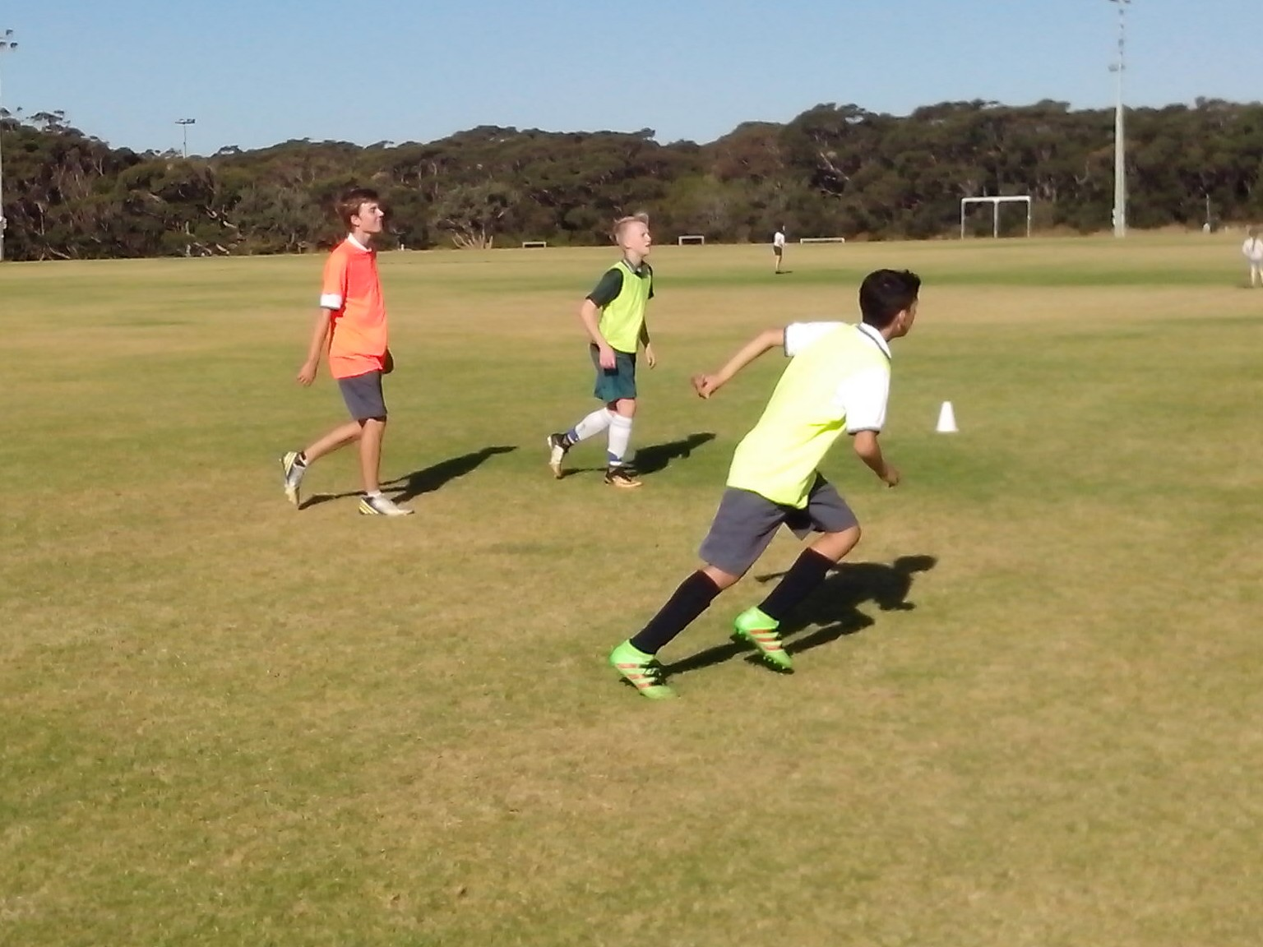

**FREESTYLE SOCCER KIDS**

***Freestyle Soccer kids practise ball skills on their own or with their mates without being told.***

Freestyle Soccer kids need a training environment where they can run their own drills*,* create their own skills and invent their own tricks just like all the Australian Freestyle kids in other sports.

Every Soccer kid needs the freedom to think for themselves*,* make their own decisions and challenge their limits without direction*,* correction*,* protection or rejection from well meaning adults.

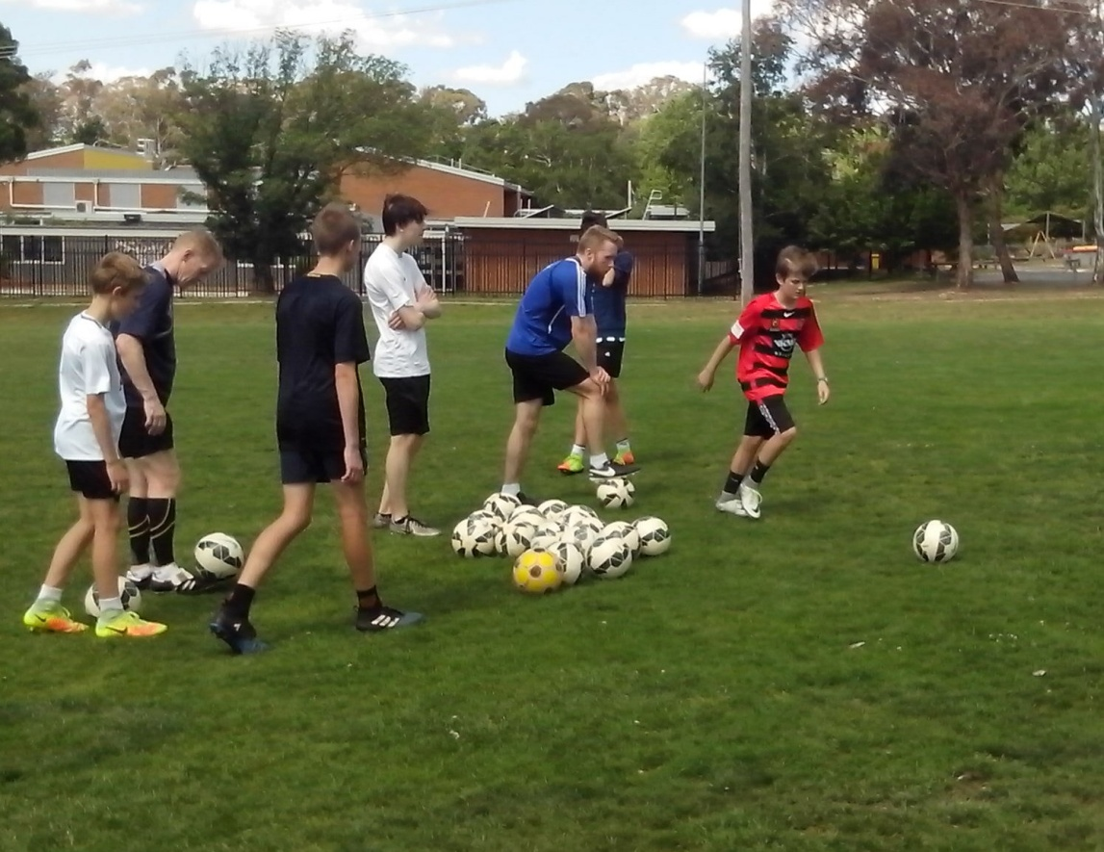

**FREESTYLE SKILLS**

***Freestyle skills fuse motor skills with mind skills.***

There are ten Freestyle skills. Footwork and vision help kids to strike the ball. Power and precision teach kids how to strike the target. Movement and decision show kids how to support the ball player.

Belief and repetition enable kids to improve their close control and challenge and intuition allow kids to identify and aim for the next highest level. Freestyle skills enable kids to use their initiative.

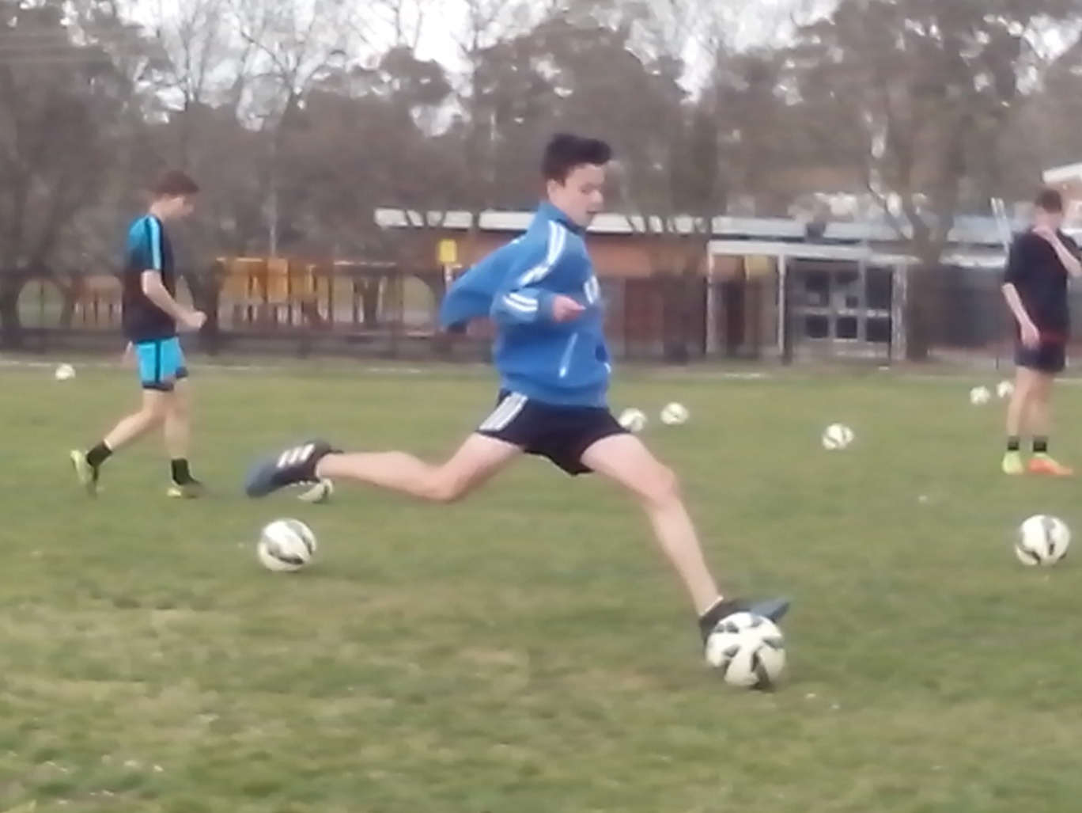

**MATCH PREPARATION**

***Soccer kids need at least 200 ball touches before they’re ready to play a game.***

Kids who stand in a circle sharing one ball with the rest of the team*,* before kickoff*,* will each get about 20 ball touches and then spend the next 20 minutes making a lot of unforced errors.

It takes 200 ball touches to reach the intuitive level where eye/foot coordination kicks in. Freestyle kids use close repetition drills in pairs to warm up before a game so that they learn to look, think, call and move while they aim for the intuitive level.

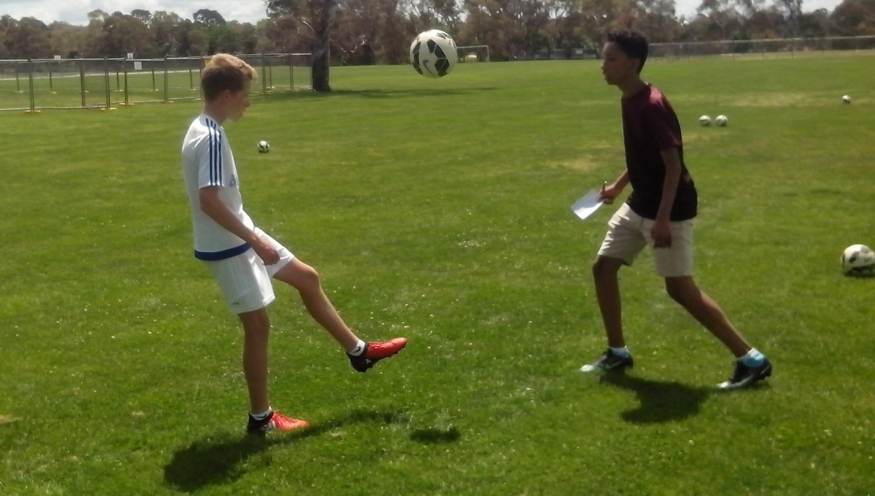

**JUGGLING**

***A competent juggler makes 100 decisions, takes 100 steps and gets 100 ball touches in 2 minutes.***

When kids juggle a ball thirty times, their last ten numbers add up to a lot more than their first ten numbers. That’s how repetition improves kids. Any coach can discover that just by keeping count.

At the cognitive level, kids have stiff, straight legs so that they stab at the ball. At the associative level, they relax and bend their knees so that they kick through the ball. At the intuitive level, kids have quick reflexes, fast moves and sharp control.

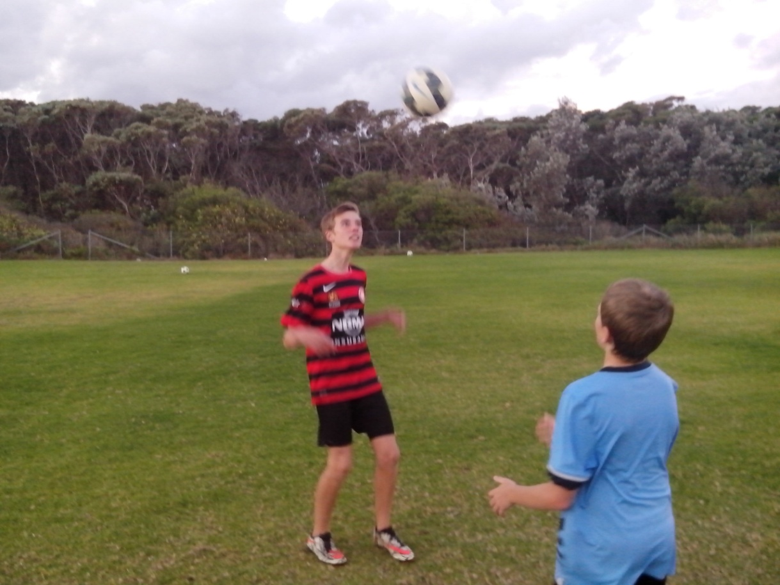

**JUGGLING CIRCLE**

***When talented kids juggle a ball in a circle, they can’t put ten passes together without dropping it.***

Players look good when we tell them where to stand, how to think and what to do but they look lost when they have to think for themselves.

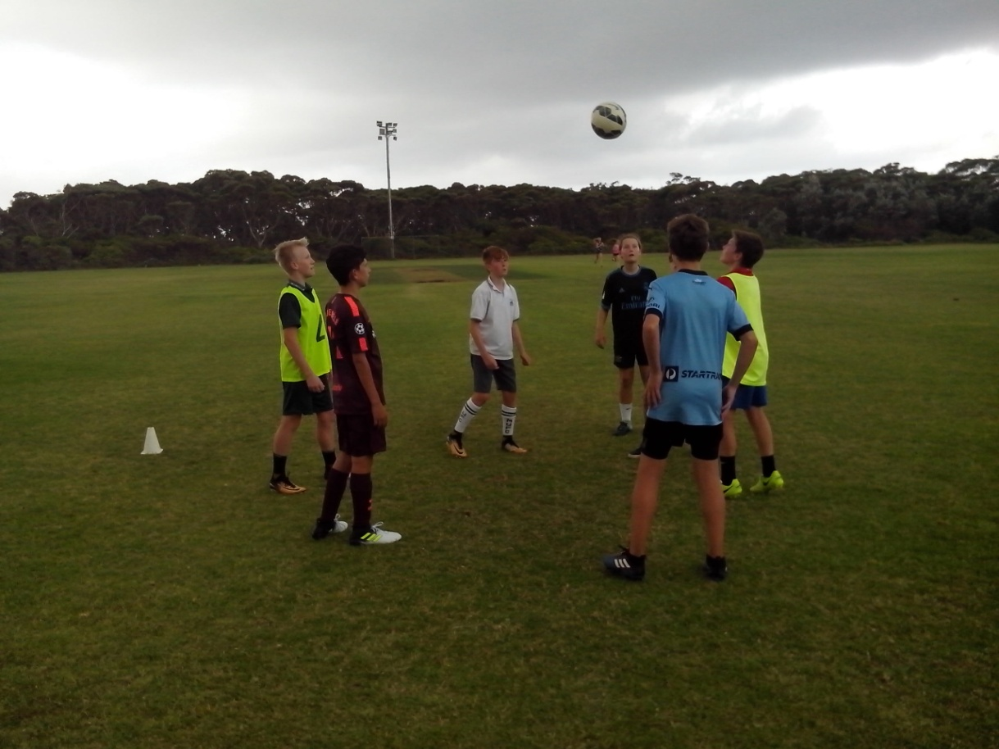

A Juggling Circle takes 5 minutes to identify how kids use their motor skills and mind skills. We’re teaching perfect ball technique to kids who don’t know how to move their feet, where to move, what to think about, what to look at when they kick a ball or what to call when they want the ball.

**FREESTYLE HQ**

***A coaching system teaches Soccer skills. A learning program identifies human qualities.***

At grading, we look for skill and fitness and later we discover that the skilful player is too selfish to pass the ball and the fit player is too lazy to run for it. A learning program looks at players and looks for the human qualities that indicate unique talent.

When we learn about Soccer kids and search for their talent, we can explore character, intelligence, mindset, mobility, self control, understanding, team spirit, drive, creativity and growth.

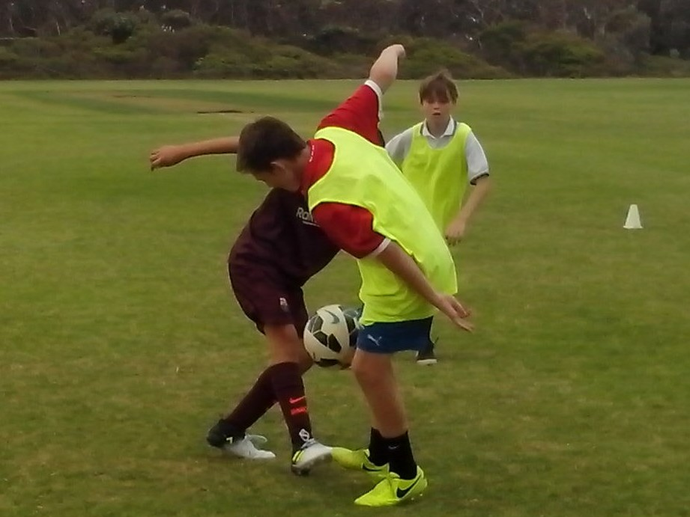

**TOP 20**

***Australia already has the talent to become a Top 20 Football nation. We just need the confidence.***

Kids need their motor skills and their mind skills to maximise their Soccer skills. They can’t kick a ball if they don’t know how to move their feet and they can’t kick a goal if they don’t know what to look at when they shoot. Kids need to move if they want to improve and they need to believe if they want to achieve. Any kid can learn to kick a ball. The development of the complete player depends on their human qualities, human intelligence, human movement and human behaviour.

