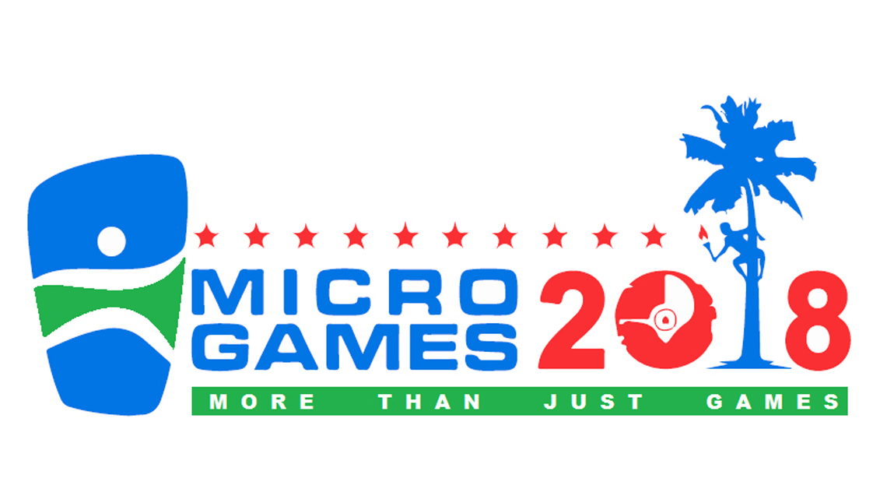

**SPEARFISHING**

**COMPETITION MANUAL**

**2018 Micronesian Games**

July 15-27, 2018

2018 Micronesian Games Organizing Committee

P.O. Box 631 • Colonia, Yap FM 96943

E-mail: 2018microgames@gmail.com

**SPEARFISHING**

Dates: Monday and Tuesday, 16 and 17 July 2018

Venue: Marina Sports Bar and Grill

Technical Meeting 1:00 pm Sunday 15 July 2018

*Tournament Director Details*

Competition Director: YapCAP (Environment Section)

Contact 1: (691) 350-2198

E-mail Address: [yalon88@gmail.com](mailto:yalon88@gmail.com) / [lancesulog@gmail.com](mailto:lancesulog@gmail.com)

**COMPETITION DETAILS**

**1. Technical Committee**

1.1 The 2018 Micronesian Games Spear Fishing Technical Committee shall consist of two representatives from the host country and one representative from each of the competing islands all with voting rights. There is no international federation for this sport. The Technical Committee shall elect its own chairperson.

1.2 The Technical committee is responsible to ensure that the 2018 Micronesian Games Spear Fishing competition is conducted in accordance with the technical rules and regulations of the competition, as established by the Organizing committee, as well as to oversee the competition schedule and rule on any and all protests brought to its attention.

**2. Technical Committee Meeting**

2.1 It is proposed that the Spear Fishing Technical Committee Meeting be held on Sunday 15 July 2018, at 1:00p.m., at a site designated by the Tournament Director. As soon as all entries from participating islands are submitted, the final confirmation of the date, time and place of the Technical Committee Meeting will be communicated to all participation countries.

**3. Competition Date/Venue**

3.1 The 2018 Micronesian Games Spear Fishing competition will be held on Monday and Tuesday 16 and 17 July 2018. All participants will assemble at Marina Sports bar and grill for briefing before heading out to the respective fishing zones designated by the Competition Director.

**4. Competition Schedule**

July 15, 2018 Sunday 1:00pm - Technical Meeting

July 16, 2018 Monday 8:00am - Day 1 Competition (Individual Event)

July 17, 2018 Tuesday 8:00am - Day 2 Competition (Team Event)

July 17, 2018 Tuesday 5:00pm - Medal Award Ceremony

**5. Winning Criterion**

5.1 The event is strictly a **“Free Dive”** underwater fishing competition. The objective is to catch and land the highest combined weight of fish.

5.2 Individual Competition: The athlete with the heaviest total weight of fish caught and landed will be selected for the Gold Medal, the second for the Silver Medal, and the third for the Bronze Medal. The spear fishing competitors **MUST NOT** combine their catch. Each individual must turn in his own catch. All competing countries must provide their own safety diver (1) throughout the competition. An alternate athlete may serve as a safety diver, but as noted above, no safety divers may assist a competitor in the capturing or landing of any fish.

5.3 Team Competition: A team consists of two athletes and one alternate representing a country. The team with the highest combined total weight of fish caught and landed by its two athletes and one alternate will be selected for the Gold Medal, the second for the Silver Medal and the third for the Bronze Medal. All competing countries must provide their own safety divers (2) throughout the competition. An alternate athlete may serve as safety diver, but as noted above, no safety divers my assist a competitor in the capturing or landing of any fish.

**6. Fishing Zone**

6.1 Fishing zones will be made known at the time the boats drop off all competitors. All fishermen will be taken to the same fishing zone each day. Anyone fishing outside the designated zone will be disqualified. A different fishing zone will be designated for each of the two days. All may begin fishing and must return to the boat before the end of five hours. Any fisherman still in the water after five hours on any day will be disqualified for that day.

**7. Weigh and Recording**

7.1 The weigh and recording of all catches will be handled by the event officials, but every fish being weighed must be confirmed by the Tournament Director.

7.2 All fish will be weighed individually. Each fish caught and turned in must weigh a minimum of 1 kilo (2.2lbs). Fish turned in which weight under 1 kilo will be disqualified.

7.3 Fishermen are required to bring in a catch from various species of reef fish and pelagic species such as Tuna and Marlin. Napoleon Wrasse, Humphead Parrotfish, Porcupine, Balloon Fish, and Cartilaginous fish such as Sharks, Turtles or Rays are NOT ALLOWED.

**8. Eligibility**

8.1 In order to be eligible to compete at the Micronesian Games, an athlete must comply with one of the following criteria:

(1) The athlete must have been born in any state, country, or territory which is a member of the Micronesian Games Council -- that is, Palau, Guam, the CNMI, Yap, Chuuk, Pohnpei, Kosrae, the Marshall Islands, Nauru, or Kiribati -- and must have lived in any of those states, countries, or territories for a period of three years up to and including the start of the Games; OR

(2) The athlete must be the child of at least one parent, or two grandparents, who were born in any state, country, or territory which is a member of the Micronesian Games Council (see above), without regard to residence; OR

(3) The athlete must have resided in any state, country, or territory which is a member of the Micronesian Games Council (see above) for a period of seven years up to and including the start of the Games, AND, resides in the state, country, or territory for which the athlete will compete, as of the start of the Games, without regard to ancestry.

The temporary absence of an athlete from the territory of a member of the Micronesian Games Council for purposes such as education, sports, training, military service, and health care, or other legitimate absences of a similar kind, are not considered as interrupting a previously-established residency.

In addition, athletes must:

(a) Complete all necessary entry and participation forms;

(b) Not be currently under disqualification or suspension by any relevant authority;

(c) Comply with all relevant rules and regulations of the Micronesian Games Council, the MGC Constitution, and the World Anti-Doping Code.

It is the responsibility of each participating state, country, or territory to ensure that all competitors comply with these requirements.

These requirements apply only to athletes. There are no eligibility requirements for coaches or technical officials.

Entries by name must be submitted at least 30 days prior to the start of the Games. Late entries will not be accepted. At the close of entries, the Yap Organizing Committee will communicate a list of all named competitors to each competing state, country, or territory. Each competing state, country, or territory will have ten days to challenge the eligibility of a competitor. A $50 bond is required for each challenge. The bond is refundable if the challenge is successful, but is forfeited if the challenge is unsuccessful.

The burden of proof of eligibility is on the sponsoring state, country, or territory, rather than the challenging state, country, or territory. In the event of a challenge, the sponsoring state, country, or territory must submit documents proving eligibility.

Challenges to athlete eligibility are made to the Micronesia Games Council Executive Board, not to the Yap Organizing Committee, which will refer them for decision by a Disputes Tribunal, consisting of three persons appointed by the Micronesia Games Council Executive Board. All challenges to eligibility shall be decided at least 10 days prior to the start of the Games. The decisions of the Disputes Tribunal are final and may not be appealed.

A state, country, or territory whose athlete is successfully challenged and is deemed ineligible to compete will be liable for a penalty in the amount of $100. Failure to pay the penalty means that the state, country, or territory will not be allowed to compete in the sport in which the ineligible athlete was registered.

The contents of this section are a summary of the relevant provisions of the Micronesia Games Council Constitution. While every attempt has been made to assure the accuracy of this summary, in the event of any inconsistencies between this summary and the provisions of the Micronesia Games Council Constitution, the provisions of the Constitution shall be controlling.

**9. Competition Rules**

9.1 All Spear Fishing competitors must meet the Eligibility Requirements as specified in the Micronesian Games Charter.

9.2 All Spear Fishing competitors must check out and check in at the Official Weigh Station.

9.3 All spear fishing athletes must be officially registered for the event competition prior to the checkout time at the Official Weigh Station.

9.4 Each boat in the event competition must at all times have a monitoring official on board during the entire fishing activity.

9.5 All athletes, fishing gear, and boats must be inspected by the Competition Director prior to leaving the Check Out Station.

9.6 The acceptable minimum weight for each single fish is 1 kilo (2.2lbs). Each fish that is less than 1kilo (2.2lbs) will be disqualified.

9.7 Fish can only be caught using a spear gun that has officially been inspected and certified by the Tournament Director.

9.8 Each athlete can possess no more than two (2) spear guns and (2) spears which must be certified by the Competition Director. Only spear guns powered by rubber may be used during the spear fishing competition. An athlete may not have more than one spear gun in the water at any time during the competition. Any competitor losing all two spear guns may not continue with the event competition.

9.9 Spear fishing competitors are allowed to use an underwater dive mask, a snorkel, a pair of fins, a weight belt and a diving knife. They may use any type of clothing such as wet suit or any type of shorts or trunks.

9.10 No spear fishing competitor is allowed to use any type of underwater breathing apparatus such as scuba or other mechanisms or gadgets. This event competition is strictly **“FREE DIVE”.**

9.11 Spear fishing competitors are allowed to use string and approved floaters for the purpose of holding speared fishes only.

9.12 No person may assist a competitor in the capturing of a fish. Any person may assist a competitor in any life-threatening or emergency situation only.

9.13 Competitors are only allowed to fish inside the established fishing zone.

9.14 Competitors may not be under the influence of either alcohol or any illegal substance(s) during the event competition.

9.15 Competitors must abide by and respect the judgment of their boat operator/captain in safety situations, such as how close to the reef the operator is willing to go, or how fast the boat should travel.

9.16 The failure to follow any of these rules will be grounds for disqualification of a competitor.

9.17 Any disagreement with officials must be respectfully voiced by the team captain or coach at the time it occurs. At the end of the event, a team captain or coach may confirm an expressed disagreement as an official protest by recording it on the score sheet. Protest should be recorded within thirty (30) minutes after the end of the event. Otherwise, the team captain or coach should sign the score sheet to ratify the outcome of the event.

**10. Team Composition**

10.1 Teams will consist of a maximum of 3 athletes and 2 coaches. Only 2 athletes can compete in both the team and the individual events.  The third athlete acts as a safety diver only.  In the event of an injury, the safety diver can then compete but only after approval of the Spear Fishing Competition Director.  Of this number, it is recommended that at least two members of the team are skilled safety divers.

**11. Protests to the Jury of Appeal**

11.1 Any written protest, verbally notifies the Competition Manager that a protest has been lodged and forwards the written protest (in English and sign by the leader of the delegation or the authorized deputy). A check or cash in the amount of $100.00 must be included with each protest.

11.2 The Jury of Appeal shall consult, all relevant person, including the Referee and Judges. If the Jury of Appeal is in doubt, other available evidence may be considered. If such evidence, including video evidence, is not conclusive, the decision of the Referee shall be upheld. The Jury Chairman gives the jury’s decision to the Competition Manager, who institutes preparation of an Amended Result, if required.

**12. Doping Control**

12.1 Athletes are advised that random drug testing will be conducted for the duration of the 2018 Micronesian Games.

12.2 It is the responsibility of the athlete to check the status of all medications and refrain from using prohibited substances. Any athlete that tests positive for a prohibited substance will be disqualified from the 2018 Micronesian Games.