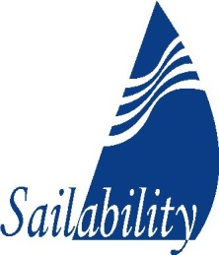

WA Inc

ABN: 55 221 846 727

Address
Australia II Drive,
CRAWLEY
Western Australia 6009

Postal Address
PO Box 5,
NEDLANDS
Western Australia 6909

Mobile 0404 145 499

Email
sailability@rpyc.com.au
Website
www.sailabilitywa.com.au

Sailability WA Inc. is proudly
supported by

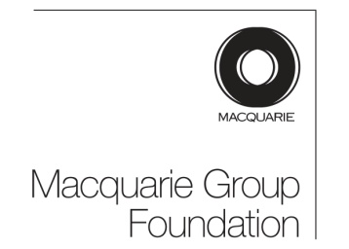

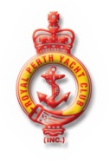

SAILABILITY WA INC

DONATION FORM

Donor Name: ...…………………….…………………………....................

Donor Organisation: .................................................................................
(If applicable)
Address: ...………………………………………………………………….

Suburb: ………………..…………………… ............ Postcode: .………...

Telephone number: ……………………...................................................

Email: ......…………………….............................................……………....

Donation amount: ..................................... Date: ……………………….…

Donor Signature: ………………………......................................................

Donation received on behalf of Associated Sailability Program:

(Please specify): ...............................................................................................................

.............................................................................................................................................

Thank you very much for your donation to Sailability WA Inc. Your funds will be forwarded to the above selected recipient.

As Sailability WA Inc is a ‘Not for Profit’ Incorporated Association, donors will be issued with a tax deductable receipt.

Payment options:

Cheques to be made payable to: Sailability WA Inc
(Postal address on side panel)

Internet payments may be made to:

Sailability WA Inc
National Australia Bank
BSB: 086 164
Account number. 454254259
(Please put surname or Organisation name into deposit details.)

NOTE: No cash payments please.

(Sailability WA Inc use)

Payment type: ……………………. Receipt No.: ……………………….

Donor contacted: ............................... Date: .............................................

