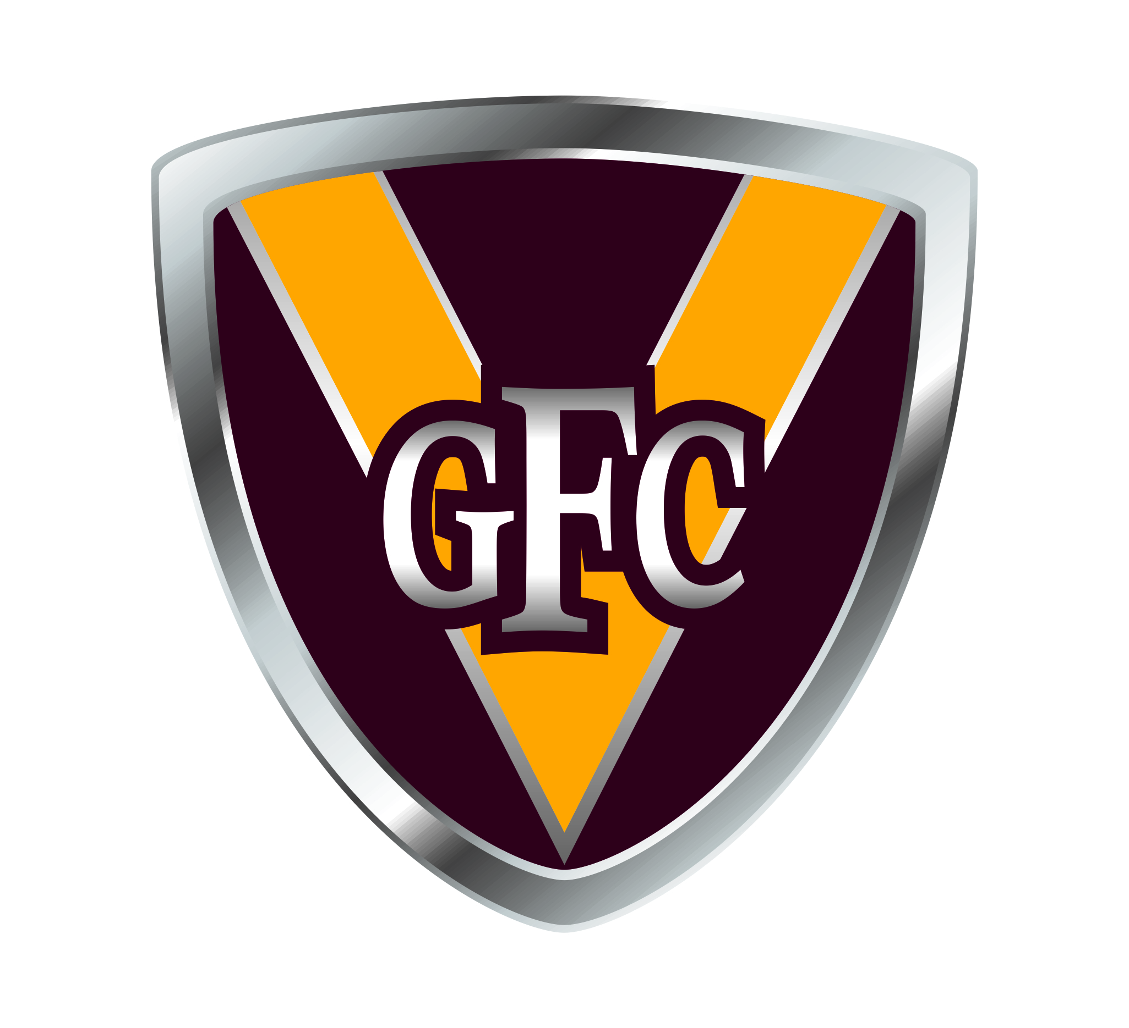 

**Glencoe Football and Netball Club’s Social Calendar - 2017 Season**

|  |  |  |  |
| --- | --- | --- | --- |
| **Day/Date** | **Home & Away Games** | **Social Event** | **Teas** |
| Saturday 29 April | Glencoe vs Kalangadoo | - | Teas at the club |
| Saturday 6 May | Port MacDonnell vs Glencoe | - | Teas at the South Aussie |
| Saturday 13 May | Glencoe vs Kongorong | Shuffle Night | Teas at the club |
| Saturday 20 May | Hatherleigh vs Glencoe | - | No teas |
| Saturday 27 May | Glencoe vs Mount Burr | Dress Up – 80s Theme | Teas at the club |
| Saturday 3 June | Tantanoola vs Glencoe | - | No teas |
| Saturday 10 June | ***Bye – South East Zone Carnival*** | - | No teas |
| Saturday 17 June | Robe vs Glencoe | - | No teas |
| Sunday 18 June | - | 50 Club | - |
| ***Saturday 24 June*** | ***Bye*** | - | No teas |
| Saturday 1 July | Glencoe vs Nangwarry | - | Teas at the club |
| ***Saturday 8 July*** | ***Bye – SA Country Championships*** | - | - |
| Saturday 15 July | Kalangadoo vs Glencoe | Variety Night | No teas |
| Saturday 22 July | Glencoe vs Port MacDonnell | Player Reunion and Auction Night | Teas at the club |
| Saturday 29 July | Kongorong vs Glencoe | - | No teas |
| Saturday 5 August | Glencoe vs Hatherleigh | Vegas Night | Teas at the club |
| Saturday 12 August | Mount Burr vs Glencoe | - | No teas |
| Saturday 19 August | Glencoe vs Tantanoola | Last Minor Round Function/Party | Teas at the club |