Volunteer Levy and Sibling discount
Since registration and fees are managed through the MyFootballClub web site, every player will have this levy built into their fee paid online. Rebate process as following:
Families with second and subsequent players are entitled to an immediate rebate of Sibling discount $30 and volunteer levy $65.
Families with just one child who are willing to volunteer please follow process below:
1) At the payment part of the registration click on tab – PURCHASE ADDITIONAL ITEMS
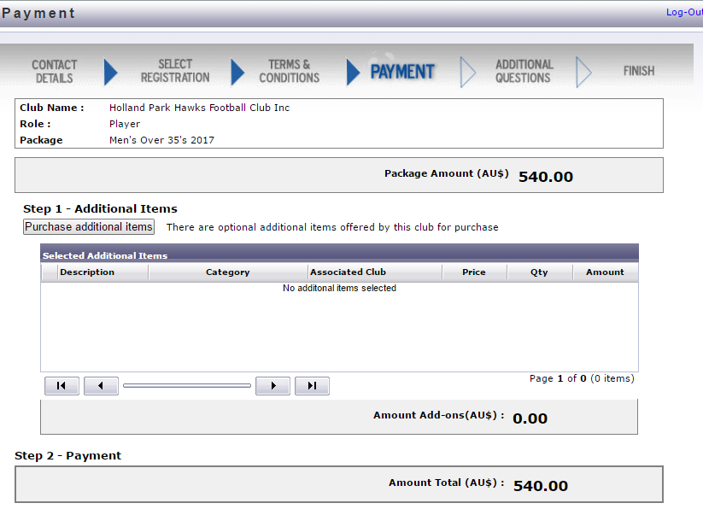
2) Select VOLUNTEER LEVY DISCOUNT by ticking the box and then press UPDATE ORDER tab.
Primary Child selects only Volunteer Levy Discount of -$65 that is going to be deducted of their registration.
Every other Child in the family is entitled to receive Sibling Discount on the top in final deduction of -95 of the registration.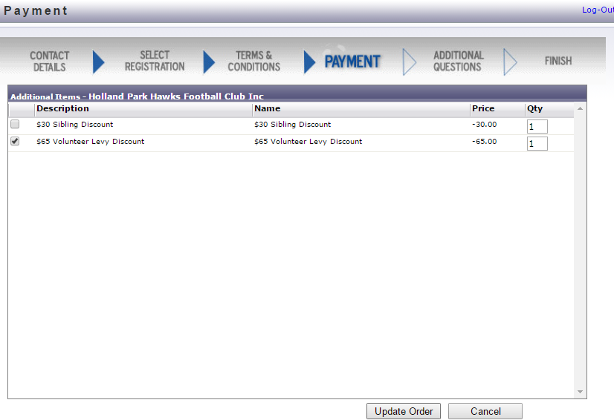
3) Registration will now be without Volunteer Levy. Clicking on payment options (Pay online/Pay manually at the club) will take you to payment part of the registration that includes ADDITIONAL QUESTIONS
Primary Child:
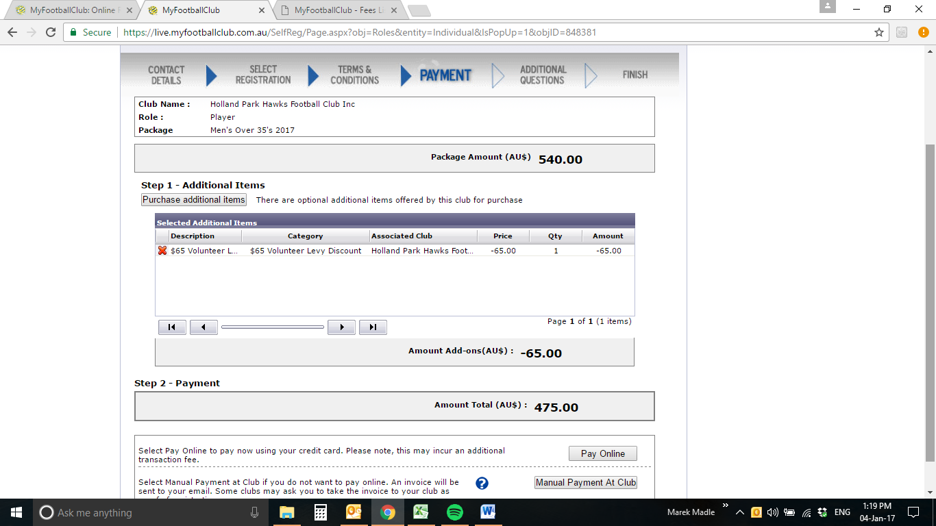
Any other siblings:
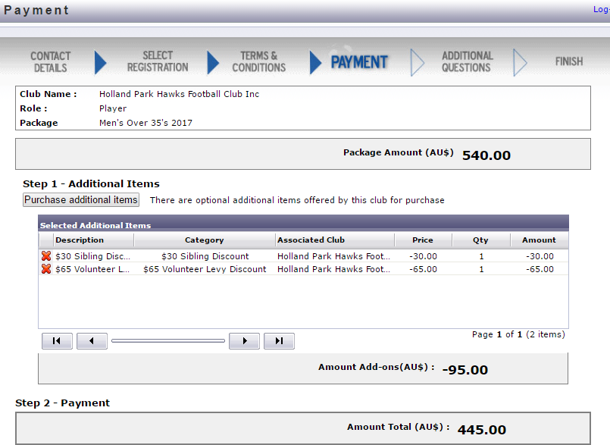
4) Select your role and Press Save All Answers – Only applies to the primary registration. If you are claiming the sibling discount you DO NOT need to answer additional questions again.
