# Receiving the ball under pressure

## By Tony Carr

This session is designed to improve your players' technique so they are confident to receive the ball under pressure. Individual practices will help develop a player's technique before putting them under pressure while in possession of the ball.

We naturally coach players' technical skills in isolation. This is to develop the key skills properly so the technique is learned correctly.

However, this technique has to be developed by using the same pressure players are going to face in a match. Lots of players can play without pressure but only the best players can perform in match conditions.

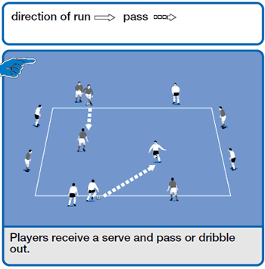

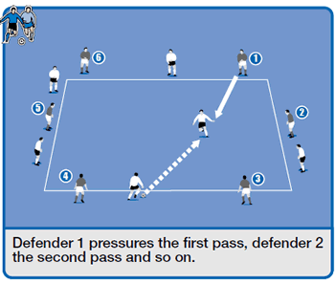

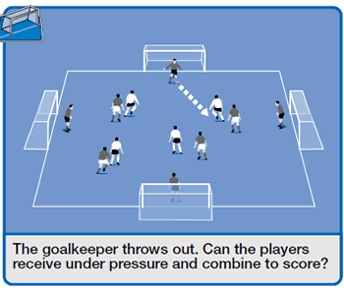

## How to set it up

Mark out a 20-yard square for the session and development, expanding to a 30-yard square for the game.

## How to play it

The server passes the ball to a player in the centre of the area who must look over his shoulder before receiving the ball and then dribble or pass out to a new player.

The server now becomes the new central player. This practice can be progressed by making the player control a bouncing or lofted ball.

## How to develop it

One team works on receiving skills and one team works on defensive pressuring techniques. The team working on receiving continues to do the same things as in the previous practice. However, this time they are under pressure from a "defender" who comes onto the pitch from different angles.

The defending players are numbered and take turns to apply pressure to win possession. The only rule is the pressuring defender must not enter the pitch until the serve has been made.

The receiver must look up and know where to make the first touch to take the ball away from the defender and keep possession.

## How to play it in a game

The goalkeeper in possession passes to one of the teams. The team that has the ball can score past any goalkeeper except the one they have received the ball from.

This means it receives the ball under pressure and then retains possession in order to try and score a goal. If the defending team wins possession, it tries to score against the starting keeper.