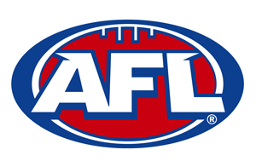

**VICE PRESIDENT**

**ROLE DESCRIPTION**

**Objectives**

* To oversee all football related matters across the Club
* To provide support to the President of the Club
* To provide leadership to all football coaches, players, support staff and

volunteers

* To provide support to the Committee members to ensure the efficient

operation of the Club

* Ensure Club Umpires are recruited, supported and developed

**Responsibilities**

VICE PRESIDENT

ROLE DESCRIPTION

* Ensure the effective and efficient operation of the Committee and all

football operations

* Ensure that all sectors of the Club football operations are managed

effectively and efficiently so that on field performance is maximised

* Ensure that all coaches and support staff are carrying out their duties and

provided with support as required

* Oversee recruitment of coaches according to policies outlined by the Committee
* Provide support to players if needed
* Oversee the Umpires and provide support/training as required to

Umpires

* Appoint umpires to weekly home matches
* Ensure all club umpires are correctly attired according to league regulations
* Keep the Cougar website up to date and modern
* Preside over meetings in the absence of the President
* Undertake tasks at the request of the President or Club Committee
* Assist other Committee members in their duties as required

**Accountability**

* Reports to the President
* Reports to the Club Committee
* Liaises with official Club suppliers and other key stakeholders
* Provide a verbal update at the monthly Committee meeting
* Seek approval from the appropriate Committee member prior to

committing the Club to any action or financial cost