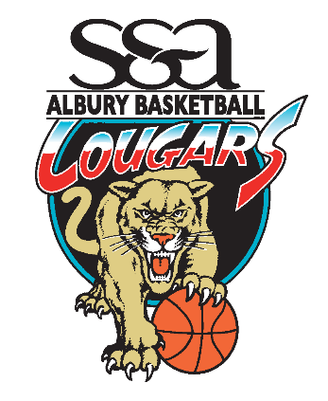

**Appointment of the Albury Cougar**











**Representative Coaches for the 2020 Season**

The ABA Board and Coaching Committee would like to thank those people that applied for Rep Coach roles for the upcoming Representative Season. Without the support of the people that volunteer to be involved we could not provide such a fantastic program for our young athletes.

The Board and Committee would like to congratulate the following applicants on their successful appointment to:

**Girls– Age Group Lead Coach**

* Under 12 – David Blakemore
* Under 14 – Matt Whitfield
* Under 16 – Shane Strang
* Under 18 – Craig Robinson

**Boys – Age Group Lead Coach**

* Under 12 – Bec Hall
* Under 14 – Clinton Lowe
* Under 16 – Peter Bauerle
* Under 18 – Andrew Harris

In addition to the above appointments the following applicants will be offered coaching roles consistent with their nominated preferences as we move closer to the Representative Season.

* Maxine Babinski
* Brett Biles
* Carla McFaull
* Andrew Thomas
* Lisa Maginnity

We anticipate having more teams than the number of coaching applications received thus far but as with other years expect further applications once Rep Teams are named and parents make themselves available based on selections.

We are looking forward to another successful Representative Season.

TOGETHER WE ATTACK!

Regards

ABA Board and Coaching Committee