Queensland Annual Report 2014

2014 began sadly with the tragic passing in February of former QLD president and life member and national Hall of Famer Bruce Wolf Steensen.

From this tragedy came an overwhelming flood of support from the AFL Masters family nationwide, starting with his funeral which was attended by 2000 friends, followed by many local QLD club benefit days including a special commemorative match, and culminating in a national carnival where every state and territory remembered and paid tribute to Wolf.

Importantly, and as an acknowledgement to all that Wolf represented, AFL Masters formed a wonderful relationship with the Qld Homicide Victims Support Group to further their One Punch Can Kill campaign. More than $15,000 was raised throughout the year and this money will be used to educate young men in our communities and counsel and support victims’ families. 2015 will see QLD AFL Masters continue to support this program and have joined up with AFLQ to push this message to junior and senior AFL clubs across the state.

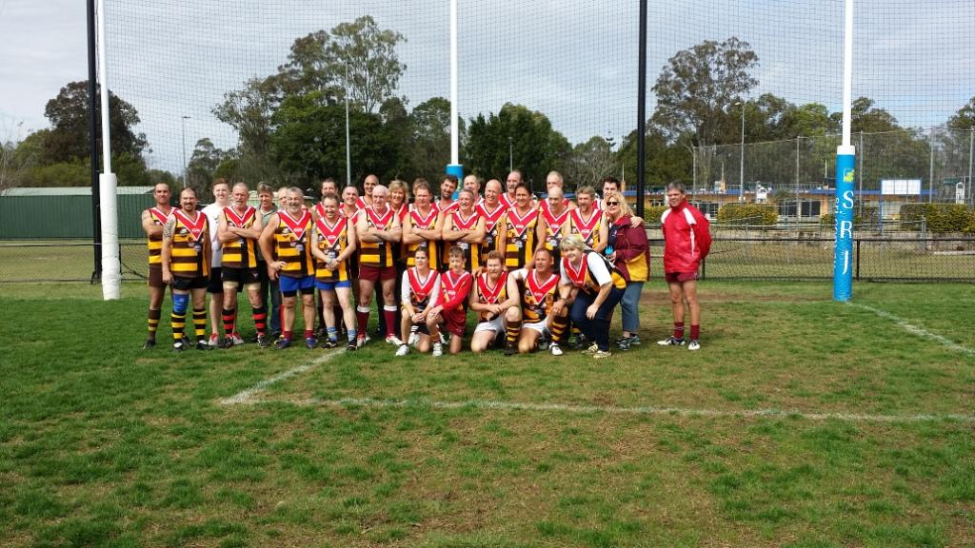
The 2014 Wolfs

Derek Delany and Steve Burchill continued as President and Treasurer and were joined by David Sullivan as Vice President at the AGM. A number of clubs appointed new club delegates and the 2014 year was underway.

North QLD continued their country carnival program and worked very hard to integrate AFL Masters footy into the wider community and introduce the game to as many Queenslanders as possible. The Metro competition continued with two age groups, over 35s and over 45s, and played a 12 round fixture throughout the year. New clubs from Jimboomba and Ipswich entered the competition and we look forward to their long association with AFL Masters. We continue to target new clubs that can fill a geographic void in both metro and country areas.

Throughout the year a new constitution was developed, adopted and registered. We also moved our match day management onto SportingPulse and see this as the future.

After what we considered to be a relatively poor performance by Queensland at the Darwin carnival, we were a lot more proactive in selecting coaches and recruiting players for Adelaide. Like Darwin, we thought the Adelaide carnival was professionally run and would like to acknowledge and thank Lou, Dean and the many people behind the scenes that put on a great week.

Adelaide saw the largest QLD contingent ever participate in a carnival outside of QLD. We had 123 players across six teams and many more families and friends join the party; and we hope we positively contributed to not only the carnival itself but the general SA economy. On the field we enjoyed great success with the 45s winning Division 1 and the 50s winning Division 2, but also the 35s, 40s and 55s performed well above expectations. All the credit must go to the coaches who put in a lot of time and effort to rally the troops and make sure everyone enjoyed their carnival experience. The coaches and All Australians for 2014 were:

- 35s, coached by Chris Harman – Jason Ellard, Adrian Hooper and Dan Nimmo.
- 40s coached by Leigh Stevenson – Craig Carman and Leigh Stevenson.
- 45s, coached by Paul Nowlan (Div 1) and Gavin Kearney (Div 2) – Gary Downes, Andrew Fidler, Phil Heers, Paul Nowlan, Gordon Oxenham, Richie Raeburn and Stephen Turner.
- 50s, coached by Steve Burchill – Derek Delany, David Sullivan and Paul White.
- 55s, coached by John Terrick– Neville Growden and John Terrick.

At the carnival, we were delighted to see Chris Guice become only the seventh Queenslander to be appointed to the AFL Masters National Hall of Fame for his outstanding service to the game across 22 years. Chris has been involved as a player, umpire and administrator at a club, state and national level and has had a major hand in developing AFL Masters football over the past two decades. We congratulate Chris and his best mate and wife Annette for a richly deserved honour.

The prestigious Superman of the Year award for 2014 went to Maurie Soars. Like Chris, Maurie has an inbuilt belief that the more you get involved in something the more you and others will get out of it. His passion and commitment to Masters footy in Townsville, North Queensland, Queensland and the carnival has significantly increased participation rates and bettered the game for everyone. Well deserved Mozza.

We look forward to further improving the experience of playing masters footy in QLD in 2015 and welcome all current and new players in joining us.

Finally, I would like to thank the current Queensland committee, all our club delegates and the national executive for their passion and drive to make AFL Masters football a game and an organisation to want to belong to.

AFL Masters – Footy for Fun, Fitness and Friendship.

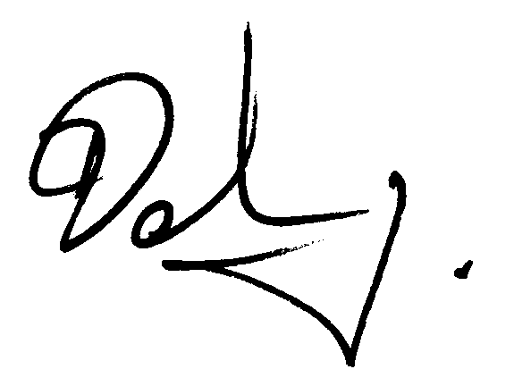

Derek Delany
Queensland President

