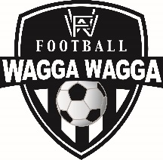

**WAGGA WAGGA & DISTRICT AMATEUR FOOTBALL ASSOCIATION Inc**.

**FOOTBALL WAGGA WAGGA**

Policy Number FWW-POL-012

Code of Conduct for Meetings

Version 0.1

This Code applies to all participants at Football Wagga Wagga meetings including, but not limited to:

1. Board Meetings
2. General Meetings
3. Council of Clubs Meetings
4. Meetings of any Football Wagga Wagga subcommittee
5. Referees Branch Meetings

**Conduct**

Personal behaviour – I will:

* act ethically and with integrity.
* act according to Football Wagga Wagga regulations, policies and ethical codes that apply.
* make decisions fairly, impartially and promptly, considering all available information, policies and procedures.
* treat other members at the meeting and all members of the football community with respect, courtesy, honesty and fairness, and have proper regard for their interests rights, safety and welfare.
* not harass, bully or discriminate against members.
* contribute to a harmonious, safe, productive and professional environment.

Conflicts of interest – I will:

* manage and declare any conflict between my personal and member duty.
* where conflicts of interest do arise, ensure they are managed in the public interest.

I am committed to upholding the principles in the Code of Ethics. I accept the minimum requirements set out in this Code of Conduct. I accept that the Chair has the full authority to enforce this Code of Conduct.