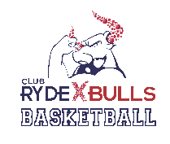

**RYDE BULLS BASKETBALL LTD**

**RISK WARNING**

You should be aware that there are risks of injury associated with playing basketball, as there are with most sports. Risks will arise in the context of the activities of running, jumping, catching, throwing and guarding opposition players. While we aim to minimise risks, it is not possible to eliminate them all.