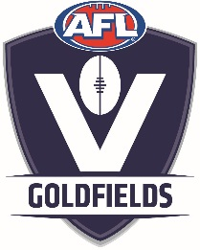****

**AFL Goldfields Junior Football Academy – proudly supported by the Western Bulldogs and McDonalds Ballarat**

**2018 – 2019 Medical Form**

Name: ……………………………………………………………………………………………………………………………………

Academy Age Group: …………………………………………………………………………………………………………….

Age & Date of Birth: ………………………………………………………………………………………………………………

Club You Play For: …………………………………………………………………………………………………………………

Position You Normally Play: ………………………………………………………………………………………………….

Any Medical Condition The coaching Staff Should Know, eg Asthma etc

………………………………………………………………………………………………………………………………………………………………………………………………………………………………………………………………………………………………

Any serious injuries sustained playing football or other sport, eg Concussion etc

………………………………………………………………………………………………………………………………………………………………………………………………………………………………………………………………………………………………

Parents names and contact numbers in case of an emergency:

………………………………………………………………………………………………………………………………………………………………………………………………………………………………………………………………………………………………

Other information:

………………………………………………………………………………………………………………………………………………………………………………………………………………………………………………………………………………………………………………………………………………………………………………………………………………………………………………………………………………………………………………………………………………………………………………………………

Singlet size: (Please circle – where possible we will provide size nominated)

Small Medium Large X Large