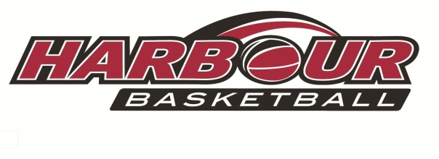

**Harbour October Holiday**

**Basketball**

**Camp**

**with Coach Kevin Braswell**

Monday October 2nd

Tuesday October 3rd

Wednesday October 4th

**North Shore Events Centre**

 9am-3pm Each Day

 PitaPit lunch provided (included in cost)

Recommended Ages 7-14

Register now thru the Harbour

Basketball website!

Cost: $150 for three days.