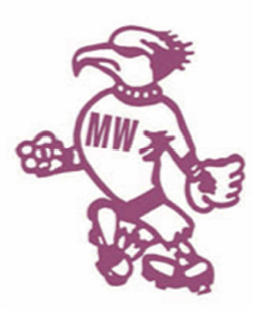

MWSA OZPITCH 2016
Friday night social competition
OzPitch is a recreational softball program for anybody wanting to have fun, increase their physical activity and is looking for the social aspects of a team sport. It is a mixed gender competition for adults young and old (as long as they are over 18) which caters for all skill levels.

COME TRY NIGHT & REGISTRATION 7th October 2016
Cost: $40 per player (to be paid in cash on registration night)
When: Comp runs for 6 rounds starting from Friday 7th October 2016
Time: Two timeslots - 6:30pm and 7:45pm - the games are 1 hr and 15 min.
Where: Abbott Rd Softball Fields, North Curl Curl
Who: Anyone over the age of 18 - no experience necessary
Teams: You can enter as a team, if you don’t have a team, we can find one for you.
Uniform: No uniforms are required, although some team have a common t-shirt.
Equipment: There will be gloves and bats at each diamond - NO METAL CLEATS ALLOWED
Rules: Basically hit and run. The actual rules are listed on the MWSA website (www.mwsa.com.au)

Welcome to our new sponsors Sew and Sew
http://sewandsewwines.com.au/
WET WEATHER
In the event that games are cancelled due to wet weather, an SMS & Email will be sent to team managers – and a notice put up on the MWSA website. It is the responsibility of the team managers to coordinate communication with their teams.
TEAM SHIRTS
If you'd like to organise team shirts (not compulsory) Graeme at Uniform Image always looks after us and can help you get some shirts printed up in your team colours. You can email him: enquiries@uniformimage.com.au or call him on 0411-112-266
Questions? Email Jess - ozpitch@mwsa.com.au

TEAM REGISTRATION FORM
Team Name
Manager Name |  | Manager Email |  | Manager Mobile

ID | First Name | Last Name | Email | Mobile | MWSA ID  (Admin only)
1
2
3
4
5
6
7
8
9
10
11
12
13
14
15
Please email team list to ozpitch@mwsa.com.au before 07/10/2016 to register your team. All individual player rego forms to be signed and handed in on rego night.

