KIRIBATI ATHLETICS ASSOCIATION & PEOPLE WITH DISABILITIES MEETING
30/09/2015
The KAA Secretary had a meeting with people with disabilities at Te Toamatoa maneaba in Nanikai. The purpose of the meeting was to convey the Federation’s interest and willingness to involve people with disabilities in Athletics more in the future. This may include: Preparing them with their training before upcoming regional and international Para-athletes competition, organising disabled tournament for Kiribati Independence day, encouraging them to attend coaching training, and applying grants for equipment that Oceania Athletics Association can help with.
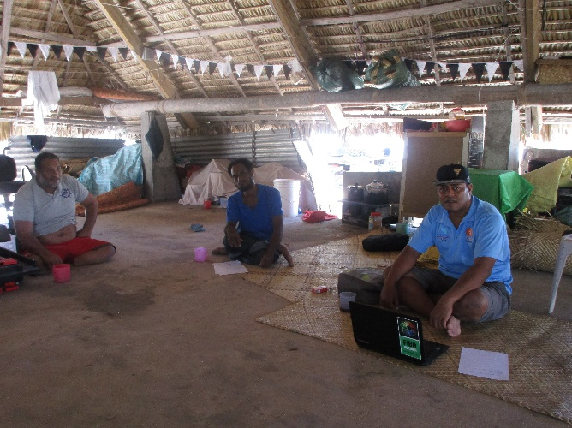

Experiences
According to the Office Manager Mr Tekamangu Bwauira, some of them had been participating in para-athletes competition in the past. In 2006, 10 para-athletes competed in the Disabled game in Malaysia whereby Meekabwa Taberannang won a Gold medal in the 200m event. In 1991, a team of 5 para-athletes with two officials were sent to attend the competition in Noumea: Taruru Tibaua won and Katarake came third in the 100m event. In addition, he mentioned that Tetoamatoa is now trying to encourage the disabled to involve in sports due to good health and skills improvement.
Para-athletes in Suva, 2016.
The result of long discussion was that they will participate in this competition. KAA will assist with their training preparation. The training will be finalised in the next Executive meeting this month.
