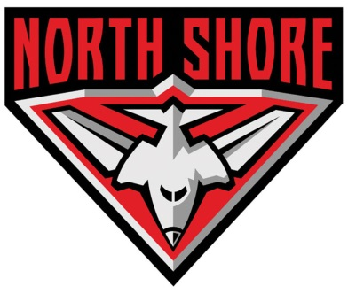

North Shore AFC

Premier Division Head Coach

North Shore, a Sydney AFL foundation club, has an opportunity for a quality coach to lead it's Premier Division team for 2015 and beyond.

North Shore has a number of quality, experienced players in its senior squad who, as a result of rebuilding over the last two seasons, are now being supplemented by a group of highly promising younger players, including a number of 2014 Rams and Swans NEAFL players.

There is a great opportunity for a dedicated individual to continue this development and help the club reap the rewards that we believe will follow.

In addition to leading the senior players and coaching group, it expected that the Head Coach will also play a key role in guiding a new Development Program that the club believes will enhance the development of the next generation of Bombers and help them to fulfil their potential.

Applicants should be able to demonstrate a successful track record in developing a quality senior squad and also be a good listener and communicator with players, the Board, sponsors and other club and community stakeholders.

The club is based in St. Leonards, on the North Shore, only a short trip from the city, North Sydney and Chatswood areas.

If you think this sounds like you, please send your application to John Goode (Football Operations) at northshorefc@yahoo.com.au by October 17, or for a confidential conversation call John on 0414 904 204.

