BASKETBALL NORTHERN TERRITORY IN CONJUNCTION WITH
BASKETBALL AUSTRALIA
PRESENT A
FREE COACHING CLINIC
For coaches of all levels.

“Offensive concepts in transition and assisting
improved player decision making”

PRESENTED BY ONE OF AUSTRALIA’S PREEMINENT DEVELOPMENT COACHES
PETER LONERGAN – BASKETBALL AUSTRALIA’S MANAGER HIGH PERFORMACE DEVELOPMENT COACH
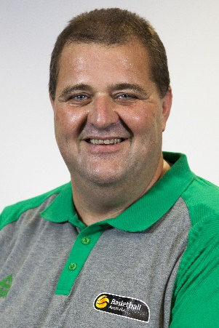

WHERE: MARRARA INDOOR STADIUM
WHEN: SATURDAY 9 JUNE 2018
TIME: 7:00 – 8:30 PM

Email rod.tremlett@nt.basketball.net.au to advise of your attendance

