Lacrosse Queensland
2021
Presentation Night

At

Mt Gravatt Bowls Club
1873 Logan Road Upper Mt Gravatt
Ph.33492367

Friday 5th November
7.00 PM
2 hours of Barefoot Bowls $10 pp (pay at door)
Drinks at bar prices, bistro opens at 5.30pm
(Please book at Bowls club for bistro).

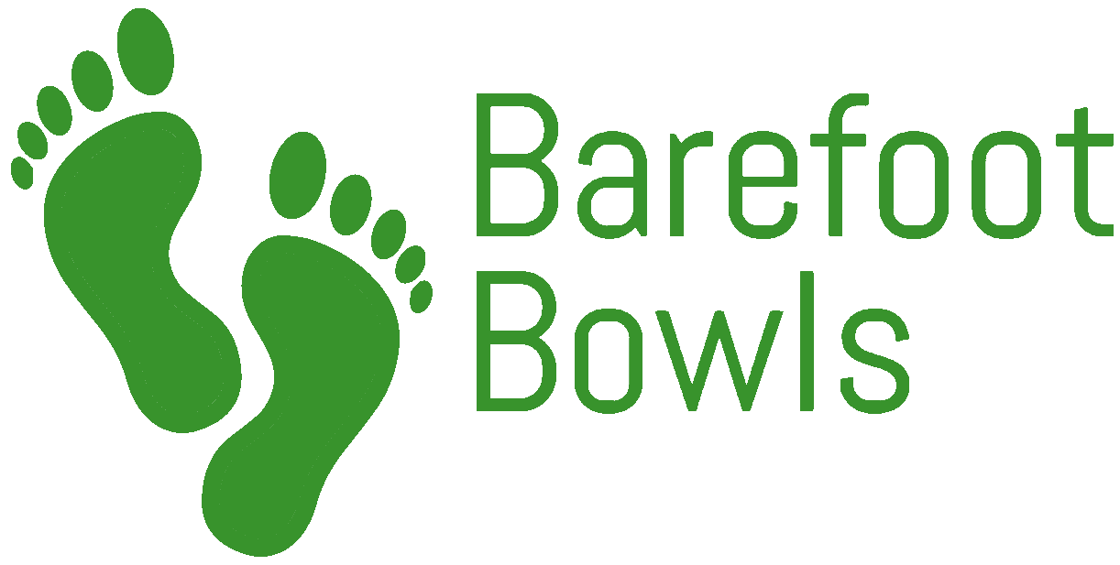

Awards Presented Include:
2021 Best and Fairest
Rising Stars
Season Premiers
State Champions
Volunteer of the Year

