Queensland Annual Report 2013

2013 ushered in a new era for AFL Masters in Queensland with the retirements of long time committee executives Bruce Steensen, Gary Mitchell and Leigh Mitchell. With 25 years of committee experience and 45 years of participation in AFL Masters between them, they have each left a lasting legacy that will enable AFL Masters Queensland to grow and prosper well into the future.

These vacancies allowed first-time committee member Steve Burchill and returning committee member and ex-president Chris Guice to come on board for 2013 and continue the good work of their predecessors. Jeff Wecker continued in his role as web master and registrar and has single handedly implemented the use of SportingPulse throughout all Queensland clubs.

Our 2013 season followed the pattern of previous years with a number of pre-season carnivals, mid season country carnivals and end of season national carnival. The south east Queensland competition consisted of 12 home and away games among 25 teams over three age groups. We welcomed one new team in 2013, Ormeau Bulldogs, located on the northern end of the Gold Coast and a big thank you to Mick, Emma and Kelly for getting this team off the ground from scratch.

We were also able to play a Masters game prior to an AFLQ divisional grand final and from that look like gaining an extra team in 2014. Through our affiliation with AFLQ we are aiming to do this again in 2014.

Queensland participated in the Bali Masters 9s for the first time in 2013 and according to tour organiser big Jack Lumby, a good time was had by all on and off the field.

Queensland sent four teams to the 2013 Darwin National Carnival and we would like to thank the professionalism and hospitality of the Darwin AFL Masters family for putting on a great carnival. While we were a smaller squad than usual, the travelling party showed true Queensland support and camaraderie for each other and many will back up for Adelaide in 2014.

We had 11 All Australians in Darwin and across all four teams there could have been 11 more, such was the evenness of our teams. Congratulations go to:

- 35s, coached by Gavin Kearney – Darren Crossley, Gavin Kearney, Andy Pethybridge, John Ryan and David Scott.
- 45s, coached by Peter Johnson – Tony Burke and Stephen Jaeger.
- 50s, coached by Steve Burchill – Derek Delany and Paul White.
- 55s, coached by Robert Templeman – Nev Growden and Peter Phelan

Off the field, we saw three events in 2013 that epitomised the character of those involved in AFL Masters in Queensland and demonstrated the sense of community amongst our family.

- Our most prestigious award is the Superman of the Year which goes to the person that has had the greatest positive effect on AFL Masters in Queensland. In 2013 that was awarded to Paul Magher from the Bayside Bombers in eastern Brisbane. Apart from being the club delegate for the past 8 years and the club coach for 4 years, Paul and his teammates launched a fundraiser across all Queensland clubs in honour of the passing of a player’s wife from cancer. Together they raised $8,000 for the Kim Walters Choices Cancer Foundation.

- One of our recent committeemen and current player, Kevin Weldon, sadly lost his wife to cancer in 2013 and through the efforts of the Mitchells and Dale Treanor from Cairns, were able to raise just under $2,500 to help Kevin and his young family.

- Each year the AFLQ select a junior and senior volunteer from all its clubs across the state and in 2013, the senior volunteer of the year went to a long time AFL Masters player and now Townsville President Maurie Soars. Maurie and his wife Denise do a mountain of work for AFL in general and Maurie’s recognition also has a positive effect on AFL Masters.

Other initiatives completed throughout 2013 to help season 2014 included:

- Conducting a new recruit questionnaire identifying how these players found AFL Masters, their level of satisfaction and suggestions for improvements.
- Initiating a carnival incentive program for each club president to attend the Adelaide carnival.
- Sending out individual invitations to 26 non Masters AFL clubs to consider participation in 2014. We are hopeful of gaining at least three next year.
- Developing and printing club-specific flyers to be used at junior sign on days and other events to attract new players.
- Conducting an age analysis of players which will see the current three age competition revert back to two, as well as being better geographically based.
- Purchasing 60 AFL Masters umpire shirts to improve professionalism of game day.
- Set up regular email communication to all registered players, currently over 1,000.
- Updating our constitution, to be ratified at our 2014 AGM.

Our challenges for 2014 will include increasing numbers on the state committee, addressing an umpire shortage and improving ground availability while trying to slowly increase team and player numbers.

Finally, I would like to thank the current Queensland committee, all our club delegates and the national executive for their passion and drive to make AFL Masters football a game and an organisation to want to belong to.

AFL Masters – Footy for Fun, Fitness and Friendship.

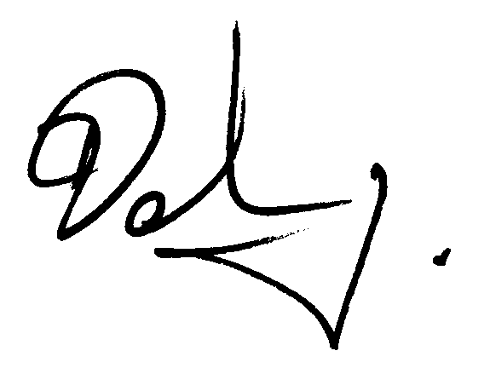

Derek Delany
Queensland President

